**Git**

**What is Git?**

Git is a distributed version control system that helps manage and track changes in the source code efficiently.

**What is GitHub?**

GitHub is a web-based platform that uses Git to store and collaborate on code.

**Version Control System**

A Version Control System (VCS) is a software tool that helps manage and track changes to files and maintain a complete history of those changes.

Listed below are the functions of a VCS

* Allows developers to work simultaneously.
* Does not allow overwriting each other’s changes.
* Maintains a history of every version.

Following are the types of VCS

* Centralized version control system (CVCS).
* Distributed/Decentralized version control system (DVCS).

**What is VSC?**

* VCS helps to track and manage changes to source code.
* Experimentation of code changes
* Reduce storage
* Maintain the different version of the code
* Encryption when uploading or downloading the files or data.

**Type of VCS**

 1. Local Version control system

 2. Centralized version control system

 3. Distributed version control system

**What is Centralised Version Control?**

* It is used for managing the versions of the codes.
* Any developer can view/modify the code of another developer.
* If the central server fails, we can lose the data
* Continuous internet is required for connecting and storing the data (Slow Process)
* Code is not available locally

      -> Operate on sync model, dependency on network.

       -> Encryption is missing while pull and push the files to remote repository.

       -> Local repository is not available.

       -> If server goes down the repo will be gone. To overcome we need to take the back up.

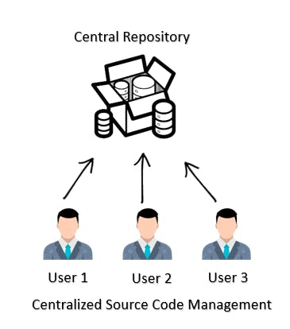

**Distributed Version Control System:**

* Git invented by Linus Torvalds in 2005
* GitHub is a web-based platform that uses Git to store and collaborate on code.
* You can access the code fast as the code is stored in a local repository as well
* If the remote repository goes down, every developer has their own code store at the local repository
* **Version control is done**

       -> Encryption is available when data is traveling over the internet, pull and push. Data encrypted. SHA 256 (secure hash algorithm).

       -> No dependency on the internet.

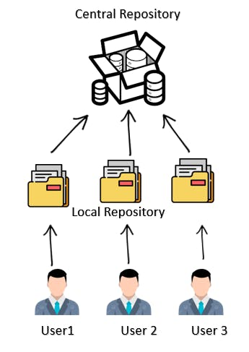

**Difference between CVCS and DVCS?**

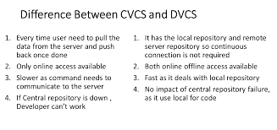

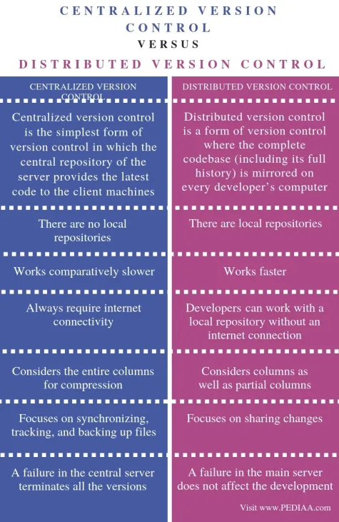

**Types of VCS:**

**CVCS Tools**

1. Team Foundation server (TFS) - ms office
2. Sub version - SVN

**DVCS tools**

1. Tortoise
2. Mercurial
3. Git

**What is Git?**

Git is a distributed version control system that helps manage and track changes in the source code efficiently.

[**https://learngitwithpra9.hashnode.dev/git-source-code-management-part-1**](https://learngitwithpra9.hashnode.dev/git-source-code-management-part-1)

**Three Stages of Git:**

1. **Untracked or Working Area:** The file exists but is not part of Git version control
2. **Staging Area:** The file has been added to Git version control but changes have not been committed
3. **Commit:** The changes/modification of the code has been committed

**The Git config command**

To register a username:

$ git config --global user.name "Ram"

To register an email address for the given author:

$ git config --global user.email "Jaisitarama@gmail.com"

To check configuration settings;

This command used to list all the settings that Git can find at that point.

$ git config --list

**Git configuration levels**

Git allows configurations at **three different levels**, each overriding the previous one.

* **Local**: It is the default level in Git. Git config will write to a local level if no configuration option is given.
* **Global:** The global level configuration is **user-specific configuration**. User-specific means, it is applied to an individual **operating system user**.
* **System:** The system-level configuration is applied **across an entire system**. The entire system means all users on an operating system and all repositories.

| **Level** | **Scope** | **Command Example** | **Config File Location** |
| --- | --- | --- | --- |
| **System** | Applies to **all users on the system**. | git config --system user.name "Alice" | /etc/gitconfig (Linux/macOS), or C:\ProgramData\Git\config (Windows) |
| **Global** | Applies to **all repositories for the current user**. | git config --global user.name "Alice" | ~/.gitconfig or ~/.config/git/config |
| **Local** | Applies only to a **single Git repository** | git config --local user.name "Alice" | .git/config in the repo directory |

🔹 Git uses settings in this **precedence order**: local > global > system.

**Git Terminology**

**Branch**

In Git, a **branch** is a lightweight movable pointer to a commit. It allows developers to create a separate copy of the project (codebase) to work on a feature, bug fixes, or experiment **without affecting the main** **project (codebase)**.

* A **branch** is a lightweight pointer to a commit.
* Branches enable **parallel development** (multiple features at once).
* The default branch is usually called **main**or**master.**

**Checkout**

**Checkout** is a command used to **switch** **between different branches** or **to restore files in the working directory** to a previous state.

* **Switching Branches**

To switch to an existing branch named "feature-branch":

$ git checkout feature-branch

* **Restoring a File to a Previous State**

To restore a specific file, "example.txt," to the version in the last commit:

$ git checkout -- file.txt

**Cherry-Picking**

The **`git cherry-pick`** command is used to **apply a specific commit from one branch to another branch** **without merging the entire branch.**

In case you made a mistake and committed a change into the wrong branch, but do not want to merge the whole branch. You can revert the commit and cherry-pick it on another branch.

$ git cherry-pick <commit-hash>

**Clone**

The **`git clone`** command is used to **copy a remote repository to local machine**. It downloads the entire repository, including all its files, commit history, and branches, to your local machine.

**Fetch**

**`git fetch`** only **downloads the latest changes from the remote repository without merging the changes.**

It downloads the latest commits, branches, and tags from a remote repository without automatically merging

**HEAD**

**HEAD** is the representation of the last commit in the current checkout branch.

 "HEAD" refers to a **Pointer to the current commit/branch.**

**Index**

**The Git index** is a **staging area** between the **working directory and repository**.

The Git index is a temporary staging area that stores a snapshot of the working tree.

**Master**

**Default primary branch (historically master, now often main).**

**Merge**

In Git, merge is a command used to **integrates (combine) changes from one branch into another. It combines the histories of two branches.**

It integrates the histories of the branches, allowing the **integration of new features or fixes into the main codebase.**

**Origin**

In Git, "origin" is the **default name for the remote repository URL**

**Pull/Pull Request**

**'git pull'** is a **combination** of two commands: **'git fetch'** and **'git merge'**. It fetches the latest changes from the remote repository and automatically merges them with the local branch. It downloads the latest changes and merges them into the current branch, creating a merge commit if necessary.

**Pull:** The git pull command fetches and merges changes from a remote repository to a local repository.

**Pull Request:** A pull request is a **request to merge code changes** from one branch into another within a repository.

**Push**

git push command is used to **upload local commits to remote repository.**

**Rebase**

Git rebase is a command used to **integrate changes from one branch onto another by moving or combining linear commits.** With rebase, you can apply a series of commits from one branch onto another, resulting in a linear commit history.

You would use 'git rebase' when you want to:

* Incorporate changes from one branch onto another with a linear commit history.
* Squash multiple commits into a single commit for a cleaner history.
* Edit or reorder commits to improve readability or resolve conflicts.

**Remote**

In Git, a remote is a reference to a version of a repository hosted on a server, commonly used to collaborate with others.

**A remote version of the repo.**

**Repository**

A **repository (or repo)** is a central storage space where **Git stores all the files and directories of a project, along with their complete history**. It contains the **entire version history** of the project, including all the commits and branches.

It keeps track of all changes made to the codebase, allowing developers to collaborate, review, and manage different versions of the project efficiently.

**Stash**

The `git stash` command is used **to temporarily save changes** that **are not ready to be committed yet**. It is useful when you need to **switch to a different branch or apply a hotfix but don't want to commit incomplete work.** You can later retrieve the changes from the stash using **`git stash apply` or `git stash pop`.**

**Tag**

A **tag** is a reference to a specific commit that is used to Marks specific points in project history (e.g., releases)., it is used to mark important events like releases or versions.

Tags are often used to create a snapshot of the project at a particular moment.

There are two types of tags.

1. **Light-weighted tag**
2. **Annotated tag**

**Upstream And Downstream**

**"Upstream"** refers to the **original repository** or **branch** from which the code is cloned, essentially the source of the code.

**"Downstream"** refers **local repository or branches** that **receive updates from the upstream.**

**Git Revert**

In Git, the revert command is used to **create a new commit that undoes a previous commit**

$ git revert <commit_hash>

**Git Reset**

It is used to **unstage the changes from the commit.** It will **rollback** to file into **working directory from staging area or index area.**

$ git reset HEAD <filename>

In Git, the reset command is used to undo changes by moving the current branch to a specific commit.

* Soft: Moves the branch pointer to the specified commit but leaves the changes in the staging area.

$ git reset --soft <commit_hash>

* Mixed: Moves the branch pointer to the specified commit and clears the staging area, but keeps the changes in the working directory.

$ git reset –mixed <commit_hash>

* Hard: Moves the branch pointer to the specified commit and discards all changes in the staging area and working directory.

$ git reset --hard <commit_hash>

**Git Ignore**

In Git, a **.gitignore** file is used to **specify which files and directories should be ignored by Git.** This helps keep the repository clean by excluding unnecessary files, such as temporary files, build artifacts, and sensitive information, from being tracked.

**Git Diff**

It is used to show the differences between **two versions of a file, commit, or branch.**

$ `git diff file.txt`

In Git, the diff command is used to show the differences between changes in the working directory, staging area, or between commits. It highlights what changes have been made to the code, making it easier to review modifications.

1. **Show differences between working directory and staging area:**

$ git diff

1. **Show differences between staging area and the latest commit:**

$ git diff --staged

1. **Show differences between two commits:**

$ git diff <commit1_hash> <commit2_hash>

1. **Show differences between a file in two commits:**

$ git diff <commit1_hash> <commit2_hash> -- <file_path>

**Git Flow: A Branching Model for Efficient Collaboration**

Git Flow is a branching model for Git that uses multiple branches to manage code changes.

It provides a **structured and efficient workflow for managing feature development, releases, and maintenance.** It defines a set of roles and rules for branches to ensure a smooth collaboration process.

**Key Branches in Git Flow**

Git Flow defines two **permanent branches** and multiple **supporting branches**:

| **Branch** | **Purpose** |
| --- | --- |
| **main (or master)** | It contains production-ready code (stable and deployable code). |
| **develop** | Integration branch for features. All changes merge here before release.  (**Serves as the integration branch where feature branches are merged before being released.**) |
| **feature/\*** | **Temporary branches used to develop new features. These are branched from develop.**  Short-lived branches for new functionality (branched from develop). |
| **release/\*** | Prepares a new production release (branched from develop).  **Used to prepare for a new production release. Created from develop and merged into both master and develop after the release** |
| **hotfix/\*** | Emergency fixes for production (branched from main).  **Used to quickly fix issues in production. Created from master and merged back into both master and develop.** |

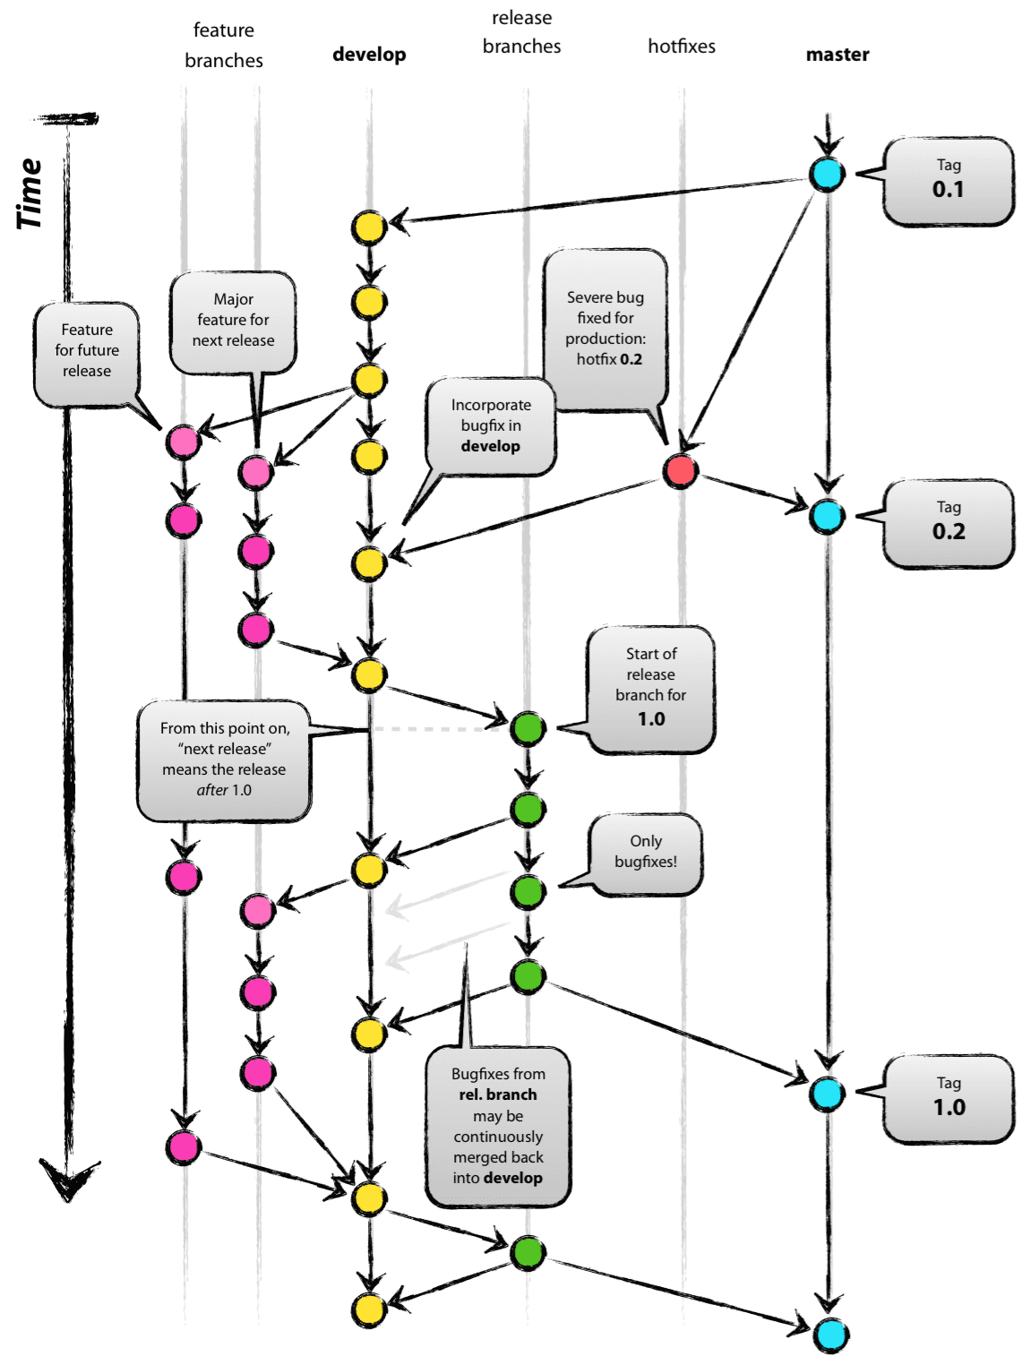

**How Git Flow Works**

**A. Feature Development**

1. **Create a feature branch**:

# git checkout develop

# git checkout -b feature/user-authentication

1. **Commit changes**:

# git add .

# git commit -m "Add login functionality"

1. **Merge back to**develop:

# git checkout develop

# git merge feature/user-authentication

# git branch -d feature/user-authentication

**B. Preparing a Release**

1. **Create a release branch**:

# git checkout develop

# git checkout -b release/1.0.0

1. **Test & bug-fix** (no new features here).
2. **Merge to**main**& tag**:

# git checkout main

# git merge release/1.0.0

# git tag -a v1.0.0 -m "Initial release"

1. **Update**develop:

# git checkout develop

# git merge release/1.0.0

# git branch -d release/1.0.0

**C. Hotfixes (Emergency Production Fixes)**

1. **Branch from**main:

# git checkout main

# git checkout -b hotfix/login-bug

1. **Fix & merge back**:

# git checkout main

# git merge hotfix/login-bug

# git tag -a v1.0.1 -m "Fixed login bug"

# git checkout develop

# git merge hotfix/login-bug

# git branch -d hotfix/login-bug

**Alternatives to Git Flow**

* **GitHub Flow**: Single main branch + feature branches (simpler).
* **Trunk-Based Development**: Fewer branches, frequent commits (used by Google, Netflix).

**Git Squash**

In Git, squash refers to the process of **combining multiple commits into a single commit** for a **cleaner history.**

* **Squash the last n commits:**

$ git rebase -i HEAD~<n>

* Replace <n> with the number of commits to squash.
* In the interactive rebase editor, change "pick" to "squash" (or "s") for the commits to combine.

pick <commit-hash> Commit message 1

squash <commit-hash> Commit message 2

squash <commit-hash> Commit message 3

* Save and exit the editor. Git will combine the selected commits into one and prompt you to provide a new commit message.

**Git Rm**

In Git, the rm command is used to **remove files from both the working directory and the staging area.**

$ git rm <file_name>

**Git Fork**

A Git fork **creates a personal copy of another user's repository**

To resolve an issue for a bug that you found, you can:

* Fork the repository.
* Make the fix.
* Forward a pull request to the project owner.

**12 Git Commands**

There are many different ways to use Git. Git supports many command-line tools and graphical user interfaces. The Git command line is the only place where you can run all the Git commands.

**Basic Git Commands**

Here is a list of most essential Git commands that are used daily.

1. Git Config command

2. Git init command

3. Git clone command

4. Git add command

5. Git commit command

6. Git status command

7. Git push Command

8. Git pull command

9. Git Branch Command

10. Git Merge Command

11. Git log command

12. Git remote command

**1) Git config command**

In Git, the **git config** command is used to **set configuration options for Git repositories**.

like your **username, email address, default editor, and other settings**. These settings can be applied at different levels: system, global, and local.

Syntax

* **Set user name:**

$ git config --global user.name "Your Name"

* **Set user email:**

$ git config --global user.email "your.email@example.com"

* **Set the default text editor:**

$ git config --global core.editor "your_editor"

* **View current configuration settings:**

$ git config --list

**2) Git Init command**

This command is used to create a local repository. This init command will **initialize an empty repository.**

Syntax

$ git init Demo

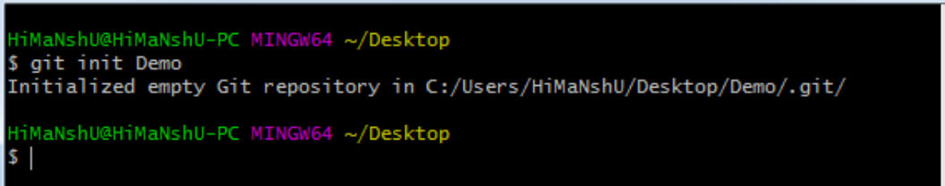

**3) Git clone command**

The git clone command is used to create a copy of an existing repository.

Syntax

$ git clone URL

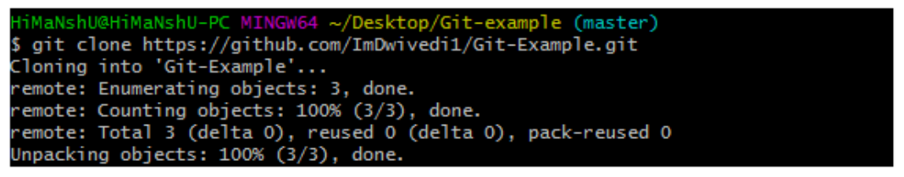

**4) Git add command**

This command is used to add one or more files to staging (Index) area.

Syntax

To add one file

$ git add Filename

To add more than one file

$ git add*



**5) Git commit command**

Commit command is used in two scenarios. They are as follows.

**Git commit -m**

The commit command is used to save changes to the local repository.

**Each commit** represents **a snapshot of the project** at a specific point in time, allowing for a detailed history of changes and easy rollback if needed.

Syntax

$ git commit -m " Commit Message"

**Git commit -a**

This command commits any files added in the repository with git add and also commits

any files you have changed since then.

Syntax

$ git commit -a

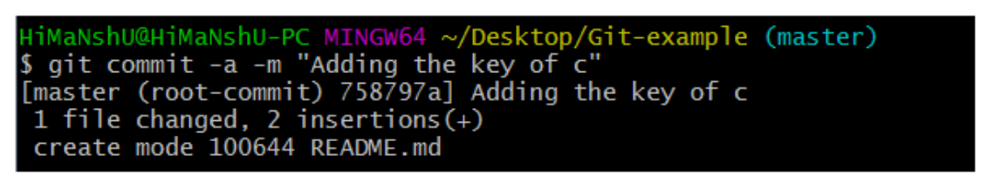

**6) Git status command**

The status command is used to **display the state of the working directory and the staging area.**

Syntax

$ git status

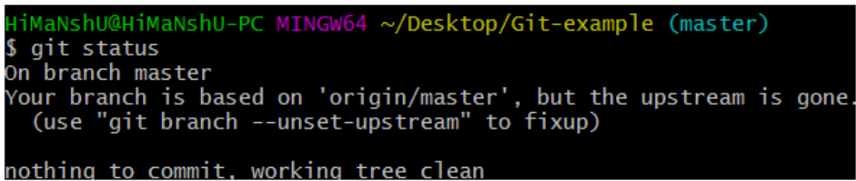

**7) Git push Command**

The push command is used to **upload local repository content to a remote repository.**

**Git push origin master**

This command sends the changes made on the master branch, to your remote repository.

Syntax

$ git push [remote] master

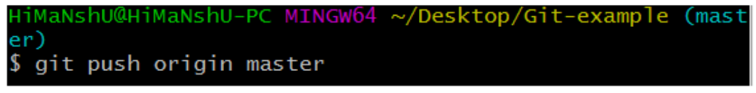

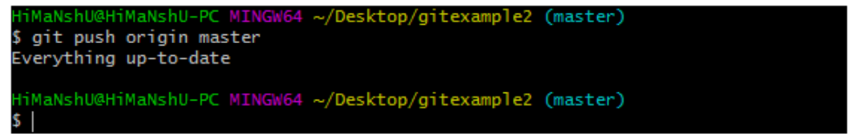

**Git push -all**

This command pushes all the branches to the server repository.

Syntax

$ git push --all

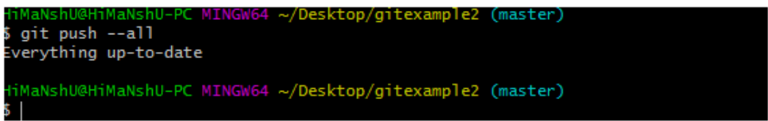

**Push tags:**

Syntax

$ git push --tags

**8) Git pull command**

The pull command is used to **fetch and merge changes from a remote repository into the current branch.**

Syntax

$ git pull URL

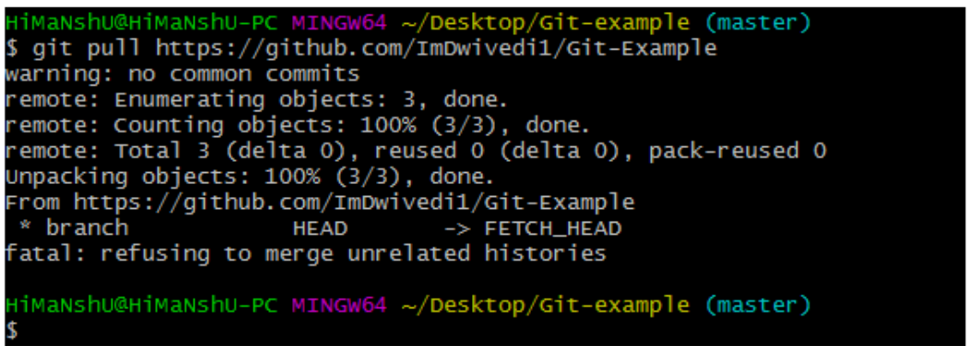

**9) Git Branch Command**

This command **displays a list all the branches available in the repository.**

Syntax

* List all branches:

$ git branch

* Create a new branch:

$ git branch <branch_name>

* Switch to a branch:

$ git branch <branch_name>

* Create and switch to a new branch:

$ git branch -b <branch_name>

* Rename a branch:

$ git branch -m <old_branch_name> <new_branch_name>

* Delete a branch:

$ git branch -d <branch_name>

* Show the last commit on each branch:

$ git branch -v

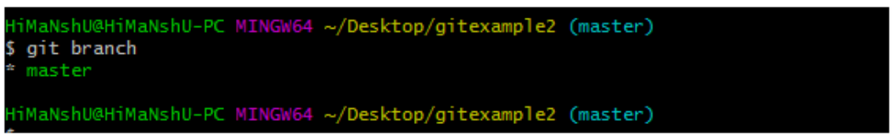

**10) Git Merge Command**

the merge command is used **to combine changes from different branches into a single branch.**

This command is commonly **used to integrate feature branches, bug fixes, or other contributions into the main codebase.**

Syntax

* Merge a branch into the current branch:

$ git merge <branch_name>

* Merge a branch without creating a merge commit (fast-forward merge):

Performs a fast-forward merge if possible, updating the current branch to match the specified branch without creating a merge commit.

$ git merge --ff-only <branch_name>

* Squash and merge a branch:

Combines all commits from the specified branch into a single commit in the current branch.

$ git merge --squash <branch_name>

* Abort a merge in progress:

Cancels an ongoing merge operation and reverts the working directory to the state before the merge.

$ git merge --abort>

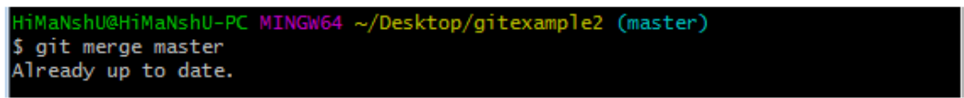

**11) Git log Command**

The log command is used to **display the commit history of a repository.**

It shows a list of commits along with information like commit hashes, authors, dates, and commit messages.

**This command is used to check the commit history.**

Syntax

* Log command:

$ git log

* Show a specified number of commits:

$ git log -n <number>

$ git log -n 5

* Show commits by a specific author:

$ git log --author="Author Name"

* Show commits containing a specific keyword:

$ git log --grep="keyword"

* Show a summary of each commit (shot format - one line per commit):

$ git log --oneline

* Show a graphical representation of the commit history:

$ git log --graph

* Show changes introduced by each commit:

$ git log -p

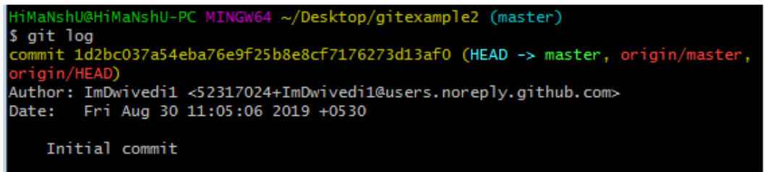

**12) Git remote Command**

The remote command is used to **manage and interact with remote repositories.**

Syntax

* List all remote repositories:

$ git remote -v

* Add a new remote repository:

$ git remote add <remote_name> <repository_url>

* Remove a remote repository:

$ git remote remove <remote_name>

* Rename a remote repository:

$ git remote rename <old_name> <new_name>

* Show details of a specific remote:

$ git remote show <remote_name>

* Update remote references:

$ git remote update

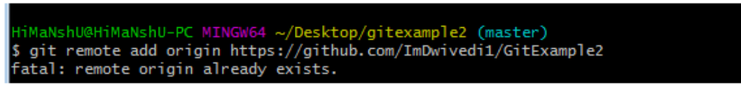

**Git Flow / Git Branching Model**

Git Stash

Git stash

Git stash save

Git stash list

Git stash apply

Git stash changes

Git stash pop

Git stash drop

Git stash clear

Git stash branch

Git Tags

**Git Merge Conflict**

$ git mergetool

<https://media.licdn.com/dms/document/media/v2/D4E1FAQG-A8EirXkWMQ/feedshare-document-pdf-analyzed/B4EZQmafNuGYAc-/0/1735811358843?e=1737590400&v=beta&t=VKeR0i-B-kjaUxRHrvZYRf1wUuBSmYR_DtfGrXMh0EY>

<https://media.licdn.com/dms/document/media/v2/D561FAQGHhm0aWFvW6Q/feedshare-document-pdf-analyzed/B56ZQLw9WMGQAY-/0/1735364193676?e=1738195200&v=beta&t=oq4Dejgh_RhLu2JGc-KYsfcrcLuStAkw5dHmGbnzHWc>

**Docker**

Docker is containerization technology tool.

Kubernetes is container orchestration tool.

**What is Docker?**

Docker is a containerization platform for developing, shipping, and running applications in **containers**—lightweight, isolated environments that package code and dependencies.

**Key Concepts**

* **Container**: A runtimeinstance of an image (like a lightweight VM).
* **Image**: A read-only template with instructions to create a container (e.g., nginx:alpine).
* **Dockerfile**: A script to build custom images.
* **Docker Hub**: Public registry for images (like GitHub for containers).

**Docker**

* Docker is mini-OS and Lightweight containers and fast responsible.
* **Docker has container runtime**, it helps to run container or manage the life cycle of the container.
* **Containers**—lightweight, isolated environments that package code and dependencies.
* **Container is ephemeral** - short life or lived, containers can die or revive anytime.
* A Docker container is a **lightweight, executable package** that includes application code, a runtime environment (e.g., Python, Node.js), libraries, and all other dependencies required to run the application.

**Containerization:**  
 It’s all about deploy application with required dependencies is known as containerization.

**Kubernetes:**

Kubernetes is an orchestration platform for running and managing container for many (100’s of) containers runtimes.

**Virtualization:**

-

**Docker vs. Virtual Machines (VMs)**

| **Feature** | **Docker** | **VM** |
| --- | --- | --- |
| **Isolation** | Process-level (light) | Hardware-level (heavy) |
| **Boot Time** | Seconds | Minutes |
| **Performance** | Near-native | Overhead |
| **Image Size** | MBs | GBs |

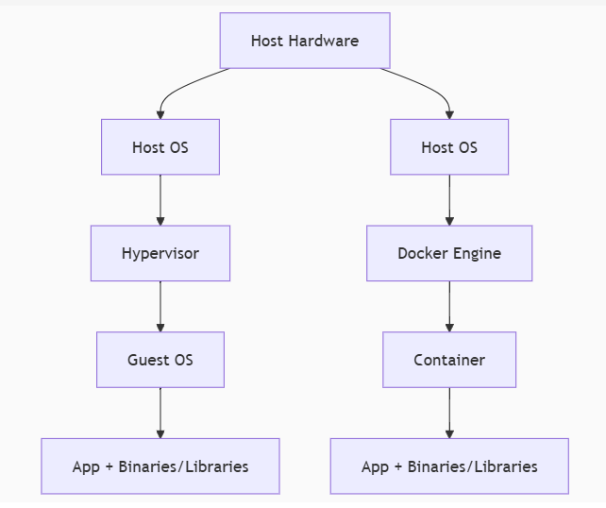

**Container Engine:**

Software which helps to **implement containerization on a machine or server** is caller container Engine.

Tool:

Docker, Jail, Crio.

**Docker Architecture:**

* **Docker Daemon**: Background service managing containers/images.
* **Docker Client**: CLI (docker) to interact with the daemon.
* **Docker Registry**: Stores images (e.g., Docker Hub, AWS ECR).

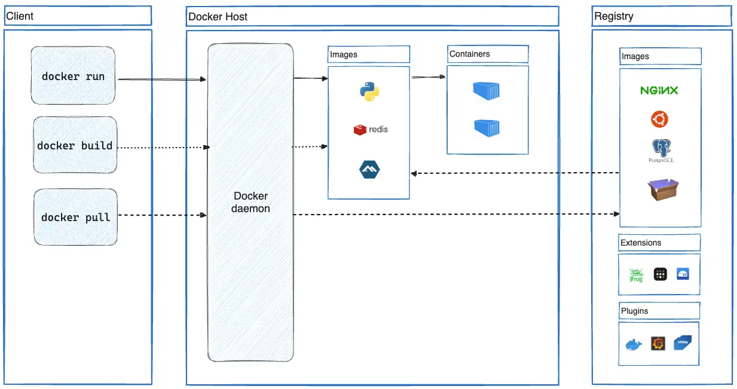

**Docker CLI/Client:**

**Docker client** is a tool helps **interact with Docker** and **manage** containers, images, networks, and volumes directly from the command line. It is a powerful interface for Docker, providing commands to perform tasks such as building, running, and stopping containers, as well as managing Docker images and networking.

Some common Docker CLI commands include:

* **docker run**: Used to create and start a container from images.
* **docker build**: Builds a Docker image from a Dockerfile.
* **docker pull**: Downloads an image from a Docker registry like Docker Hub.
* **docker ps**: Lists all running containers.
* **docker images**: Lists all available Docker images in server.
* **docker push**: Uploads an image to a Docker registry.
* **docker stop**: Stops a running container.
* **docker rm**: Removes a stopped container.
* **docker exec:** Executes a command inside a running container.
* **docker start:** Starts a stopped container.
* **docker logs:** Displays logs from a container.
* **docker attach:** Attaches to a running container’s main process (useful for debugging).

**Docker Daemon (Docker service):**

**Docker daemon** **manages all the services** by **communicating with other daemons** (**services**). It manages docker objects such as images, containers, networks, and volumes with the help of the API requests of Docker.

(**The Docker daemon** listens for **Docker API requests** and **manages Docker objects** such as **images, containers, networks,** and **volumes**.)

**Docker Host**

In simple terms:

* **Docker Host** is the machine or environment where the **Docker Engine** is installed and running.
* It provides the environment where containers are created, managed, and executed.
* **Docker Host** is responsible for **managing Docker containers and images**, as well as **handling the resources** (CPU, memory, disk, etc.) needed to run them.

**Docker Registry**

**Registry**:

* It is a collection of all dependencies and docker container images
* All the docker images are stored in the docker registry.

**Docker pull:**

* It helps to download the images or dependencies from registry on to the docker host.

# Docker pull <image name:version>

**Docker Images**

* **Image** is collection of layers. (Hash tag or commit id). An image contains **instructions** to create a docker container. It helps to create container from docker images.
* A Docker image includes the application code, libraries, dependencies, tools, and other files required to run an application.

**Docker Container**

* **A Docker container** is a **runtime instance of a Docker image**. It is a **lightweight, executable package** that includes application code, a runtime environment (e.g., Python, Node.js), libraries, and all other dependencies required to run the application.
* Containers are created from docker images. With the help of Docker API or CLI, we can start, stop, delete, or move a container.

**Docker Services**:

* After docker install, we must follow 3 steps (or) activities.

1. Start the docker services.

Ex: **service docker start**

1. Enable docker services at boot time.

**chkconfig docker on**

1. Add the user account to the docker root group.

Ex: **usermod -a -G dockerroot <username>**

* After installing docker, it will create group called **dockerroot**. We must add user account to the docker root group.

**Docker commands:**

**How to check docker client and engine version?**docker version

**How to check docker server configuration?**

docker info

**How to find the container image?**

Docker images

**How to check the container information?**

Docker ps -a

Or

Docker ps -> it will shows only live or running containers

**How to create images?**

Docker build –tag <image Name> <file path to docker file>

**How to create a container?**

Docker run -it <image name or Id> <container shell ex: sh, bash>

Note : -it is used for create and log into the container

**How to close a container and come out?**

Type exit in container and click on enter.

**How to come out from container without closing session?**

Ctrl + pq

**How to stop container?**

Docker container stop <container id or name>

**How to start container?**

Docker container start <container id or name>

**How to log into the container or docker exec command?**

Docker exec -it <container name or id > <container shell>

Note: the container should be running and up to log into the container. If container is stopped or not running, we have to start and log in.

**How to start and log into a container?**

Docker start -ai <container name or id >

Note: Here we can’t change the shell, default shell is sh

**Create or update container names?**

Docker rename <old container name > <new container name>

**How to name a container while creating?**

Docker run -name <container name> -it <image id> <container shell>

**How to delete containers?**

Docker rm <container id or name>

Note: always delete a container when status is showing as exited.

docker rm <container id or name> --force (to remove container forcefully)

**How to delete multiple containers?**

Docker rm < container name1> name2 name3 etc…

**How to delete docker images?**

Docker rmi <image name or id >

Note: it will only delete images not the container running from those images.

**Image tagging:**

Two types of image tags are available.

1. **Local tag**

Local tag helps to create an alias name use case on docker server or host. We can’t upload local tag images to docker registry

# Docker image tag <source image name or id > <new image name >

1. **Remote tag**

We can generate image alias both for use case or keeping images on docker host and upload to the docker registry.

# Docker tag <source image name or id > <docker hub id>/<new image name>:<image version>

**How to login to docker hub from cli mode?**

Docker login

**How to push images to docker registry or hub?**

Docker push <image name>

Note: **only use image names to push images to docker hub**

**How to logout from docker hub?**

Docker logout

**Docker image inspect:**

Inspect command shows the properties of the image.

**How to get the image meta data info or properties?**

Docker image inspect <image id or name>

**How to get the container meta data info or properties?**

Docker container inspect <container name or id>

**Docker image history:**

This command helps to check the layers of the image or code of the image.

# Docker image history

**Docker layer:**

Docker build follows the process of interpretation it will check the code line by line.

If we have 4 lines in a code

First line code is correct it will create hashtag or commit id. If the hashtag crated this will generate a layer.

Image is a collection of layers

In dockerfile output layers are arranged in descending order

The last line of the layer in an image automatically considered as image id.

Each line of code in dockerfile we have to call as instruction.

If instruction executed correctly docker will create layer, all these instructions are written in a file is called dockerfile. For docker file no extension.

Docker build is process of converting instructions into layers if all layers are successfully executed then it will generate a docker image else if one of the instructions fails then layer will not generate.

If one of the layers fails then docker image fails to generate.

**Dockerfile**:

* Dockerfile helps to create images,
* File contains instructions.
* These instructions more look like Linux commands.

Work flow of docker image process:

1. Crete project folder
2. Cd into folder, create dockerfile. Name is Dockerfile.
3. Open the dockerfile, write the code and save it.

Eg: FROM python:3.12

WORKDIR /usr/local/app

# Install the application dependencies

COPY requirements.txt ./

RUN pip install --no-cache-dir -r requirements.txt

# Copy in the source code

COPY src ./src

EXPOSE 5000

# Setup an app user so the container doesn't run as the root user

RUN useradd app

USER app

CMD ["uvicorn", "app.main:app", "--host", "0.0.0.0", "--port", "8080"]

1. Excute it (Image build process)

Commad:

Docker image build –tag <image_name > <docker file path>

1. Result: docker ps
2. Then push to docker hub.

**Dockerfile Basics**

Example Dockerfile for a Node.js app:

dockerfile

FROM node:18-alpine          # Base image

WORKDIR /app                # Set working directory

COPY package*.json ./       # Copy dependency files

RUN npm install             # Install dependencies

COPY . .                    # Copy app code

EXPOSE 3000                 # Declare port

CMD ["npm", "start"]        # Default command

**Build and Run**:

* docker build -t my-node-app .
* docker run -p 3000:3000 my-node-app

**Docker instructions:**

* **FROM <image>** - this specifies the base image that the build will extend.
* **WORKDIR <path>** - this instruction specifies the "working directory" or the path in the image where files will be copied and commands will be executed.
* **COPY <host-path> <image-path>** - this instruction tells the builder to copy files from the host and put them into the container image.
* **RUN <command>** - this instruction tells the builder to run the specified command. It executed at time of image build process.
* **ENV <name> <value>** - this instruction sets an environment variable that a running container will use.
* **EXPOSE <port-number> -** this instruction sets configuration on the image that indicates a port the image would like to expose.
* **USER <user-or-uid>** - this instruction sets the default user for all subsequent instructions.
* **CMD ["<command>", "<arg1>"]** - this instruction sets the default command a container using this image will run. It executed at time of container creation.
* **ENTRYPOINT [command param1 param2]:** specifies the main command to execute when a container starts.

For more information about docker installations:

<https://docs.docker.com/get-started/docker-concepts/building-images/writing-a-dockerfile/>

**Docker Networking**

**Docker Networking**

* **Bridge**: Default network for containers on the same host.
* **Host**: Shares the host’s network stack.
* **Overlay**: Connects containers across multiple hosts (Swarm/Kubernetes).

Example:

* docker network create my-net
* docker run --network=my-net nginx

**Docker Networking** refers to how Docker containers communicate with each other and the outside world. Docker uses a network model that allows containers to connect to one another and to external systems while ensuring isolation, security, and scalability.

**Key Concepts in Docker Networking:**

1. **Container Networking**: Each container gets its own network stack (IP address, ports, etc.) when it is created, and it can communicate with other containers and external services based on its network configuration.
2. **Network Drivers**: Docker uses different network drivers to control how containers communicate. Each driver defines a networking mode (e.g., bridge, host, overlay, etc.) and manages the behaviour of containers in that network.

The Docker Network command is the main command that would allow you to create, manage, and configure your Docker Network. Let’s see what the sub-commands can be used with the Docker Network command. to know more about Creating a Network in Docker and Connecting a Container to That Network.

1. **IP Addresses and Ports**: Each container gets its own IP address on the network. Containers can expose ports, allowing external systems to communicate with them (e.g., HTTP on port 80).
2. **Network Isolation**: Containers can be isolated in different networks for better security and control. By default, containers that are part of the same network can communicate with each other, while containers on different networks are isolated.

**Docker Network Drivers:**

Docker supports several types of network drivers, each designed for different use cases:

**1. Bridge Network (default)**

* [**Bridge networks**](https://docs.docker.com/network/bridge)create a **virtual bridge between host and the container**. Containers connected to the network can communicate with each other, but they’re isolated from those outside the network.
* **Description**: This is the default network driver when you create a container. Containers on a bridge network are connected to a virtual bridge (a software-based network bridge) on the host system. **Containers can communicate with each other through this bridge and can be accessed externally by exposing ports.**
* **bridge:** If you build a container without specifying the kind of driver, the container will only be created in the bridge network, which is the default network.

# Run a container on the bridge network (default)

**$ docker run -d --name my_container --network bridge my_image**

**2. Host Network**

* **Description**: When a container is run on the host network, **it shares the host’s network stack directly.** The **container doesn’t get its own IP address** but uses the **host’s IP and network interfaces.** It can access all ports and services available on the host machine.
* **host:** Containers will not have any IP address they will be directly created in the system network which will remove isolation between the docker host and containers.

# Run a container on the host network

**$ docker run -d --name my_container --network host my_image**

**3. Overlay Network**

* **Description**: Overlay networks allow containers to **communicate across multiple Docker hosts.** This network driver is commonly used when deploying applications in a **Swarm** or **Kubernetes** cluster. It abstracts the underlying network and connects containers across different hosts over a virtual network.
* **Use Case**: Ideal for multi-host communication in a Docker Swarm or Kubernetes cluster.
* **overlay:** overlay network will enable the connection between multiple Docker demons and make different Docker swarm services communicate with each other

# Create an overlay network

**$ docker network create --driver overlay my_overlay_network**

# Run containers on the overlay network (example in Swarm mode)

**$ docker service create --name my_service --network my_overlay_network my_image**

**4. None Network**

* **Description**: This driver disables networking for the container entirely. The container will not have any network interfaces or be able to communicate with other containers or the external network.
* **Use Case**: Used when you want to isolate a container from any networking (e.g., for security reasons or when running an application that doesn't require networking).

* **none:** IP addresses won’t be assigned to containers. These containments are not accessible to us from the outside or from any other container.

# Run a container with no network access

**$ docker run -d --name my_container --network none my_image**

**5. Macvlan Network**

* [**macvlan**](https://docs.docker.com/network/macvlan/)is another advanced option that **allows containers to appear as physical devices on your network.** It works by assigning each container in the network a unique MAC address.
* **Description**: The Macvlan driver allows containers to appear as individual devices on the physical network. Each container gets its own MAC address and IP address, making it behave as if it is a physical device connected to the network.
* **Use Case**: Useful when you need containers to directly interact with the physical network or when legacy applications require containers to have a unique MAC address and IP.
* **macvlan:** macvlan driver makes it possible to assign MAC addresses to a container.

# Create a Macvlan network

**$ docker network create -d macvlan --subnet=192.168.1.0/24 --gateway=192.168.1.1 my_macvlan_network**

# Run a container on a Macvlan network

**$ docker run -d --name my_container --network my_macvlan_network my_image**

**6. ipvlan Network:**

* [**IPvLAN**](https://docs.docker.com/network/ipvlan)is an advanced driver that offers precise control over the IPv4 and IPv6 addresses assigned to your containers, as well as layer 2 and 3 VLAN tagging and routing.
* Users have complete control over both IPv4 and IPv6 addressing by using the IPvlan driver.

**Common Docker Networking Commands:**

* List Networks:

**$ docker network ls**

* Create a Network:

**$ docker network create --driver bridge my_bridge_network**

* Inspect a Network (get detailed information about a network):

**$ docker network inspect my_bridge_network**

* Connect a Container to a Network:

**$ docker network connect my_bridge_network my_container**

* Disconnect a Container from a Network:

**$ docker network disconnect my_bridge_network my_container**

* View Container's Network Information:

**$ docker inspect my_container**

**Exposing Ports for External Access:**

In Docker, containers typically run in isolated networks and cannot be accessed externally unless specific ports are exposed. You can map container ports to host ports using the -p or --publish option.

# Run a container and expose its port (e.g., 80 in container to port 8080 on the host)

**$ docker run -d -p 8080:80 my_image**

This allows you to access the container's service (running on port 80 inside the container) via the host machine's port 8080.

**sudo docker network**

How to create a docker network.  
**$ sudo docker network create --driver <driver-name> <bridge-name>**

Using the “Connect” command, you can connect a running Docker Container to an existing Network.

**sudo docker network connect <network-name> <container-name or id>**

Using the Network Inspect command, you can find out the details of a Docker Network.

You can also find the list of Containers that are connected to the Network.

**sudo docker network inspect <network-name>**

The disconnect command can be used to remove a Container from the Network.

**sudo docker network disconnect <network-name> <container-name>**

You can remove a Docker Network using the rm command.  
Note that if you want to remove a network, you need to make sure that no container is currently referencing the network.

**sudo docker network rm <network-name>**

To remove all the unused Docker Networks, you can use the prune command.

**sudo docker network prune**

**Docker Networking – Basics, Network Types & Examples**<https://spacelift.io/blog/docker-networking>

**Docker Volume and Bind Mounts:**

**Docker Volumes**

Persist data outside containers:

* docker volume create my-data
* docker run -v my-data:/data alpine

In Docker, **volumes** and **bind mounts** are both used to persist data and share data between the host system and containers. **Docker volumes and bind mounts** are two ways to manage persistent data in Docker containers.

Here's an explanation of each:

**1. Docker Volumes**

A **Docker volume** is a specialized storage mechanism managed by Docker, designed for storing data that should persist even after containers are stopped, removed, or recreated. Volumes are stored in a specific location on the host filesystem, but Docker manages the underlying filesystem for the volume.

**Key Features of Volumes:**

* **Managed by Docker:** Volumes are stored outside the container filesystem, managed, and maintained by Docker.
* **Persistence**: Data stored in volumes persists even if a container is deleted and restarted. Volumes can be reused across multiple containers.
* **Isolation**: Volumes are independent of the host filesystem, making them more portable and secure. Docker handles the storage location.
* **Sharing Data**: Volumes can be shared and reused by multiple containers. For example, multiple containers can mount the same volume, enabling data sharing between them.
* **Backup and Restore**: Volumes are easier to back up and restore compared to bind mounts because Docker provides built-in tools.

**Example:**

# Create a volume

**$ docker volume create my_volume**

# Run a container with a volume mounted

**$ docker run -d -v myvolume:/data myimage**

**$ docker run -d -v my_volume:/data my_container**

**2. Bind Mounts**

**Bind mounts** allow you to mount a directory or file from the host system directly into a container. This means that changes made inside the container will be reflected on the host, and vice versa.

Bind mounts allow you to directly access and modify files and directories on the host machine from within the container.

**Key Features of Bind Mounts:**

* **Direct Host Access**: Bind mounts provide direct access to the host filesystem. You specify an exact path on the host (e.g., /path/on/host), and Docker mounts it to the container.
* **More Flexibility**: You can mount specific files or directories from the host into a container, allowing for custom configurations, shared logs, or easy development workflows.
* **Less Isolation**: Since bind mounts expose the host filesystem directly, they are less isolated than volumes, which may present security risks.
* **Performance**: Bind mounts can be faster for certain use cases, such as when you're working with large amounts of data and need direct access to the host filesystem.

**Use Case:**

Bind mounts are often used when you want a container to access files or directories that are located on the host system (e.g., source code during development or configuration files).

**Example:**

# Run a container with a bind mount (host directory to container directory)

**$ docker run -d -v /path/on/host:/data myimage**

**$ docker run -d -v /host/path:/container/path my_container**

**Comparison Between Docker Volumes and Bind Mounts**

| **Feature** | **Docker Volumes** | **Bind Mounts** |
| --- | --- | --- |
| **Storage Location** | Managed by Docker (location depends on Docker setup) | Defined by the user on the host filesystem |
| **Persistence** | Data persists after container removal | Data persists unless the file or directory is deleted from the host |
| **Backup and Restore** | Easier, as volumes are managed by Docker | Backup and restore must be handled manually |
| **Portability** | Portable across hosts (if shared between containers) | Tied to the host filesystem |
| **Security** | More isolated from the host filesystem | Direct access to the host filesystem |
| **Performance** | May have slight overhead due to Docker management | Faster in some cases since it's a direct mount |
| **Use Cases** | Ideal for persistent storage (databases, logs, etc.) | Ideal for shared development files or custom configurations |

**When to Use Volumes vs Bind Mounts:**

* **Use Volumes** when:
  + You need persistent, portable storage that is independent of the host filesystem.
  + You are running databases or applications that need reliable, managed storage.
  + You want Docker to handle storage management for backups, snapshots, and migration.
* **Docker Volumes** are typically preferred for production environments due to their portability, easier management, and Docker's built-in support for persistence and backup.
* **Use Bind Mounts** when:
  + You need to share files or directories directly between the host and the container (e.g., for development, configuration files, or logs).
  + You need more control over the location of the data on the host.
  + You want to mount specific files (e.g., a configuration file) into a container.
* **Bind Mounts** provide more flexibility and are useful for development or situations where you need direct access to the host filesystem.

**Docker Volumes – Guide with Examples**

<https://spacelift.io/blog/docker-volumes>

**Docker Compose**

**Docker Compose** is a tool that makes it easier to create and run multi-container applications. It automates the process of managing several Docker containers simultaneously, such as a website frontend, API, and database service.

Orchestrate multi-container apps with docker-compose.yml:

version: '3.8'

services:

  web:

    image: nginx:alpine

    ports:

      - "80:80"

  db:

    image: postgres:13

    volumes:

      - db-data:/var/lib/postgresql/data

volumes:

  db-data:

**Commands**:

* docker-compose up -d # Start services in detached mode
* docker-compose down # Stop and remove containers

**Dockerfile**

# syntax=docker/dockerfile:1

FROM python:3.10-alpine

WORKDIR /code

ENV FLASK_APP=app.py

ENV FLASK_RUN_HOST=0.0.0.0

RUN apk add --no-cache gcc musl-dev linux-headers

COPY requirements.txt requirements.txt

RUN pip install -r requirements.txt

EXPOSE 5000

COPY . .

CMD ["flask", "run", "--debug"]

**compose.yaml**

services:

  web:

    build: .

    ports:

      - "8000:5000"

  redis:

    image: "redis:alpine"

* **docker compose up**
* **docker compose down**
* **docker compose stop**

**Docker Compose – What is It, Example & Tutorial**

<https://spacelift.io/blog/docker-compose>

**Docker Security:**

**Docker security** is essential for ensuring the safe operation of containers in both development and production environments. By applying these security practices and tools, you can minimize risks, protect the host system, and prevent attacks. Security should be an ongoing process, with regular updates, scans, and reviews to ensure Docker environments remain secure.

**1. Image Security**

**Use Official Images:** Official images on Docker Hub are often vetted for security issues. You should prefer official or trusted images over random, unverified ones.

**Scan for Vulnerabilities:** Docker images may contain vulnerabilities. You can use tools like Docker’s docker scan (integrated with Snyk) to scan images for known vulnerabilities.

**Minimize Base Image:** Use minimal base images (e.g., alpine or scratch) to reduce the attack surface, avoiding unnecessary software in the image.

**2. Container Isolation**

**Namespace Isolation:** Docker uses namespaces to isolate containers from each other and from the host system. This helps ensure that one container cannot affect the others or the host system directly.

**Control Groups (cgroups):** Docker uses cgroups to control resources allocated to containers (like CPU, memory, and disk). This prevents one container from consuming too many resources and impacting others.

**Seccomp Profiles:**

**AppArmor/SELinux:**

**3. User and Permissions Management**

**Least Privilege Principle:** Containers should run with the least privileges required. This means avoiding running containers as the root user when unnecessary.

**File Permissions:** Properly manage file permissions in your container and on the host system to prevent unauthorized access.

**User Namespaces:**

**4. Docker Daemon Security**

**Docker Daemon Socket:** By default, the Docker daemon listens on a Unix socket (/var/run/docker.sock), which is accessible to users in the docker group. Restrict access to this socket to prevent unauthorized control over Docker.

**Remote API Security:** If you're using the Docker Remote API, ensure it is securely configured using TLS/SSL to encrypt communication. Access should be controlled with appropriate authentication mechanisms.

**Limit Docker Daemon Privileges:** Ensure that the Docker Daemon itself is running with the least privileges required, and limit its exposure to unnecessary services.

**5. Networking Security**

**Network Segmentation:** Use Docker's built-in networking capabilities (e.g., bridge, overlay) to isolate containers and limit network communication between them, based on their needs.

Secure Connections: Containers communicating over the network should use encryption (e.g., HTTPS, TLS) to prevent data from being intercepted.

**Firewalls:** Control network access to Docker containers using firewalls, either on the Docker host itself or within the container’s network settings.

**6. Logging and Monitoring**

Log Container Activity:

Monitor Resources:

Audit Docker Commands:

**7. Container Runtime Security**

Runtime Security Tools:

Container Scanning at Runtime:

**10. Vulnerability Patching**

**Regularly Update Images:** Regularly pull the latest versions of images from official repositories to ensure you get security patches and updates.

**Update Docker and Host Systems:** Make sure that both Docker and the host system are kept up-to-date with the latest security patches and updates.

**11. Security Tools for Docker**

**Trivy:** A simple and comprehensive vulnerability scanner for containers, which checks images for vulnerabilities in OS packages and application dependencies.

**12. Orchestration Security**

When using orchestration systems like Docker Swarm or Kubernetes, consider the security of the cluster, such as secure communication (TLS), role-based access control (RBAC), and secrets management.

Image layers

what is the Base layers in docker file?

Latest version: 1.27.0-alpine

If the layers are more, then it can be easy to hack

Docker exec -it

we need to create new user to login into container.

It should username@container name.

trivy - to scan the images - it will teach in pipeline projects.

Docker ignore --

We should not use add command, this comes under security.

Add command can also download the files from url, because of this there might causes of hack.

Environmental variables, username and password.

Don't hard code the passwords and username.

User docker secretes.

Interview questions

1. which image have you used, base image or latest image?

2. which user have you user, either root user or different user?

3. don't provide the privileges for some users.

4. docker instructions commands

5. what is the Base layers in docker file?

Docker Troubleshooting:

Top

Stats

Logs

Logs -f

exce -it

inspect volume, network,

History

Docker compose and docker multi stage build.

**Essential Docker Commands**

**Container Management**

| **Command** | **Description** |
| --- | --- |
| docker run -d -p 80:80 nginx | Run Nginx in detached mode, mapping port 80. |
| docker ps | List running containers. |
| docker ps -a | List all containers (including stopped). |
| docker stop <container> | Gracefully stop a container. |
| docker rm <container> | Delete a stopped container. |
| docker logs <container> | View container logs. |

**Image Management**

| **Command** | **Description** |
| --- | --- |
| docker pull nginx | Download an image from Docker Hub. |
| docker images | List local images. |
| docker rmi <image> | Delete an image. |
| docker build -t my-app . | Build an image from a Dockerfile. |

**Networking & Volumes**

| **Command** | **Description** |
| --- | --- |
| docker network ls | List networks. |
| docker volume create my-vol | Create a persistent volume. |
| docker run -v my-vol:/data | Mount a volume into a container. |

**Best Practices**

✔ **Use**.dockerignore to exclude unnecessary files (like .gitignore).  
✔ **Prefer small base images** (e.g., alpine over ubuntu).  
✔ **Run one process per container**.  
✔ **Use multi-stage builds** to reduce final image size.

**Common Use Cases**

* **Microservices**: Deploy isolated services.
* **CI/CD Pipelines**: Consistent build environments.
* **Local Development**: Replicate production setups.

**Troubleshooting**

* **Debug a crashing container**:

docker logs <container>

docker run -it --entrypoint sh <image> # Override entrypoint

* **Clean up resources**:

docker system prune -a # WARNING: Deletes unused images/networks/volumes

**Kubernetes**

**Kubernetes:**

* Kubernetes is an open-source Container orchestration platform that automates the deployment, management, scaling, and networking of containers across the cluster.
* It is focused on managing the life cycle of containers. It schedules, run, manage isolated containers which are running on virtual/physical/cloud machine
* Kubernetes is a cluster. Cluster is a group of nodes, that run containerized applications.

Docker is container platform

Kubernetes is a container orchestration platform

Orchestration tool = Container Management tool

**Docker**

Docker has container runtime, it will allow to run container or manage the life cycle of the container.

**Container is ephemeral** - short life or lived, containers can die or revive anytime.

* Problem with scaling up the container:
* can't communicate with each other.
* Auto scaling and auto healing
* load balancing
* container had to be managed carefully.
* Single host nature of docker container
* **Enterprise level support**.
* Auto scaling
* Auto healing
* Load balancer support
* Firewall support
* Api support gateways
* White listing
* Black listing

Advantages for k8s:

* **Container Orchestration:** It automates the management of containers running across a cluster of machines. Kubernetes ensures that containers are deployed, scaled, and maintained consistently.
* **Auto Scaling**: Kubernetes can automatically scale applications up or down based on resource utilization (like CPU or memory) or other custom metrics.
* **Auto Healing:** Kubernetes automatically replaces failed containers, restarts them, or reschedules them as necessary, ensuring the application remains available.
* **Load Balancing:** It automatically distributes incoming traffic to containers to ensure that no single container is overwhelmed, improving the overall performance and availability.
* **Service Discovery and Networking:** Kubernetes helps containers communicate with each other by providing a DNS-based service discovery system.
* **Platform independent (cloud/virtual/physical)**
* **Fault tolerance (node/pod failure)**
* **Rolling application upgrades and downgrades with zero downtime (Rolling back)**
* **Health Monitoring of pod**
* **Updates/new release/deployment**
* **Secrete/config (master node)**

**Kubernetes architecture:**

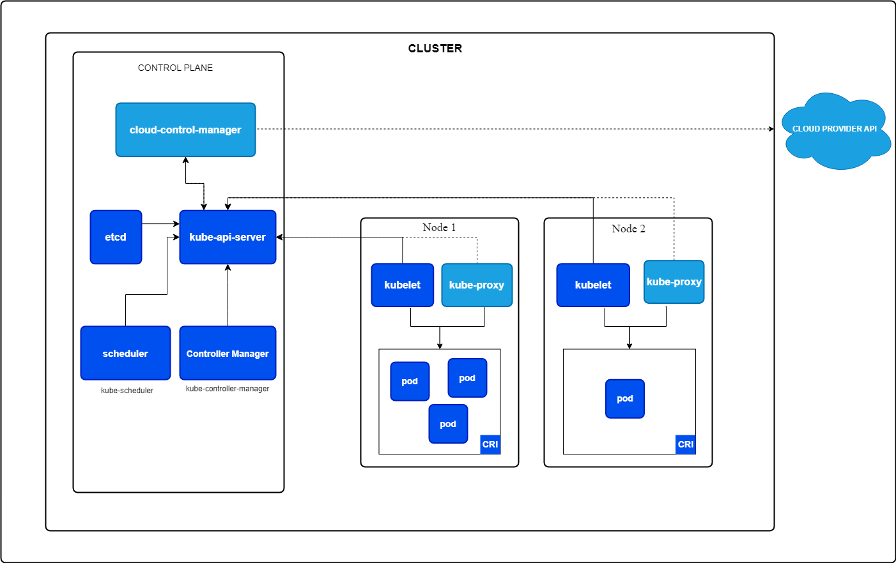

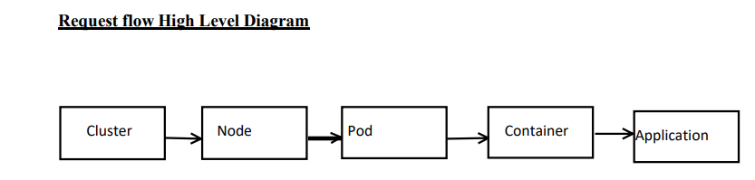

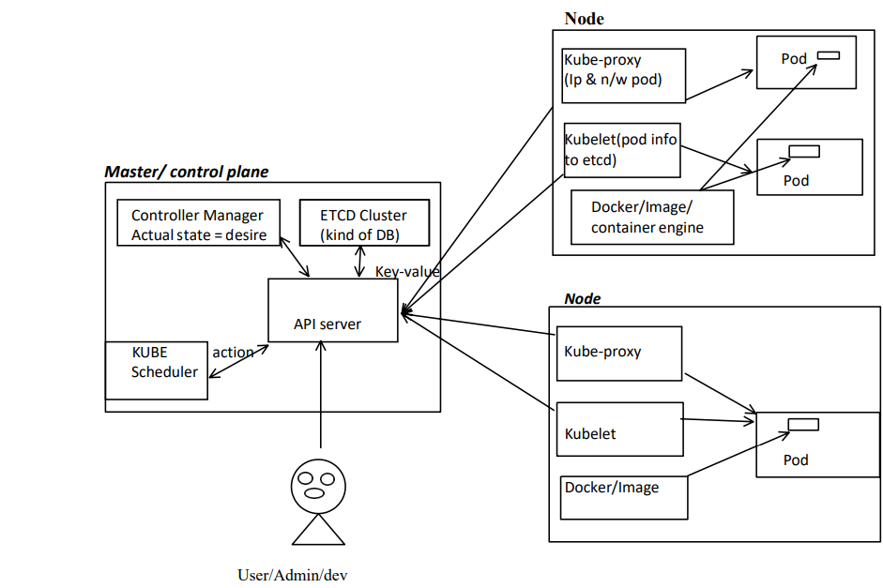

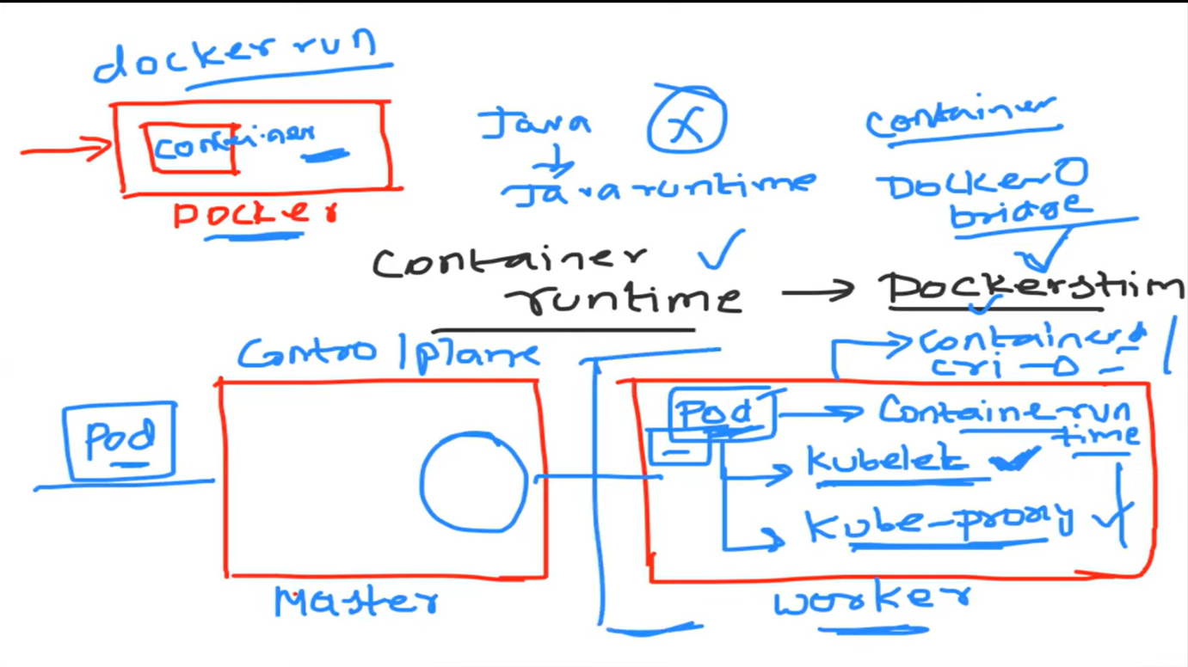

Kubernetes architecture allows Kubernetes to provide a scalable, reliable, and flexible platform for managing containerized applications

**Kubernetes Workflow:**

1. **User interacts with the API server** (using kubectl or other tools).
2. **API server** processes the request and stores the data in etcd.
3. **Scheduler** assigns Pods to appropriate nodes based on resources and constraints.
4. **Kubelet** ensures that containers are running on the nodes.
5. **Kube Proxy** manages network traffic between services and Pods.

**Role Of Master:**

Kubernetes cluster runs on VM / BareMetal / cloud or mix.

1. K8s having one or more master and one or more workers.

2. The master is now going to run set of k8s process. These process with ensure smooth functioning of master these processes are called control plane

3. Can be multi master for high availability

4. Master runs control plane to run cluster smoothly.

**Components Of master plane:**

1. API Server

2. ETCD (not part of k8s but without this k8s won't work so consider this also a part of k8s)

3. Kube Scheduler

4. Kube Controller Manager

5. Cloud Controller Manager

**1. API Server:**

* The API server is a component of the Kubernetes [control plane](https://kubernetes.io/docs/reference/glossary/?all=true#term-control-plane) that exposes the Kubernetes API and it is responsible for **handling RESTful API requests**. The API server is the **front end** for the Kubernetes control plane.
* The API server authenticates and authorizes the request, and then sends the request to the relevant K8s components
* It validates and configures API objects (e.g., pods, services, deployments) via the kubectl command-line tool or client libraries.

**2. ETC:**

* It will **store the entire cluster information as a objects or key value pair.**
* It stores all Kubernetes objects (e.g., Pods, Deployments, Services) and ensures data consistency across the entire cluster.
* A key-value store that stores the configuration data of the cluster, including configurations, secrets, and state of the cluster information.

**Features:**

* 1. **Fully replicated:** entire state is available on every node of cluster
  2. **Secure:** implements TLS with optional client-certificate authentication
  3. **Fast:** benchmark at 10,000 writes per second

**3. Kube Scheduler:**

* The **Kube Scheduler** is responsible for scheduling the Kubernetes resources or pods on worker nodes.
* It will assign newly created Pods to nodes based on resource availability and policies **or** **[**based on resource requirements and other constraints (e.g., availability of resources, node affinity, taints/tolerations).**]**

**4. Kube Controller Manager:**

* The controller manager is responsible for ensuring that **the desired state of the cluster same as the actual state.**
* This component **runs controllers** that manage the state of the cluster. It **watches** the state of the cluster through the **API server** and makes changes to reach the desired state. Examples of controllers include the **Replication Controller** and **Deployment Controller**.
* **Controller** will ensure that the actual state in the yaml manifest is same as desired state.

**Controller Manager types:**

* Service controller
* Pod controller
* Ingress controller
* Deployment controller
* Replicaset controller
* DaemonSet controller
* Job Controller ([Kubernetes Jobs](https://devopscube.com/create-kubernetes-jobs-cron-jobs/))
* CronJob Controller
* endpoints controller
* namespace controller
* [service accounts](https://devopscube.com/kubernetes-api-access-service-account/) controller.
* Node controller
* It manages all the controllers.
* You can extend Kubernetes with **custom controllers**associated with a custom resource definition.

**Controller Components:**

* 1. **Node Controller:** for checking of nodes that has detect in cloud after it's stop responding
  2. **Route Controller:** Responsible to setting up n/w, route
  3. **Service Controller:** Responsible for load balancing
  4. **Volume Controller:** Managing Volumes

**5. Cloud Controller Manager:**

* This component integrates Kubernetes with cloud provider APIs to manage cloud specific resources (e.g., load balancers, storage, etc.)
* The cloud controller manager acts as a bridge between Cloud Platform APIs and the Kubernetes cluster.

**Components Of Worker Plane:**

1. Kube Proxy

2. Kubelet

3. Pods

4. Container Engine

**1. Kube Proxy:**

* The **Kube Proxy** is responsible for maintaining network rules for pod communication.
* **Kube Proxy** implements networking rules defined by the API server and ensures that network requests (traffic) are routed to the correct pods across different nodes.
* It manages load balancing and routing the network traffic between services in the cluster.
* It provides networking, IP address and load balancing capabilities to pods.
* This component will distribute to pods
* It runs on each node

**2. Kubelet:**

* It helps to interact with different Kubernetes services.
* This is responsible for creation of pods and ensuring that pods are in running state.
* **Kubelet** is an **agent** that runs on each worker node and ensures that **containers are running and healthy in a pod** as expected by communicating with the API server to receive instructions and report back the current state of pods.
* Kubelet will check the pods health status.
* The health of pods is checked using **liveness probes** and **readiness probes**. These probes are configured in the pod's definition and helps to ensure the application inside the pod is running properly and can handle requests.

**3. Pods:**

* Pods are the Kubernetes objects.
* Pods are the smallest deployable units in Kubernetes that can contain one or more containers, which share the same network and storage resources.
* Pod having it’s IP address but container don't have
* Auto scaling and auto healing by default not provided by pod. For this high level k8s object required

4. **Container Engine or Runtime:**

* The container runtime is responsible for running and managing containers on the worked node. Kubernetes supports several container runtimes, including Docker, containerd, CRI-O and docker shim (Docker runtime)
* Kubernetes interacts with the container runtime via the **Container Runtime Interface (CRI)**.

**Kubernetes Cluster Addon Components**

* Apart from the core components, the Kubernetes cluster needs addon components to be fully operational. Choosing an addon depends on the project requirements and use cases.

Following are some of the popular addon components that you might need on a cluster.

1. **CNI Plugin (Container Network Interface):** Manages networking for containers, ensuring seamless communication between pods.
2. **CoreDNS (For DNS server):**Acts as Kubernetes built-in DNS server, enabling **DNS-based service discovery** for pods and services.
3. **Metrics Server (For Resource Metrics):**This addon helps to collect performance data and resource usage of Nodes and pods in the cluster.
4. **Web UI (Kubernetes Dashboard):**This addon enables the Kubernetes dashboard to manage the object via web UI.

**1. CNI Plugin**

**What is CNI?**

* Container Networking Interface (**CNI**) is a **plugin-based architecture** with vendor-neutral specifications that provide networking capabilities for containers.
* It standardizes container networking across different **container orchestration platforms** such
* Kubernetes
* Mesos
* CloudFoundry
* Podman
* Docker
* It was originally designed by the Cloud Native Computing Foundation (CNCF) and is **not specific to Kubernetes**.

**🌐 Why Use CNI?**

Container networking requirements vary across organizations—some may need advanced **isolation**, **security**, **encryption**, or **scalability**. As container technology evolved, many networking vendors built **CNI-based solutions** to address these varied needs. These solutions are known as **CNI Plugins**.

**How CNI Works with Kubernetes**

1. **Pod CIDR Assignment**
   * The **Kube-controller-manager** assigns a **pod CIDR** (a unique range of IP addresses) to each node.
2. **Pod Launch via Kubelet**
   * **Kubelet** interacts with the **container runtime** to launch scheduled pods.
   * The **CRI plugin** (part of the container runtime) communicates with the **CNI plugin** to configure pod networking.
3. **Pod-to-Pod Networking**
   * The **CNI Plugin** ensures networking between **pods across different nodes** using an overlay network.

**🔐 Key Features of CNI Plugins**

1. **Pod Networking**
   * Handles IP address allocation, routing, and connectivity.
2. **Network Security & Isolation**
   * Uses **Network Policies** to control traffic flow between pods and namespaces.

**Popular CNI Plugins**

* **Calico** – Provides high-performance **networking and security** using BGP.
* **Flannel** – A simple overlay network solution for Kubernetes clusters.
* **Weave Net** – Offers automatic encryption and **peer-to-peer networking**.
* **Cilium** – Uses **eBPF** for efficient network security and observability.
* **Amazon VPC CNI** – Optimized for **AWS Kubernetes clusters**.
* **Azure CNI** – Integrates with **Azure Virtual Networks** for Kubernetes networking.

**Kubernetes Networking Based on Hosting Platforms**

* **Single Cloud Deployment** → Use kubectl.
* **On-Premise Deployment** → Use kubeadm.
* **Hybrid/Federated Kubernetes** → Use kubefed.

**The difference between an object and a resource in Kubernetes.**

**Object**

Anything a **user creates and persists in Kubernetes is an object**. For example, a namespace, pod, Deployment configmap, Secret, etc.

**Resource**

In Kubernetes, everything is accessed through APIs.

a **resource** is a **specific API URL** used to access an object, and they can be accessed through HTTP verbs such as GET, POST, and DELETE.

<https://devopscube.com/kubernetes-objects-resources/>

**Kubernetes Objects**

* **Pod**
* **Services**
* **Deployments**
* **Volume**
* **Namespace**
* **ReplicaSets**
* **Replica Controller**
* **Secrete**
* **Config Maps**
* **StatefulSets**
* **Jobs**
* **Daemon Sets**
* **Label**
* **Ingress**
* **Network**

1. Pod: A thin wrapper around one or more containers.
2. Service: Maps a fixed IP address to a logical group of pods
3. Volume: a directory with data that is accessible across multiple containers in a Pod
4. Namespace: a way to organize clusters into virtual sub-clusters
5. ReplicaSets: Ensure high availability. Ensures a defined number of pods are always running.
6. Replica Controller: Ensures a defined number of pods are always running
7. Secrets: an object that contains a small amount of sensitive data such as a password, a tok1en, or a key
8. Config Maps: Manage app config. an API object that lets you store configuration for other objects to use
9. Deployments: Deployment-manage app updates.
10. StatefulSets: Manage stateful app the workload API object used to manage stateful applications.
11. Jobs: Run & scheduled jobs. Ensures a pod properly runs to completion and stop after process complete it's execution
12. Daemon Sets: Running on each node. Implements a single instance of a pod on all (or filtered subset of) worker node(s).
13. Label: Key/Value pairs used for association and filtering
14. **Pod:**

* Pods are the Kubernetes objects
* The smallest deployable units in Kubernetes that can contain one or more containers, which **share the same network and storage (volumes) resources.**
* Pods are often ephemeral.
* Each pod is assigned a unique IP address within the cluster.
* **K8s uses** **YAML file to describe the desired state** of the containers in a pod. This is also called a **Pod Spec**. These objects are passed to the kubelet through the API server.

**Imperative vs Declarative commands**

* Kubernetes API defines a lot of objects/resources, such as namespaces, pods, deployments, services, secrets, config maps etc.
* There are two basic ways to deploy objects in Kubernetes: **Imperatively and Declaratively**

**Imperatively Management:**

* Involves using any of the verb-based commands like kubectl run, kubectl create, kubectl expose, kubectl delete, kubectl scale and kubectl edit
* Suitable for testing and interactive experimentation

**Declaratively Management:**

* Objects are written in **YAML files** and deployed using **kubectl create or kubectl apply**
* Best suited for production environments

**Manifest /Spec file**

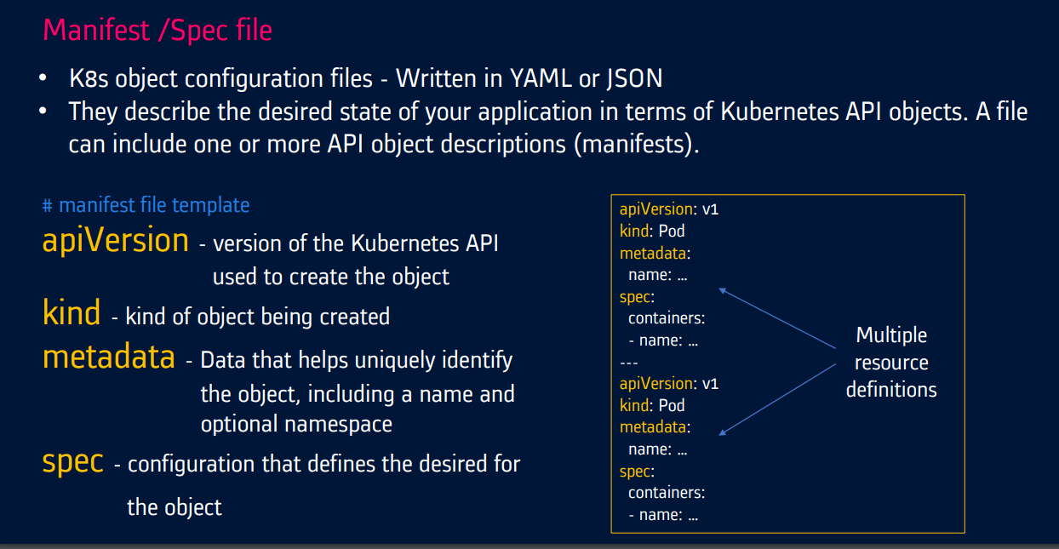

**Annotations**

* **Annotations** are key-value pairs that provide metadata about objects. Unlike labels, which are used to select and organize resources.
* **Annotations** are used to **store non-identifying information** that can be used by tools and libraries.

**Eg:**

Pod example with annotations, multiple containers, and environment variables

apiVersion: v1

kind: Pod

metadata:

  name: Pod examples annotations, multiple containers, environment variables # Basic Pod configuration with Pod name

  annotations:

    description: "This is an example Pod with annotations."

    config.checksum: "123456789"

    prometheus.io/scrape: "true"

    prometheus.io/port: "8080"

spec:

  containers:

  - name: main-container        # First container in the Pod

    image: nginx

    env:

    - name: MAIN_ENV_VAR

      value: "MainContainerValue"

  - name: sidecar-container     # Second container in the Pod

    image: busybox

    command: ["sh", "-c", "echo Hello from the sidecar container; sleep 3600"]

    env:                        # Pod Example with Environment Variable

    - name: SIDECAR_ENV_VAR

      value: "SidecarContainerValue"

**Pod Lifecycle**

**1.Pending:** The Pod is created but not yet running. This happens while Kubernetes schedules the Pod to a node.

**2.Running:** The Pod is successfully scheduled and all containers are running or in the process of starting.

**3.Succeeded:** All containers in the Pod have terminated successfully (exit code 0).

**4.Failed:** At least one container in the Pod has terminated with a non-zero exit code.

**5.Unknown:** The state of the Pod cannot be determined.

**Pod Health check:**

The health of pods is checked using **liveness probes** and **readiness probes**. These probes are configured in the pod's definition and help ensure the application inside the pod is running properly and can handle requests.

**Liveness Probe**

**A liveness probe** is used to **check if the application inside the pod is still running**. If the liveness probe fails, Kubernetes will restart the pod to try to recover the application.

Example of a liveness probe configuration:

livenessProbe:

  httpGet:

    path: /healthz

    port: 8080

  initialDelaySeconds: 3

  periodSeconds: 3

**Readiness Probe**

**A readiness probe** is used to **check if the application inside the pod is ready to handle requests**. If the readiness probe fails, the pod will be removed from the service's load balancer until it becomes ready again.

Example of a readiness probe configuration:

readinessProbe:

  httpGet:

    path: /ready

    port: 8080

  initialDelaySeconds: 3

  periodSeconds: 3

**Types of Probes**

Kubernetes supports three types of probes:

1. **HTTP Probes**: Perform an HTTP GET request against a specified endpoint.
2. **Command Probes**: Execute a command inside the container and check the exit code.
3. **TCP Probes**: Perform a TCP check against a specified port.

**Example Configuration**

Here is an example of a complete pod configuration with liveness and readiness probes:

apiVersion: v1

kind: Pod

metadata:

  name: example-pod

spec:

  containers:

  - name: example-container

    image: my-application:latest

    livenessProbe:

      httpGet:

        path: /healthz

        port: 8080

      initialDelaySeconds: 3

      periodSeconds: 3

    readinessProbe:

      httpGet:

        path: /ready

        port: 8080

      initialDelaySeconds: 3

      periodSeconds: 3

These probes help ensure that your application is running smoothly and can recover from failures automatically.

Pod contains single container or multiple containers.

**Multiple containers**

1. Init container.
2. Side-car container

By utilizing **init and sidecar containers**, we can create more robust and flexible deployments that meet the specific needs of your applications.

**Init container.**

* **Init containers** are special containers that **runs before the main application containers** in a pod.
* These containers are used to perform setup tasks (such as configuration, initialization, or data preparation) that need to be completed before the main application begins running.
* **Containers will delete, post complete the task** and only the main container will remain the same.

apiVersion: v1

kind: Pod

metadata:

  name: pod-with-init-container

spec:

  initContainers:

  - name: init-myservice

    image: busybox

    command: ['sh', '-c', 'echo Initializing; sleep 10']

  containers:

  - name: my-app-container

    image: nginx

**Use cases**

* **Initializing shared volumes**
* Data Initialization
* Changing the file system before starting the app container
* Performing **automation backup** before starting an application.
* **Waiting for Dependencies to Be Ready**

**Scenario**: A web application that depends on a database being initialized first.

* **Initializing Configurations or Secrets**: Pulling secrets from a vault and storing them in the application configuration file

**Scenario**: A containerized application that needs to fetch secrets or configuration files from a centralized service (e.g., AWS SSM or HashiCorp Vault).

* **Preparing Data for the Main Application:**

**Scenario**: A container that runs a web application that needs to download an initial set of data or files (like JSON or CSV files) from an external server or cloud storage.

**Side-car container**

* Sidecar containers are **secondary containers** within the same Pod that **runs alongside the main application container.**
* Sidecar containers extend the functionality of the main container by providing additional services, such as logging, monitoring, proxying, security, or data synchronization.
* Side car container contains envoy proxy application. It is proxy server it will handles the traffic management of pods.

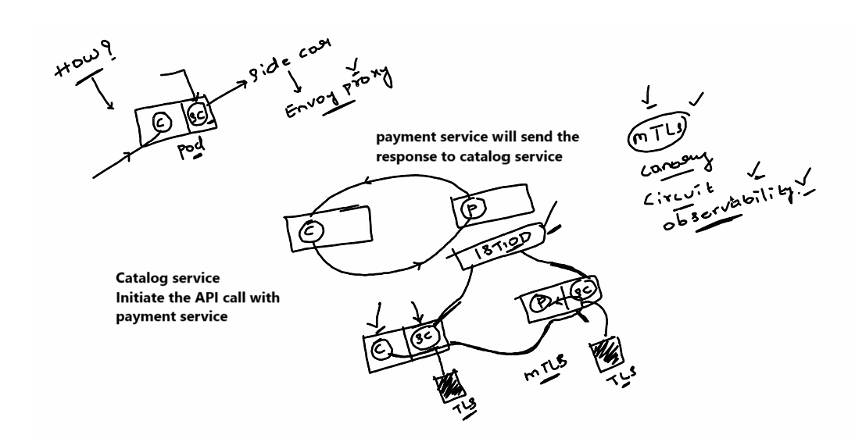

apiVersion: v1

kind: Pod

metadata:

  name: pod-with-sidecar

spec:

  containers:

  - name: main-app

    image: nginx

  - name: sidecar-logging

    image: busybox

    command: ['sh', '-c', 'tail -f /var/log/nginx/access.log']

    volumeMounts:

        - name: log-volume

          mountPath: /logs

  volumes:

    - name: log-volume

      emptyDir: {}

**Use Cases:**

* **Logging (Fluentd, Elasticsearch)**: A sidecar container can be responsible for gathering logs from the main container and sending them to a logging system or processing them.
* **Monitoring (Metrics and Health Checks)**: A sidecar might collect metrics or health information from the main container for external monitoring purposes.
* **Proxying (Service Proxy or Service Mesh)**: A sidecar container can act as a proxy or a service mesh component (e.g., Istio sidecar) to manage inbound/outbound traffic for the main application container.
* **Security and Identity Management (Secret Injection and Identity Management)**: Sidecars can provide security features like injecting secrets into the environment of the main container.
* **Networking/Proxying (API Gateway/Proxying Requests):** Sidecar containers can serve as proxies or API gateways to route requests between services, for example, caching, rate limiting, or transforming requests.

**When to Use Sidecar Containers**

* **Sidecar Containers:** Use sidecar containers to add additional functionalities to your application, such as logging, monitoring, or communication proxies, without modifying the main application.

|  |  |  |
| --- | --- | --- |
| **Feature** | **Init Containers** | **Sidecar Containers** |
| **Execution Time** | Runs before the main container starts. | Runs alongside the main container during its lifecycle. |
| **Primary Purpose** | Initialization or setup tasks. | Auxiliary tasks that extend functionality (e.g., logging, proxying). |
| **Example Use Cases** | Waiting for dependencies, data migration. | Collecting logs, monitoring, proxying traffic. |

**Type of pods:**

1. **Single-container Pods:**

This is the simplest form of a Pod, containing only one container.

1. **Multi-container Pods:**

These Pods contain **multiple containers** that need to work together.

1. **Static Pods:**

Static pods are managed directly by the kubelet on a specific node, rather than through the API server. They are defined in the kubelet's configuration. **(kube-apiserver,** **etcd, kube-controller-manager, kube-scheduler)**

1. **Ephemeral Pods:**

Ephemeral containers are used for troubleshooting running pods. They can be added to a pod without restarting it and are removed once the troubleshooting is complete.

1. **Guaranteed Pods:**

These Pods are designed with **resource guarantees** (CPU and memory) in mind. Kubernetes will ensure that the requested resources are available.

1. **Pod Templates:**

While not exactly a separate type of Pod, Pod templates are used to define a blueprint for creating Pods.

1. **Service**

**Service:**

* **Services:** Services in Kubernetes enables communication between Pods and external clients. They expose applications running inside Pods as **network services**.
* **Load Balancing and Health Monitoring:** A Service is a **round-robin load balancer** for Pods that match its labels or selector, and constantly monitors the Pods. If any Pod becomes unhealthy, the Service reroutes traffic to healthy Pods.
* **Stable Network Endpoint**: Services object provides a **stable network endpoint** to access a **set (group)** **of Pods**, along with **service discovery and load balancing**.
* Kubernetes **automatically distributes traffic between Pods** and provides **DNS resolution** for Service hostnames.
* Services provide **stable networking, load balancing, and service discovery**, ensuring **consistent communication within the cluster**, even when Pods are dynamically created, scaled, or replaced.
* Service objects is a logical bridge between pods and end user, which provide virtual IP
* **Scalability and Flexibility:** These features are designed to be **scalable, reliable**, and **flexible**, making it easier for developers to manage and orchestrate complex microservices architectures.
* **External Access:** Additional features like **Ingress** and **DNS-based service discovery** provide flexible external access to services and simplify service discovery within the cluster.
* **Networking plugins and configuration** options enable pod-to-pod communication and network isolation.
* Kubernetes uses a combination of **DNS-based service discovery** and **a built-in load balancer** called **kube-proxy**. Each Service is assigned a **unique DNS name**, which resolves to the cluster IP. The kube-proxy component load balances traffic across the Pods associated with the Service, distributing requests evenly.

**Why Do We Need Services in Kubernetes?**

If service is not available, due some issues, pod has deleted and created again because of auto healing. Pod IP address will change automatically, if IP address changes, we will not able to access the application with old IP address. To overcome this problem, we will create a service yaml file, it will interact with pods using labels and selectors. If any requested came, service file with communication with pods using the labels and selectors.

* 1. **Pods are Ephemeral:** Pods are temporary and can be destroyed or recreated for reasons like scaling, updates, or failures. Each new Pod gets a different IP address, making direct communication with Pods unreliable.
  2. **Stable Communication:** Services provide a consistent way to access the Pods, regardless of changes in the underlying Pods IPs.
  3. **Load Balancing:** Services distribute network traffic across multiple Pods.
  4. **Service Discovery:** Simplifies communication between Pods by using stable IP addresses and DNS names.

**Types of Kubernetes Services:**

1. **ClusterIP (default):**
   * Exposes the Service on an internal IP address within the cluster.
   * It allows other Pods inside the cluster to communicate with it, but it's not accessible outside the cluster.
   * **Use case**: Internal communication between services within the cluster.

kind: Deployment

apiVersion: apps/v1

metadata:

  name: httpddeployment

spec:

  replicas: 1

  selector: # tells the controller which pods to watch/belong to

    matchLabels:

      name: httpddeployment

  template:

    metadata:

      name: testpod1

      labels:

        name: httpddeployment

    spec:

      containers:

        - name: c00

          image: httpd

          ports:

            - containerPort: 80

---

kind: Deployment

apiVersion: apps/v1

metadata:

  name: ubuntudeployment

spec:

  replicas: 1

  selector: # tells the controller which pods to watch/belong to

    matchLabels:

      name: ubuntudeployment

  template:

    metadata:

      name: testpod2

      labels:

        name: ubuntudeployment

    spec:

      containers:

        - name: c01

          image: ubuntu

          command: ["/bin/bash", "-c", "while true; do echo Hello-sagar; sleep 5 ; done"]

---

kind: Service # Defines to create Service type Object

apiVersion: v1

metadata:

  name: demoservice

spec:

  ports:

    - port: 80 # Containers port exposed

      targetPort: 80 # Pods port

  selector:

    name: httpddeployment # Apply this service to any pods which has the specific label

  type: **ClusterIP** # Specifies the service type i.e ClusterIP or NodePort

1. **NodePort**:
   * Exposes the Service on each Node's IP address at a static port.
   * Pods can accessible from outside the cluster using **<NodeIP>:<NodePort>.**
   * Expose the service on the same port of each selected node in the cluster using NAT.
   * It allows external traffic to access the service by connecting to **<NodeIP>:<NodePort>.**
   * **Use case**: When you need external access to your service (but not via LoadBalancer) and you can target specific Node IPs.

kind: Deployment

apiVersion: apps/v1

metadata:

  name: httpddeployment

spec:

  replicas: 1

  selector: # tells the controller which pods to watch/belong to

    matchLabels:

      name: httpddeployment

  template:

    metadata:

      name: testpod1

      labels:

        name: httpddeployment

    spec:

      containers:

        - name: c00

          image: httpd

          ports:

            - containerPort: 80

---

kind: Service # Defines to create Service type Object

apiVersion: v1

metadata:

  name: demoservice

spec:

  ports:

    - port: 80 # Containers port exposed

      targetPort: 80 # Pods port

  selector:

    name: httpddeployment # Apply this service to any pods which have this specific label

  type: **NodePort** # Specifies the service type i.e ClusterIP or NodePort

1. **LoadBalancer**:
   * A service that distributes network traffic across multiple Pods.
   * Exposes the Service externally using an external (cloud provider's) load balancer.
   * This type of Service is accessible from outside the cluster, mainly via a public IP address.
   * **Use case**: To expose a service to the internet with automatic load balancing across Pods.

kind: Deployment

apiVersion: apps/v1

metadata:

  name: httpddeployment

spec:

  replicas: 1

  selector: # tells the controller which pods to watch/belong to

    matchLabels:

      name: httpddeployment

  template:

    metadata:

      name: testpod1

      labels:

        name: httpddeployment

    spec:

      containers:

        - name: c00

          image: httpd

          ports:

            - containerPort: 80

---

kind: Service # Defines to create Service type Object

apiVersion: v1

metadata:

  name: demoservice

spec:

  ports:

    - port: 80 # Containers port exposed

      targetPort: 80 # Pods port

  selector:

    name: httpddeployment

  type: **LoadBalancer**

1. **ExternalName**:
   * This Service type maps a service to an external DNS name (such as example.com), without exposing any Pods.
   * **Use case**: When you want Kubernetes to forward traffic to an external service by DNS name instead of managing Pods directly.

apiVersion: v1

kind: Service

metadata:

  name: example-externalname-service

spec:

  type: **ExternalName**

  externalName: my.database.example.com

* **selector**: This defines which Pods the Service will route traffic to (those with label app=exmaple-app).
* **port**: The port on the Service (80 in this case).
* **targetPort**: The port on the Pods that the Service will forward traffic to (8080 in this case).

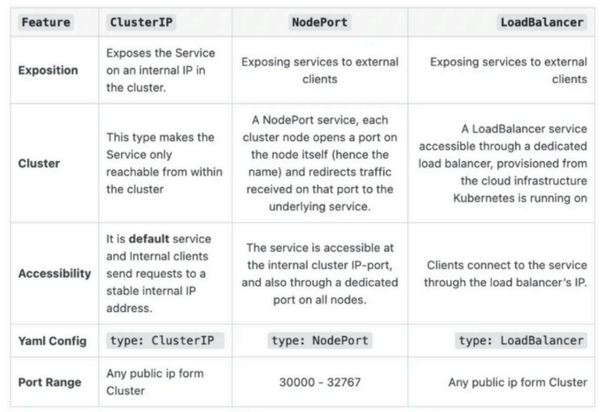

**How Services work internally:**

1. **Service Label Selector**: A Service identify the set of Pods using label selectors.
2. **End Points Object**: Kubernetes creates an Endpoints object, which keeps track of the IPs of the Pods selected by the label selector and Kubernetes automatically adjusts the endpoints when Pods are added or removed.
3. **Service Proxying (Routing)**: Kubernetes uses **kube-proxy** to route traffic to the Service and forward it to the appropriate Pod. **kube-proxy** uses methods like **iptables or IPVS for load balancing.**

**Key Features of Kubernetes Services:**

* **Stable Endpoint**: Services provide stable IP addresses and DNS names to access Pods.
* **Discovery and Load Balancing:** Kubernetes Services allow clients to discover and communicate with the right Pods using DNS-based service discovery and label selectors, while automatically distributing traffic across Pods through load-balancing mechanisms.
* **Selector and Labels:** A Service uses selectors to identify which Pods it should target. Pods with labels that match the selector will automatically become part of the Service.

**Service responsibilities.**

* Load balancing
* Service discovery mechanism (using labels and selectors)
* Expose to the external world.

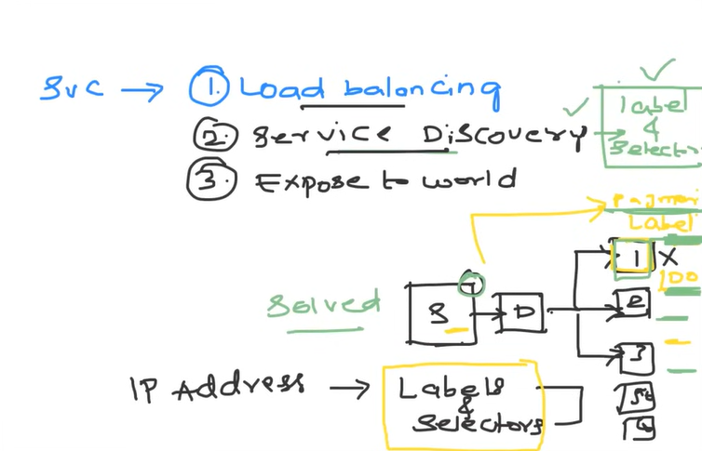

**Service discovery**

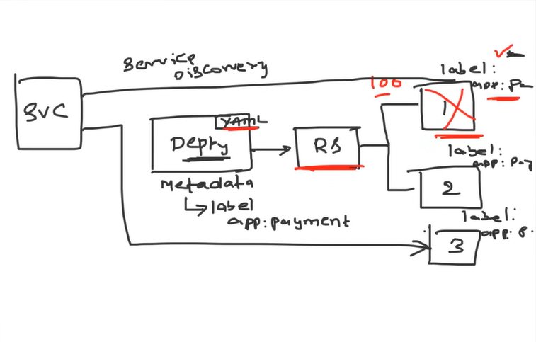

**Load Balancer:**

* A **LoadBalancer** service **provisions an external load balancer** to **expose applications** to **external traffic** and **distribute incoming network traffic** across multiple pods or nodes within the cluster, ensuring **reliability and scalability**.
* The Load Balancer will **forward the traffic** to the available nodes in the cluster on **the nodePort** assigned to the service
* Kubernetes offers **three types** of **load balancing** **algorithms** for Services, which distribute traffic based on **round-robin, least connections, or IP hash.**
* Load balancing is an essential part of Kubernetes networking, providing efficient and reliable traffic distribution across a cluster.

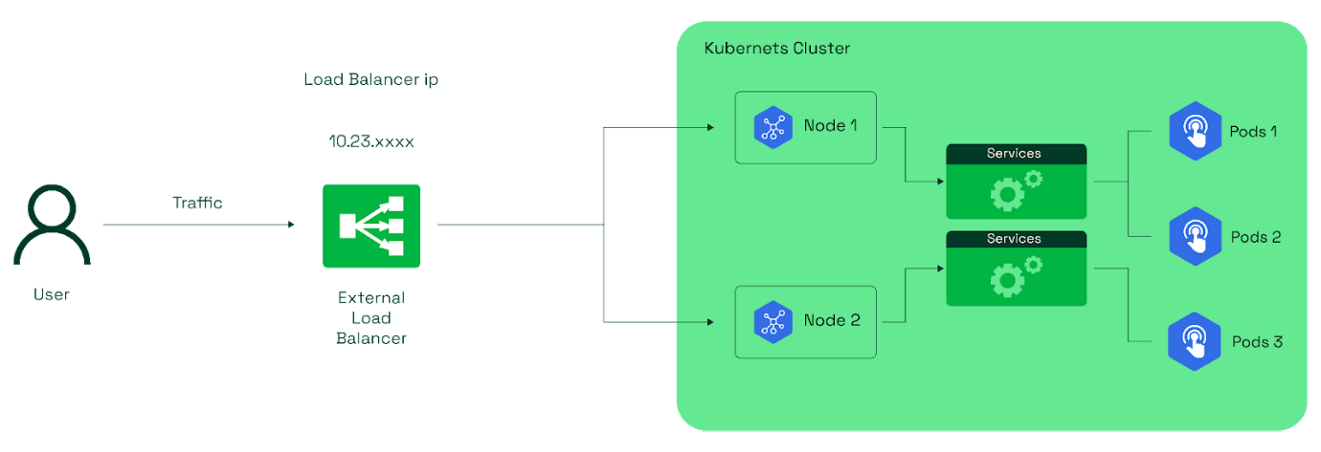

Eg:

kind: Deployment

apiVersion: apps/v1

metadata:

  name: httpddeployment

spec:

  replicas: 1

  selector: # tells the controller which pods to watch/belong to

    matchLabels:

      name: httpddeployment

  template:

    metadata:

      name: testpod1

      labels:

        name: httpddeployment

    spec:

      containers:

        - name: c00

          image: httpd

          ports:

            - containerPort: 80

---

kind: Service # Defines to create Service type Object

apiVersion: v1

metadata:

  name: demoservice

spec:

  ports:

    - port: 80 # Containers port exposed

      targetPort: 80 # Pods port

  selector:

    name: httpddeployment

  type: **LoadBalancer**

**LoadBalancer Use-cases in K8s**

* Expose your applications to the public internet.
* Traffic distribution across Nodes and Pods

**How Load Balancer works in K8s?**

* A load balancer service is created, which identifies the cloud platform
* The cloud provider generates a load balancer with a unique IP address
* The load balancer distributes client requests to the appropriate nodes hosting the pods
* Configure LoadBalancer as Service
* Distribute traffic to external IP

**Advantages of Load Balancer:**

* **Automatic provisioning:** Simplifies exposing services externally.
* **Traffic distribution:** Automatically balances traffic across pods.
* **Managed service:** Especially useful in cloud environments where you don't need to manually configure or maintain the load balancer.

**Types of LoadBalancer:**

**AWS**: Elastic Load Balancer (ELB)

* + 1. Application Load Balancer (ALB)
    2. Network Load Balancer (NLB)
    3. Classic Load Balancer (CLB).

**Summary of Key Types:**

* **Cloud Provider Managed Load Balancer:** Automatically provisions and manages external load balancers.
* **Internal Load Balancer:** Used for internal traffic within the cluster (cloud environment).
* **MetalLB:** A load balancer solution for bare-metal Kubernetes clusters.
* **Ingress Controller:** Manages routing of HTTP(S) traffic via rules and works with external load balancers.
* **Layer 4 Load Balancer:** Routes traffic based on IP address and port (TCP/UDP).
* **Layer 7 Load Balancer:** Routes traffic based on content of the request (HTTP/S).
* **DNS Load Balancer:** Distributes traffic via DNS resolution, often used for geo-distribution.
* **Global Load Balancer:** Distributes traffic across geographically distributed data centres.

**In Virtual machines**

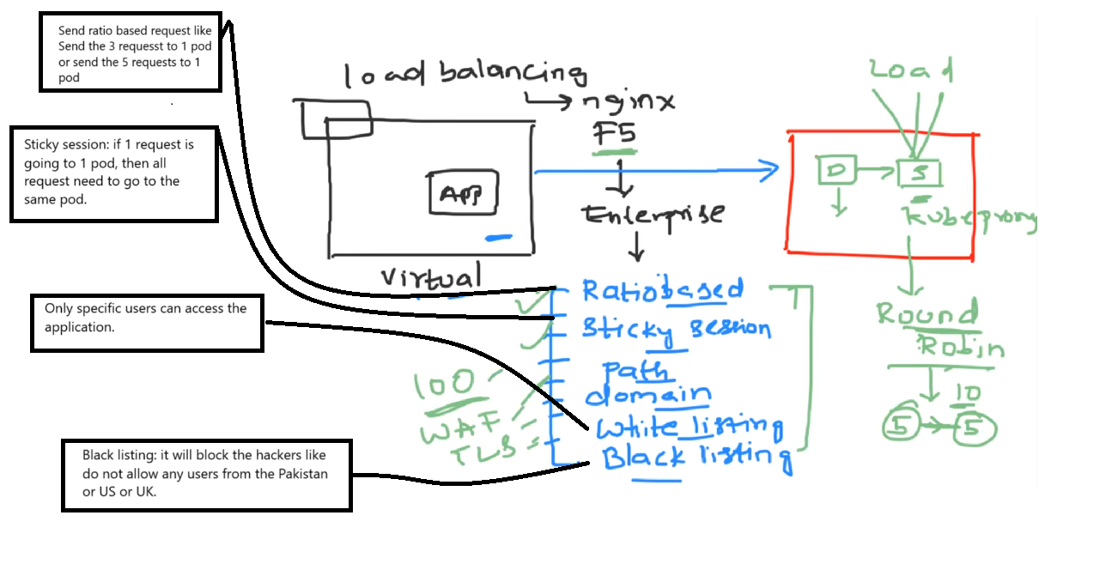

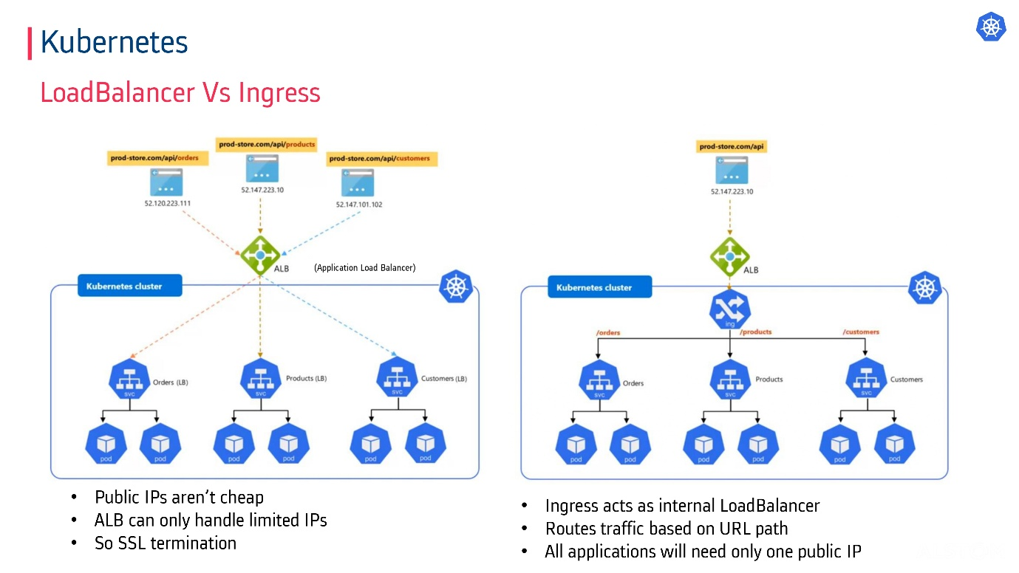

**Load balancer limitations:**

* Limited URL routing
* Cloud provider dependent.
* Lacks SSL termination.
* It doesn't support URL rewriting and rate limiting.
* Enterprise level support and TLS Loadbalancer capabilities.

(Ratio Based routing, Sticky, path, domain, writing listing and black listing-based routing.)

* Loadbalancer static IP address will be charged by cloud provider. if we created more loadbalancer static IP address

**Ingress, Routes and Ingress Controllers:**

**Load Balancer Type Service**

**Q:** Is Load Balancer service type only restricted to Cloud providers?

**A:** Bare Metal LB Implementation - <https://github.com/metallb/metallb>

**Q:** If Load Balancer service type can do the thing for you, why use an Ingress resource?

1. 1. If you have the large-scale ecommerce application, consider it has 200 to 300 services, if you want to user cloud provider load balancer, then you must create 200 to 300 static external IP addresses, which will cloud provider will charge huge amount. To overcome you can create ingress resource, it will manage all services with one static external IP address.

**2.** It defines routing for specific service using host base routing and path-based routing, session-based routing, or cookies-based routing etc.

Before 2015, in K8s v1.1, it provides only basic load balancer support. Ingress concept is not there.

Load balancing mechanism is providing simple round robin mechanism, If 10 request come, if you have 2 pods, then round robin mechanism distribute it equal to 2 to pods. 5 requests must go to 1 pod and another request must go to another pod.

**Ingress:**

**What is a Kubernetes Ingress?**

* **Kubernetes Ingress** is an **API object** that manages external access to services within a cluster. It is primarily used to configure and manage HTTP and HTTPS routing to services running inside the cluster.
* Ingress **exposes** **HTTP and HTTPS endpoints** to external users and **routes incoming traffic to internal services** based on **rules defined** in the **Ingress resource**.
* **Traffic routing** is controlled by **rules** **defined** in the **Ingress resource** based on hostnames and paths. **(**Specifying how external traffic should be directed to internal services within the Kubernetes cluster.**)**
* **The ingress controller** is responsible for routing HTTP(S) traffic based on defined rules
* **Ingress Controllers** mainly **work alongside a load balancer** (often a cloud-managed one or MetalLB) to handle HTTP(S) traffic.
* Once the **Ingress controller** is installed on a Kubernetes cluster, it continuously watches for Ingress resources (like nginx.conf, where all the routing details are updated) within the cluster. Along with the Ingress controller, NGINX applications are also deployed.
* Comparedto **NodePort** or **LoadBalancer services**, **Ingress** offers advanced features like **path-based** or **host-based routing**, providing more flexible traffic management.
* Ingress allows exposing multiple services using a single external IP or domain, combining features of both a LoadBalancer and an API Gateway.

**Key Features**:

* Used for HTTP(S) traffic routing, mainly for web applications.
* Works well with SSL termination (decrypting) and path-based routing.
* Involves more advanced routing, including features like URL rewriting, traffic splitting, and authentication.

**How ingress works?**

* **The ingress controller** is responsible for routing traffic based on defined rules.
* The **Ingress Controller** routes incoming requests based on URL paths or hostnames (e.g., /app1, api.example.com). It often sits behind a load balancer to distribute the traffic across multiple Pods or services.
* Manages routing of HTTP(S) traffic via rules and works with external load balancers.
* NGINX Ingress Controller, Traefik, and AWS ALB Ingress

**Examples of Ingress Advantages and Use Cases:**

* **Path-based routing**: Routes requests to different services based on the URL path.

For example:

* + example.com/api goes to the api-service.
  + example.com/web goes to the web-service.
* **Host-based routing**: Routes traffic based on the requested domain name (hostname). For example:
  + app1.example.com routes to service1.
  + app2.example.com routes to service2.
* **SSL/TLS termination**: Handles HTTPS traffic, terminating (decrypting) SSL connections, reducing the burden on backend services. You can configure Ingress to terminate SSL and forward traffic as HTTP. [SSL termination](https://www.f5.com/glossary/ssl-termination)
* **Why SSL Termination at LoadBalancer?**
* **Traffic Load balancing**: Distributes incoming traffic across multiple instances (replicas) of a service for high availability and better resource utilization.
* **Rate Limiting and Security**: Limiting the number of requests or enforcing authentication at the Ingress level to prevent abuse or ensure secure access.

**Why do we use Ingress?**

* Expose multiple microservices with domains and subdomains
* Centralized routing
* So ingress is best compared to LoadBalancer and NodePort

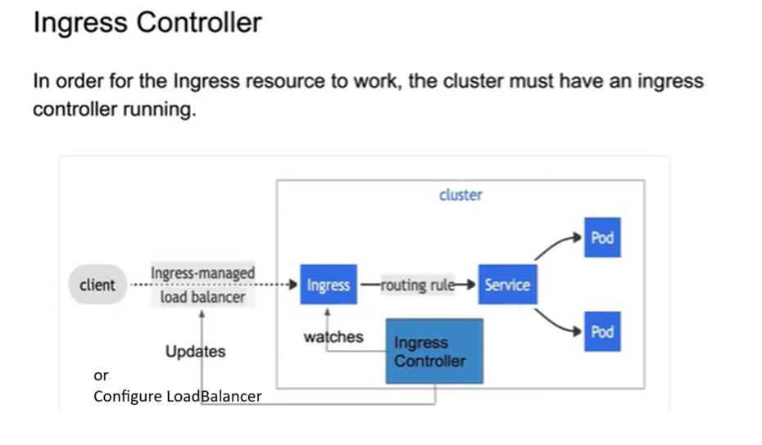



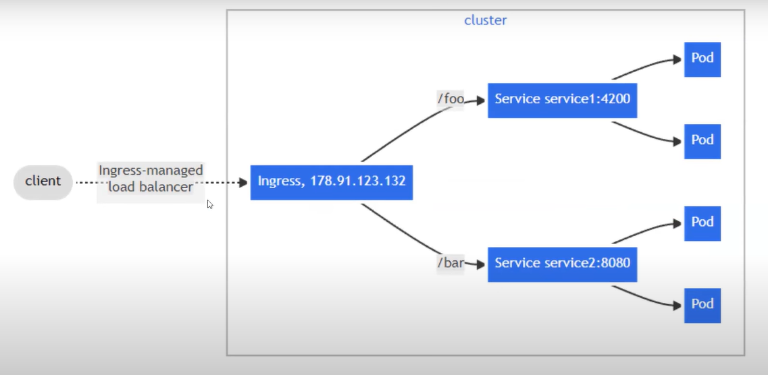

apiVersion: networking.k8s.io/v1

kind: Ingress

metadata:

  name: nginx-ingress

  annotations:

    nginx.ingress.kubernetes.io/rewrite-target: /

spec:

  rules:

  - host: nginx.you_url.com

    http:

      paths:

      - path: /nginx

        pathType: Prefix

        backend:

          service:

            name: nginx-loadbalancer-service

            port:

              number: 8080

              name: http

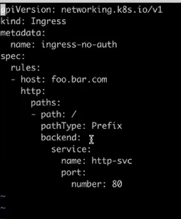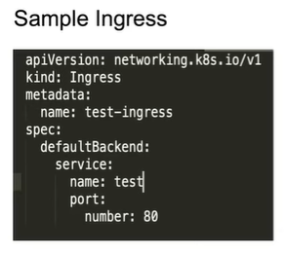

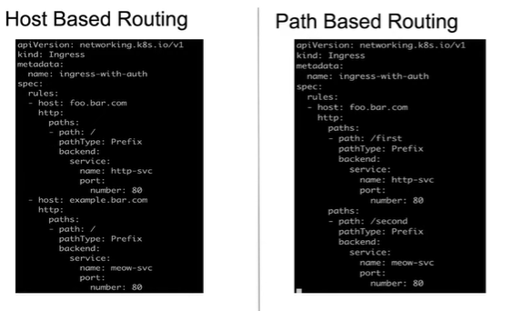

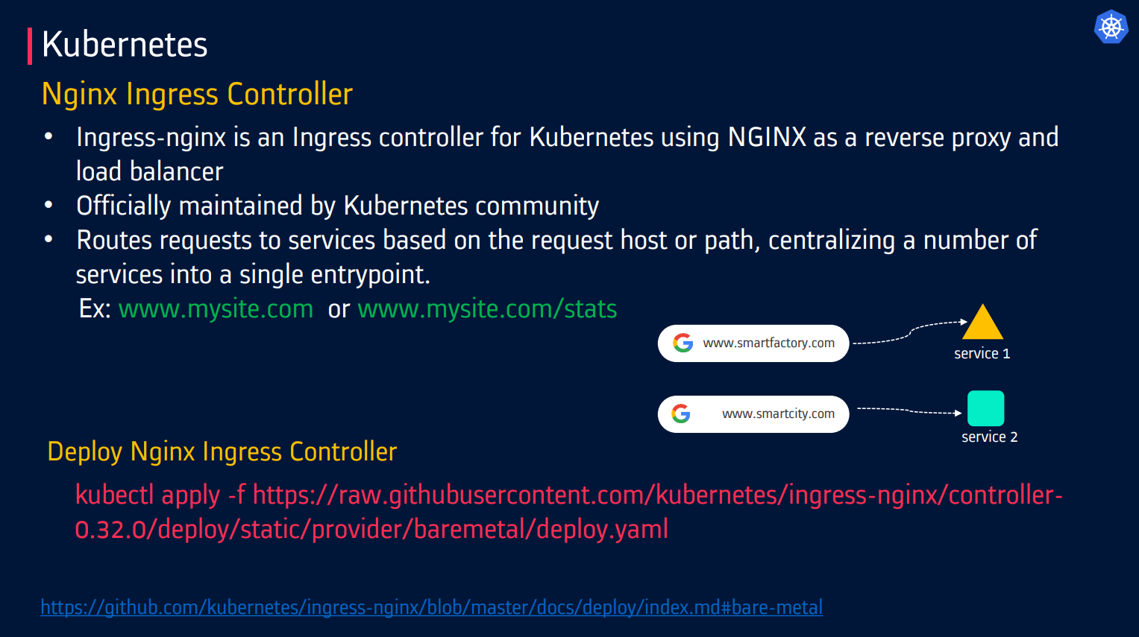

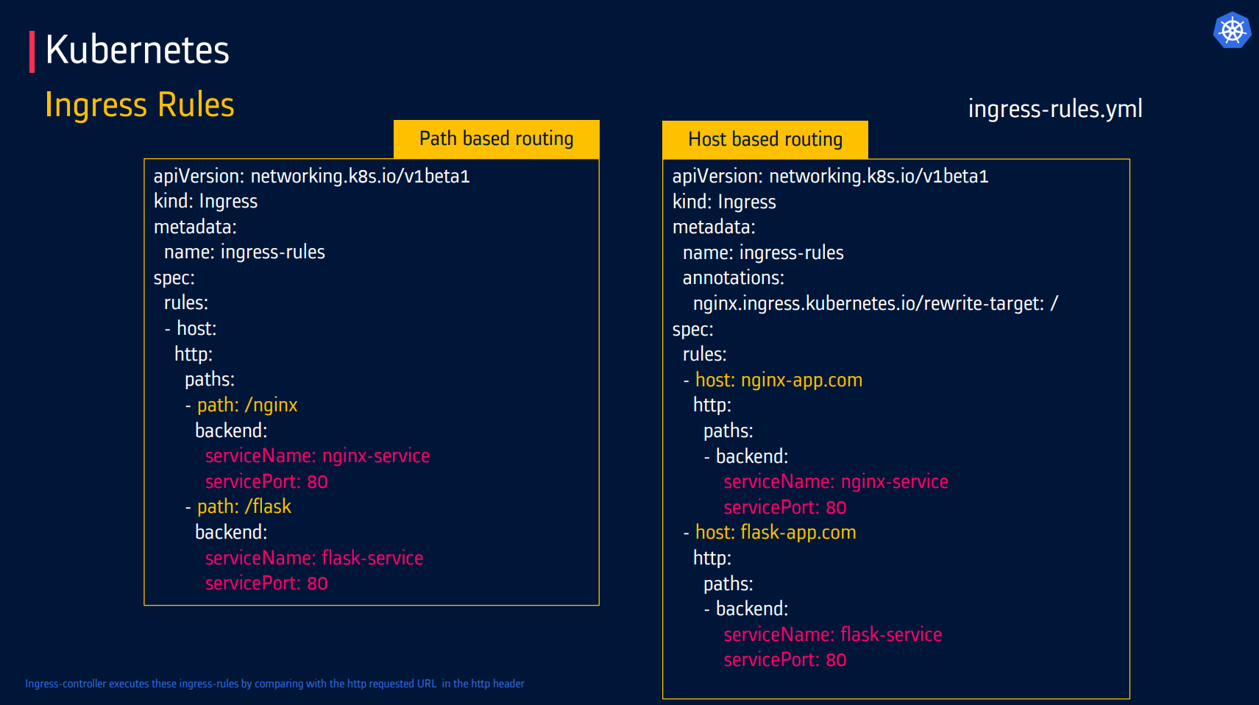

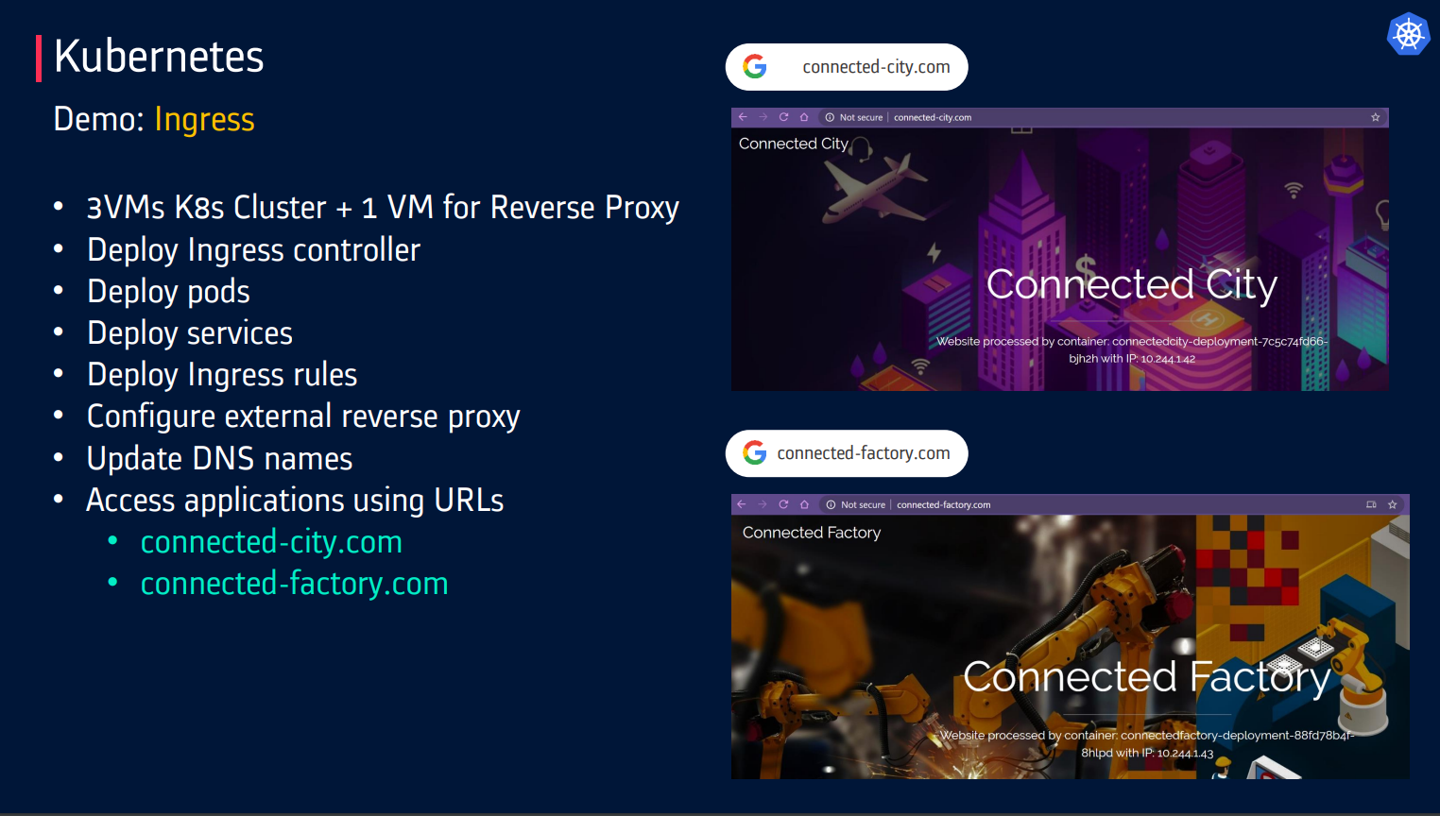

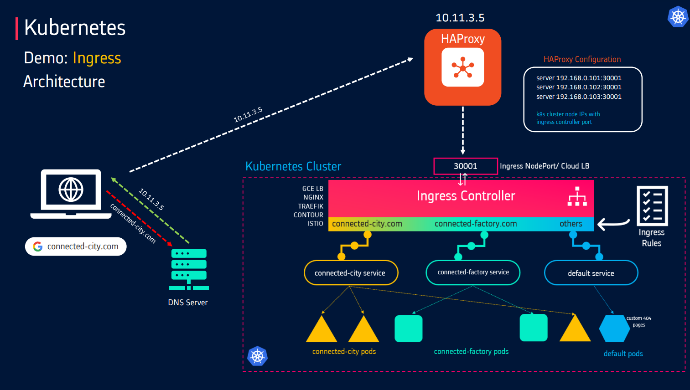

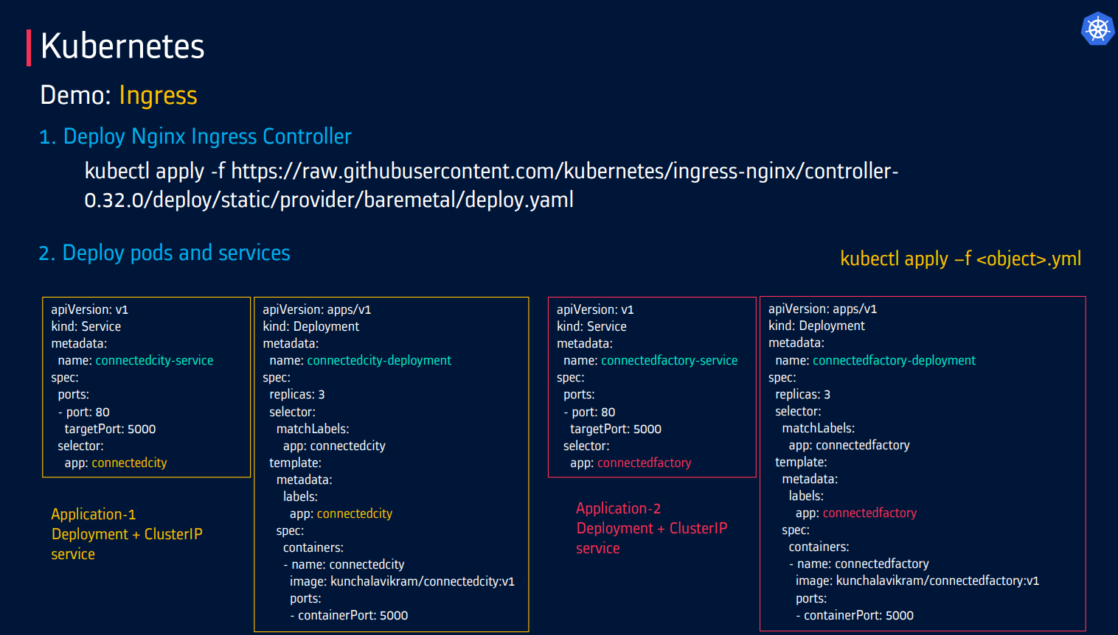

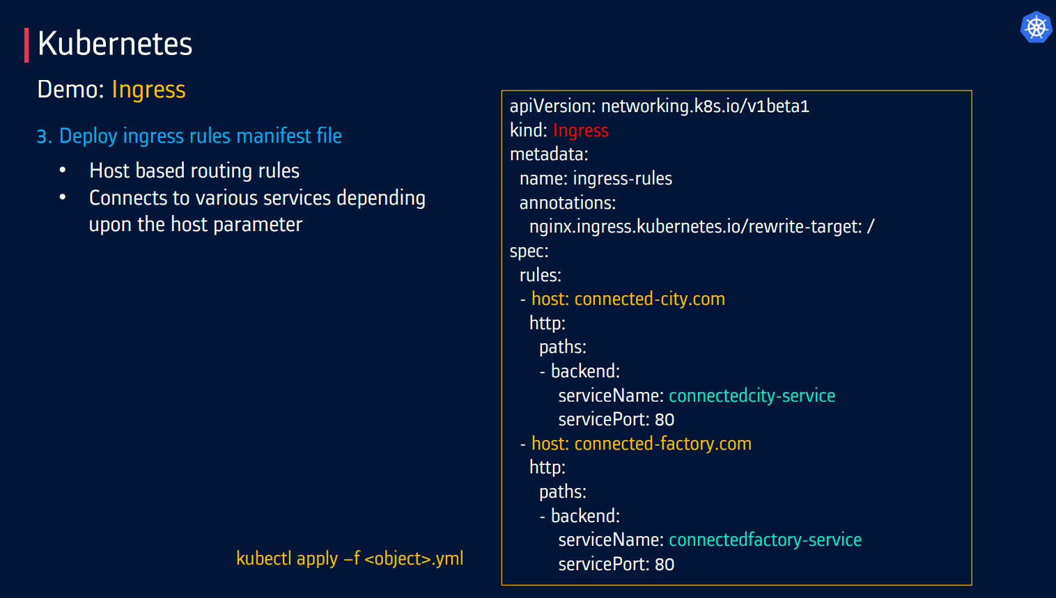

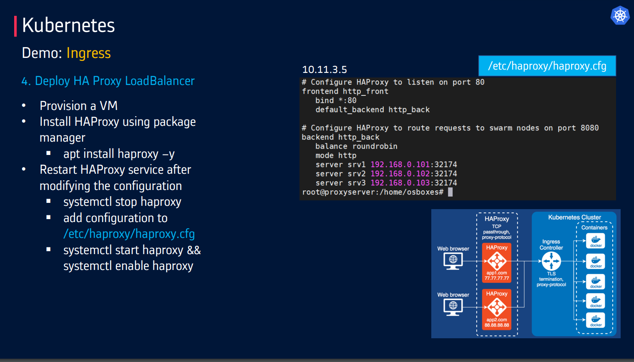

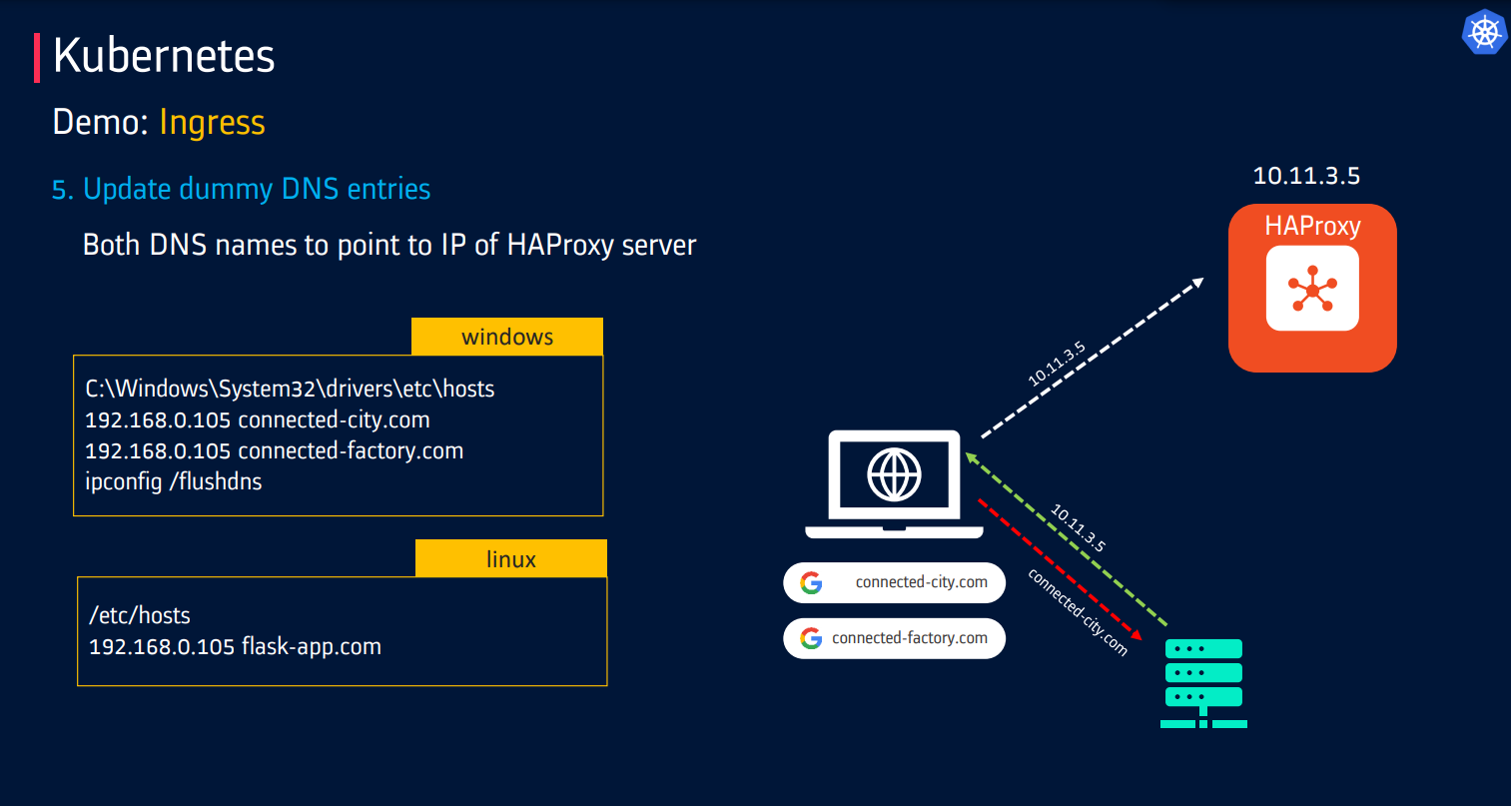

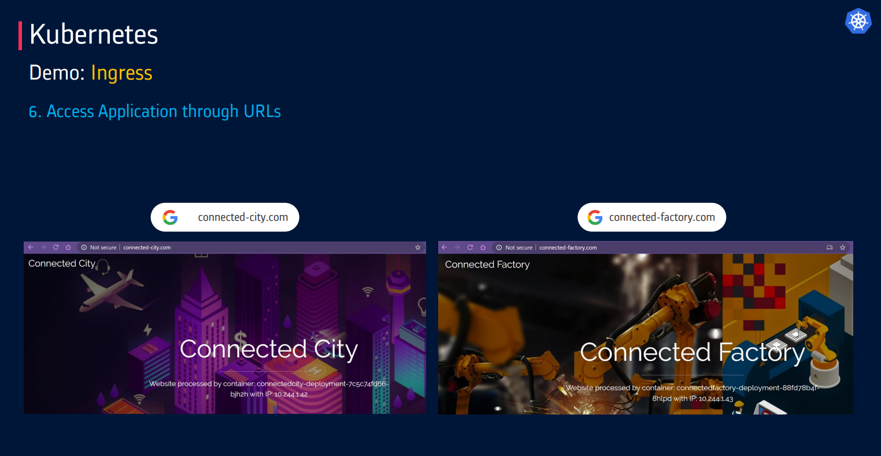

**Ingress vs. LoadBalancer Services**

* **Ingress**:
  + Provides a single-entry point for HTTP and HTTPS traffic.
  + Offers flexible routing based on hostnames, paths, and headers.
  + Can handle SSL/TLS termination.
  + Requires an Ingress controller to implement the Ingress resource.
* **LoadBalancer Service**:
  + Directly exposes a service to the internet using a cloud provider's load balancer.
  + Simpler to set up but less flexible in terms of routing rules.
  + Mainly used for non-HTTP/HTTPS traffic, like TCP and UDP.

**Common Ingress Controllers:**

1. **NGINX Ingress Controller**: One of the most widely used Ingress controllers, offering robust features like load balancing, SSL termination and path-based routing.
2. **Traefik**: A dynamic and modern reverse proxy, Traefik is highly adaptable and integrates seamlessly with Kubernetes.
3. **HAProxy Ingress**: A reliable and high-performance option, HAProxy supports advanced load balancing features.
4. **Istio**: Primarily a service mesh, Istio can also serve as an Ingress Controller with advanced routing, security, and observability features.
5. **Envoy**: A high-performance proxy used for microservices architectures, integrated with Kubernetes as an Ingress Controller for advanced traffic management.

**Troubleshooting Common Ingress Configuration Errors:**

1. **Ingress Not Routing Traffic Correctly**:
   * **Cause**: Incorrect path or host definitions.
   * **Solution**: Verify the path and host rules in the Ingress definition. Check for typos or mistakes in URL matching and ensure services are correctly defined under the rules.
2. **503 Service Unavailable Error**:
   * **Cause**: The Ingress controller cannot reach the backend service (often due to misconfigured service names or ports).
   * **Solution**: Check that the service specified in the Ingress resource exists, is exposed, and is properly configured with the correct port. Use **kubectl describe ingress** to check for errors related to backend services.
3. **SSL/TLS Errors (e.g., Certificate Mismatch)**:
   * **Cause**: A mismatch between the SSL/TLS certificate in the Ingress controller and the domain or expired certificates.
   * **Solution**: Ensure that the **TLS secret** associated with your Ingress has a valid certificate for the domain in question. Use **Cert-Manager** to automate certificate renewal.
4. **404 Not Found**:
   * **Cause**: The path or hostname in the request doesn't match any defined Ingress rules.
   * **Solution**: Verify that the Ingress paths and hostnames are correctly defined and that they match the incoming request. Check for correct service names and that the Ingress rules are pointing to the correct backend services.
5. **Incorrect Annotations or Configuration Settings**:
   * **Cause**: Misconfigured annotations or settings in the Ingress definition (e.g., missing or incorrect load balancing settings).
   * **Solution**: Review and validate the Ingress resource annotations. For example, NGINX has specific annotations like **nginx.ingress.kubernetes.io/rewrite-target** that must be configured correctly.
6. **Ingress Controller Not Running or Misconfigured**:
   * **Cause**: The Ingress controller might not be deployed or properly configured.
   * **Solution**: Ensure the Ingress controller pod is running by checking with kubectl get pods -n <namespace>. Check logs using kubectl logs <ingress-controller-pod-name> to look for errors.
7. **Timeout or Slow Response**:
   * **Cause**: The backend service might be slow or misconfigured, causing timeouts.
   * **Solution**: Investigate the backend service logs to ensure it is responsive. Increase timeout settings in the Ingress controller if necessary.
8. **Inconsistent Ingress Controller and Service Ports**:
   * **Cause**: Mismatch between the port configured on the Ingress and the port exposed by the service.
   * **Solution**: Ensure that the service port specified in the Ingress matches the actual service port.
9. **Check Logs**: Review the logs of the Ingress controller to identify any errors or misconfigurations.
10. **Validate Ingress Resources**: Ensure that Ingress resources are correctly defined and that annotations are valid.
11. **Inspect ConfigMaps**: Verify that ConfigMap keys and values are correctly configured.
12. **Health Checks**: Ensure that backend services are healthy and responding as expected.
13. **DNS Resolution**: Confirm that DNS resolution is working correctly and that the Ingress controller can resolve service names.
14. **Check Events**: Review Kubernetes events related to Ingress resources to identify any issues.

**TLS:**

**TLS in Kubernetes: Secure Communication for Cluster Components**

* **TLS (Transport Layer Security)** in Kubernetes is used to secure communication between components within the cluster and between external clients and Kubernetes services.
* TLS ensures that **data is encrypted**, **preventing unauthorized access** and **protects sensitive data.**

**Where TLS is Used in Kubernetes?**

**🔹 API Server –** TLS secures communication between the Kubernetes API server and clients (kubectl, controllers, etc.).

**🔹 etcd Database –** Data stored in etcd is encrypted using TLS to prevent unauthorized access.

**🔹 Kubelet & API Server –** TLS ensures **mutual** **authentication** between nodes and the control plane.

**🔹 Ingress Controller –** TLS enables HTTPS traffic for applications exposed externally.

**🔹 Service-to-Service Communication –** Applications within the cluster use TLS certificates for **secure pod-to-pod communication.**

**TLS Certificates in Kubernetes**

**✅ Self-Signed Certificates –** Default certificates generated for internal communication within Kubernetes.

**✅ Cert-Manager –** A Kubernetes tool that automates certificate issuance and renewal for TLS.

**✅ Let's Encrypt –** A popular service for issuing free TLS certificates for Kubernetes applications.

apiVersion: networking.k8s.io/v1

kind: Ingress

metadata:

  name: my-secure-ingress

  annotations:

    nginx.ingress.kubernetes.io/ssl-redirect: "true"

spec:

  tls:

  - hosts:

      - example.com

    secretName: tls-secret

  rules:

  - host: example.com

    http:

      paths:

      - path: /

        pathType: Prefix

        backend:

          service:

            name: my-service

            port:

              number: 443

**✅ This Ingress configuration enables HTTPS using a TLS secret (tls-secret).**

**Understanding SSL Passthrough, SSL Offloading, and SSL Bridging**

These are techniques used to handle **SSL/TLS encryption** in web applications, particularly within **load balancers, proxies, and Kubernetes ingress controllers**.

In Kubernetes, **SSL/TLS termination** can be handled in different ways depending on security and performance requirements. Here’s a breakdown of **SSL Passthrough, SSL Offloading (Termination), and SSL Bridging (Re-Encryption)**, along with their use cases in Kubernetes (especially with Ingress Controllers like Nginx, Traefik, or HAProxy).

**1. SSL Passthrough**

* **Definition:** The load balancer (**Ingress Controller) forwards encrypted** **HTTPS** **traffic** directly to the backend server **without decrypting it**.
* The backend service (e.g., a Pod running a web server) is responsible for **SSL termination** (handles decryption and serves the request).
* **Use case:** Best for **security-sensitive applications**, since the encryption remains **intact end-to-end**.

| **Pros** | **Cons** |
| --- | --- |
| End-to-end encryption | Backend must handle TLS (decryption) |
| No decryption at Ingress | Harder to debug (traffic stays encrypted) |
| Good for compliance | Higher workload on backend |

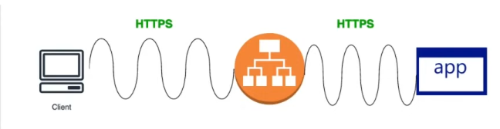

Load Balancer capabilities are merely used.

Attacker can pass hacking codes in the traffic and will be directly passed to the backend server.

SSL Passthrough is also a costly process. Might require more CPU.

apiVersion: networking.k8s.io/v1

kind: Ingress

metadata:

  annotations:

    nginx.ingress.kubernetes.io/ssl-passthrough: "true"  # Enables passthrough

spec:

  tls:

  - hosts:

    - myapp.example.com  # Client-facing domain

  rules:

  - host: myapp.example.com

    http:

      paths:

      - path: /

        backend:

          service:

            name: my-service

            port:

              number: 443  # Backend must handles HTTPS

**2. SSL Offloading**

* **Definition:** The load balancer (**Ingress Controller) decrypts all HTTPS** **traffic** and forwards it as **plain HTTP** to the backend servers.
* The load balancer handles **SSL termination** to improve backend performance.
* **Use case:** AWS Application Load Balancer (**ALB**) uses **SSL Offloading** to handle HTTPS requests efficiently. (**Layer 7 routing**)

| **Pros** | **Cons** |
| --- | --- |
| Reduces backend workload | Traffic is unencrypted between Ingress and Pods |
| Easier to debug | Requires network policies to secure internal traffic |
| Supports advanced routing | Not compliant for strict end-to-end encryption |

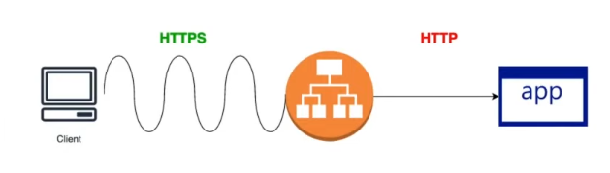

Vulnerable to data theft, man-in-the-middle attacks.

Faster

apiVersion: networking.k8s.io/v1

kind: Ingress

metadata:

  name: ssl-offload-ingress

spec:

  tls:

  - hosts:

    - myapp.example.com

    secretName: my-tls-secret  # Cert stored in a Secret

  rules:

  - host: myapp.example.com

    http:

      paths:

      - path: /

        backend:

          service:

            name: my-service

            port:

              number: 80  # Backend receives HTTP

**3. SSL Bridging**

* **Definition:** The load balancer (**Ingress Controller) decrypts TLS traffic** (like SSL Offloading) but then **re-encrypts it** before sending it to the backend.
* **How it works:** Maintains **end-to-end encryption** while allowing traffic inspection.
* **Use case:** When **internal traffic must also be encrypted** (e.g., multi-tenant clusters).

| **Pros** | **Cons** |
| --- | --- |
| Internal traffic stays encrypted | Slightly higher latency |
| Allows L7 inspection | More complex setup |
| Good for compliance | Needs backend TLS certs |

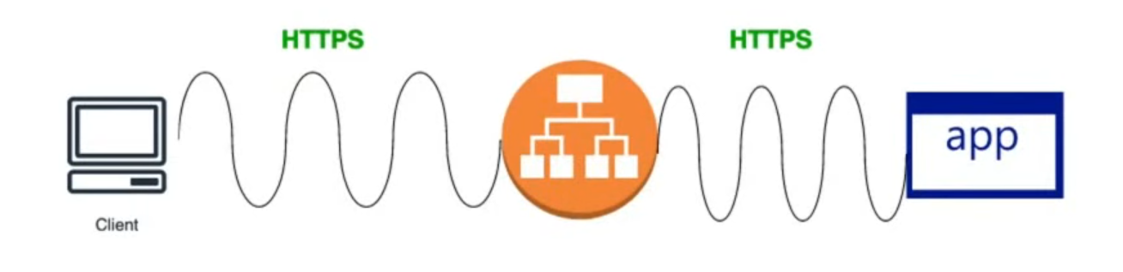

E2E encrypted and validated for malware attacks by Load Balancer.

More secure more costly in processing as server has to decrypt the traffic.

apiVersion: traefik.containo.us/v1alpha1

kind: IngressRoute

metadata:

  name: ssl-bridge-route

spec:

  entryPoints:

    - websecure

  routes:

  - match: Host(`myapp.example.com`)

    services:

    - name: my-service

      port: 443

      scheme: https  # Forces HTTPS to backend

      tls: {}       # Enables re-encryption

  tls:

    secretName: my-tls-secret  # Cert for client-side

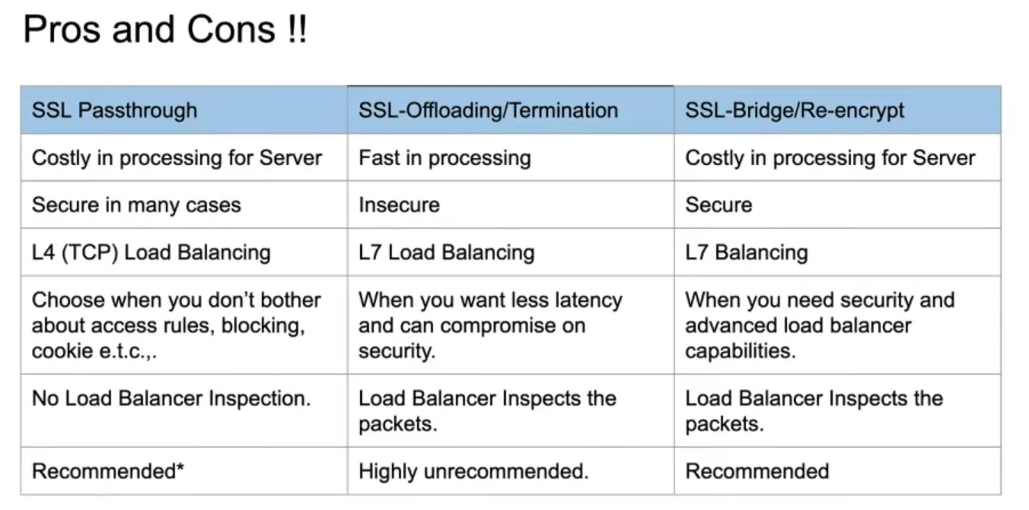

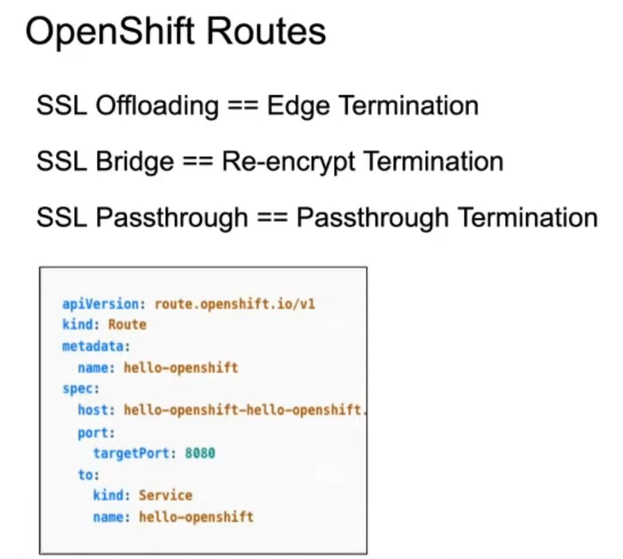

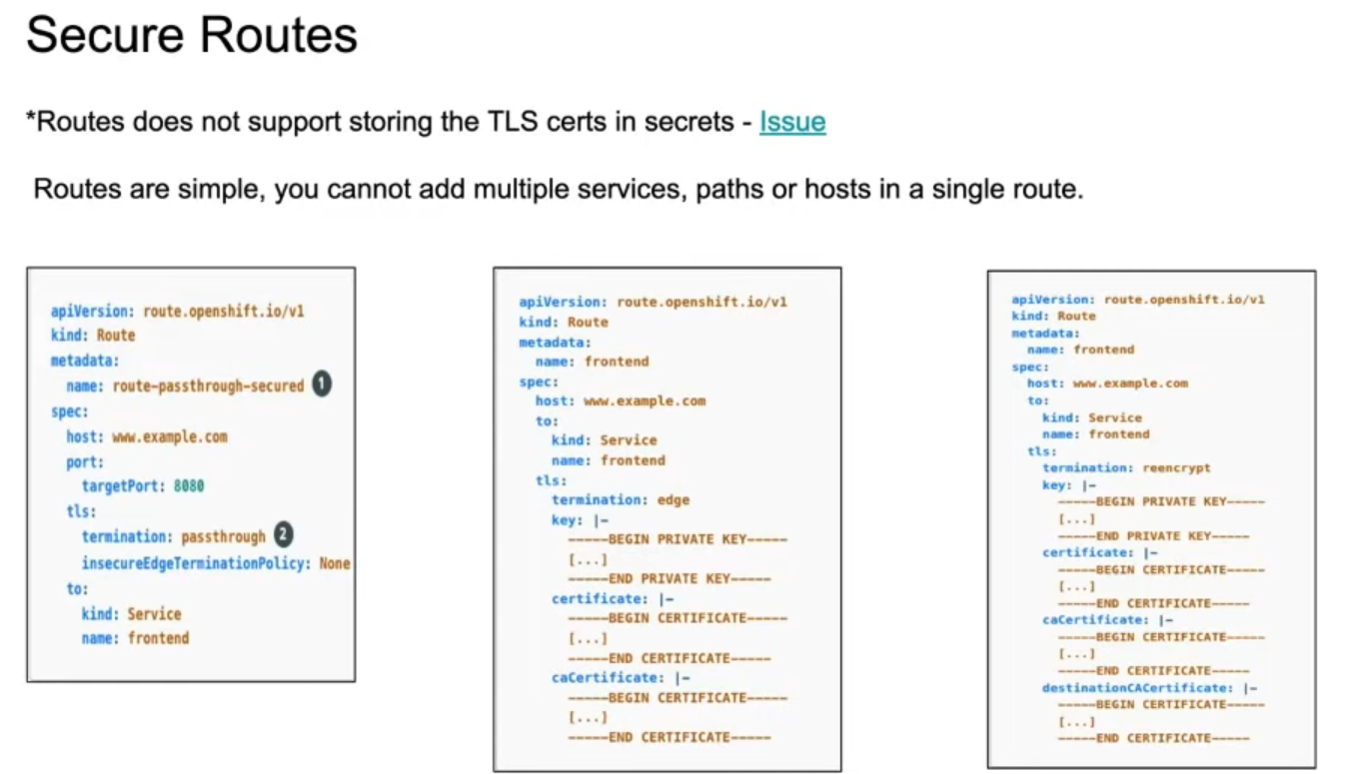

**Service mesh**

**Service mesh**

* It will help to manage the traffic between services in cluster. Mainly (East-West traffic).
* **East-West traffic** refers to **communication between Pods within the cluster**—basically, Pod-to-Pod communication inside Kubernetes.

**For example**, a frontend Pod calling a backend Pod or database Pod.

* **North-South traffic** means **traffic entering or leaving the cluster**—communication between Pods and external clients or services outside the cluster.

**For example**, user requests coming into your app from the internet, or your app calling an external API.

Why service mesh needs?

* A **service mesh** enhances **service-to-service communication** within a cluster and supports features like **mTLS** (Mutual TLS) for secure communication.
* It will also add the advanced capabilities such as **deployment strategies** (Canary / A-B / Blue Green)
* **Observabilities** – Kiali – it will keeps a track of service to service communication information. It will helps to understand how services are behaving and metrics health of services.
* **Circuit breaking** – it can helps to split traffic splitting

In **Kubernetes**, a **Service Mesh** is an infrastructure layer that manages **service-to-service communication** within a cluster. It provides advanced features like **traffic control, observability, security**, and **reliability** without requiring changes to your application code.

**🔧 What Does a Service Mesh Do?**

1. **Traffic Management**
   * Controls how requests are routed between services.
   * Supports features like retries, timeouts, and circuit breakers.
2. **Security**
   * Implements **mTLS (Mutual TLS)** to encrypt traffic and authenticate services.
   * Ensures secure communication between microservices.
3. **Observability**
   * Provides metrics, logs, and tracing for service interactions.
   * Helps monitor performance and troubleshoot issues.
4. **Policy Enforcement**
   * Allows defining access control and rate-limiting policies.

**🧱 How It Works in Kubernetes**

A service mesh typically uses **sidecar proxies** (like Envoy) that are injected into each pod. These proxies handle all incoming and outgoing traffic for the service, enabling the mesh to manage communication transparently.

**📌 Example Use Case**

Imagine you have three microservices: **frontend**, **backend**, and **database**. A service mesh can:

* Encrypt traffic between them using mTLS.
* Automatically retry failed requests.
* Monitor latency and error rates.
* Apply policies like "only frontend can talk to backend."

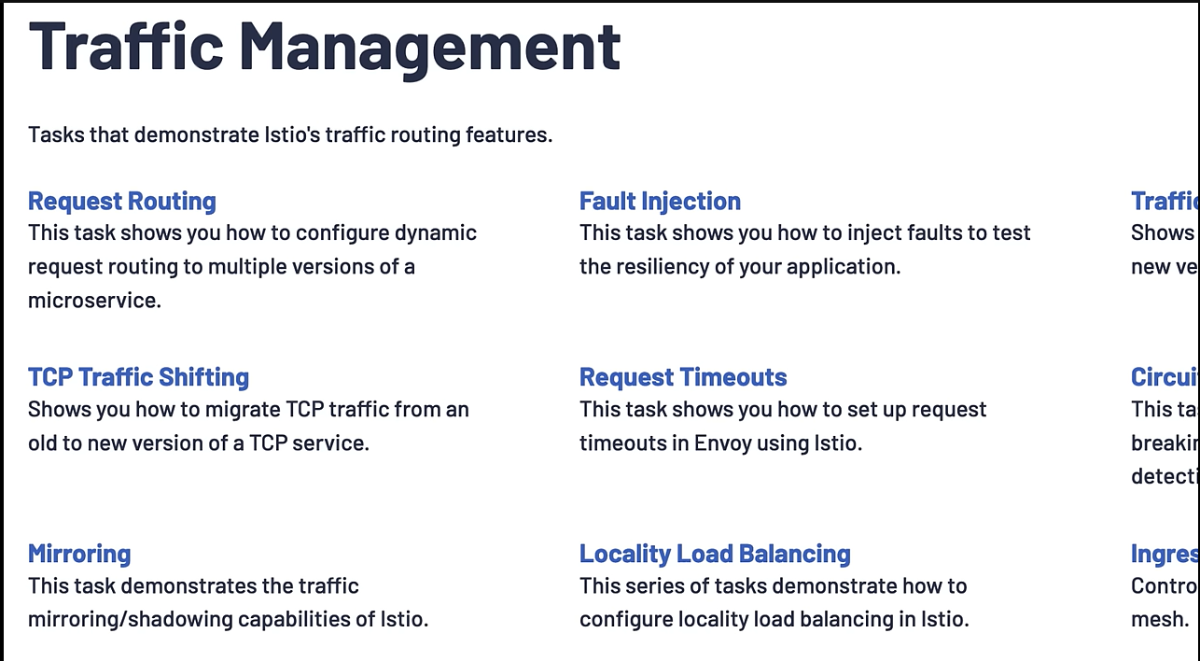

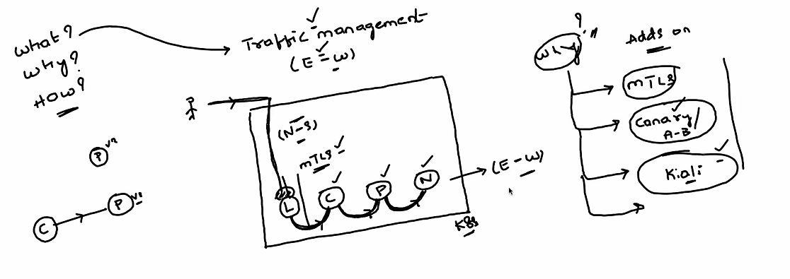



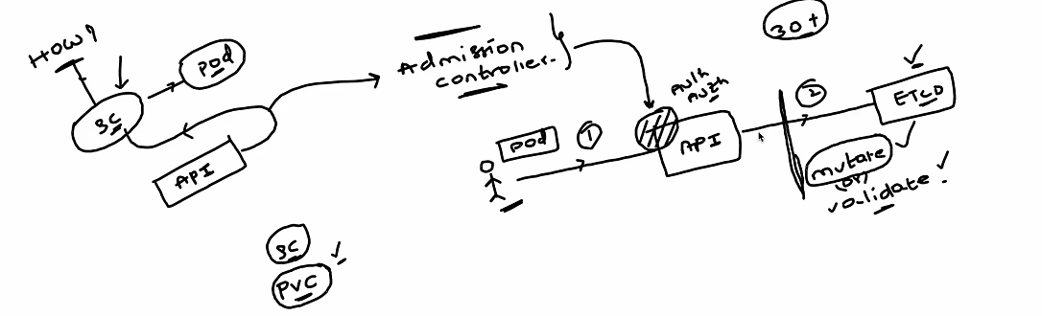

Admission controller

It will validate and mutate the authenticated and authenticated user request

* Mutate
* Validate

1. **Replicaset**

**ReplicaSets:**

* **A ReplicaSet** is a Kubernetes object that ensures that the exact number of pods(replicas) are always running in the cluster by replacing any failed pods with new ones. It’s primarily used to maintain **high availability** and **scalability** of applications.
* The replica count is controlled by the replicas field in the resource definition file
* **Replicaset** uses **set-based selectors** whereas **replicacontroller** uses **equality-based selectors**

**🔁 What Does a ReplicaSet Do?**

* **Ensures desired state**: If a pod crashes or is deleted, the ReplicaSet automatically creates a new one to maintain the desired number.
* **Supports rolling updates**: Often used behind the scenes by **Deployments** to manage updates.
* **Scales applications**: You can increase or decrease the number of replicas easily.

**🧱 Key Components**

* **replicas**: Number of pod copies you want running.
* **selector**: Labels used to identify which pods the ReplicaSet should manage.
* **template**: The pod specification (like image, ports, etc.).

**ReplicationController:**

A **ReplicationController** is an older Kubernetes resource with a similar purpose to ReplicaSets. It ensures that a specified number of pod replicas are running at all times.

**Differences between ReplicaSet and ReplicationController:**

**➣ Replicaset:**

**- Selectors:** Supports set-based selectors (more flexible).

**- Use Case:** Used with Deployments for modern applications.

**- Efficiency:** More advanced and flexible.

**➣ ReplicationController**

**- Selectors:** Supports only equality-based selectors.

**- Use Case:** Considered legacy, replaced by ReplicaSet.

**- Efficiency:** Limited to basic replication tasks.

Example:

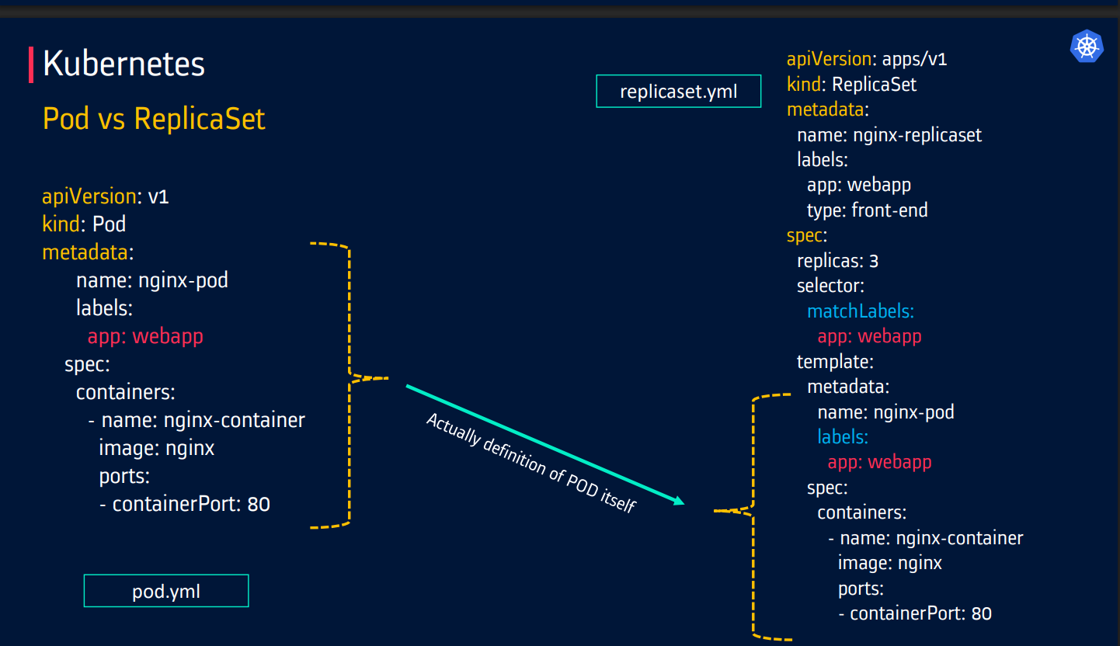

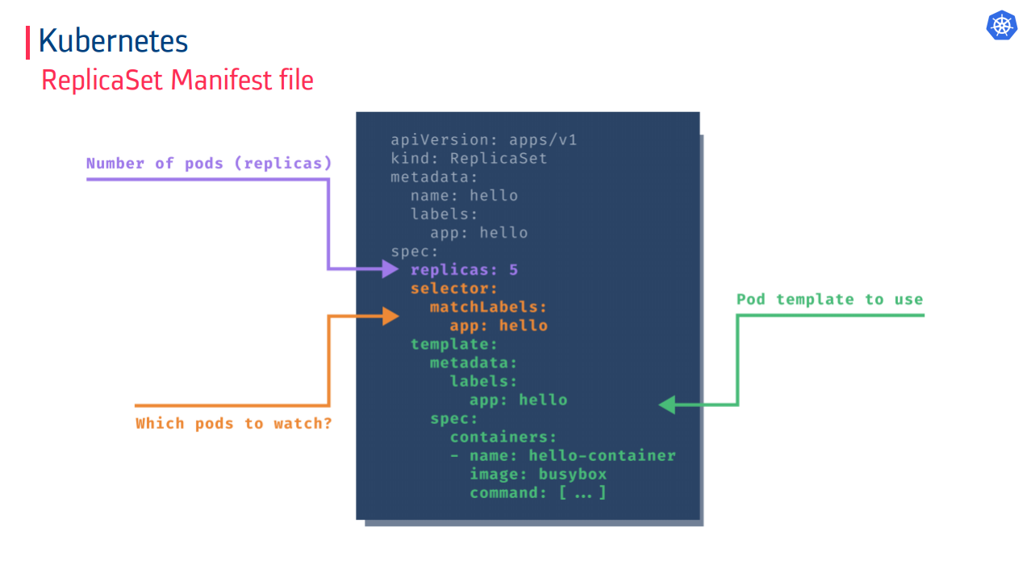

Example:

apiVersion: apps/v1

kind: ReplicaSet

metadata:

  name: frontend

  labels:

    app: guestbook

    tier: frontend

spec:

  replicas: 3  # modify replicas according to your case

  selector:

    matchLabels:

      tier: frontend

  template:

    metadata:

      labels:

        tier: frontend

    spec:

      containers:

        - name: php-redis

          image: gcr.io/google_samples/gb-frontend:v3

1. **Deployments**

**Deployments:**

* A **Deployment** is a Kubernetes object used to manage Pods and ReplicaSets through a declarative configuration. It defines the desired state of an application including the number of Pods, deployment strategies, container images and manages the rollout and rollback of changes.
* The **Deployment Controller** ensures the actual state matches the desired state by replacing failed pods.
* Deployments support several **deployment strategies** like “**recreate**” and “**rolling update**” and can be customized for advanced methods such as blue/green or canary deployments.
* A **Deployment** provides replication functionality and **auto-healing** and **auto-scaling** features with the help of ReplicaSets.
* It also facilitates **rolling out** and **rolling back** changes effectively.

**Key Features of Deployments**

1. **Declarative Management:** You describe the desired state in a YAML or JSON file. Kubernetes takes care of the changes.
2. **Rolling Updates:** Gradually replaces old pods with new ones, ensuring zero downtime
3. **Rollback Capability:** Kubernetes can revert to previous versions if an update fails.
4. **Self-healing:** Automatically replaces failed or deleted pods.

**Command to rollout and rollback**

1. **Monitor the Update Progress:**

Check Deployment status: **kubectl rollout status deployment/my-app**

View update history: **kubectl rollout history deployment/my-app**

1. **Rollback if Needed:** If the update causes issues,

**rollback to the previous version:**

kubectl rollout undo deployment/my-app

**You can also specify a specific revision to rollback to:**

kubectl rollout undo deployment/my-app --to-revision=2

1. **Blue-Green Deployment (Optional)**

Instead of a rolling update, you can create a new Deployment with the updated version and use a Service to switch traffic between the old and new versions.

1. **Canary Deployment (Optional)**

This approach deploys the new version to a small subset of users first, allowing testing in a production-like environment. Gradually, the new version replaces the old one.

apiVersion: apps/v1

kind: Deployment

metadata:

  name: nginx-deployment

  labels:

    app: nginx

spec:

  replicas: 3

  selector:

    matchLabels:

      app: nginx

  template:

    metadata:

      labels:

        app: nginx

    spec:

      containers:

      - name: nginx

        image: nginx:1.14.2

        ports:

        - containerPort: 80

**Explanation of the YAML:**

* **spec:** The specifications of the Deployment.
  + **replicas:** Defines the number of Pods to run (e.g., 3).
  + **selector:** Defines the label selector to match the Pods managed by this Deployment.
  + **template:** Defines the template for the Pods that will be created by the Deployment. It includes the metadata and spec for the Pods (such as the container image and port to expose).

**Failed Deployment:**

Your Deployment may get stuck trying to deploy its newest ReplicaSet without ever completing. This can occur due to some of the following factors:

• Insufficient quota

• Readiness probe failures

• Image pull errors

• Insufficient permissions

• Limit ranges

• Application runtime misconfiguration

**Deployment Strategy:**

In **Kubernetes**, a **Deployment Strategy** defines **how updates** to your application are rolled out. It controls **how new versions of pods replace old ones**, ensuring minimal downtime and maximum reliability.

**🚀 Common Deployment Strategies**

**1. Rolling Update (Default)**

* Gradually replaces old Pods with new ones, **one-by-one or in batches**.
* Ensures **zero downtime** by keeping at least some Pods running during the update.

**Key Features**:

* **Controlled Scaling**:
  + **maxSurge:** How many extra Pods can be created during the update (default: 25%).
  + **maxUnavailable:** How many Pods can be unavailable during the update (default: 25%).
* **Smooth Transition**:
  + New Pods are started before old ones are terminated.
* **Automatic Rollback**:
  + If new Pods fail health checks, Kubernetes reverts to the previous version.

apiVersion: apps/v1

kind: Deployment

metadata:

  name: nginx-deployment

spec:

  replicas: 3

  strategy:

    type: RollingUpdate

    rollingUpdate:

      maxSurge: 1       # Allows 1 extra Pod during update

      maxUnavailable: 0 # Ensures all Pods remain available

  selector:

    matchLabels:

      app: nginx

  template:

    metadata:

      labels:

        app: nginx

    spec:

      containers:

      - name: nginx

        image: nginx:1.25

        ports:

        - containerPort: 80

* + **RollingUpdate:** release a new version on a rolling update fashion, one after the other. **It’s the default strategy in K8s. No application downtime is required.**
  + **Blue/green:** release a new version alongside the old version then switch traffic

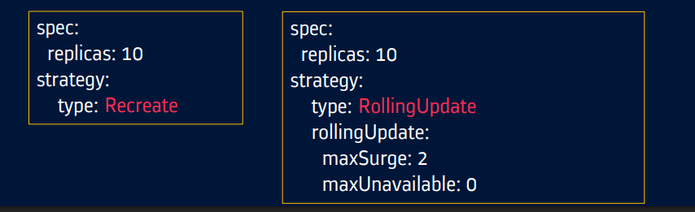

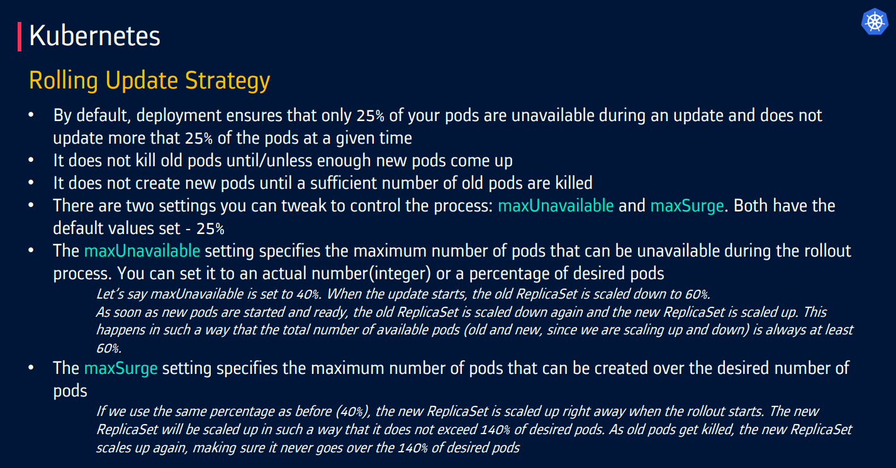

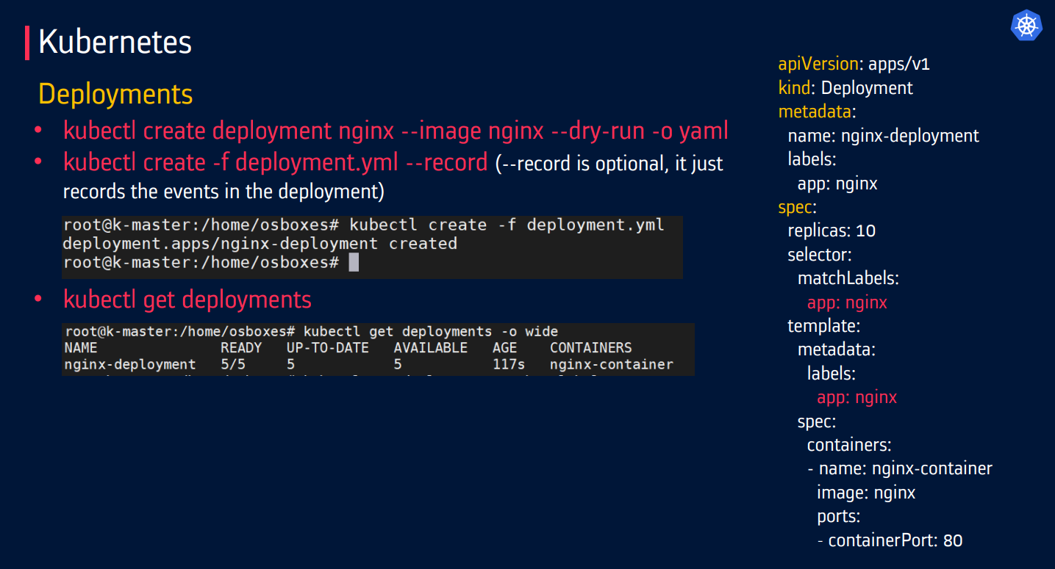

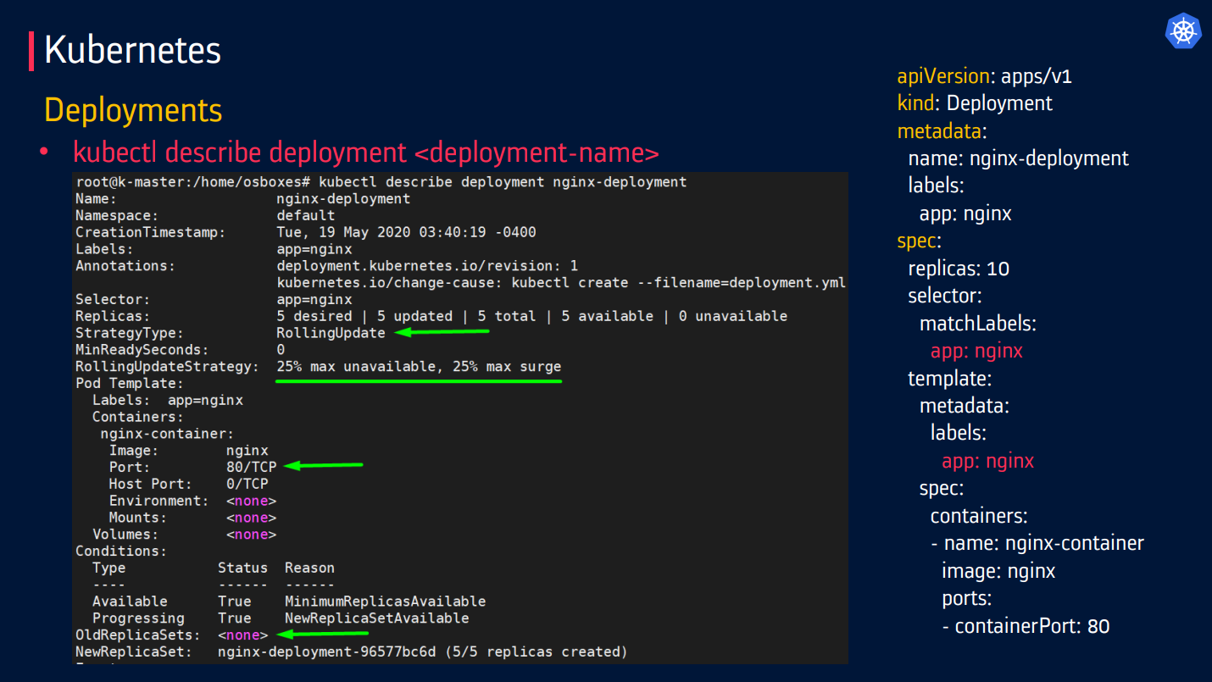

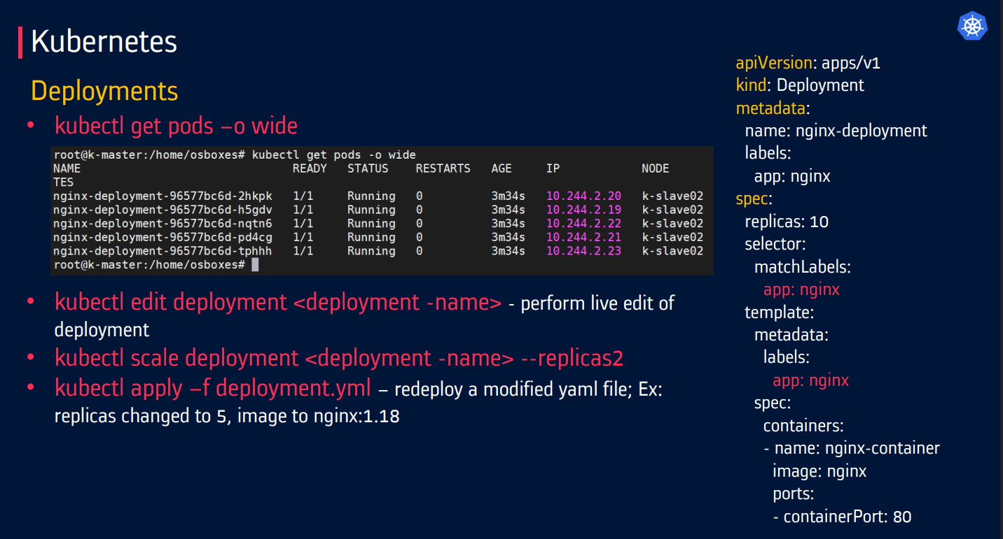

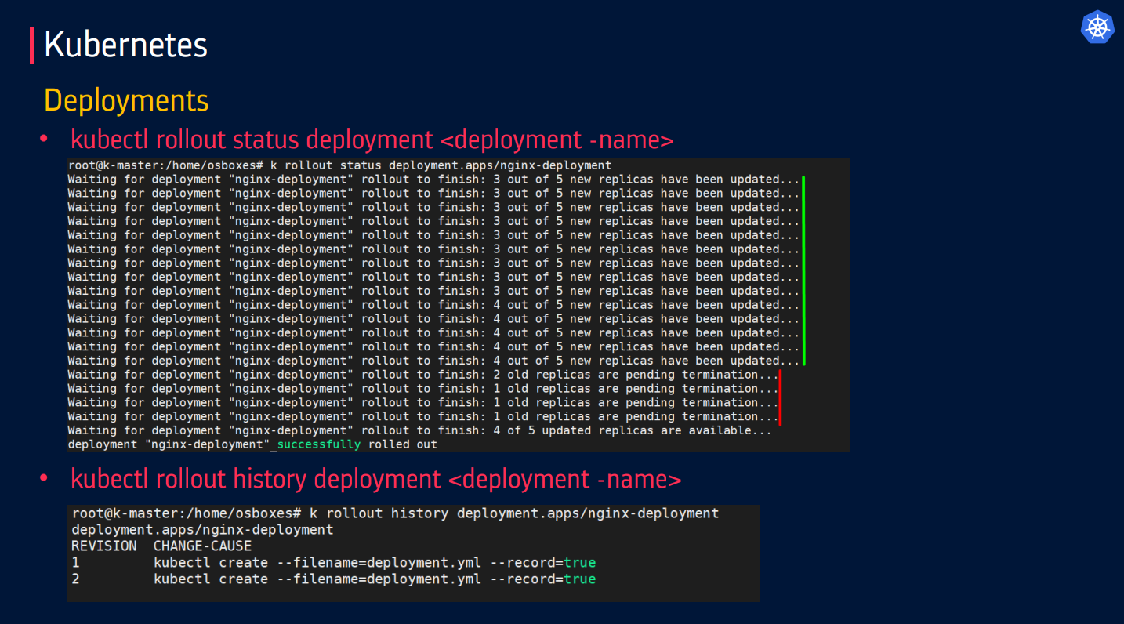

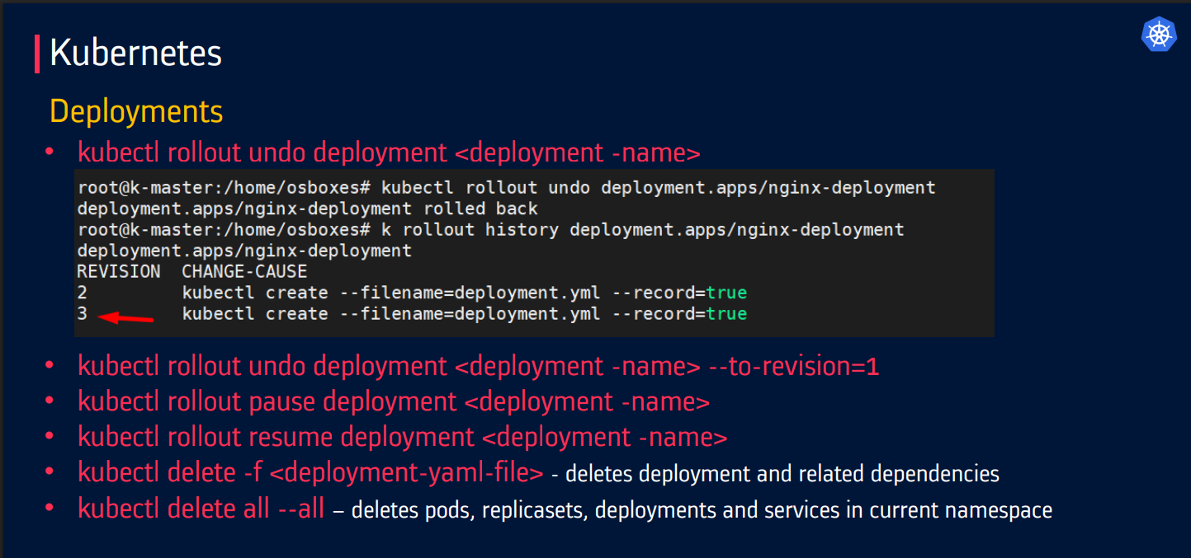

**2. Recreate**

* **Terminates all old Pods first**, then creates new ones.
* Causes **downtime**, but ensures a clean start.

**Key Features**:

* **Simple but disruptive**:
  + No overlap between old and new Pods.
* **Useful for non-version-tolerant apps**:
  + E.g., databases or apps that can't run multiple versions simultaneously.
  + Useful when old and new versions **can’t run together** (e.g., database schema changes).

apiVersion: apps/v1

kind: Deployment

metadata:

  name: mysql-deployment

spec:

  replicas: 1

  strategy:

    type: Recreate  # All old Pods are killed before new ones start

  selector:

    matchLabels:

      app: mysql

  template:

    metadata:

      labels:

        app: mysql

    spec:

      containers:

      - name: mysql

        image: mysql:8.0

        env:

        - name: MYSQL_ROOT_PASSWORD

          value: "password"

**Blue/Green** and **Canary** deployments are advanced deployment strategies used in Kubernetes and DevOps to release new versions of applications **safely and with minimal risk**.

**3. Blue/Green Deployment 🔵🟢**

**Concept**:

* Two identical environments **(Blue = current, Green = new)**run simultaneously.
* Traffic switches all at once from Blue to Green after testing.
* Zero downtime, but requires double the resources during the transition.
* Tools: Service meshes (Istio), Kubernetes Services with label switching.

**How it works**:

1. Deploy the new version to the **Green** environment.
2. Test it thoroughly.
3. Switch traffic from **Blue** to **Green** (usually via a load balancer).
4. If something goes wrong, you can quickly roll back to **Blue**.

**Pros**:

* Instant rollback.
* No downtime during switch.

**Cons**:

* Requires double the infrastructure (two environments).

**Implementation in Kubernetes**

**Using Services & Selectors**

1. Deploy**v1 (Blue)**and**v2 (Green)**with different labels:

# Blue (v1)

apiVersion: apps/v1

kind: Deployment

metadata:

  name: app-v1

spec:

  replicas: 3

  selector:

    matchLabels:

      app: myapp

      version: v1

  template:

    metadata:

      labels:

        app: myapp

        version: v1

    spec:

      containers:

      - name: app

        image: myapp:v1

# Green (v2)

apiVersion: apps/v1

kind: Deployment

metadata:

  name: app-v2

spec:

  replicas: 3

  selector:

    matchLabels:

      app: myapp

      version: v2

  template:

    metadata:

      labels:

        app: myapp

        version: v2

    spec:

      containers:

      - name: app

        image: myapp:v2

1. Use a **Service** to switch traffic:

apiVersion: v1

kind: Service

metadata:

  name: myapp-service

spec:

  selector:

    app: myapp

    version: v1  # Initially points to Blue (v1)

  ports:

    - protocol: TCP

      port: 80

      targetPort: 8080

1. **Cutover to Green (v2)** by updating the Service selector:

kubectl patch service myapp-service -p '{"spec":{"selector":{"version":"v2"}}}'

**4. 🐤 Canary Deployment**

**Concept:**

* Gradually roll out the new version to a small subset of users before a full rollout.

**How it works**:

1. Deploy the new version to a small percentage of users (e.g., 5%). **Gradually shifts traffic** (e.g., 5% → 20% → 100%) to the new version.
2. **Monitors metrics** (errors, latency) before full rollout. [Monitor for errors or performance issues.]
3. Gradually increase traffic to the new version.
4. If stable, complete the rollout; if not, roll back.
5. **Reduces risk** by testing in production with a small subset of users.

**Pros**:

* Safer, controlled rollout.
* Real-world testing with minimal risk.

**Cons**:

* More complex monitoring and traffic routing setup.

**When to Use?**

✔ **A/B testing** (e.g., UI changes).  
✔ **High-risk updates** (e.g., major version upgrades).

**Implementation in Kubernetes**

**Using Nginx Ingress (Traffic Splitting)**

1. Deploy **v1 (stable)** and **v2 (canary)**:

# Stable (v1)

apiVersion: apps/v1

kind: Deployment

metadata:

  name: app-v1

spec:

  replicas: 3

  selector:

    matchLabels:

      app: myapp

  template:

    metadata:

      labels:

        app: myapp

        version: v1

    spec:

      containers:

      - name: app

        image: myapp:v1

# Canary (v2)

apiVersion: apps/v1

kind: Deployment

metadata:

  name: app-v2

spec:

  replicas: 1  # Fewer replicas = less traffic

  selector:

    matchLabels:

      app: myapp

  template:

    metadata:

      labels:

        app: myapp

        version: v2

    spec:

      containers:

      - name: app

        image: myapp:v2

1. Configure **Ingress** to split traffic:

apiVersion: networking.k8s.io/v1

kind: Ingress

metadata:

  name: myapp-ingress

  annotations:

    nginx.ingress.kubernetes.io/canary: "true"

    nginx.ingress.kubernetes.io/canary-weight: "10"  # 10% to v2

spec:

  rules:

  - host: myapp.example.com

    http:

      paths:

      - path: /

        pathType: Prefix

        backend:

          service:

            name: myapp-service

            port:

              number: 80

1. **Gradually increase traffic**:

kubectl annotate ingress myapp-ingress nginx.ingress.kubernetes.io/canary-weight="50" --overwrite

1. **DaemonSet**

**DaemonSet** is a Kubernetes object that ensures that a specific pod runs on every node in a cluster. It is useful for running background tasks, system monitoring, or log collection on every node.

**How DaemonSet Works?**

1. **Node Addition** → If a new node joins, the DaemonSet **automatically schedules a Pod** on it.
2. **Node Removal** → If a node is deleted, its Pod is **garbage-collected**.
3. **Manual Scaling?** → No, it’s **node-dependent** (unlike Deployments).

**Example YAML:**

apiVersion: apps/v1

kind: DaemonSet

metadata:

  name: fluentd

  namespace: logging

  labels:

    app: fluentd-logging

spec:

  selector:

    matchLabels:

      name: fluentd

  template:

    metadata:

      labels:

        name: fluentd

    spec:

      containers:

      - name: fluentd-elasticsearch

        image: quay.io/fluentd_elasticsearch/fluentd:v2.5.2

        resources:

          limits:

            memory: 200Mi

          requests:

            cpu: 100m

            memory: 200Mi

        volumeMounts:

        - name: varlog

          mountPath: /var/log

      terminationGracePeriodSeconds: 30

      volumes:

      - name: varlog

        hostPath:

          path: /var/log

**Key Components:**

1. tolerations → Allows Pods to run on master nodes (if needed).
2. hostPath**volumes** → Access node files (e.g., logs).
3. selector.matchLabels → Ensures only DaemonSet-managed Pods are controlled.

**🔧 Common Use Cases**

| **Use Case** | **Description** |
| --- | --- |
| **Log collection** | Run agents like Fluentd or Logstash on every node. |
| **Monitoring** | Deploy Prometheus Node Exporter or Datadog agents. |
| **Networking** | Run CNI plugins or kube-proxy on each node. (Calico, Weave) |
| **Security** | Install security agents or scanners on all nodes. |

**How DaemonSets Differ from Other Controllers**

* **Deployment**: Focuses on stateless applications and scalable services, with pods distributed across nodes based on resource needs.
* **StatefulSet**: Manages stateful applications where stable pod identities and persistent storage are required.
* **DaemonSet**: Ensures pods are deployed uniformly across all (or selected) nodes, mainly for system-level tasks.

1. **StatefulSet**

**StatefulSet:**

* + A **StatefulSet** is a Kubernetes controller designed to **manage and deploy stateful applications** that require **persistent storage**, **stable network identity**, and **ordered deployment or scaling.**
  + It ensures each Pod has a **unique and stable identity** (like pod-0, pod-1) and a **dedicated persistent storage volume** that persists even during scaling, node failures, or replacements.
  + Unlike **Deployments** used for **stateless applications**, **StatefulSets** are specifically built for **stateful workloads** where the **order of Pod creation**, **deletion**, and **stable identities** are crucial.
  + They are ideal for running **databases** and **clustered applications** (e.g., MongoDB, Kafka, Cassandra).
  + StatefulSets are defined using a YAML manifest that includes:
  + A **Pod template**
  + A **Headless Service** (clusterIP: None) for stable DNS
  + A **VolumeClaimTemplate** to create PVCs per Pod

A **StatefulSet** is a Kubernetes workload API object used to manage **stateful applications** that require:

* Stable, unique network identifiers
* Persistent storage
* Ordered, graceful deployment and scaling

A **StatefulSet** ensures that:

* Each pod has a **unique, stable name** (e.g., web-0, web-1, web-2).

Pattern **<statefulset-name>-<ordinal>.**

* Each pod gets its own **persistent volume**, which is **not shared** and **not deleted** when the pod is removed.
* Pods are **created, updated, and deleted in order**.

**🔧 Key Features**

| **Feature** | **Description** |
| --- | --- |
| **Stable Identity** | Each pod keeps the same name and network identity. (pod-0, pod-1 etc.) |
| **Persistent Storage** | Each pod gets a dedicated volume that persists across restarts. |
| **Ordered Operations** | Pods are started, updated, and terminated in a defined order. (0→1→2) |
| **Use Case** | Databases (MySQL, Cassandra), Kafka, Zookeeper, etc. |

**🧠 When to Use StatefulSet?**

✔ Databases (MySQL, PostgreSQL, MongoDB)  
✔ Message queues (Kafka, RabbitMQ)  
✔ Any application requiring:

* Stable network identity
* Requires **persistent storage** tied to each pod.
* Must be **started or stopped in a specific order**. (Ordered deployments)

**Example YAML:**

apiVersion: v1

kind: Service

metadata:

  name: redis

  namespace: default

  labels:

    app: redis

spec:

  ports:

  - port: 6379

    protocol: TCP

  selector:

    app: redis

  type: ClusterIP

  clusterIP: None

---

apiVersion: apps/v1

kind: StatefulSet

metadata:

  name: redis

spec:

  selector:

    matchLabels:

      app: redis

  serviceName: "redis"

  replicas: 1

  template:

    metadata:

      labels:

        app: redis

    spec:

      containers:

      - name: redis

        image: redis:5.0.4

        command: ["redis-server"]

        ports:

        - containerPort: 6379

          name: web

        volumeMounts:

        - name: redis-aof

          mountPath: /data

  volumeClaimTemplates:

  - metadata:

      name: redis-aof

    spec:

      accessModes: [ "ReadWriteOnce" ]

      storageClassName: "gp2"

      resources:

        requests:

          storage: 1Gi

**Explanation:**

1. **Pod Naming**:
   * Pods are named sequentially, like mongodb-0, mongodb-1, mongodb-2.
2. **Persistent Volumes (volumeClaimTemplates)**:
   * Dynamically provisions PVs for each pod.
   * Ensures data persistence across pod even if a pod is recreated. its data is retained.
3. **Order Pod Management**:
   * Pods are created one after another (from mongodb-0 to mongodb-2) and terminated in reverse order.

**Common Use Cases for StatefulSets**

1. **Databases**:
   * Applications like MySQL, PostgreSQL, MongoDB, or Cassandra, where data consistency is critical.
2. **Distributed File Systems**:
   * Systems like Ceph or GlusterFS require persistent storage and stable network identities.
   * Elasticsearch, Cassandra, ZooKeeper
3. **Message Queues**:
   * Services like Kafka or RabbitMQ that rely on ordered operations.

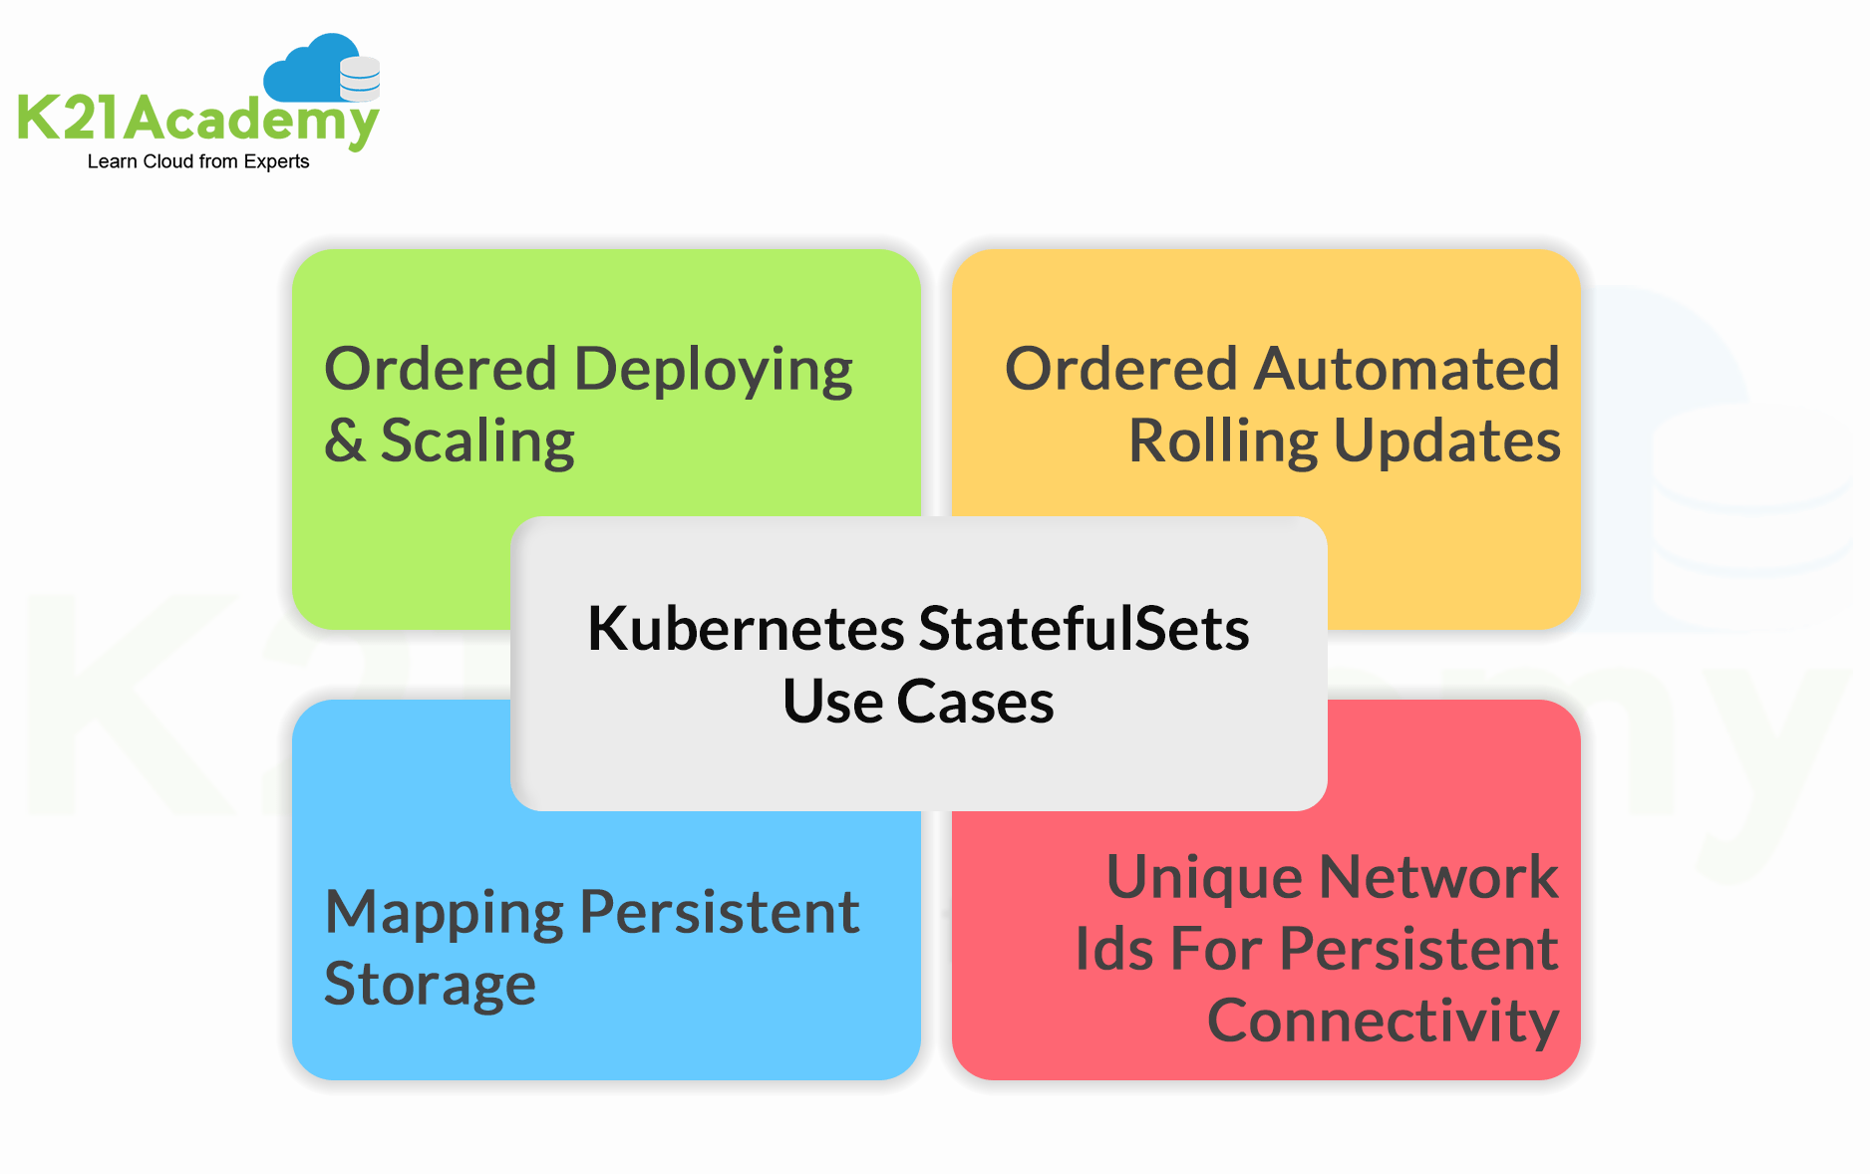

**Kubernetes Deployment VS StatefulSet:**

**1. Overview**

| **Feature** | **Deployment** | **StatefulSet** |
| --- | --- | --- |
| **Purpose** | Stateless applications | Stateful applications |
| **Pod Identity** | No stable identity (interchangeable) | Stable hostname + ordinal number |
| **Scaling** | Seamless scaling up/down | Ordered scaling (0→1→2...) |
| **Storage** | Ephemeral or shared volumes | Persistent, pod-specific volumes |
| **Networking** | Random service endpoints | Stable DNS names (pod-0, pod-1) |
| **Rollout Strategy** | Rolling updates (default) | Ordered updates (or rolling) |
| **Use Cases** | Web servers, APIs, microservices | Databases (MySQL, Kafka, etc.) |

**2. Key Differences Explained**

**A. Pod Identity & Naming**

* **Deployment**:
  + Pods get random names (e.g., nginx-7dfd6c7b9c-abc12).
  + No guaranteed order during restarts.
* **StatefulSet**:
  + Pods get **stable, predictable names** (e.g., mysql-0, mysql-1).
  + Each pod retains its identity even after rescheduling.

**B. Scaling Behavior**

* **Deployment**:
  + Pods are **scaled arbitrarily** (no order).
  + Deleting a pod creates a new one with a random name.
* **StatefulSet**:
  + Scaling follows **strict order** (0→1→2...).
  + Downscaling deletes pods in **reverse order** (2→1→0).

**C. Storage (Persistent Volumes)**

* **Deployment**:
  + Typically uses **emptyDir** or **shared volumes** (all pods write to the same storage).
* **StatefulSet**:
  + Each pod gets **its own PersistentVolume (PV)** via volumeClaimTemplates.
  + Example (MySQL StatefulSet):

volumeClaimTemplates:

- metadata:

    name: mysql-data

  spec:

    accessModes: ["ReadWriteOnce"]

    resources:

      requests:

        storage: 10Gi

**D. Networking (DNS & Service Access)**

* **Deployment**:
  + Accessed via a **single Service** (load-balanced).
  + No individual pod DNS.
* **StatefulSet**:
  + Each pod gets a **stable DNS name** (e.g., mysql-0.mysql.default.svc.cluster.local).
  + Requires a **headless Service** (clusterIP: None).

**3. When to Use Which?**

**Use Deployment If:**

✔ Running **stateless apps** (e.g., Nginx, APIs).  
✔ Need **rolling updates** with zero downtime.  
✔ Pods are **interchangeable** (no persistent data).

**Use StatefulSet If:**

✔ Running **stateful apps** (e.g., MySQL, MongoDB, Kafka).  
✔ Need **stable pod names and storage**.  
✔ Require **ordered scaling** (e.g., primary-replica databases).

**Final Recommendation**

* **Use**Deployment**for stateless, scalable microservices.**
* **Use**StatefulSet**for databases, queues, and clustered stateful apps.**

1. **Jobs**

**Jobs:**

* + **A Job** is a Kubernetes controller used to **run a** **specific task to completion or batch job**. It is designed for one-time or on-demand tasks that terminate automatically after completion.
  + Jobs are ideal for **short-lived tasks** such as batch processing, data analysis, or backups.
  + A Job creates **one or more pods** to run the task and **monitor their completion status**. If a pod fails, the Job automatically replaces it to ensure the task is successfully completed.
  + Jobs are configured using a **YAML manifest** that includes:
* A **Pod template**
* **Completion criteria** (completions, parallelism)
* Optional retry settings (backoffLimit)

A **Job** creates one or more Pods to run a **specific task to completion**.

**🔧 Key Features**

| **Feature** | **Description** |
| --- | --- |
| **One-time execution** | Runs a task once and exits. like data processing or backups. |
| **Retry on failure** | Automatically retries failed pods.  If a pod fails during job execution, Kubernetes automatically retries the job until it succeeds or meets the set limit. |
| **Parallelism** | Can run multiple pods in parallel. |
| **Completion tracking** | Tracks how many pods have completed successfully, even if Pods fail. |
| **Automatic cleanup** | Once the task is finished, the Job and its Pods are removed. |

**Example YAML:**

apiVersion: batch/v1

kind: Job

metadata:

  name: kubernetes-parallel-job

  labels:

    jobgroup: jobexample

spec:

  completions: 6

  parallelism: 2

  template:

    metadata:

      name: kubernetes-parallel-job

      labels:

        jobgroup: jobexample

    spec:

      containers:

      - name: c

        image: devopscube/kubernetes-job-demo:latest

        args: ["100"]

      restartPolicy: OnFailure

**Explanation:**

1. **completions**: Specifies how many times the job needs to complete successfully (here, 1 time).
2. **parallelism**: Sets the number of pods to run simultaneously (here, 1 pod).
3. **restartPolicy**: Ensures the pod doesn’t restart on completion (Never).
   * **Never:** Pod won't restart after failure
   * **OnFailure:** Pod will restart if fails

**Job Lifecycle**

1. **Created** → Job object created
2. **Pod Creation** → Kubernetes creates Pod(s)
3. **Running** → Pod executes task
4. **Completion** → Pod exits successfully
5. **Cleanup** → Completed Pods remain for debugging (by default)

**Common Use Cases for Jobs**

1. **Batch Processing**: Process large datasets (e.g., image or video processing).
2. **Data Backups**: Perform database dumps and store them securely.
3. **Maintenance Tasks**: Automate cleanup tasks like deleting outdated resources.
4. **Analytics**: Run complex analytics computations on datasets.
5. **Migrations**: When you need to run **one-time tasks** such as database migrations or batch processing.

* Run **data processing** batches or **ETL tasks**.
* Perform **database migrations**.
* Backup operations
* CI/CD pipeline tasks
* Execute **scheduled tasks** (with CronJobs).
* Run **one-time scripts** or **maintenance tasks**.

1. **CronJobs**

**CronJobs:**

* + A CronJob is a Kubernetes resource that schedules Jobs to run periodically based on a specified schedule. It's like a time-based trigger that initiates Jobs at predefined intervals.
  + In Kubernetes, a **CronJob** is a specialized resource used to **schedule and run Jobs at specific time intervals or recurring schedules.**
  + A **CronJob** runs **Jobs on a schedule** similar to Linux cron.

A **CronJob** creates **Jobs on a time-based schedule** (similar to Unix/Linux cron).

**🔧 Key Features**

| **Feature** | **Description** |
| --- | --- |
| **Scheduled execution** | Runs at specific times using cron syntax. |
| **Automatic retries** | Retries failed jobs based on configuration. |
| **History Retention** | Keeps track of successful/failed jobs. |
| **Concurrency Control** | Manages how concurrent jobs are handled |
| **Job Creation** | Creates Job objects at scheduled times |
| **Recurring Tasks** | Automates repetitive tasks, such as backups, cleanup operations, log rotation, or data synchronization |

**Cron Expression Format:**

The schedule for a CronJob is defined using a cron expression, which consists of five fields:

* * * * *

| | | | |

| | | | +--- Day of the week (0 - 7, both 0 and 7 represent Sunday)

| | | +----- Month (1 - 12)

| | +------- Day of the month (1 - 31)

| +--------- Hour (0 - 23)

+----------- Minute (0 - 59)

For example:

* "*/5 * * * *": Runs every 5 minutes.
* "0 0 * * *": Runs daily at midnight.

Examples:

* 0 * * * * - Every hour at :00
* 30 3 * * * - Daily at 3:30 AM
* 0 0 * * 0 - Weekly on Sunday midnight

**Example YAML:**

apiVersion: batch/v1

kind: CronJob

metadata:

    name: kubernetes-cron-job

spec:

  schedule: "*/5 * * * *" # Every 5 minutes

  jobTemplate:

    spec:

      template:

        metadata:

          labels:

            app: cron-batch-job

        spec:

          restartPolicy: OnFailure

          containers:

          - name: kube-cron-job

            image: busybox:1.28

            command: ["echo", "Hello, Kubernetes CronJobs!"]

**Explanation:**

1. **schedule:** Defines when the CronJob should run using a cron expression.
2. **jobTemplate:** Specifies the template for the job that the CronJob will create.
3. **restartPolicy:** Ensures that the pod doesn’t restart after completion (Never).
4. **concurrencyPolicy**
   * Allow (default): Concurrent jobs allowed
   * Forbid: Skip new job if previous still running
   * Replace: Cancel current job and start new one

**Common Use Cases for CronJobs**

1. **Data Backups**: Automating regular backups of databases, filesystems, or applications.
2. **Log Rotation/Cleanup**: Automate deleting old logs files or temporary files to save disk space.
3. **Data synchronization:** Keeping data consistent across different systems or databases
4. **Scheduled Emails**: Send periodic notifications or updates.
5. **Monitoring and alerting:** Running scripts to monitor system health and send alerts.
6. **Recurring Reports generation**: Generating reports at regular intervals.

* **Recurring health checks**

✔ Daily database backups  
✔ Hourly log analysis  
✔ Weekly report generation  
✔ Monthly data archiving  
✔ Any recurring task with a fixed schedule

**How Jobs and CronJobs Work Together:**

**1. CronJob Scheduling:** The CronJob controller monitors the cluster for CronJob objects. When a CronJob's schedule matches the current time, it creates a new Job.

**2. Job Execution:** The Job controller creates Pods to execute the task defined in the Job spec.

**3. Task Completion:** The Pods run the task and report their status to the Job controller.

**4. Job Completion:** Once all Pods associated with the Job complete successfully, the Job is considered finished.

**5. Cleanup:** The Job and its Pods are automatically deleted.

By effectively utilizing Jobs and CronJobs, you can automate routine tasks, optimize resource utilization, and ensure the reliability and efficiency of your Kubernetes applications.

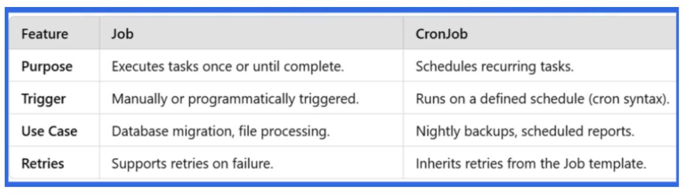

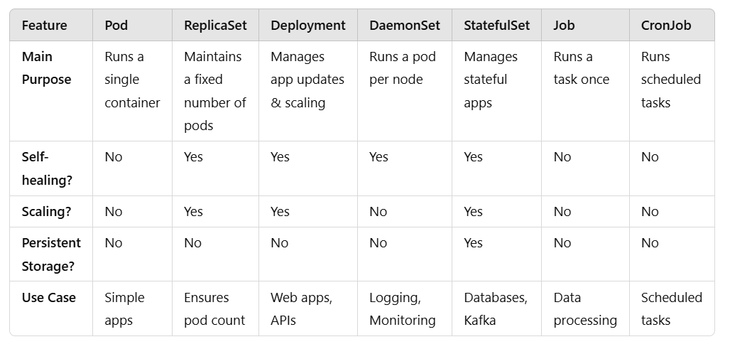

1. **Namespace in Kubernetes**

**Namespace:**

* + **A Kubernetes Namespace** is a virtual cluster within a Kubernetes cluster. It provides a way to organize and isolate resources such as Pods, Services, Deployments, and other objects within the cluster. Namespaces allow different teams or projects to use the same cluster without affecting each other's resources, ensuring resource isolation and access control.

A **Namespace** in Kubernetes is a virtual cluster within a physical cluster.

**A Namespace is used to:**

* **Organize and isolate resources (like pods, services, deployments).**
* Apply different policies (like resource limits or access control).
* Support multi-tenancy in a single cluster.
* Access control boundaries

**📦 Default Namespaces in Kubernetes**

| **Namespace** | **Purpose** |
| --- | --- |
| **default** | Used when no other namespace is specified. resources are created in the default namespace. |
| **kube-system** | Contains system components like kube-dns, kube-proxy, scheduler, controller manager. |
| **kube-public** | Readable by all users (used for cluster info). This namespace is generally reserved for cluster usage like cluster-info ConfigMap |
| **kube-node-lease** | Tracks node heartbeats for node health monitoring. |

**Key Features of Namespaces:**

* + **Resource Isolation:** Namespaces allows isolation of environments for different teams or projects to use the same cluster without interference.
  + **Resource Quota Management:** It defines limits (e.g., CPU, memory) for resources within a namespace to avoid resource contention.
  + **Access Control:** Kubernetes uses Role-Based Access Control (RBAC) to restrict access to specific users or teams in different namespaces.
  + **Network Isolation (Policies):** Namespaces are used to control communication between resources in different namespaces. However, by default, Pods in different namespaces can communicate with each other.
  + **Default Namespace**
  + **Ease of Management**

**🧠 When to Use Namespaces?**

* Separate environments (e.g., dev, staging, prod).
* Isolate teams or projects.
* Apply different resource quotas or RBAC rules.

**Important Considerations**

⚠ **Not all objects are namespaced**

* Nodes, PersistentVolumes, ClusterRoles are cluster-scoped

⚠ **Scoping Resources:**

* Resources like Pods, Services, ConfigMaps, and Secrets are created within a specific namespace.

**Namespace vs Cluster**

| **Feature** | **Namespace** | **Cluster** |
| --- | --- | --- |
| **Scope** | Virtual partition | Physical cluster |
| **Isolation** | Logical | Physical |
| **Resources** | Shares cluster resources | Dedicated resources |
| **Access Control** | RBAC per namespace | Cluster-wide policies |

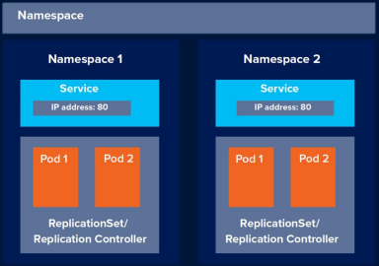

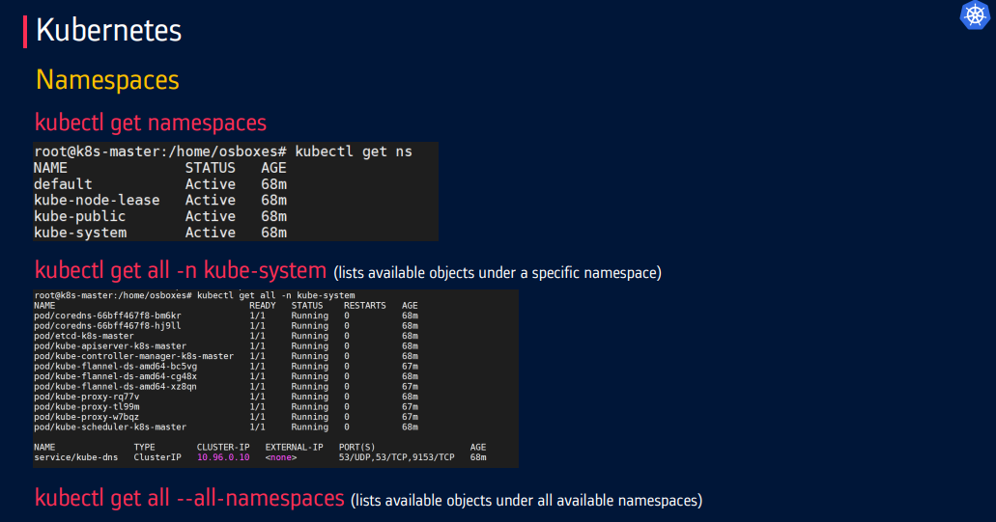

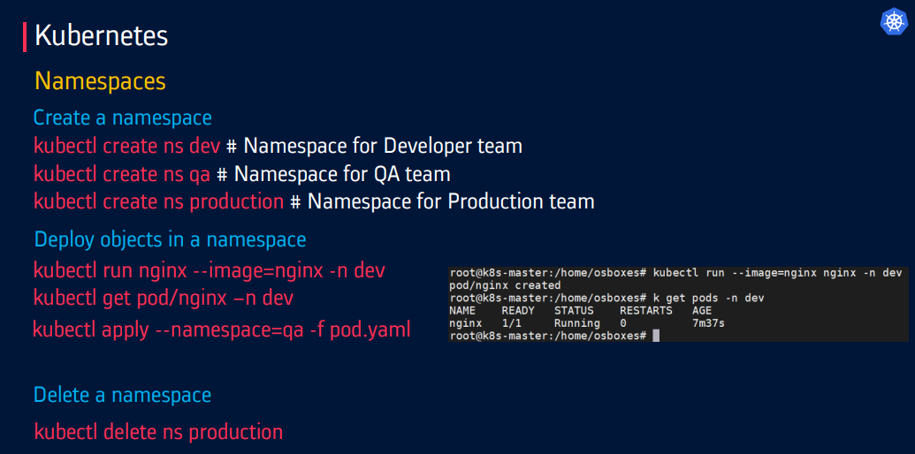

1. **Volumes**

**Volumes:**

* + In Kubernetes, **Volumes** are used to manage **persistent storage** to containers. Pods are temporary, but **Volumes help keep the data alive** even if the Pod dies or restarts.
  + a Volume is a directory accessible to containers in a Pod that allows data to persist beyond the container's lifecycle.

**Volumes** are used to manage **persistent or shared storage for containers** running in Pods. Unlike the ephemeral storage inside a container, volumes provide a way to persist data across container restarts or share data between containers in the same Pod.

**🔹 Key Concepts of Kubernetes Volumes**

1. **Ephemeral vs Persistent Storage**
   * Ephemeral: Data is lost when the container restarts.
   * Persistent: Data is retained using volumes, even if the container restarts.
2. **Volume Lifecycle**
   * A volume exists as long as the Pod exists.
   * For longer persistence, use Persistent Volumes (PVs) and Persistent Volume Claims (PVCs).

**Key Components:**

**PV (PersistentVolume)**

A pre-provisioned storage resource in the cluster, like a hard disk.

A piece of storage in the cluster provisioned by an admin or dynamically.

**PVC (PersistentVolumeClaim)**

A request made by a Pod to use storage (i.e., "I need 5Gi of space").

A request for storage by a user.

**StorageClass**

Defines **how storage is created,** including type (like SSD, HDD), speed, etc. It enables **dynamic provisioning** of storage.

**Key Volume Features**

| **Feature** | **Description** |
| --- | --- |
| **Lifecycle** | Tied to Pod lifecycle (unless using PersistentVolumes) |
| **Sharing** | Multiple containers in a Pod can access same volume |
| **Types** | Many storage backends supported (local, cloud, network, etc.) |
| **Persistence** | Some types persist beyond Pod lifetime |

**Types of Kubernetes Volumes**

There are different types of volumes you can use in a Kubernetes pod:

**❑ Node-local memory** (emptyDir and hostPath)

**❑ Cloud volumes** (e.g., awsElasticBlockStore, gcePersistentDisk, and azureDiskVolume)

**❑ File-sharing volumes**, such as Network File System (NFS)

**❑ Distributed-file systems** (e.g., CephFS and GlusterFS)

**❑ Special volume types** such as PersistentVolumeClaim, secret, configmap and gitRepo

**1. Ephemeral Volumes**

* Exist only while Pod runs
* Examples: emptyDir, configMap, secret
* Types like emptyDir or configMap last only for the lifecycle of a pod.

**2. Persistent Volumes**

* Survive Pod restarts
* Examples: persistentVolumeClaim, awsElasticBlockStore, nfs

**3. Special Purpose Volumes**

* For specific use cases
* Examples: downwardAPI, projected

**🔸 Types of Volumes**

| **Volume Type** | **Description** |
| --- | --- |
| **Ephemeral emptyDir** | Temporary storage shared between containers in a Pod. Deleted when the Pod is removed.  (Temporary directory created when Pod starts) |
| **hostPath** | Mounts a file or directory from the host node’s filesystem into the pod. |
| **configMap** | Mounts configuration data as files. |
| **secret** | Mounts sensitive data like passwords or tokens. |
| **persistentVolumeClaim** | **PVC:** A request for PV by a pod to claim storage resources.  **PV:** Pre-provisioned storage in the cluster, independent of pods. |
| **Nfs (Network File System)** | Mounts a remote Network File System share.  Allows multiple pods across nodes to access shared storage on an NFS server. |
| **CSI (Container Storage Interface)** | Enables Kubernetes to integrate with external storage systems. |
| **awsElasticBlockStore, gcePersistentDisk, azureDisk** | Cloud provider-specific persistent storage. |

**Persistent Volume (PV) & PVC Workflow**

1. **Admin provisions PV** (storage resource in cluster)
2. **User creates PVC** (storage request)
3. **Kubernetes binds PVC to PV**
4. **Pod uses PVC**

**Example Volume Configuration**

Here’s an example of a pod with a PersistentVolume and PersistentVolumeClaim:

**PersistentVolume (PV):**

apiVersion: v1

kind: PersistentVolume

metadata:

  name: my-pv

spec:

  capacity:

    storage: 1Gi

  accessModes:

    - ReadWriteOnce

  hostPath:

    path: /mnt/data

**PersistentVolumeClaim (PVC):**

apiVersion: v1

kind: PersistentVolumeClaim

metadata:

  name: my-pvc

spec:

  accessModes:

    - ReadWriteOnce

  resources:

    requests:

      storage: 1Gi

**Pod Using PVC:**

apiVersion: v1

kind: Pod

metadata:

  name: my-pod

spec:

  volumes:

  - name: my-volume

    persistentVolumeClaim:

      claimName: my-pvc

  containers:

  - name: my-container

    image: busybox

    volumeMounts:

    - mountPath: /data

      name: my-volume

    command: ["sh", "-c", "echo Hello Kubernetes > /data/hello.txt && sleep 3600"]

**AWS EBS Example**

volumes:

- name: ebs-volume

  awsElasticBlockStore:

    volumeID: "vol-123456"

    fsType: "ext4"

**AWS EBS Volume Example**

**1. StorageClass (Dynamic Provisioning)**

apiVersion: storage.k8s.io/v1

kind: StorageClass

metadata:

  name: ebs-sc

provisioner: kubernetes.io/aws-ebs

parameters:

  type: gp3  # gp2, gp3, io1, io2, sc1, st1

  fsType: ext4

  encrypted: "true"  # Enable EBS encryption

volumeBindingMode: WaitForFirstConsumer  # Recommended for EBS

reclaimPolicy: Delete  # Or Retain for persistent data

**2. PersistentVolumeClaim (PVC)**

apiVersion: v1

kind: PersistentVolumeClaim

metadata:

  name: ebs-pvc

spec:

  accessModes:

    - ReadWriteOnce  # EBS only supports RWO

  storageClassName: ebs-sc

  resources:

    requests:

      storage: 10Gi

**3. Pod Using the EBS Volume**

apiVersion: v1

kind: Pod

metadata:

  name: ebs-pod

spec:

  containers:

  - name: app

    image: nginx

    volumeMounts:

    - name: ebs-storage

      mountPath: "/usr/share/nginx/html"

  volumes:

  - name: ebs-storage

    persistentVolumeClaim:

      claimName: ebs-pvc

**4. Static Provisioning (Existing EBS Volume)**

If you need to use an **existing EBS volume** (instead of dynamic provisioning):

apiVersion: v1

kind: PersistentVolume

metadata:

  name: ebs-pv

spec:

  capacity:

    storage: 10Gi

  accessModes:

    - ReadWriteOnce

  awsElasticBlockStore:

    volumeID: vol-1234567890abcdef0  # Your EBS volume ID

    fsType: ext4

  storageClassName: ebs-sc  # Optional: Match to StorageClass

---

apiVersion: v1

kind: PersistentVolumeClaim

metadata:

  name: ebs-pvc

spec:

  accessModes:

    - ReadWriteOnce

  resources:

    requests:

      storage: 10Gi

  volumeName: ebs-pv  # Explicitly bind to existing PV

**Key AWS-Specific Parameters**

| **Parameter** | **Values** | **Description** |
| --- | --- | --- |
| **type** | gp2, gp3, io1, io2, sc1, st1 | EBS volume type |
| **iopsPerGB** | e.g., "10" | Required for io1/io2 types |
| **encrypted** | "true"/"false" | Enable EBS encryption |
| **kmsKeyId** | AWS KMS key ARN | Custom encryption key |

**Verification Commands**

# Check StorageClass

kubectl get storageclass ebs-sc

# Verify PVC status

kubectl get pvc ebs-pvc

# Check PV (auto-created for dynamic provisioning)

kubectl get pv

# Verify Pod mounted the volume

kubectl describe pod ebs-pod | grep -A 5 "Volumes"

**When to Use Volumes**

* Database storage
* Configuration files
* Shared cache between containers
* SSL certificates
* Application logs

**Access Modes**

| **Mode** | **Description** |
| --- | --- |
| **ReadWriteOnce (RWO)** | Read-write by single node (EBS, GCE PD) |
| **ReadOnlyMany (ROX)** | Read-only by many nodes. Some file/NFS systems |
| **ReadWriteMany (RWX)** | Read-write by many nodes. NFS, CephFS, AzureFile |
| **ReadWriteOncePod (RWOP)** | Read-write by single pod. CSI drivers supporting this |

**Reclaim Policy (For PVs)**

| **Policy** | **What Happens When PVC is Deleted** | **Use Case** |
| --- | --- | --- |
| **Retain** | Volume is kept (not deleted) | Critical data that should never be automatically deleted |
| **Delete** | Volume is automatically deleted | Temporary or easily reproducible data |
| **Recycle** (Deprecated) | Volume is wiped and made available again | Older clusters (not recommended) |

1. **ConfigMaps and Secrets in Kubernetes**

**ConfigMaps** and **Secrets** are used to manage **configuration data and sensitive information** for applications running within the cluster.

1. **ConfigMaps**
   * A **ConfigMap** is used to **store non-sensitive configuration data** as **key-value pairs**.

This can include things like:

* Application settings
* Environment variables
* Command-line arguments
* Configuration files

**Key Features of ConfigMaps:**

* Store configuration separate from application code
* Can be mounted as files or exposed as environment variables
* **Application Environment Variables**: Pass configuration details as environment variables or volume mounts.

**Example of ConfigMap:**

**Create a ConfigMap**

apiVersion: v1

kind: ConfigMap

metadata:

  name: app-config

data:

  ENV: production

  LOG_LEVEL: info

  API_URL: <https://api.example.com>

**Use ConfigMap in a Pod (as Environment Variables)**

apiVersion: v1

kind: Pod

metadata:

  name: my-app

spec:

  containers:

    - name: app-container

      image: myapp:latest

      env:

        - name: ENV

          valueFrom:

            configMapKeyRef:

              name: app-config

              key: ENV

        - name: LOG_LEVEL

          valueFrom:

            configMapKeyRef:

              name: app-config

              key: LOG_LEVEL

**Use ConfigMap as a File (Mounted Volume)**

volumes:

  - name: config-volume

    configMap:

      name: app-config

containers:

  - name: app

    volumeMounts:

      - name: config-volume

        mountPath: /etc/config

2. Create a ConfigMap to store application settings:

apiVersion: v1

kind: ConfigMap

metadata:

  name: app-config

data:

  APP_ENV: production

  LOG_LEVEL: debug

Use the ConfigMap in a Pod:

apiVersion: v1

kind: Pod

metadata:

  name: example-pod

spec:

  containers:

  - name: example-container

    image: busybox

    env:

    - name: APP_ENV

      valueFrom:

        configMapKeyRef:

          name: app-config

          key: APP_ENV

    - name: LOG_LEVEL

      valueFrom:

        configMapKeyRef:

          name: app-config

          key: LOG_LEVEL

**Explanation**:

* **APP_ENV:** The environment variable is set to production from the ConfigMap.
* **LOG_LEVEL:** Configures the logging level as debug.

Inside your container, the config will appear as files:

* /etc/config/ENV
* /etc/config/LOG_LEVEL

**Types of ConfigMaps**

There’s **no official “type” field**, but there are **ways to create ConfigMaps**:

1. **From Literal Values**

kubectl create configmap my-config --from-literal=ENV=prod

1. **From a File**

kubectl create configmap my-config --from-file=config.properties

1. **From a Directory**

kubectl create configmap my-config --from-file=./config-dir/

**Each file or line in the directory becomes a key in the ConfigMap.**

**Common Use Case**:

Dynamically update the environment configuration for a web application without rebuilding or redeploying its containers.

* **Dynamic Updates**:
  + **If used as environment variables:** changes **won’t reflect** unless the Pod is restarted.
  + **If mounted as a volume:** changes **can auto-refresh** (depending on how Kubernetes is set up).
* 📦 **Helm + ConfigMaps**: In production, you often manage ConfigMaps using Helm charts for templating and versioning.
* 🔁 **Rolling Updates**: You can trigger a rolling update by modifying the ConfigMap and restarting the Pods.

1. **Secrets**
   * **A Secret** is used to **store sensitive data** like**:**

* **Passwords**
* **API keys**
* **Tokens**
* **SSH keys**
* **TLS certificates**
  + Secrets are **base64-encoded** and can be **encrypted at rest** by the Kubernetes API server.

**✅ Use Cases:**

* Storing credentials securely
* Injecting secrets into containers as environment variables or mounted files

**🧱 Types of Secrets**

|  |  |
| --- | --- |
| **Type** | **Description** |
| **Opaque (default)** | Generic key-value pairs (most common) |
| **kubernetes.io/tls** | TLS cert and private key |
| **kubernetes.io/dockerconfigjson** | Docker registry credentials for private image pulls |
| **kubernetes.io/basic-auth** | For username/password pairs |
| **kubernetes.io/ssh-auth** | SSH keys |

**Example of Secrets:**

Create a Secret to store database credentials:

apiVersion: v1

kind: Secret

metadata:

  name: db-credentials

type: Opaque

stringData:

  username: admin

  password: SuperSecretPass123

**Use the Secret in a Pod:**

apiVersion: v1

kind: Pod

metadata:

  name: db-pod

spec:

  containers:

  - name: db-container

    image: busybox

    env:

    - name: DB_USERNAME

      valueFrom:

        secretKeyRef:

          name: db-credentials

          key: username

    - name: DB_PASSWORD

      valueFrom:

        secretKeyRef:

          name: db-credentials

          key: password

**Explanation**:

* **DB_USERNAME:** Retrieves the username admin from the Secret.
* **DB_PASSWORD:** Retrieves the password SuperSecretPass123.

**2. Create a Secret YAML**

**This stores a DB username and password (values must be base64 encoded):**

apiVersion: v1

kind: Secret

metadata:

  name: db-secret

type: Opaque

data:

  username: YWRtaW4=       # base64 for "admin"

  password: cGFzc3dvcmQ=   # base64 for "password"

**Use Secret in a Pod as Environment Variables**

apiVersion: v1

kind: Pod

metadata:

  name: secret-demo

spec:

  containers:

    - name: app

      image: myapp:latest

      env:

        - name: DB_USER

          valueFrom:

            secretKeyRef:

              name: db-secret

              key: username

        - name: DB_PASS

          valueFrom:

            secretKeyRef:

              name: db-secret

              key: password

**Use Secret as a File (Mounted Volume)**

volumes:

  - name: secret-volume

    secret:

      secretName: db-secret

containers:

  - name: app

    volumeMounts:

      - name: secret-volume

        mountPath: "/etc/secret-data"

**📁 Now inside the container:**

* **/etc/secret-data/username will contain admin**
* **/etc/secret-data/password will contain password**

**Applying ConfigMaps and Secrets**

Use the following commands:

* **Apply ConfigMap:** kubectl apply -f configmap.yaml
* **Apply Secret:** kubectl apply -f secret.yaml

**Example: WordPress with ConfigMap and Secret**

# ConfigMap for non-sensitive config

apiVersion: v1

kind: ConfigMap

metadata:

  name: wordpress-config

data:

  WORDPRESS_DB_HOST: mysql-service

  WORDPRESS_TABLE_PREFIX: wp_

# Secret for database credentials

apiVersion: v1

kind: Secret

metadata:

  name: wordpress-secret

type: Opaque

data:

  WORDPRESS_DB_USER: YWRtaW4=

  WORDPRESS_DB_PASSWORD: UzNjcjN0IQ==

# Deployment using both

apiVersion: apps/v1

kind: Deployment

metadata:

  name: wordpress

spec:

  template:

    spec:

      containers:

      - name: wordpress

        image: wordpress

        envFrom:

        - configMapRef:

            name: wordpress-config

        - secretRef:

            name: wordpress-secret

**🌍 Real-Time Use Cases**

|  |  |
| --- | --- |
| **Scenario** | **How Secrets Help** |
| **🔑 Database Access** | **Store DB credentials securely** |
| **🔐 API Authentication** | **Store API keys or tokens** |
| **🔐 TLS/SSL Certificates** | **Store TLS certs and private keys for HTTPS** |
| **📲 Third-party services** | **Keep credentials for services like AWS, Stripe, etc.** |
| **🧪 CI/CD Integration** | **Inject secrets into build pipelines safely** |

1. **Resource Limits in Kubernetes**

**Resource Limits:**

* + In Kubernetes, **Resource Limits** are used to control how much **CPU and memory (RAM)** a container can **use**.
  + This helps ensure efficient **resource distribution, prevents resource hogging (**starvation**)**, and improves cluster performance.

**🔹 Why Use Resource Limits?**

* Prevent a single container from consuming all node resources.
* Ensure high availability and performance.
* Enable Kubernetes to make better scheduling decisions.
* Protect against memory leaks or runaway processes.

**🔸 Key Terms**

| **Term** | **Description** |
| --- | --- |
| **Requests** | Minimum amount of CPU/memory guaranteed for the container. Used by the scheduler to place Pods. |
| **Limits** | Maximum amount of CPU/memory a container can use. If exceeded, the container may be throttled or killed. |

**Types of Resources**

Kubernetes allows specifying limits for two primary resources:

1. **CPU** (measured in cores or millicores, e.g., 0.5 CPU or 500m)
2. **Memory** (measured in bytes, e.g., 256Mi, 1Gi)

**Consequences of Exceeding Limits (CPU and Memory)**

* **CPU Throttling**: If a container exceeds CPU limits, Kubernetes throttles (slowed down), its CPU usage.
* **OOM Kill**: If a container exceeds memory limits, Kubernetes terminates it (OOMKilled).

**Key Features of Resource Limits**

1. **Requests**: Define minimum resources (CPU & memory) to a container needs to run.
2. **Limits**: Specify the maximum resources a container is allowed to use.
3. **Quality of Service (QoS)**: Kubernetes uses resource requests and limits to categorizes Pods based on their resource settings:
   * **Guaranteed**: Requests = Limits → Stable & reliable performance

Both requests and limits are equal, ensuring reliable performance.

* + **Burstable**: Limits > Requests → Can use extra resources if available

Pods with higher limits than requests can use extra resources when available.

* + **BestEffort**: No requests or limits → May get less priority

No requests or limits are defined, so resource allocation is uncertain.

**Real-Time Example of Resource Limits**

Define resource limits for a container running a web server:

apiVersion: v1

kind: Pod

metadata:

  name: resource-limits-example

spec:

  containers:

  - name: nginx

    image: nginx:latest

    resources:

      requests:

        memory: "128Mi"

        cpu: "500m"

      limits:

        memory: "256Mi"

        cpu: "1"

**Explanation**:

* **Requests**:
  + memory: "128Mi": Guarantees the container will have at least 128MB of memory.
  + cpu: "500m": Ensures the container gets 0.5 CPU cores minimum.
* **Limits**:
  + memory: "256Mi": Caps memory usage to 256MB.
  + cpu: "1": Caps CPU usage to 1 full core.

**2. Define CPU & Memory Resource Requests and Limits**

apiVersion: v1

kind: Pod

metadata:

  name: resource-demo

spec:

  containers:

    - name: app

      image: myapp:latest

      resources:

        requests:

          memory: "128Mi"

          cpu: "250m"

        limits:

          memory: "256Mi"

          cpu: "500m"

🔹 This means:

* The container **requests** 128Mi memory and 250 millicores of CPU
* The container can **use up to** 256Mi memory and 500 millicores of CPU

**Quality of Service Classes**

Based on the above example:

* Pods will be classified as **Burstable** because requests (128Mi) are lower than limits (256Mi).

**Real-Time Scenario**

Imagine a production environment with:

* **Critical Services** (e.g., payment gateway): Use Guaranteed QoS to ensure reliable performance with equal requests and limits.
* **Batch Jobs** (e.g., video processing): Use Burstable QoS with lower requests to allow flexible allocation when the system has idle resources.
* **Testing Pods** (e.g., debugging tools): Use BestEffort QoS without requests or limits to avoid impacting critical workloads.

**Monitoring Resource Usage**

Use Kubernetes tools like:

1. **kubectl describe pod**: View resource requests and limits for a pod.
2. **Metric Server**: Monitor live resource usage via kubectl top pod.
3. **Prometheus**: Collect and analyze resource metrics for detailed insights.

You can also set limits on **Ephemeral Storage**:

requests:

  ephemeral-storage: "500Mi"

limits:

  ephemeral-storage: "1Gi"

**✅ Default Resource Limits (LimitRange)**

You can set **default limits** at the namespace level:

apiVersion: v1

kind: LimitRange

metadata:

  name: mem-limit-range

  namespace: dev

spec:

  limits:

  - default:

      memory: 256Mi

    defaultRequest:

      memory: 128Mi

    type: Container

So even if a developer forgets to set resource values, defaults will apply.

**⚖️ Resource Quotas**

You can combine Resource Limits with **Resource Quotas** to control the **total amount of resources** used by all Pods in a namespace:

apiVersion: v1

kind: ResourceQuota

metadata:

  name: dev-quota

spec:

  hard:

    requests.cpu: "2"

    requests.memory: "1Gi"

    limits.cpu: "4"

    limits.memory: "2Gi"

**🔧 Best Practices**

* Always set both **requests** and **limits**.
* Use **resource quotas** at the namespace level to control total usage.
* Monitor usage with tools like **Prometheus**, **Grafana**, or **Kubernetes Metrics Server**.

1. **Custom Resource Definitions (CRDs), Custom Resources (CRs) in Kubernetes and Custom Controllers**

**Custom Resource Definitions (CRDs)** allow users to extend Kubernetes by defining their own resource types, while **Custom Resources (CRs)** are instances of those resource types. These mechanisms empower developers to create domain-specific abstractions that suit their application needs.

**🔸 1. Custom Resource Definition:**

* + A **Custom Resource Definitions (CRDs)** is a way to **extend Kubernetes** by defining a new **kind** of resource, just like built-in ones (like Pods, Services, etc.).

**✅ Purpose:**

* Extend the Kubernetes API without modifying the core code.
* Define your own objects (e.g., MyApp, Database, BackupJob or LogCollector).

**Key Features of CRDs**

1. **API Extension**: CRDs allow users to extend Kubernetes' API dynamically by creating new resource types like Database or Backup.
2. **Declarative Resource Management**: Custom Resources (CRs) can be created, updated, and deleted like native Kubernetes objects.
3. **Custom Controllers**: Controllers can manage CRs, ensuring the desired state of the system.

**🔸 2. Custom Resources (CRs)**

A **Custom Resource (CR)** is an instance of a CRD. (like how a Pod is an instance of the Pod kind).

**Once a CRD is created, you can create and manage CRs just like any other Kubernetes object.**

**🔸 3. Custom Controllers (Operators)**

**A Custom Controller** watches for changes to Custom Resources and performs actions in response. It ensuring the cluster state matches the desired state.

**How It Works:**

1. **Watches** for changes **(create/update/delete)** to CRs
2. **Reconciles** the actual state with the desired state.
3. **Takes actions** (e.g., creating Pods, Deployments, etc.).
4. **Automate complex operations** (e.g., backups, scaling, healing).

**Key Points:**

* + You can write a controller/operator to watch your custom resource and act on it.
  + Example: When a Database CR is created, the controller could:
  + Create a StatefulSet
  + Configure a PVC
  + Set up a Service
  + Update CR status

**🔁 How They Work Together**

1. **CRD defines a new resource type.**
2. **CR is an instance of that type.**
3. **Controller watches the CR and acts accordingly.**

**Real-Time Example of CRD and CR**

**Step 1: Define a CRD and Use it**

Let's define a Database resource type:

apiVersion: apiextensions.k8s.io/v1

kind: CustomResourceDefinition

metadata:

  name: databases.example.com

spec:

  group: example.com

  names:

    kind: Database

    plural: databases

    singular: database

    shortNames:

    - db

  scope: Namespaced

  versions:

  - name: v1

    served: true

    storage: true

    schema:

      openAPIV3Schema:

        type: object

        properties:

          spec:

            type: object

            properties:

              type:

                type: string

              version:

                type: string

              storage:

                type: string

**Explanation**:

* **group:** Specifies the API group for the custom resource (example.com).
* **names:** Defines how the resource will be identified (e.g., Database with shorthand db).
* **scope:** Indicates whether the resource is namespaced or cluster-wide (Namespaced here).
* **schema:** Defines the structure of the resource's specification, including fields like type, version, and storage.

**Step 2: Creating a Custom Resource (CR)**

With the Database CRD defined, we can create an instance (CR) of it:

apiVersion: example.com/v1

kind: Database

metadata:

  name: my-database

spec:

  type: MySQL

  version: "8.0"

  storage: "10Gi"

**Explanation**:

* **type:** Specifies the type of the database (e.g., MySQL).
* **version:** Defines the version of the database (e.g., 8.0).
* **storage:** Requests 10Gi of storage for the database.

**Step 3: Applying the CRD and CR**

1. Apply the CRD: kubectl apply -f database-crd.yaml
2. Apply the CR: kubectl apply -f my-database.yaml

**🧾 Step 1: Define a Custom Resource Definition (CRD)**

apiVersion: apiextensions.k8s.io/v1

kind: CustomResourceDefinition

metadata:

  name: databases.mycompany.com

spec:

  group: mycompany.com

  names:

    kind: Database

    plural: databases

    singular: database

  scope: Namespaced

  versions:

    - name: v1

      served: true

      storage: true

      schema:

        openAPIV3Schema:

          type: object

          properties:

            spec:

              type: object

              properties:

                engine:

                  type: string

                version:

                  type: string

                storage:

                  type: string

**🧾 Step 2: Create a Custom Resource Based on the CRD**

apiVersion: mycompany.com/v1

kind: Database

metadata:

  name: my-database

spec:

  engine: postgres

  version: "14"

  storage: "20Gi"

Now you can run:

kubectl get databases

And see your custom object!

**✅ Custom Controller (Optional)**

A controller can be written to monitor and manage Database Custom Resources (CRs). The controller ensures the desired state, such as provisioning database instances or managing backups.

**Common Use Cases for CRDs**

1. **Domain-Specific Resources**:
   * Example: Creating resources like Database, Backup, or MonitoringRule to model application-specific abstractions.
2. **Simplify Complex Applications**:
   * Example: Automate lifecycle management for applications like databases or machine-learning models using controllers and CRDs.
3. **Integration with Kubernetes Ecosystem**:
   * Example: Create CRDs to integrate third-party services like cloud databases or monitoring tools.

**🌍 Real-Time Use Cases**

|  |  |
| --- | --- |
| **Use Case** | **Example** |
| **🧩 Databases as a service** | Create a Database CRD to manage Postgres/MySQL instances |
| **📦 Custom Deployments** | Create a WebApp resource with auto-scaling and config built-in |
| **🔁 Backups** | Define a Backup CRD that automates snapshots for PVCs or DBs |
| **📊 Monitoring/Logging** | Use LogCollector or MetricsJob CRDs to define monitoring pipelines |

1. **Plugins in Kubernetes: CNI, CSI, and CRI**

Plugins in Kubernetes enhance its functionality by enabling seamless networking, storage, and container runtime management.

The three key plugin interfaces are:

1. **CNI (Container Network Interface)** – Manages pod networking.
2. **CSI (Container Storage Interface)** – Manages persistent storage.
3. **CRI (Container Runtime Interface)** – Manages container execution.

**1. Container Network Interface (CNI)**

* + CNI is responsible for **managing network connectivity** for Kubernetes pods.
  + It provides a way to configure networking resources dynamically when a container is created.
  + CNI plugins manage **networking for containers** in Kubernetes. It handles:
* **Pod IP assignment (**allocation**)**
* **Enable Pod-to-pod communication** or **(**Enables communication between Pods and services.)
* **Network policies**
* Ensures pods can communicate within the cluster and with external services.

**How It Works**

1. When a pod is created, the **kubelet** calls the CNI plugin.
2. The plugin assigns an IP, sets up networking, and connects the pod to the cluster network.
3. When the pod is deleted, the CNI plugin cleans up the network resources.

**📄 Example YAML (Network Policy using CNI)**

apiVersion: networking.k8s.io/v1

kind: NetworkPolicy

metadata:

  name: deny-all

  namespace: default

spec:

  podSelector: {}

  policyTypes:

    - Ingress

    - Egress

➡️ This denies all traffic unless explicitly allowed.

**Example: Using Flannel as a CNI Plugin**

Flannel is a simple CNI implementation for overlay networks.

* Deploy Flannel using:

kubectl apply -f https://raw.githubusercontent.com/flannel-io/flannel/master/Documentation/kube-flannel.yml

**Real-Time Use Case**:

* + **Flannel** creates an overlay network that enables pods on different nodes to communicate seamlessly. It’s commonly used in clusters hosted on bare-metal or cloud providers.

**🧱 Popular CNI Plugins:**

* **Calico** – (Networking + Network Policies) Adds network policies for security and granular control **and routing.**
* **Weave** – (**Peer-to-peer mesh networking.)** Offers automatic encryption for cluster networking. (**Automatic IP address management.**)
* **Flannel** – Simple overlay networking
* **Cilium** – Powered by eBPF, very fast and secure

**2. Container Storage Interface (CSI)**

* + CSI standardizes the integration of external storage systems with Kubernetes.
  + It allows storage vendors to create plugins that manage their resources directly.
  + CSI plugins manage **storage** **for containers.** in Kubernetes. It allows:
* Manages **persistent storage** (dynamic provisioning, attaching volumes, mounting volumes).
* Allows integration with cloud storage (EBS, Azure Disk, GCE PD) and on-prem solutions (Ceph, NFS).
* Working with block/file storage.

**How It Works**

1. A **StorageClass** defines the provisioner (CSI driver).
2. When a **PersistentVolumeClaim (PVC)** is created, the CSI driver provisions storage.
3. The volume is attached to the node and mounted into the pod.

**Example: Using AWS EBS CSI Driver**

Create a PersistentVolume with the EBS CSI plugin:

apiVersion: v1

kind: PersistentVolumeClaim

metadata:

  name: ebs-pvc

spec:

  accessModes:

  - ReadWriteOnce

  storageClassName: ebs-sc

  resources:

    requests:

      storage: 10Gi

* Apply the plugin: kubectl apply -f ebs-csi-plugin.yaml

**2. YAML (Persistent Volume Claim using CSI)**

apiVersion: v1

kind: PersistentVolumeClaim

metadata:

  name: mypvc

spec:

  accessModes:

    - ReadWriteOnce

  resources:

    requests:

      storage: 5Gi

  storageClassName: standard

➡️ The CSI driver (like AWS EBS) handles provisioning and attaching the volume.

**Real-Time Use Case**:

* + CSI simplifies the management of persistent storage for stateful applications like databases. For example, using CSI, you can dynamically allocate Amazon EBS volumes for pods running MySQL.

**🧱 Popular CSI Drivers:**

* **AWS EBS CSI**
* **GCP PD CSI**
* **Azure Disk/File CSI**
* **CephFS / Rook**

**3. Container Runtime Interface (CRI)**

* + **Container Runtime Interface (CRI)** is the API that allows Kubernetes to communicate with container runtimes like **containerd** and **CRI-O**. It helps Kubernetes run and manage containers efficiently, without being tied to a specific runtime.
  + Kubernetes doesn’t run containers itself — it uses a runtime to do that. **CRI** is the “**translator**” between kubelet and container runtimes.

* + It is used to manages container runtimes.
* Allows Kubernetes to communicate with **container runtimes** like containerd or CRI-O.
* Abstracts the container runtime implementation.
* Allows swapping runtimes (Docker → containerd → CRI-O) without modifying kubelet.
* Enables lightweight and efficient container execution.

**How It Works**

1. The **kubelet** communicates with the **CRI runtime** (e.g., containerd).
2. The runtime pulls images, starts/stops containers, and manages storage.

**📄 No YAML Needed**

CRI is configured on the **Kubelet side**, not at the Pod level.

**Example: Using CRI-O**

CRI-O is a lightweight container runtime designed specifically for Kubernetes.

* Configure kubelet to use CRI-O:

kubelet --container-runtime=remote --runtime-request-url=/var/run/crio/crio.sock

**Real-Time Use Case**:

* + A Kubernetes cluster running CRI-O improves performance for workloads where runtime efficiency is critical, such as in high-throughput microservices environments.

**🧱 Popular CRI Runtimes:**

* **containerd** – **Lightweight, production-grade container runtime.**
* **CRI-O** – Lightweight runtime used by OpenShift. (Kubernetes-native container runtime.)
* **gVisor** – Sandboxed, secure containers
* **Kata Containers** – Lightweight VMs for strong isolation

**Comparing CNI, CSI, and CRI**

**Real-World Scenario**

Imagine you’re running a Kubernetes cluster for a cloud-based e-commerce application:

1. Use **CNI (Calico)** for pod networking with granular security policies.
2. Use **CSI (AWS EBS)** to allocate storage dynamically for databases.
3. Use **CRI (containerd)** for lightweight container execution.

**🧩 Summary Table**

| **Plugin Type** | **Interface** | **Purpose** | **Examples** |
| --- | --- | --- | --- |
| **CNI** | **Networking** | **Pod-to-Pod and external communication** | **Calico,** Flannel, Cilium |
| **CSI** | **Storage** | **Persistent volume management** | **AWS EBS,** Ceph, OpenEBS |
| **CRI** | **Runtime** | **Container lifecycle management** | **containerd,** CRI-O |

1. **Service Accounts and RBAC in Kubernetes**

Kubernetes uses **Service Accounts** for intra-cluster authentication and **Role-Based Access Control (RBAC)** for authorization. Together, they ensure secure access to Kubernetes resources.

**1. Service Accounts**

* **A Service Account** is an identity used by Pods to interact with the Kubernetes API.
* A **Service Account** in Kubernetes is used to provide an **identity for pods** to **authenticate** with the Kubernetes API server and access cluster resources securely.
* It allows pods to securely interact with the Kubernetes API and access resources in the cluster.
* Unlike **regular user accounts** (designed for human interaction), **service accounts** are for non-human entities such as pods, **apps, controllers, and jobs** to authenticate and perform actions inside the cluster.

**✅ Purpose:**

* Allow Pods to **authenticate** to the Kubernetes API.
* Automatically mounted into Pods as a **token**.
* Unlike user accounts (for humans), service accounts are for machines/automation.
* Used by controllers, jobs, and other system components.

**Key Concepts**

* **Default Service Account**: Every namespace has a default service account.
* **Tokens**: Mounted into pods at /var/run/secrets/kubernetes.io/serviceaccount.
* **Automounting**: Pods automatically use the default service account unless specified otherwise.

**Key Features of Service Accounts**

1. **Secure API Access**: Provides pods with unique credentials to access the Kubernetes API.
2. **Namespace Scope**: Service accounts are scoped to a specific namespace.
3. **Automatic Creation**: Each namespace has a default service account created automatically.
4. **Customization**: You can create custom service accounts with specific permissions.

**Real-Time Example of Service Accounts**

**Creating a Service Account**

apiVersion: v1

kind: ServiceAccount

metadata:

  name: custom-service-account

  namespace: default

**Apply the service account:**

kubectl apply -f service-account.yaml

**Using the Service Account in a Pod**

apiVersion: v1

kind: Pod

metadata:

  name: example-pod

spec:

  serviceAccountName: custom-service-account

  containers:

  - name: example-container

    image: busybox

    command: ["sh", "-c", "echo Hello from custom ServiceAccount!"]

**Explanation**:

* **serviceAccountName:** Tells the pod to use the custom-service-account for API access.

**🧾 Step 1: Create a Service Account**

apiVersion: v1

kind: ServiceAccount

metadata:

  name: my-app-sa

  namespace: dev

**🧾 Step 2: Use It in a Pod**

apiVersion: v1

kind: Pod

metadata:

  name: my-pod

  namespace: dev

spec:

  serviceAccountName: my-app-sa

  containers:

    - name: my-container

      image: myapp:latest

This tells Kubernetes:  
 📣 “Run this Pod using my-app-sa, so the app inside can access only what it's allowed to.”

**🔐 Service Account Tokens**

A **JWT token** is created for each SA and mounted in the Pod at:

* /var/run/secrets/kubernetes.io/serviceaccount/token

**🧰 Bind SAs to Roles using RBAC**

To allow only limited actions:

kind: RoleBinding

apiVersion: rbac.authorization.k8s.io/v1

metadata:

  name: read-pods-binding

  namespace: dev

subjects:

- kind: ServiceAccount

  name: my-app-sa

  namespace: dev

roleRef:

  kind: Role

  name: pod-reader

  apiGroup: rbac.authorization.k8s.io

**Common Use Cases of Service Accounts**

1. **Pods Accessing Secrets**:
   * **Example:** A pod requires access to a **Secret** for database credentials. A service account enables controlled access.
2. **External Authentication**:
   * **Example:** Applications that need to interact with external services securely using Kubernetes authentication.

**2. Role-Based Access Control (RBAC)**

* **Role-Based Access Control (RBAC) in** Kubernetes is a security mechanism that **restricts access** to **cluster resources** based on **the roles assigned to users, service accounts or groups.**
* It provides fine-grained control over access to cluster resources.
* Define roles, role bindings, and service accounts to grant or restrict access to specific resources and actions within the cluster.

**Purpose**

* Controls **who (users/service accounts) can do what (verbs) on which resources**.
* Uses **Roles** (namespace-scoped) and **ClusterRoles** (cluster-scoped).
* Binds them using **RoleBindings** or **ClusterRoleBindings**.

**Key Components**

| **Component** | **Scope** | **Description** |
| --- | --- | --- |
| **Role** | Namespaced | Defines a set of permissions within a namespace. |
| **ClusterRole** | Cluster-wide | Defines permissions across the cluster (including non-namespaced resources) |
| **RoleBinding** | Namespaced | Binds a Role/ClusterRole to a user/group/service account in a namespace. |
| **ClusterRoleBinding** | Cluster-wide | Binds a ClusterRole to a user/group/service account across the cluster. |

**Real-Time Example of RBAC**

**Creating a Role**

apiVersion: rbac.authorization.k8s.io/v1

kind: Role

metadata:

  namespace: default

  name: pod-reader

rules:

- apiGroups: [""]

  resources: ["pods"]

  verbs: ["get", "watch", "list"]

**Explanation**:

* **apiGroups:** Empty string indicates core Kubernetes resources (e.g., pods, services).
* **resources:** Specifies the resources the role applies to (e.g., pods).
* **verbs:** Defines the actions allowed (e.g., get, list).

**Binding the Role to a Service Account**

Create a RoleBinding to link the pod-reader role with the custom-service-account:

apiVersion: rbac.authorization.k8s.io/v1

kind: RoleBinding

metadata:

  name: read-pods-binding

  namespace: default

subjects:

- kind: ServiceAccount

  name: custom-service-account

  namespace: default

roleRef:

  kind: Role

  name: pod-reader

  apiGroup: rbac.authorization.k8s.io

**Explanation**:

* **subjects:** Specifies the entity (service account) to bind to the role.
* **roleRef:** References the pod-reader role created earlier.

**🧾 Step 1: Create a Role (Namespace-scoped)**

apiVersion: rbac.authorization.k8s.io/v1

kind: Role

metadata:

  namespace: dev

  name: pod-reader

rules:

  - apiGroups: [""]

    resources: ["pods"]

    verbs: ["get", "list", "watch"]

➡️ This Role allows reading Pods in the dev namespace.

**🧾 Step 2: Create a RoleBinding (Assign Role to a User)**

apiVersion: rbac.authorization.k8s.io/v1

kind: RoleBinding

metadata:

  name: read-pods-binding

  namespace: dev

subjects:

  - kind: User

    name: dev-user

    apiGroup: rbac.authorization.k8s.io

roleRef:

  kind: Role

  name: pod-reader

  apiGroup: rbac.authorization.k8s.io

➡️ This binds the pod-reader Role to the user dev-user.

**🧾 Cluster-wide Role Example (ClusterRole + ClusterRoleBinding)**

apiVersion: rbac.authorization.k8s.io/v1

kind: ClusterRole

metadata:

  name: admin-role

rules:

  - apiGroups: ["*"]

    resources: ["*"]

    verbs: ["*"]

**ClusterRoleBinding**

apiVersion: rbac.authorization.k8s.io/v1

kind: ClusterRoleBinding

metadata:

  name: admin-binding

subjects:

  - kind: User

    name: admin-user

    apiGroup: rbac.authorization.k8s.io

roleRef:

  kind: ClusterRole

  name: admin-role

  apiGroup: rbac.authorization.k8s.io

➡️ Gives full admin access to the user admin-user across the entire cluster.

**Common Use Cases of RBAC**

1. **Restricting Access**:
   * **Example**: Allow developers to only view pods without making changes.
2. **Separate Dev/Test/Prod Access**
   * **Example**: Developers can access only their namespace.
3. **Granular Resource Management**: **CI/CD Pipelines**
   * **Example**: Grant CI/CD pipelines access to deploy applications but restrict access to secrets.
4. **Service Account Scoping**:
   * **Example**: Bind service accounts to roles for specific tasks, like accessing only storage-related resources.

**⚙️ Additional Functionalities**

**✅ Predefined ClusterRoles**

* view → Read-only access (no secrets).
* edit → Modify resources (no RBAC changes).
* admin → Full namespace control.
* cluster-admin → Superuser (cluster-wide).

**✅ Integration with Authentication**

* RBAC works **after authentication**. Auth systems (like OIDC, Active Directory, etc.) confirm identity → RBAC decides what they’re allowed to do.

**Best Practices**

✅ **Least Privilege Principle**: Grant only necessary permissions.  
✅ **Avoid**default**Service Account**: Create dedicated service accounts.  
✅ **Use**ClusterRole**Sparingly**: Prefer Role for namespace-scoped access.  
✅ **Audit RBAC Rules**: Regularly check unused roles/bindings.

**Summary**

| **Feature** | **Service Account** | **RBAC** |
| --- | --- | --- |
| **Purpose** | Authenticate pods to access Kubernetes APIs. | Define and enforce resource permissions. |
| **Scope** | Namespace-specific | Namespace or cluster-wide |
| **Real Time Use Case** | Pod accessing external APIs | Developer with read-only access to pods |

1. **Metrics Server in Kubernetes and Horizontal Pod Autoscaler (HPA)**

Kubernetes **Horizontal Pod Autoscaler (HPA)** automatically scales the number of pods in a deployment or replica set based on observed **resource usage like** CPU/memory usage or custom metrics.

The **Metrics Server** provides the necessary resource usage data for HPA to make scaling decisions.

**1. Metrics Server**

* The **Metrics Server** collects **resource usage data** (**CPU and memory**) from **nodes and pods** within a Kubernetes cluster. These **metrics** are used by **HPA** and other components.

**Purpose**

* Collects and aggregates (compiles or gathers) **resource metrics** (CPU/memory) from Kubernetes nodes and pods.
* Acts as a lightweight, in-memory monitoring solution.
* Required for **HPA** and **kubectl top** **commands**.

**Key Features**

* **Lightweight and** **scalable**: No persistent storage (unlike Prometheus).
* **Cluster-wide Metrics**: Provides CPU/memory usage for nodes and pods.
* **Kubernetes-native**: Integrates with the Kubernetes API.

**Installing Metrics Server**

1. Deploy the Metrics Server:

kubectl apply -f https://github.com/kubernetes-sigs/metrics-server/releases/latest/download/components.yaml

1. Verify the installation:

kubectl get apiservices | grep metrics

**Troubleshooting**

If **kubectl top fails**:

1. Check logs:

kubectl logs -n kube-system deployment/metrics-server

1. Common issue:

SSL/TLS errors (**add --kubelet-insecure-tls flag in deployment args**).

**Common Use Cases of Metrics Server**

1. Provides resource usage data for tools like HPA.
2. Monitors pod and node performance metrics using kubectl top:

kubectl top pod

kubectl top node

**Key Considerations**

* The Metrics Server must be installed and running for HPA to work with resource metrics.
* Use custom metrics for advanced autoscaling logic (e.g., scaling based on request count or latency).
* Configure resource requests and limits for all containers to avoid unpredictable scaling.

**Real-World Scenario**

Consider a **cluster hosting** an **API backend** with **unpredictable traffic**:

1. **Deploy Metrics Server** to collect **CPU and memory metrics**.
2. Use **HPA to scale** the **API backend** deployment from 2 to 20 pods **during traffic spikes.**
3. Monitor scaling decisions using: kubectl get hpa

**2. Horizontal Pod Autoscaler (HPA)**

* The **Horizontal Pod Autoscaler (HPA)** automatically adjuststhe **number of Pods** in a Deployment, ReplicaSet, or StatefulSet based on observed **CPU utilization** or **custom metrics**.
* It helps maintain application performance during traffic spikes while optimizing resource usage during idle periods.

**Purpose**

* Automatically **scales pods horizontally** (increases/decreases replicas) based on:
  + **CPU/Memory usage** (default).
  + **Custom metrics** (e.g., requests per second, queue length).

**How HPA Works**

1. **Metrics Server** collects CPU/memory usage.
2. **HPA Controller** checks metrics against **defined thresholds**.
3. **Scaling Decision**:
   * If usage > target → **Increase replicas**.
   * If usage < target → **Decrease replicas**.

**✅ Key Features:**

* Scales Pods horizontally (adds/removes replicas).
* Uses metrics like CPU, memory, or custom metrics.
* Helps maintain performance and optimize resource usage.

**🔁 How Metric server and HPA Work Together**

1. Metrics Server collects real-time resource usage.
2. HPA queries the Metrics Server.
3. Based on the metrics, HPA adjusts the number of Pods.

**Real-Time Example of HPA**

**Step 1: Create a Deployment**

Start with a deployment:

apiVersion: apps/v1

kind: Deployment

metadata:

  name: example-deployment

spec:

  replicas: 2

  selector:

    matchLabels:

      app: example

  template:

    metadata:

      labels:

        app: example

    spec:

      containers:

      - name: example-container

        image: nginx

        resources:

          requests:

            cpu: 200m

          limits:

            cpu: 400m

**Step 2: Enable HPA**

Create an HPA resource to auto-scale the deployment based on CPU usage:

apiVersion: autoscaling/v2

kind: HorizontalPodAutoscaler

metadata:

  name: example-hpa

spec:

  scaleTargetRef:

    apiVersion: apps/v1

    kind: Deployment

    name: example-deployment

  minReplicas: 2

  maxReplicas: 10

  metrics:

  - type: Resource

    resource:

      name: cpu

      target:

        type: Utilization

        averageUtilization: 50

**Explanation**:

* **scaleTargetRef:** Links the HPA to the example-deployment.
* **minReplicas:** Ensures a minimum of 2 replicas are running at all times.
* **maxReplicas:** Caps the scaling to 10 replicas.
* **averageUtilization:** Targets 50% CPU usage. If CPU usage exceeds 50%, the HPA scales up the pods.

**Applying the HPA**

1. Apply the deployment: kubectl apply -f deployment.yaml
2. Apply the HPA: kubectl apply -f hpa.yaml
3. Monitor scaling: kubectl get hpa

2. Let’s create a Horizontal Pod Autoscaler for a **Deployment** based on **CPU usage**.

**🧾 Step 1: Define the Deployment**

apiVersion: apps/v1

kind: Deployment

metadata:

  name: my-app

spec:

  replicas: 1

  selector:

    matchLabels:

      app: my-app

  template:

    metadata:

      labels:

        app: my-app

    spec:

      containers:

        - name: my-container

          image: myapp:latest

          resources:

            requests:

              cpu: "200m"

            limits:

              cpu: "500m"

* Here, the app starts with **1 replica**, and we’ve defined CPU **requests** and **limits** for the container.

**🧾 Step 2: Define the Horizontal Pod Autoscaler (HPA)**

apiVersion: autoscaling/v2

kind: HorizontalPodAutoscaler

metadata:

  name: my-app-hpa

spec:

  scaleTargetRef:

    apiVersion: apps/v1

    kind: Deployment

    name: my-app

  minReplicas: 1

  maxReplicas: 10

  metrics:

  - type: Resource

    resource:

      name: cpu

      target:

        type: Utilization

        averageUtilization: 50

**Key points of the HPA YAML:**

* **scaleTargetRef**: Points to the Deployment (the object we want to scale).
* **minReplicas**: The minimum number of Pods to maintain (1 in this case).
* **maxReplicas**: The maximum number of Pods to scale to (10 in this case).
* **metrics**: Defines that we are scaling based on CPU utilization. In this example, the target CPU utilization is **50%**.

**Troubleshooting HPA**

| **Issue** | **Solution** |
| --- | --- |
| **HPA shows `<unknown>** | Check if Metrics Server is running (**kubectl top pods**). |
| **No scaling happens** | Verify **resources.requests** are set in the deployment. |
| **Too frequent scaling** | Adjust **behavior.stabilizationWindowSeconds**. |

**Common Use Cases of HPA**

1. **E-commerce Web Applications Traffic Spikes**:
   * Example: Scale an e-commerce app to handle traffic spikes during sales.
2. **Processing Pipelines**:
   * Example: Scale data processing pods during peak workloads.
3. **APIs**:
   * Example: Scale API servers dynamically based on the number of incoming requests.
4. **Microservices:**
   * In microservices architectures, each service can scale independently based on its needs (e.g., scaling a payment service during high load).

**🧱 Types of Metrics in HPA**

**🧮 1. Resource Metrics (CPU & Memory)**

* **CPU Utilization**: Autoscale based on the CPU usage of Pods.
* **Memory Usage**: Autoscale based on the memory usage of Pods.

**🧩 2. Custom Metrics (v2)**

* Allows scaling based on application-specific metrics (e.g., number of requests, queue length, latency).
* For custom metrics, you'll need **Prometheus** or another monitoring solution to expose those metrics.

**📊 3. External Metrics (v2)**

* Scale based on metrics from outside Kubernetes, such as queue length in a messaging system (e.g., RabbitMQ), or request counts from an external API.
* This requires integration with external monitoring systems.

**Best Practices**

✅ **Set Resource Requests**: HPA needs resources.requests to calculate utilization.  
✅ **Avoid Too Aggressive Scaling**: Use behavior to stabilize scaling.  
✅ **Monitor HPA Events**:

1. **Cluster Autoscaling**

**Cluster Autoscaling**

* **Cluster Autoscaling** in Kubernetes automatically adjusts the number of **nodes** in a cluster based on resource demands.
* Cluster Autoscaling automatically adjusts the size of Kubernetes **node pool** (adding or removing worker nodes).
* This helps optimize resource utilization and costs.

**Scaling Triggers**

* **Scale-Up**: When pods fail to schedule due to:
  + Insufficient CPU/memory.
  + Node affinity/taint constraints.
* **Scale-Down**: When nodes are underutilized (configurable threshold).

**How Cluster Autoscaler Works**

1. **Scale Up** – It watches **unschedulable** pods and adjusts node count.
2. **Scale Down** – When nodes are **underutilized** for a certain period, they are removed.

**Node Group Integration** – Integrate with **cloud-specific autoscaling groups** to manage instances dynamically.

Defines min/max size for scaling (e.g., **AWS Auto Scaling Groups**).

1. **Cloud Provider API** – Integrates with AWS/GCP/Azure to manage nodes.

**Key Features of Cluster Autoscaler**

1. **Automatic Scaling** – Adds or removes nodes based on pod scheduling requirements.
2. **Cost Optimization** – Adds or removes nodes in **node pools** based on pending pods or underutilized nodes to save costs in cloud environments.
3. **Works with Node Groups** – Integrates with cloud providers like AWS, Azure, and GCP.
4. **Improves High Availability** – Ensures pods have enough compute resources to run smoothly.
5. **Pod Scheduling Awareness** – Reacts to unallocated or pending pods by provisioning nodes.

**📄 Example YAML Code for Cluster Autoscaler**

**Step 1: Cluster Autoscaler Deployment YAML**

The Cluster Autoscaler is typically deployed as a **Deployment** or **Pod** in your cluster.

apiVersion: apps/v1

kind: Deployment

metadata:

  name: cluster-autoscaler

  namespace: kube-system

spec:

  replicas: 1

  selector:

    matchLabels:

      app: cluster-autoscaler

  template:

    metadata:

      labels:

        app: cluster-autoscaler

    spec:

      serviceAccountName: cluster-autoscaler

      containers:

        - name: cluster-autoscaler

          image: registry.k8s.io/autoscaling/cluster-autoscaler:v1.21.0

          command:

            - ./cluster-autoscaler

            - --v=4

            - --cloud-provider=aws

            - --nodes=1:10:k8s-nodepool

            - --scale-down-enabled=true

            - --scale-down-unneeded-time=10m

            - --stderrthreshold=info

            - --skip-nodes-with-local-storage=false

            - --expander=least-waste # Prefer node pool with least wasted resources

            - --node-group-auto-discovery=asg:tag=k8s.io/cluster-autoscaler/enabled,k8s.io/cluster-autoscaler/my-eks-cluster

          resources:

            requests:

              cpu: 100m

              memory: 128Mi

            limits:

              cpu: 200m

              memory: 256Mi

**Key Points:**

* **cloud-provider=aws**: Specifies that the Cluster Autoscaler is set to run on **AWS Cloud (AWS)**.
* **--nodes=1:10:k8s-nodepool**: Specifies the **node pool** (k8s-nodepool) and sets the **minimum** (1 node) and **maximum** (10 nodes) number of nodes.
* **--scale-down-enabled=true**: Enables automatic scaling down of unused nodes.
* **--scale-down-unneeded-time=10m**: A node is removed only if it’s unused for at least 10 minutes.

**2. Tag Your Auto Scaling Group (ASG)**

* Add tags to your ASG:
  + Key: **k8s.io/cluster-autoscaler/enabled** → Value: **true**
  + Key: **k8s.io/cluster-autoscaler/<CLUSTER-NAME>** → Value: **owned**

**3. Verify Autoscaler Logs**

kubectl logs -n kube-system deployment/cluster-autoscaler

**Step 2: Example of ConfigMap (Optional)**

Cluster Autoscaler often uses a ConfigMap to configure specific settings. Here's how you can use a ConfigMap to configure the behavior of Cluster Autoscaler:

apiVersion: v1

kind: ConfigMap

metadata:

  name: cluster-autoscaler-config

  namespace: kube-system

data:

  cluster-autoscaler.cfg: |

    scale-down-unneeded-time=10m

    scale-down-delay-after-add=10m

    scale-up-from-zero=true

* **scale-down-unneeded-time=10m**: Ensures that a node is only scaled down after being unused for 10 minutes.
* **scale-up-from-zero=true**: Allows scaling the cluster from zero nodes if required.

**Pod not schedulable.**

1. **Node Selector - will update details in pod yml**
2. **Node Affinity - will update details in pod yml**
3. **Taints - will update configure in nodes**
4. **Tolerations**

**Troubleshooting**

| **Issue** | **Solution** |
| --- | --- |
| **Autoscaler not scaling up** | Check ASG tags, IAM permissions, and pod resource requests. |
| **Autoscaler not scaling down** | Verify scale-down-utilization-threshold and pod eviction constraints. |
| **Nodes stuck in "NotReady"** | Ensure termination hooks and drain operations work. |

**Combining HPA + Cluster Autoscaler**

* **HPA** scales pods horizontally.
* **Cluster Autoscaler** scales nodes to fit the pods.

**Example Workflow**:

1. HPA increases pod replicas due to high CPU.
2. If no nodes have capacity, Cluster Autoscaler adds a new node.
3. When load decreases, HPA scales down pods.
4. Cluster Autoscaler removes underutilized nodes.

**🧾 Example Use Case**

* You have a Deployment with HPA that scales Pods from 2 to 20.
* If the current nodes can't handle 20 Pods, the Cluster Autoscaler will **add more nodes**.
* When traffic drops and fewer Pods are needed, it will **remove unused nodes**.

**Best Practices**

✅ **Set Pod Resource Requests/ Limits** → Ensures accurate scaling decisions.  
✅ **Use Pod Disruption Budgets (PDBs)** → Prevent scale-down from disrupting critical pods.  
✅ **Avoid Overlapping Node Pools** → Use separate pools for different workloads (e.g., GPU vs CPU).  
✅ **Monitor Autoscaler Events** → Check logs and Kubernetes events. **Prometheus**, **Grafana**,

1. **Node Selector**

**✅ Node Selector:**

* A **Node Selector** is **used to schedule Pods onto specific nodes** in a Kubernetes cluster based on **node labels**.
* If no node matches, the Pod will not be scheduled.

**🧩 How It Works:**

1. **Nodes are labeled** with key-value pairs (e.g., disk=ssd, gpu=true).
2. In the **Pod/Deployment spec**, use nodeSelector to match node labels.
3. Kubernetes **schedules the pod only on nodes** that match the specified labels.

**✅ Purpose**

* Control **where** a Pod runs.
* Ensure Pods are scheduled only on nodes that meet specific criteria (e.g., hardware, region, OS).

**📄 Example YAML for Node Selector**

The nodeSelector field in a Pod specification is used to define which nodes the Pod can be scheduled on.

**1. Example: Node Selector to Schedule Pod on Specific Nodes**

This example shows how to use a Node Selector to schedule a Pod on nodes with a specific label (e.g., zone=us-west-1).

apiVersion: v1

kind: Pod

metadata:

  name: my-pod

spec:

  nodeSelector:

    zone: us-west-1

  containers:

    - name: my-container

      image: nginx

**Explanation:**

* **nodeSelector**: A key-value pair where the key is zone and the value is us-west-1.
* This configuration ensures that the Pod will only be scheduled on nodes that are labeled with zone=us-west-1.

**Example of Node Labeling:**

* For this nodeSelector to work, the nodes in your cluster need to have a matching label, like:

kubectl label nodes <node-name> zone=us-west-1

This command adds the label zone=us-west-1 to the specified node. Now, the Pod in the previous YAML can be scheduled on this node.

**2. Example with Multiple Node Selectors:**

You can specify multiple label selectors in the nodeSelector field, but all conditions must match exactly. Here's an example:

apiVersion: v1

kind: Pod

metadata:

  name: my-pod

spec:

  nodeSelector:

    zone: us-west-1

    hardware: gpu

  containers:

    - name: my-container

      image: nginx

In this case, Kubernetes will only schedule the Pod on nodes that have both zone=us-west-1 **and** hardware=gpu labels.

**3. Example**

**Step 1: Label a node**

* **kubectl label nodes node-1 disktype=ssd**

**Step 2: Use nodeSelector in your Pod**

apiVersion: v1

kind: Pod

metadata:

  name: ssd-pod

spec:

  containers:

    - name: my-container

      image: nginx

  nodeSelector:

    disktype: ssd

This Pod will only be scheduled on nodes labeled with disktype=ssd.

**Troubleshooting**

| **Issue** | **Solution** |
| --- | --- |
| **Pod Pending** | Check node labels and capacity (kubectl describe pod <pod-name>). |
| **Label Missing** | Verify node labels (kubectl get nodes --show-labels). |

**Differences Between Node Selector and Node Affinity**

* **Node Selector**:
  + Simple key-value pair.
  + No flexibility or complex rule-based matching.
  + Only exact matches are allowed.
* **Node Affinity**:
  + More complex and flexible.
  + Can use operators like In, NotIn, Exists, and DoesNotExist.
  + Allows **preferred** and **required** rules for scheduling.

For more complex scheduling needs, **Node Affinity** or **Node Anti-Affinity** might be a better choice.

**🛠️ Other Functionalities and Considerations**

**Taints and Tolerations with Node Selector**

* **Node Selector** can be combined with **taints and tolerations** for advanced scheduling.
* **Taints** are applied to nodes to **prevent Pods** from **being scheduled** on c**ertain nodes** unless they have a matching **toleration**.

For example, a node may have a taint like this:

kubectl taint nodes <node-name> dedicated=high-performance:NoSchedule

Then, the Pod must include a toleration to be scheduled on that node:

apiVersion: v1

kind: Pod

metadata:

  name: my-pod

spec:

  nodeSelector:

    hardware: gpu

  tolerations:

    - key: "dedicated"

      operator: "Equal"

      value: "high-performance"

      effect: "NoSchedule"

  containers:

    - name: my-container

      image: nginx

This configuration ensures the Pod is only scheduled on nodes labeled with hardware=gpu and can tolerate the dedicated=high-performance:NoSchedule taint.

**✅ Use Cases:**

* Ensuring pods run on nodes with specific hardware (e.g., GPU, SSD).
* Separating workloads by environment (e.g., env=prod vs. env=dev).
* Managing licensing or resource constraints.

**⚠️ Limitations:**

* Only supports **exact match only** (no expressions or complex logic).
* **Static**: You must manually label nodes and update selectors.

**🔄 Alternatives for More Flexibility**

| **Feature** | **Description** |
| --- | --- |
| **Node Affinity** | More expressive (supports operators like In, NotIn, Exists). |
| **Label Missing** | Prevent Pods from being scheduled unless they tolerate the node's taint. |
| **Pod Affinity/Anti-Affinity** | Schedule Pods based on other Pods' locations. |

1. **Node Affinity and Anti-Affinity**

**✅ Node Affinity and Anti-Affinity**

* **Node Affinity** and **Node Anti-Affinity** are advanced scheduling features that control pod scheduling by defining rules based on node labels
* They provide fine-grained control beyond simple nodeSelector rules.

**1. Node Affinity**:

* **Node Affinity** is used to **schedule pods** on **specific nodes** based on **node labels**, similar to **Node Selector**, but offers more flexibility.

(**e.g**., "run this Pod on a node labeled as zone=us-west-1").

**✳️ Types of Node Affinity Rules:**

* 1. **requiredDuringSchedulingIgnoredDuringExecution (Hard Rule)**
* Pod **must** be scheduled on Node matching the rule.
* If no match exists, pod remains unscheduled or pending**.**
  1. **preferredDuringSchedulingIgnoredDuringExecution (Soft Rule)**
* Kubernetes **prefers** to schedule Pods on matching Nodes.
* If no match exists, Pod is placed elsewhere.

**Example YAML for Node Affinity**

This example demonstrates how to use node affinity to ensure that a Pod is scheduled only on nodes with a specific label.

**Example:** Node Affinity to Schedule Pod on Specific Nodes

apiVersion: v1

kind: Pod

metadata:

  name: my-pod

spec:

  affinity:

    nodeAffinity:

      requiredDuringSchedulingIgnoredDuringExecution:

        nodeSelectorTerms:

          - matchExpressions:

              - key: "zone"

                operator: In

                values:

                  - us-west-1

  containers:

    - name: my-container

      image: nginx

**Explanation:**

* **nodeSelectorTerms**: Specifies the conditions that the node must meet.
* **key: "zone":** The node must have a label with the key zone.
* **operator: In:** The value of the node's zone label must be in the specified set (here, "us-west-1").

This configuration ensures that the Pod is scheduled only on nodes labeled with zone=us-west-1.

**2. Node Anti-Affinity**:

* **Node Anti-Affinity** **prevents pods** from **being scheduled** on **nodes with specific labels.** It's used to **spread pods across nodes** or **to avoid scheduling** on certain types of nodes.
* (e.g., "don’t run this Pod on a node labeled as zone=us-west-1").

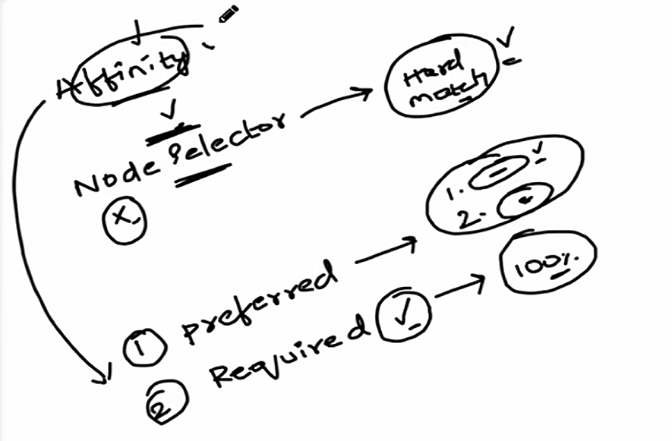

**Types of Node Anti-Affinity**

Similar to node affinity, anti-affinity has two types:

1. **requiredDuringSchedulingIgnoredDuringExecution**:
   * **Strict enforcement**: Pods **will not be scheduled** unless the anti-affinity rule is satisfied.
   * **Example**: "I do not want to run this Pod on a node with zone=us-west-1."
2. **preferredDuringSchedulingIgnoredDuringExecution**:
   * The scheduler will try to find a node that meets the anti-affinity rules, but if it cannot find one, the pod will still be scheduled on a node that does not meet the rules.
   * **Example**: "I prefer not to run this Pod on nodes in the us-west-1 zone, but it's not strictly required."

**Node Anti-Affinity Example:**

This example shows how to use **node anti-affinity** to avoid scheduling Pods on nodes with specific labels.

**Example: Node Anti-Affinity to Avoid Certain Nodes**

apiVersion: v1

kind: Pod

metadata:

  name: my-pod

spec:

  affinity:

    nodeAffinity:

      requiredDuringSchedulingIgnoredDuringExecution:

        nodeSelectorTerms:

          - matchExpressions:

              - key: "zone"

                operator: NotIn

                values:

                  - us-west-1

  containers:

    - name: my-container

      image: nginx

**Explanation:**

* **operator: NotIn**: Specifies that the zone label on the node should **not** be one of the listed values.
* **values: ["us-west-1"]**: The Pod should **not** be scheduled on nodes labeled zone=us-west-1.

This configuration ensures that the Pod **won’t** be scheduled on any nodes in the "us-west-1" zone.

**Key Operators**

| **Operator** | **Description** |
| --- | --- |
| **In** | Label value is in the specified list. |
| **NotIn** | Label value is **not** in the list. |
| **Exists** | Label key exists (values ignored). |
| **DoesNotExist** | Label key **does not** exist. |

**Troubleshooting**

| **Issue** | **Solution** |
| --- | --- |
| **Pod Stuck in Pending** | Check affinity rules and Node labels. |
| **Unexpected Scheduling** | Verify weight in soft rules. |

**⚙️ Other Functionalities of Node Affinity and Anti-Affinity**

**Advanced Matching**

* **matchExpressions**: You can combine multiple conditions to refine scheduling decisions.
  + **Example**: "Pod must be scheduled on a node labeled with zone=us-west-1 and environment=production."
* **matchFields**: You can use **field selectors** to match other attributes, like node name or status.
  + **Example**: "Pod should only be scheduled on nodes with status=Ready."

**Combining Affinity with Taints and Tolerations**

* You can combine **Node Affinity** with **taints and tolerations** for even more fine-grained control over Pod scheduling.

1. **Pod Affinity and Anti-Affinity**

* **Pod Affinity** and **Pod Anti-Affinity** are advanced scheduling rules that control **how Pods are placed relative to other Pods** in the cluster.

They help optimize:

* **High Availability** (spread Pods across zones/nodes)
* **Co-location** (group related Pods together)
* **Workload Isolation** (prevent Pods from sharing nodes)

**✅ Pod Affinity:**

* **Pod Affinity** rules ensure that a **pod is scheduled on the same node** (or in the same zone) as other specified pods, based on labels.

🔹 **Use Case**:

* Used for applications that benefit from **low latency** or **better communication** (e.g., microservices that frequently interact).
* Ensuring Pods that share data are on the same node or zone.

**🔧 YAML Examples**

**✅ Pod Affinity Example: Place Pods together**

This Pod wants to run on a node **where another Pod with label app=nginx** is already running.

apiVersion: v1

kind: Pod

metadata:

  name: web-app

spec:

  affinity:

    podAffinity:

      requiredDuringSchedulingIgnoredDuringExecution:

        - labelSelector:

            matchExpressions:

              - key: app

                operator: In

                values:

                  - nginx

          topologyKey: "kubernetes.io/hostname"

  containers:

    - name: web

      image: nginx

📝 **Explanation**:

* podAffinity: Means "I want to be close to..."
* requiredDuringSchedulingIgnoredDuringExecution: A **hard rule** for scheduling.
* topologyKey: kubernetes.io/hostname: Means Pods should be on the **same node**.

**❌ Pod Anti-Affinity:**

* **Pod Anti-Affinity** rules **prevent** pods from being scheduled **on the same node (or zone)** as other specified pods, based on labels.
* This is useful for **high availability** or to reduce resource contention.

🔹 **Use Case**:

* Improved **High availability** and **redundancy** (spread replicas across nodes).
* Avoiding resource contention.

**❌ Pod Anti-Affinity Example: Place Pods apart**

This Pod should **not** run on the same node as another Pod with app=nginx.

apiVersion: v1

kind: Pod

metadata:

  name: web-app

spec:

  affinity:

    podAntiAffinity:

      requiredDuringSchedulingIgnoredDuringExecution:

        - labelSelector:

            matchExpressions:

              - key: app

                operator: In

                values:

                  - nginx

          topologyKey: "kubernetes.io/hostname"

  containers:

    - name: web

      image: nginx

📝 **Explanation**:

* podAntiAffinity: Means "I want to stay away from..."
* Keeps high-availability workloads separated across nodes.

You can use one or both in a Pod spec depending on how strict you want the rule to be.

**🔑 Key Concepts**

* **topologyKey**: Defines the domain over which the rule applies (e.g., node, zone).
  + Common values: kubernetes.io/hostname, topology.kubernetes.io/zone
* **requiredDuringSchedulingIgnoredDuringExecution**:
  + **Hard rule**: Pod won't be scheduled if the condition isn't met.
* **preferredDuringSchedulingIgnoredDuringExecution**:
  + **Soft rule**: Scheduler tries to meet it, but may ignore if necessary.

**Troubleshooting**

| **Issue** | **Solution** |
| --- | --- |
| **Pod stuck in Pending** | Check affinity conflicts with kubectl describe pod. |
| **Unexpected co-location** | Verify topologyKey and label selectors. |
| **High churn during scaling** | Prefer preferredDuringScheduling over hard rules. |

1. **Taints and Tolerations**

* **Taints and Tolerations** work together to ensure that Pods are only scheduled onto appropriate nodes. They prevent Pods from being scheduled on certain nodes unless the Pods explicitly tolerate the taint. They are essentially the inverse of affinity rules.

They work together but serve opposite roles:

* **Taints** are applied to **Nodes** to prevent (repel) Pods.
* **Tolerations** are applied to **Pods** to allow them to ignore taints.

**✅ Taints:**

* A **taint** is applied to a **Node** and **prevents** **Pods** from being scheduled on it unless those Pods have a matching toleration.
* It tells Kubernetes:

“**Don’t schedule any Pod here** unless it can tolerate this taint.”

**Use Case**:

* Prevent regular workloads from running on specialized nodes (e.g., GPU nodes, storage-heavy nodes).

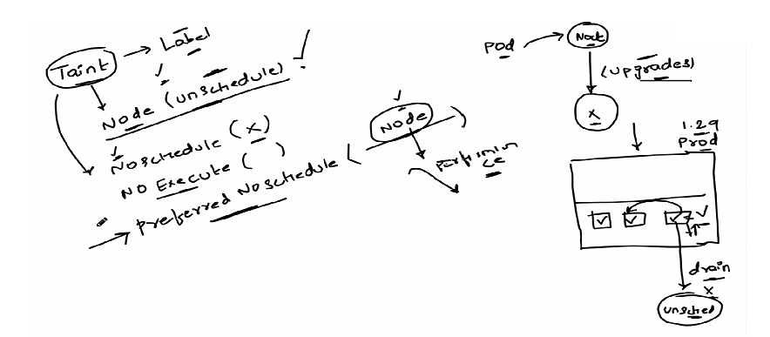

**Taint Components**

Each taint has three parts:

1. **Key** (e.g., gpu)
2. **Value** (e.g., true)
3. **Effect**:
   * **NoSchedule** → Pods without matching toleration **won’t be scheduled**.
   * **PreferNoSchedule** → Kubernetes tries to avoid scheduling but not strictly required.
   * **NoExecute** → Don’t schedule and **Evicts existing Pods** without matching toleration

**✅ Tolerations:**

* **Tolerations** are applied to Pods to allow them to be scheduled on Nodes with matching taints.
* It tells Kubernetes:

“This Pod is **okay to run on** a node with this specific taint.”

So, taints repel Pods, and tolerations let Pods tolerate (i.e., ignore) that taint.

* A **toleration** is added to a Pod to let it **bypass a Node’s taint**.

**Use Case**:

* Allow certain workloads, like system-critical services, to run on specific nodes despite taints.

**Toleration Components**

Tolerations match taints using:

* **key, value, and operator (Equal or Exists).**

**🔑 Key Features**

|  |  |
| --- | --- |
| **Feature** | **Description** |
| 🚫 Prevent unwanted scheduling | Taints can block certain Pods from running on sensitive or special nodes. |
| ✅ Allow only specific Pods | Only Pods with matching tolerations can run on tainted nodes. |
| 🎯 Node-level control | Taints are applied per node. |

**🧾 Example:**

**Add a taint to a node**

kubectl taint nodes node1 key=value:NoSchedule

This means: “Do not schedule any Pod on node1 unless it tolerates this taint.”

**Example YAML + Commands**

**🧱 Step 1: Add a taint to a node**

* kubectl taint nodes <node-name> key=value:NoSchedule

📝 Example:

* kubectl taint nodes worker1 env=prod:NoSchedule

This tells Kubernetes: ❌ “Don’t schedule Pods here unless they tolerate env=prod.”

**📦 Step 2: Pod with a matching toleration**

apiVersion: v1

kind: Pod

metadata:

  name: my-prod-pod

spec:

  tolerations:

    - key: "env"

      operator: "Equal"

      value: "prod"

      effect: "NoSchedule"

  containers:

    - name: nginx

      image: nginx

✅ This Pod says: “I tolerate the env=prod taint, so it's okay to schedule me there.”

**🧾 More Examples**

**⛔ NoExecute Taint Example**

* kubectl taint nodes worker2 key=value:NoExecute

Pods **without toleration** are evicted immediately.

**Toleration with Duration**

tolerations:

  - key: "key"

    operator: "Equal"

    value: "value"

    effect: "NoExecute"

    tolerationSeconds: 60

⏱ This Pod will be evicted **after 60 seconds** if the taint is added.

**Troubleshooting**

| **Issue** | **Solution** |
| --- | --- |
| **Pod stuck in Pending** | Check kubectl describe pod for taint conflicts. |
| **Unexpected evictions** | Verify NoExecute taints on nodes. |

**📌 Use Cases**

* **Dedicated nodes** for specific workloads (e.g., GPU, high-memory).
* **Node isolation** for security or compliance.
* **Graceful eviction** of Pods during maintenance.
* **Node Maintenance:** Drain nodes without deleting Pods**.**
* **Spot Instance Handling:** Prevent critical Pods from running on spot nodes**.**

**📘 Summary Table**

|  |  |
| --- | --- |
| **Component** | **Description** |
| **Taint** | Applied to a node to reject unwanted Pods |
| **Toleration** | Applied to a Pod to allow it to run on tainted nodes |
| **Effect Types** | NoSchedule, PreferNoSchedule, NoExecute |
| **Use Cases** | Node isolation, special workloads, critical systems |
| **Commands** | kubectl taint nodes for tainting, tolerations go in Pod YAML |

**💡 Pro Tips**

* You can **remove a taint** using this command:  
  kubectl taint nodes <node-name> env=prod:NoSchedule-
* Taints and tolerations don’t **guarantee** Pod placement — they just **allow** or **prevent** it.
* Combine with **nodeSelector** or **nodeAffinity** for stricter control.

1. **Network Policies**

* **Network Policies** are Kubernetes are used to control **traffic flow between Pods** and **external client**
* It helps **secure communication** inside the cluster by restricting or allowing connections based on labels, namespaces, and IP blocks.
* They act like **firewall rules** for Pods, allowing you to define **which Pods can communicate with each other** and with external endpoints.

🧠 In simple words:  
 It’s like a **firewall for Pods** — it allows or deny traffic **based on labels, ports, and namespaces**.

By default, **all Pods can communicate** with each other. Network Policies let you **lock that down**.

**✅ Purpose**

* Improve **security** by restricting unwanted traffic.
* Enforce **least privilege** networking.
* Control **ingress** (incoming) and **egress** (outgoing) traffic.

**📌 Key Concepts**

|  |  |
| --- | --- |
| **Term** | **Description** |
| podSelector | Selects which Pods the policy applies to. |
| ingress | Rules for incoming traffic to Pods. |
| egress | Rules for outgoing traffic from Pods. |
| policyTypes | Specifies whether the policy applies to ingress, egress, or both. |

**How Network Policies Work**

1. **Pods are labeled** to identify their traffic rules.
2. **Network Policies define allowed or restricted communication** between labeled pods.
3. **Only pods matching the policy can send or receive traffic**, ensuring controlled access.

**Key Features of Network Policies**

1. **Pod-to-Pod Traffic Control** – Define which pods can communicate with each other.
2. **Namespace-Level Isolation** – Restrict traffic between namespaces for better security.
3. **Ingress and Egress Rules** – Control incoming and outgoing network traffic.
4. **Label-Based Rules** – Apply policies dynamically using pod labels.
5. **Works with CNI Plugins** – Requires a networking provider that supports policies (e.g., Calico, Cilium, Weave).

**🔀 Types of Network Policies**

|  |  |
| --- | --- |
| **Type** | **Description** |
| **Ingress** | Controls incoming traffic to a Pod |
| **Egress** | Controls outgoing traffic from a Pod |
| **Both** | You can define both at once |

**📄 Example YAMLs**

**✅ a. Allow traffic from specific Pods (Ingress)**

apiVersion: networking.k8s.io/v1

kind: NetworkPolicy

metadata:

  name: allow-from-frontend

spec:

  podSelector:

    matchLabels:

      app: my-backend

  ingress:

    - from:

        - podSelector:

            matchLabels:

              role: frontend

🔐 Only Pods with label role: frontend can access Pods labeled app: my-backend.

**✅ b. Allow traffic only from a specific Namespace**

apiVersion: networking.k8s.io/v1

kind: NetworkPolicy

metadata:

  name: allow-from-namespace

spec:

  podSelector:

    matchLabels:

      app: secure-api

  ingress:

    - from:

        - namespaceSelector:

            matchLabels:

              team: dev

🔐 Only Pods from the namespace with label team: dev can access the secure-api Pods.

**✅ c. Allow outgoing traffic only to a specific IP (Egress)**

apiVersion: networking.k8s.io/v1

kind: NetworkPolicy

metadata:

  name: restrict-egress

spec:

  podSelector:

    matchLabels:

      app: myapp

  egress:

    - to:

        - ipBlock:

            cidr: 10.0.0.0/24

🔐 myapp Pods can only send traffic to IPs in 10.0.0.0/24.

**Troubleshooting**

| **Issue** | **Debugging Command** |
| --- | --- |
| **Policy not enforced** | kubectl describe networkpolicy <name> |
| **Unexpected blocked traffic** | Check CNI plugin logs (e.g., Calico logs). |
| **DNS failures** | Ensure egress to CoreDNS Pods (kube-system namespace). |

**🚨 Important Notes**

* **By default, all traffic is allowed**. Once you apply a Network Policy to a Pod, **only allowed traffic is permitted**.
* **You must label your Pods properly** for policies to work.
* **Test carefully**! It’s easy to accidentally block traffic you need.

1. **Kustomize**

* **Kustomize** is a tool built into kubectl that helps customize Kubernetes YAML files for different environments (like dev, staging, and prod) without duplicating the files
* It helps to reuse, override, and patch YAML files in a clean, structured way — like templates, but **without using Helm or templating engines**.
* It's great for managing different environments like **dev, staging, and prod** using the same base YAML files.

**How Kustomize Works**

* **Base**: Original YAML files (common across environments. e.g., Deployment, Service).
* **Overlay**: Environment-specific customizations (patches, replacements. e.g, dev, pods)
* **Generates final YAML (kustomization.yaml)** by merging bases + overlays.

**No Templating!**

Unlike Helm, Kustomize **doesn’t use templates** ({{ .Values }}). Instead, it:

* **Patches** existing YAML (JSON Merge Patch, Strategic Merge Patch).
* **Modifies fields** (e.g., replicas, labels, env vars).

**✅ Key Features**

* No need for templating languages (like Helm).
* Layered configuration using **overlays**.
* Supports **patching**, **variable substitution**, and **resource composition**.
* Built into kubectl (kubectl apply -k).
* **Generators**: Auto-generate ConfigMaps and Secrets

**📁 Folder Structure and YAML Examples**

Let’s say you want different configs for dev and prod using a single base.

**📂 File Structure:**

my-app/

├── base/

│   ├── deployment.yaml

│   ├── service.yaml

│   └── kustomization.yaml

├── overlays/

    ├── dev/

    │   ├── kustomization.yaml

    │   └── patch.yaml

    └── prod/

        ├── kustomization.yaml

        └── patch.yaml

**📦 Base Deployment (base/deployment.yaml)**

apiVersion: apps/v1

kind: Deployment

metadata:

  name: my-app

spec:

  replicas: 2

  template:

    metadata:

      labels:

        app: my-app

    spec:

      containers:

        - name: my-container

          image: my-app:latest

**📄 Base Kustomization (base/kustomization.yaml)**

resources:

  - deployment.yaml

  - service.yaml

**🧪 Dev Overlay (overlays/dev/kustomization.yaml)**

resources:

  - ../../base

patchesStrategicMerge:

  - patch.yaml

**🧪 Dev Patch (overlays/dev/patch.yaml)**

apiVersion: apps/v1

kind: Deployment

metadata:

  name: my-app

spec:

  replicas: 1

  template:

    spec:

      containers:

        - name: my-container

          image: my-app:dev

**🧾 Example Patch**

apiVersion: apps/v1

kind: Deployment

metadata:

  name: my-app

spec:

  replicas: 2

This patch overrides the number of replicas in the base deployment.

**🏗️ Apply Dev Config with Kustomize**

* kubectl apply -k overlays/dev

**Troubleshooting**

| **Issue** | **Solution** |
| --- | --- |
| **Patch not applied** | Verify kustomization.yaml references the patch file. |
| **Name collisions** | Use namePrefix or nameSuffix. |

**🧩 Extra Functionalities**

|  |  |
| --- | --- |
| **Feature** | **Description** |
| images: | Override container images |
| namePrefix: | Add prefixes to resource names (like dev-) |
| namespace: | Set all resources to a specific namespace |
| commonLabels: | Add labels to all resources |
| configMapGenerator / secretGenerator | Auto-create ConfigMaps and Secrets from files or literals |

**Example:**

namespace: dev

namePrefix: dev-

commonLabels:

  env: dev

**Kustomize vs. Helm**

| **Feature** | **Kustomize** | **Helm** |
| --- | --- | --- |
| **Approach** | Declarative patching | Templating ({{ .Values }}) |
| **Learning Curve** | Low (YAML-only) | Medium (Go templates) |
| **Secrets Management** | Built-in (secretGenerator) | Requires external tools |
| **Community Plugins** | Limited | Extensive (charts) |

**🧪 Bonus: Common Commands**

kubectl kustomize .                 # See the output YAML

kubectl apply -k overlays/dev       # Apply dev config

kubectl apply -k overlays/prod      # Apply prod config

1. **Logs**

**🔎 Fluentd**

* **Fluentd** is an **open-source log processor**. In Kubernetes, it's commonly used to **collect, filter, transform, and forward logs** from all Pods and nodes to a log storage system like **Elasticsearch, Splunk, or Cloud Logging**.

🧠 Think of Fluentd as a **log router**. It reads logs from the system, changes them if needed, and sends them where you want.

**📄 How Fluentd Works in Kubernetes**

* Logs are written to /var/log/containers on each node.
* **Fluentd (as a DaemonSet)** reads those logs.
* It then filters and formats the logs.
* Sends logs to **a central location** (like Elasticsearch or a cloud logging service).

**📁 Example YAML (Fluentd as DaemonSet)**

apiVersion: apps/v1

kind: DaemonSet

metadata:

  name: fluentd

  namespace: kube-system

spec:

  selector:

    matchLabels:

      name: fluentd

  template:

    metadata:

      labels:

        name: fluentd

    spec:

      containers:

      - name: fluentd

        image: fluent/fluentd:v1.14-1

        env:

        - name: FLUENTD_ARGS

          value: "--no-supervisor -q"

        volumeMounts:

        - name: varlog

          mountPath: /var/log

        - name: varlibdockercontainers

          mountPath: /var/lib/docker/containers

          readOnly: true

      volumes:

      - name: varlog

        hostPath:

          path: /var/log

      - name: varlibdockercontainers

        hostPath:

          path: /var/lib/docker/containers

📝 This sets up Fluentd on **every node**, pulling logs from Docker containers and system logs.

**📌 Fluentd Config Example (fluent.conf)**

conf

<source>

  @type tail

  path /var/log/containers/*.log

  format json

  tag kube.*

</source>

<match kube.**>

  @type elasticsearch

  host elasticsearch.logging.svc.cluster.local

  port 9200

  logstash_format true

</match>

🔄 This config reads logs from containers and forwards them to **Elasticsearch**.

**🔗 Types / Plugins**

Fluentd doesn't have "types" like Services do, but it has **input, filter, and output plugins**.

|  |  |  |
| --- | --- | --- |
| **Plugin Type** | **Example** | **Purpose** |
| **Input** | tail, http, syslog | Collect logs |
| **Filter** | record_transformer, grep | Modify logs |
| **Output** | elasticsearch, s3, gcs | Send logs somewhere |

**🔚 Summary**

|  |  |
| --- | --- |
| **Item** | **Info** |
| Tool | Fluentd |
| Purpose | Log aggregation, transformation, and forwarding |
| Runs As | DaemonSet |
| Used With | Elasticsearch, Splunk, Cloud Logging |
| Config File | fluent.conf |
| Key Use Case | Centralized and enriched logging for Kubernetes clusters |

**Scaling in Kubernetes**

**Kubernetes supports two types of scaling:**

**1. Horizontal Pod Autoscaling (HPA):** Dynamically adjusts the number of pod replicas for a deployment or replica set. It monitors metrics like CPU, memory, or custom application metrics.Adds or removes pod replicas based on thresholds.

**2. Node Scaling:** Adding or removing nodes to/from the cluster. Managed manually or automatically using tools like Cluster Autoscaler. Cluster Autoscaler integrates with cloud providers to add remove virtual machines dynamically.

**Managing Workloads in Kubernetes**

**Workloads:** Workloads are the applications or services running on Kubernetes. It is defined in Kubernetes using manifests (YAML or JSON files).

**Types of Workloads:**

**Deployments:** For stateless applications; supports scaling and updates.

**StatefulSets:** For stateful applications that require unique identities and stable storage (e.g., databases).

**DaemonSets:** Ensures a copy of a pod runs on every node (e.g., log collectors).

**Jobs and CronJobs:** For running one-time or scheduled tasks.

**Other Features:**

**Load Balancing:** Kubernetes ensures workloads are balanced across the cluster using Services and Ingress.

**Monitoring and Logging:** Tools like Prometheus, Grafana, and ELK Stack (Elasticsearch, Logstash, Kibana) help monitor workloads and log activities.

**High Availability and Resilience:** Kubernetes automatically restarts failed pods and reschedules them to healthy nodes.

**SECURE KUBERNETES**

1. Secure API server

2. RBAC

3. Network policies

4. Encrypted at rest (ETCD)

5. Secure Container Images

6. Cluster monitoring

7. upgrades.

**🔐 Encryption at Rest**

* Secrets are stored base64 encoded by default.
* For better security, enable encryption at rest in your cluster using KMS or a custom encryption provider.

Networking:

* Networking plugins and configuration options also facilitate pod-to-pod communication and network isolation

**What is AWS RDS?**

**AWS RDS (Relational Database Service)** is a fully managed relational database service that simplifies database management tasks like provisioning, patching, backups, scaling and failover. It supports popular database engines:

* MySQL
* PostgreSQL
* MariaDB
* Oracle
* Microsoft SQL Server

**Key Features:**

* Automated backups & patching
* Storage and compute scaling
* High availability with Multi-AZ
* Read replicas for scaling
* Automatic failover
* Secure and VPC-integrated networking

**How to Use AWS RDS with Kubernetes**

AWS RDS runs outside the Kubernetes cluster. Application pods in Kubernetes access it over the network, using securely stored credentials.

**High-Level Steps for Production Integration:**

1. **Create an RDS Instance**
2. **Store Credentials Securely in Kubernetes Secrets**
3. **Deploy Application to Kubernetes with RDS Access**
4. **Secure Communication with Proper VPC and Security Groups**
5. **Monitor and Scale the RDS Instance**
6. **Expose Application via Kubernetes Service**

**Step 1: Create an AWS RDS Instance**

Use the AWS Management Console or AWS CLI to create an RDS instance.

**Example (PostgreSQL via CLI):**

aws rds create-db-instance \

--db-instance-identifier myprod-db \

--db-instance-class db.m5.large \

--engine postgres \

--allocated-storage 100 \

--master-username adminuser \

--master-user-password adminpassword \

--backup-retention-period 7 \

--multi-az \

--vpc-security-group-ids sg-0123456789abcdef0

**Step 2: Configure Secrets in Kubernetes**

Store database credentials securely:

kubectl create secret generic mydb-credentials \

--from-literal=DB_USER=adminuser \

--from-literal=DB_PASSWORD=adminpassword \

--from-literal=DB_HOST=myprod-db.c1h1h3d22dkk.us-east-1.rds.amazonaws.com \

--from-literal=DB_PORT=5432 \

--from-literal=DB_NAME=mydatabase

**Step 3: Deploy an Application that Connects to RDS**

Define your app deployment to connect to RDS:

Deployment Example (Node.js-based App):

apiVersion: apps/v1

kind: Deployment

metadata:

  name: webapp-deployment

spec:

  replicas: 3

  selector:

    matchLabels:

      app: webapp

  template:

    metadata:

      labels:

        app: webapp

    spec:

      containers:

      - name: webapp

        image: myapp-image:latest

        env:

        - name: DB_USER

          valueFrom:

            secretKeyRef:

              name: mydb-credentials

              key: DB_USER

        - name: DB_PASSWORD

          valueFrom:

            secretKeyRef:

              name: mydb-credentials

              key: DB_PASSWORD

        - name: DB_HOST

          valueFrom:

            secretKeyRef:

              name: mydb-credentials

              key: DB_HOST

        - name: DB_PORT

          valueFrom:

            secretKeyRef:

              name: mydb-credentials

              key: DB_PORT

        - name: DB_NAME

          valueFrom:

            secretKeyRef:

              name: mydb-credentials

              key: DB_NAME

        ports:

        - containerPort: 80

**Step 4: Secure Communication** **between Kubernetes and RDS**

Ensure secure access between RDS and Kubernetes:

* Use the **same VPC** or set up **VPC peering**.
* Configure **RDS** **Security Groups** to allow access from Kubernetes worker nodes on the DB port (e.g., 5432 for PostgreSQL).

**Example security group rule:**

aws ec2 authorize-security-group-ingress \

--group-id sg-0123456789abcdef0 \

--protocol tcp --port 5432 \

--source-group sg-0987654321abcdef0

**Step 5: Monitor and Scale RDS**

* **CloudWatch** for metrics
* **Performance Insights** for diagnostics
* **Enhanced Monitoring** for real-time stats
* Use modify-db-instance to scale:

aws rds modify-db-instance \

--db-instance-identifier myprod-db \

--db-instance-class db.m5.2xlarge \

--apply-immediately

**Step 6: Expose the Application**

Use a LoadBalancer service to make the app accessible externally:

apiVersion: v1

kind: Service

metadata:

  name: webapp-service

spec:

  selector:

    app: webapp

  ports:

    - protocol: TCP

      port: 80

      targetPort: 80

  type: LoadBalancer

**Example Application Connection Code (Node.js)**

**javascript**

const mysql = require('mysql');

const connection = mysql.createConnection({

host: process.env.DB_HOST,

user: process.env.DB_USER,

password: process.env.DB_PASSWORD,

database: process.env.DB_NAME

});

connection.connect(err => {

if (err) {

console.error('Connection error:', err.stack);

return;

}

console.log('Connected as id', connection.threadId);

});

**Summary**

**Benefits of Using AWS RDS with Kubernetes**:

* Offloads database management tasks
* Enhances scalability and availability
* Simplifies Kubernetes deployments
* Ensures production readiness with monitoring, backups, and HA

**How to set up SSO for application inside the kubernetes pods and with examples**

To set up **Single Sign-On (SSO)** for an application running inside Kubernetes pods, you need to integrate an **Identity Provider (IdP)** that supports **OAuth2** or **OIDC (OpenID Connect)**. In this example, I will show you how to integrate **OIDC** for SSO using **AWS Cognito** as the IdP, which is one of the popular choices for managing authentication and user access.

The general approach will involve:

1. Configuring **AWS Cognito** as the **IdP**.

2. Setting up the **application** to use **OIDC** for authentication.

3. Deploying the application in a **Kubernetes cluster**.

4. Setting up appropriate configurations in the application to handle authentication through Cognito.

**Steps to Set Up SSO for Application Inside Kubernetes Pods**

**Prerequisites**

1. **AWS Cognito** set up as the IdP for managing users.

2. Kubernetes cluster running with **Ingress** configured for external access to the app.

3. A sample application running in Kubernetes (e.g., a web application like **Node.js**, **Spring Boot**, **Express.js**).

4. OAuth2 or OpenID Connect integration in your application.

**Step 1: Configure AWS Cognito for Authentication**

1. **Create a Cognito User Pool**:

- Go to the **Cognito Console** in AWS and create a **User Pool** for your application.

- Configure attributes like **email**, **username**, **password policies**, etc.

2. **Create an App Client**:

- Inside the **User Pool**, go to **App clients** and create a new **App Client**.

- Ensure that **OAuth 2.0** flows like **Authorization Code Grant** are enabled.

- Note down the **App Client ID** and **App Client Secret** (for use in your application).

3. **Configure Cognito App Client Settings**:

- Set the **Callback URL** (where Cognito will redirect the user after login, e.g., `http://your-app/callback`).

- Set the **Sign-out URL** (where users will be redirected after signing out).

- Enable **OAuth 2.0** scopes: `openid`, `email`, `profile`.

4. **Configure Domain**:

- Set up a **Domain** for your Cognito instance so it can provide the login page (e.g., `https://<your-cognito-domain>.auth.us-west-2.amazoncognito.com`).

5. **Enable the OIDC Settings**:

- You’ll need the **Issuer URL** for the OIDC configuration, which will look something like:

```

https://cognito-idp.us-west-2.amazonaws.com/us-west-2_XXXXXXXXX

```

- This URL will be used to integrate the authentication mechanism into your app.

**Step 2: Integrating OIDC into Your Application**

Let's assume you are using a **Node.js** application, but the general process applies to other frameworks (e.g., **Spring Boot**, **Express**, **Flask**).

1. **Install OIDC Authentication Library**:

Use libraries like **passport.js** for Node.js to handle OAuth2 or OIDC authentication.

For Node.js with **passport.js**:

npm install passport passport-oidc express-session

2. **Configure OIDC Authentication**:

In your **Node.js** application, configure **passport-oidc** to authenticate users using AWS Cognito.

**Example of `server.js` with OIDC authentication:**

```javascript

const express = require('express');

const passport = require('passport');

const session = require('express-session');

const OIDCStrategy = require('passport-oidc').Strategy;

const app = express();

passport.use(

new OIDCStrategy(

{

issuer: 'https://cognito-idp.us-west-2.amazonaws.com/us-west-2_XXXXXXXXX',

authorizationURL: 'https://<your-cognito-domain>.auth.us-west-2.amazoncognito.com/oauth2/authorize',

tokenURL: 'https://<your-cognito-domain>.auth.us-west-2.amazoncognito.com/oauth2/token',

clientID: '<your-app-client-id>',

clientSecret: '<your-app-client-secret>',

callbackURL: 'http://localhost:3000/callback',

},

function (issuer, profile, done) {

return done(null, profile);

}

)

);

app.use(session({ secret: 'secret', resave: true, saveUninitialized: true }));

app.use(passport.initialize());

app.use(passport.session());

app.get('/login', (req, res) => {

passport.authenticate('oidc')(req, res);

});

app.get('/callback', (req, res) => {

passport.authenticate('oidc', { failureRedirect: '/' })(req, res, function () {

res.redirect('/');

});

});

app.get('/', (req, res) => {

if (req.isAuthenticated()) {

res.send(`Hello, ${req.user.displayName}!`);

} else {

res.send('Hello, guest! Please <a href="/login">login</a>');

}

});

app.listen(3000, () => {

console.log('App is listening on port 3000');

});

3. **Start the Application Locally** (for testing):

Run the app locally first to verify that the authentication flow works before deploying to Kubernetes.

node server.js

Visit `http://localhost:3000` and test the SSO login flow with AWS Cognito.

**Step 3: Deploy the Application in Kubernetes**

**1. **Containerize the Application**:**

Create a `Dockerfile` for your application.

**Example `Dockerfile` for a Node.js app:**

**dockerfile**

FROM node:16

WORKDIR /app

COPY package.json package-lock.json ./

RUN npm install

COPY . .

EXPOSE 3000

CMD ["node", "server.js"]

Build and push the image to a container registry (e.g., DockerHub, AWS ECR).

docker build -t my-app .

docker tag my-app:latest <your-dockerhub-username>/my-app:latest

docker push <your-dockerhub-username>/my-app:latest

**2. **Create Kubernetes Deployment YAML**:**

Define your Kubernetes deployment (`deployment.yaml`).

**Example:**

apiVersion: apps/v1

kind: Deployment

metadata:

name: my-app

spec:

replicas: 1

selector:

matchLabels:

app: my-app

template:

metadata:

labels:

app: my-app

spec:

containers:

- name: my-app

image: <your-dockerhub-username>/my-app:latest

ports:

- containerPort: 3000

env:

- name: CLIENT_ID

valueFrom:

secretKeyRef:

name: cognito-credentials

key: client-id

- name: CLIENT_SECRET

valueFrom:

secretKeyRef:

name: cognito-credentials

key: client-secret

```

**3. **Create Kubernetes Service and Ingress (optional)**:**

Expose your app using a **Service** and optionally an **Ingress**.

**Example `service.yaml`:**

apiVersion: v1

kind: Service

metadata:

name: my-app-service

spec:

selector:

app: my-app

ports:

- protocol: TCP

port: 80

targetPort: 3000

```

**Example `ingress.yaml` for exposing the service via Ingress:**

apiVersion: networking.k8s.io/v1

kind: Ingress

metadata:

name: my-app-ingress

spec:

rules:

- host: my-app.example.com

http:

paths:

- path: /

pathType: Prefix

backend:

service:

name: my-app-service

port:

number: 80

```

**4. **Deploy to Kubernetes**:**

Apply the Kubernetes resources (`deployment.yaml`, `service.yaml`, `ingress.yaml`) to deploy the app:

kubectl apply -f deployment.yaml

kubectl apply -f service.yaml

kubectl apply -f ingress.yaml

**Step 4: Verify the SSO Flow in Kubernetes**

1. **Access the application** via the Ingress URL or external IP (e.g., `http://my-app.example.com`).

2. **Test the login flow** by accessing the login page, which should redirect to AWS Cognito for authentication.

3. After successful login, Cognito will redirect back to the callback URL (`/callback`), and your application should be authenticated.

**Step 5: Manage Secrets for Sensitive Information**

For sensitive information like the **Client ID** and **Client Secret**, store them in **Kubernetes Secrets** instead of hardcoding them in the app code. Here’s how to create a

**Kubernetes Secret:**

apiVersion: v1

kind: Secret

metadata:

name: cognito-credentials

type: Opaque

data:

client-id: <base64-encoded-client-id>

client-secret: <base64-encoded-client-secret>

**Apply the Secret:**

kubectl apply -f secret.yaml

**Conclusion**

Setting up **SSO** for an application inside Kubernetes involves configuring an **Identity Provider** (e.g., AWS Cognito) and integrating your application to authenticate via **OIDC** or **OAuth2**. Once integrated, deploy the app inside Kubernetes and configure **Ingress** or **Service** for external access. Ensure **Kubernetes Secrets** are used for managing sensitive credentials securely. This will enable **SSO** authentication for your users in the application running in Kubernetes.

**AWS**

**AWS IAM**

* **AWS IAM (Identity and Access Management)** is a web service helps to control access to AWS resources securely. It enables management of users, security credentials, and permissions that that determine which AWS resources users and applications can access.
* **IAM** allows you to create and manage users, groups, and roles.

Core IAM Components

1. Users

* **Users**: IAM users represent individual people or entities (such as applications or services) that interact with AWS resources.
* Each user has a **unique name and security credentials** (password or access keys) used for authentication and access control.

2. Groups

* **Groups** are collections of users that share the same permissions.
* Simplifies permission management (assign permissions to group rather than individual users)

3. Roles

* **Roles:** IAM roles are used to grant temporary access to AWS resources.
* Often used by AWS services or for cross-account access
* Generate temporary security credentials instead of permanent ones
* A Role can be assigned to a federated user who signed in from an external Identity Provider.

4. Policies

* **Policies:** IAM policies are JSON documents that define permissions.
* Policies can be attached to users, groups, or roles to control access.
* Two main types:
  + Identity-based policies (attached to IAM identities users, groups, or roles)
  + Resource-based policies (attached to AWS resources like S3 buckets)

**AMI:**

AMI Stands for Amazon Machine Image.

● AMI decides the OS, installs dependencies, libraries, data of your EC2 instances.

● Multiple instances with the same configuration can be launched using a single AMI.

In AWS (Amazon Web Services), **AMI** stands for **Amazon Machine Image**. It's a template that contains the software configuration (operating system, application server, and applications) required to launch an instance (a virtual server) in the EC2 (Elastic Compute Cloud) environment.

**Key Components of an AMI:**

1. **A root volume**: Typically includes the OS and installed applications.
2. **Launch permissions**: Control which AWS accounts can use the AMI to launch instances.
3. **Block device mapping**: Specifies the volumes to attach to the instance when it's launched.

**Types of AMIs:**

* **Public AMIs**: Provided by AWS or shared by the community.
* **Private AMIs**: Created by users for internal use.
* **AWS Marketplace AMIs**: Provided by third-party vendors, often with pre-installed software.

**Security Group:**

In AWS, a Security Group acts as a virtual firewall for your EC2 instances to control inbound and outbound traffic.

A Security group acts as a virtual firewall for your EC2 Instances.

● It decides the type of port and kind of traffic to allow**.**

● **Security groups** are active at **the instance level** whereas **Network ACLs** are active at the **subnet level.**

● Security Groups can only allow but can’t deny the rules.

● The Security group is considered **stateful**.

● By default, in the outbound rule all traffic is allowed and needs to define the inbound rules.

**Key Pair:**

A key pair, consisting of a private key and a public key, is a set of security credentials that you can use to prove your identity while connecting to an instance.● Amazon EC2 instances use two keys, one is the public key which is attached to your EC2 instance.

● Another is the private key which is with you. You can get access to the EC2 instance only if these keys get matched.

● Keep the private key in a secure place.

**AWS EC2**

**What is AWS EC2?**

**Amazon EC2 (Elastic Compute Cloud)** is a core service in AWS that provides **resizable compute capacity in the cloud**. It allows you to run virtual servers (called **instances**) on-demand, making it ideal for hosting applications, websites, databases, and more.

AWS EC2 (Amazon Elastic Compute Cloud) is a core service within Amazon Web Services (AWS) that provides scalable virtual servers (instances) in the cloud.

**Launching an EC2 Instance**

Steps to launch an EC2 instance:

1. **Choose an AMI** (Amazon Machine Image) – Preconfigured OS templates.
2. **Select Instance Type** (e.g., t3.micro, m5.large).
3. **Configure Network (VPC, Subnet, Security Group)**.
4. **Add Storage (EBS volumes or instance store)**.
5. **Set Tags & Review**.
6. **Launch (Select or create a key pair for SSH access)**.

**Storage Options**

* **EBS (Elastic Block Store)**: Persistent, network-attached storage (SSD/HDD).
* **Instance Store**: Temporary, high-speed local storage (ephemeral).
* **EFS (Elastic File System)**: Shared NFS storage for multiple instances.

**Networking & Security**

* **VPC (Virtual Private Cloud)**: Isolated network for your instances.
* **Security Groups**: Virtual firewalls controlling inbound/outbound traffic.
* **Key Pairs**: SSH key authentication for Linux/Windows instances.
* **IAM Roles**: Assign permissions to instances without storing credentials.

**Auto Scaling & Load Balancing**

* **Auto Scaling**: Automatically adjust the number of instances based on demand.
* **ELB (Elastic Load Balancing)**: Distribute traffic across instances.

**Instance Store:**

* Instance store is the ephemeral block-level storage for the EC2 instance
* Instance stores can be used for faster processing and temporary storage of the application.

**AWS EBS (Elastic Block Store) Volumes**

Amazon **EBS (Elastic Block Store)** provides persistent block storage volumes for use with **EC2 instances**. Unlike instance store (ephemeral) storage, EBS volumes persist independently of the instance lifecycle, making them ideal for databases, file systems, and applications requiring durable storage.

It is the block-level storage that is assigned to your single EC2 Instance.

**Amazon EBS (Elastic Block Store)** is a scalable, high-performance block storage service designed for use with **Amazon EC2** instances. It provides persistent storage that remains available even after the instance is stopped or terminated.

**2. EBS Volume Types**

AWS offers several EBS volume types optimized for different workloads:

| **Volume Type** | **Description** | **Use Case** | **Max IOPS/Throughput** |
| --- | --- | --- | --- |
| **gp3 (SSD)** | General Purpose SSD (default) | Boot volumes, apps, dev environments | 16,000 IOPS, 1,000 MB/s |
| **io1/io2 (SSD)** | High-performance, low-latency | Databases (RDS, Oracle, SAP) | 64,000 IOPS (io2 Block Express: 256K IOPS) |
| **st1 (HDD)** | Throughput-optimized HDD | Big data, log processing | 500 MB/s |
| **sc1 (HDD)** | Cold HDD (lowest cost) | Infrequently accessed data | * 1. /s |

**3. EBS vs. Instance Store**

| **Feature** | **EBS Volume** | **Instance Store (Ephemeral)** |
| --- | --- | --- |
| **Persistence** | Survives instance termination | Lost on stop/termination |
| **Performance** | Network-attached (varies by type) | Direct-attached (very high speed) |
| **Use Case** | Databases, long-term storage | Temp data, cache, scratch disks |
| **Scalability** | Can resize (with limitations) | Fixed size per instance type |

**4. Key Operations**

**a) Creating & Attaching an EBS Volume**

1. **AWS Console** → **EC2 Dashboard** → **Volumes** → **Create Volume**.
2. Select **type, size, AZ, and encryption**.
3. Attach to an EC2 instance (must be in the same AZ).

**b) Expanding an EBS Volume**

1. **Increase volume size** (via Console/CLI).
2. **Extend the file system** (for Linux: resize2fs or xfs_growfs).

**c) Taking Snapshots**

* Snapshots are **incremental** (only changed blocks are stored).
* Can **copy snapshots across regions** for disaster recovery.
* Used to **create new volumes** or **AMI images**.

**d) Restoring from a Snapshot**

1. Create a new volume from a snapshot.
2. Attach it to an instance.

**5. Performance Optimization**

* **Use Provisioned IOPS (**io1/io2**)** for high-performance databases.
* **RAID 0 (striping)** for higher throughput (combine multiple volumes).
* **EBS-optimized EC2 instances** ensure dedicated bandwidth.
* **Monitor with CloudWatch** (VolumeReadOps, VolumeWriteOps).

**AWS VPC**

**What is AWS VPC?**

Amazon Virtual Private Cloud (VPC) is a service that allows users to create a virtual dedicated network for resources.

**Amazon VPC (Virtual Private Cloud)** is a foundational AWS service that lets you **provision a logically isolated network** within the AWS cloud. It gives you full control over your virtual networking environment, including IP address ranges, subnets, route tables, internet gateways, and more.

**🌐 Key Concepts in VPC:**

| **Component** | **Description** |
| --- | --- |
| **VPC** | **A virtual network dedicated to your AWS account.** |
| **Subnets** | **Segments of a VPC's IP address range. Can be public or private.** |
| **Route Tables** | **Control traffic routing within the VPC.** |
| **Internet Gateway (IGW)** | **Enables internet access for resources in public subnets.** |
| **NAT Gateway** | **Allows instances in private subnets to access the internet securely.** |
| **Security Groups** | **Instance-level firewalls.** |
| **Network ACLs** | **Subnet-level firewalls.** |
| **VPC Peering** | **Connects two VPCs for private communication.** |
| **Endpoints** | **Connect to AWS services privately without using the internet.** |

**Example Architecture:**

* **Public Subnet**: Contains a load balancer and NAT gateway.
* **Private Subnet**: Contains EC2 instances and databases.
* **Route Tables**: Direct traffic to IGW or NAT as needed.
* **Security Groups**: Allow HTTP/HTTPS to the load balancer, and internal traffic to the backend.

**Security Groups:**

Default Security Groups:-

Inbound rule - Allows all inbound traffic

Outbound rule - Allows all outbound traffic

Custom Security Groups:- (by default)

Inbound rule - Allows no inbound traffic

Outbound rule - Allows all outbound traffic

**Network ACLs (access control list):**

**Default Network ACL:-**

Inbound rule - Allows all inbound traffic

Outbound rule - Allows all outbound traffic

Custom Network ACL:- (by default)

Inbound rule - Denies all inbound traffic

Outbound rule - Denies all outbound traffic

**AWS VPC (Virtual Private Cloud) - Complete Guide**

Amazon **VPC (Virtual Private Cloud)** is a logically isolated network within AWS where you can launch AWS resources (EC2, RDS, Lambda, etc.) in a **private, secure, and customizable cloud environment**.

**1. Key Features of AWS VPC**

✅ **Isolated Networking** – Your own virtual network inside AWS.  
✅ **Subnet Segmentation** – Divide your VPC into public/private subnets.  
✅ **Internet Connectivity** – Control inbound/outbound traffic via **Internet Gateways (IGW)** and **NAT Gateways**.  
✅ **Security** – Use **Security Groups** (instance-level firewall) and **Network ACLs** (subnet-level firewall).  
✅ **Hybrid Cloud** – Connect to on-premises data centers via **VPN** or **AWS Direct Connect**.  
✅ **Scalability** – Automatically scales with your AWS resources.

**2. Core Components of a VPC**

**a) VPC & CIDR Block**

* A VPC is defined by an **IPv4/IPv6 CIDR block** (e.g., 10.0.0.0/16).
* **Max size**: /16 (65,536 IPs) to /28 (16 IPs).
* **Private IP ranges** (RFC 1918):
  + 10.0.0.0/8
  + 172.16.0.0/12
  + 192.168.0.0/16

**b) Subnets**

* Subnets are **segments within a VPC** (e.g., 10.0.1.0/24).
* **Public Subnet**: Has a route to the internet (via **Internet Gateway**).
* **Private Subnet**: No direct internet access (uses **NAT Gateway** for outbound traffic).
* **Availability Zones (AZs)**: Subnets must reside in a single AZ.

**c) Route Tables**

* Determine **how traffic is routed** within the VPC.
* Every subnet is associated with a **route table**.
* Example route for a public subnet:

text

Copy

Download

Destination: 0.0.0.0/0 → Target: igw-12345 (Internet Gateway)

**d) Internet Gateway (IGW)**

* Allows **public subnets** to communicate with the internet.
* **1 IGW per VPC**.

**e) NAT Gateway / NAT Instance**

* Allows **private subnets** to access the internet (for updates, downloads) without exposing them.
* **NAT Gateway** (AWS-managed) is preferred over **NAT Instance** (self-managed EC2).

**f) Security Groups (SGs) & Network ACLs (NACLs)**

| **Feature** | **Security Group (SG)** | **Network ACL (NACL)** |
| --- | --- | --- |
| **Scope** | Instance-level | Subnet-level |
| **Stateful?** | Yes (return traffic allowed automatically) | No (stateless, explicit rules needed) |
| **Rule Evaluation** | Allow rules only | Allow + Deny rules |
| **Order of Rules** | All rules evaluated | Evaluated in order (lowest rule # first) |

**g) VPC Peering**

* Connects **two VPCs** (same/different AWS accounts/regions).
* **No transitive peering** (must be direct).
* **CIDR blocks must not overlap**.

**h) VPC Endpoints (PrivateLink)**

* Privately connect to AWS services (S3, DynamoDB) **without internet/NAT**.
* **Types**:
  + **Interface Endpoint** (uses ENI, powered by PrivateLink).
  + **Gateway Endpoint** (only for S3 & DynamoDB).

**i) VPN & Direct Connect**

* **Site-to-Site VPN**: Securely connect on-premises network to AWS via IPsec.
* **AWS Direct Connect**: Dedicated private network connection (lower latency).

**3. Default vs. Custom VPC**

| **Feature** | **Default VPC** | **Custom VPC** |
| --- | --- | --- |
| **CIDR Block** | 172.31.0.0/16 | User-defined |
| **Subnets** | One per AZ | Manually created |
| **Internet Access** | Enabled (public subnets) | Configurable |
| **Deletion** | Can be deleted & restored | Permanent deletion |

**4. Creating a VPC (Step-by-Step)**

1. **Define CIDR Block** (e.g., 10.0.0.0/16).
2. **Create Subnets** (public/private, e.g., 10.0.1.0/24 in us-east-1a).
3. **Set Up Internet Gateway (IGW)** and attach to VPC.
4. **Configure Route Tables** (public route: 0.0.0.0/0 → IGW).
5. **Launch EC2 Instances** in subnets with proper Security Groups.

**5. Best Practices**

✔ **Use multiple AZs** for high availability.  
✔ **Private subnets for databases** (no direct internet access).  
✔ **VPC Flow Logs** to monitor traffic.  
✔ **Avoid overlapping CIDR blocks** in peering.  
✔ **Use Security Groups for granular access control**.

**6. Use Cases**

* **Multi-tier applications** (web, app, DB layers).
* **Hybrid cloud** (connect on-premises to AWS).
* **Isolated environments** (dev/test/prod).
* **Secure access to AWS services** (via VPC endpoints).

**AWS Security: Security Groups (SGs) vs. Network ACLs (NACLs)**

Security Groups (SGs) and Network Access Control Lists (NACLs) are two fundamental **firewall** mechanisms in AWS that control traffic to and from your resources. While both provide security, they operate at **different layers** and have **different rule structures**.

**1. Security Groups (SGs) - Instance-Level Firewall**

**Key Features**

✅ **Stateful** – Return traffic is automatically allowed.  
✅ **Operates at the instance level** (applied to ENIs, EC2, RDS, Lambda, etc.).  
✅ **Supports "allow" rules only** (no explicit deny).  
✅ **Evaluates all rules before allowing traffic**.  
✅ **Default behavior**:

* **No inbound traffic allowed** (unless explicitly permitted).
* **All outbound traffic allowed** (can be restricted).

**Example Security Group Rules**

| **Type** | **Protocol** | **Port Range** | **Source/Destination** | **Use Case** |
| --- | --- | --- | --- | --- |
| Inbound | TCP | 80 (HTTP) | 0.0.0.0/0 | Allow web traffic |
| Inbound | TCP | 22 (SSH) | 203.0.113.1/32 | Allow SSH from a specific IP |
| Outbound | TCP | 443 (HTTPS) | 0.0.0.0/0 | Allow outbound HTTPS |

**Best Practices for Security Groups**

✔ **Follow the principle of least privilege** (only allow necessary ports).  
✔ **Use descriptive names & tags** (e.g., web-sg, db-sg).  
✔ **Reference other security groups** (not just IPs) for tighter security.  
✔ **Avoid using**0.0.0.0/0 unless absolutely necessary.

**2. Network ACLs (NACLs) - Subnet-Level Firewall**

**Key Features**

✅ **Stateless** – Return traffic must be explicitly allowed.  
✅ **Operates at the subnet level** (applies to all instances in the subnet).  
✅ **Supports both "allow" and "deny" rules**.  
✅ **Rules are evaluated in order (lowest rule # first)**.  
✅ **Default behavior**:

* **New custom NACLs deny all inbound/outbound traffic**.
* **Default NACL allows all inbound/outbound traffic**.

**Example NACL Rules**

| **Rule #** | **Type** | **Protocol** | **Port Range** | **Source/Destination** | **Allow/Deny** | **Use Case** |
| --- | --- | --- | --- | --- | --- | --- |
| 100 | Inbound | TCP | 80 (HTTP) | 0.0.0.0/0 | ALLOW | Allow HTTP |
| 110 | Inbound | TCP | 22 (SSH) | 203.0.113.1/32 | ALLOW | Allow SSH from a specific IP |
| 120 | Inbound | ALL | ALL | 0.0.0.0/0 | DENY | Block all other inbound |
| 100 | Outbound | TCP | 443 (HTTPS) | 0.0.0.0/0 | ALLOW | Allow HTTPS outbound |
| 110 | Outbound | ALL | ALL | 0.0.0.0/0 | DENY | Block all other outbound |

**Best Practices for NACLs**

✔ **Use NACLs for broad subnet-level filtering** (e.g., block known malicious IPs).  
✔ **Order rules carefully** (lower-numbered rules take precedence).  
✔ **Explicitly allow ephemeral ports** (e.g., 1024-65535) for return traffic.  
✔ **Use NACLs for compliance requirements** (e.g., deny certain countries).

**3. Security Groups vs. NACLs (Comparison)**

| **Feature** | **Security Group (SG)** | **Network ACL (NACL)** |
| --- | --- | --- |
| **Scope** | Instance-level | Subnet-level |
| **Stateful?** | Yes (return traffic allowed automatically) | No (must explicitly allow return traffic) |
| **Rule Types** | Allow only | Allow + Deny |
| **Rule Evaluation** | All rules evaluated | Processed in order (lowest rule # first) |
| **Default Behavior** | Deny all inbound, allow all outbound | Default NACL: Allow all; Custom NACL: Deny all |

**4. When to Use Security Groups vs. NACLs?**

**Use Security Groups When:**

🔹 You need **instance-level security**.  
🔹 You want **automatic return traffic handling** (stateful).  
🔹 You need **granular control per instance** (e.g., different rules for web and DB servers).

**Use NACLs When:**

🔹 You need **subnet-wide traffic control**.  
🔹 You want to **explicitly block certain IPs or ports**.  
🔹 You need **compliance-mandated deny rules**.

**5. Example Security Architecture**

**Multi-Tier Web Application**

1. **Public Subnet (Web Tier)**
   * **SG**: Allow HTTP/80, HTTPS/443 from the internet.
   * **NACL**: Allow HTTP/80, HTTPS/443 inbound; deny everything else.
2. **Private Subnet (DB Tier)**
   * **SG**: Allow MySQL/3306 only from the Web Tier SG.
   * **NACL**: Allow inbound from Web Tier subnet, deny all else.

**🔐 Security Groups (SGs)**

| **Feature** | **Description** |
| --- | --- |
| **Level** | Instance-level (attached to EC2 instances) |
| **Stateful** | Yes – return traffic is automatically allowed |
| **Rules** | Only allow rules (no deny rules) |
| **Applies to** | EC2 instances, ENIs (Elastic Network Interfaces) |
| **Evaluation** | All rules are evaluated together (OR logic) |
| **Default behavior** | Deny all inbound, allow all outbound |

**🌐 Network ACLs (NACLs)**

| **Feature** | **Description** |
| --- | --- |
| **Level** | Subnet-level (applies to all resources in a subnet) |
| **Stateful** | No – return traffic must be explicitly allowed |
| **Rules** | Allow and deny rules |
| **Applies to** | All traffic entering or leaving a subnet |
| **Evaluation** | Rules are evaluated in order (lowest number first) |
| **Default behavior** | Allow all inbound and outbound (modifiable) |

**🧠 Key Differences:**

| **Aspect** | **Security Group** | **Network ACL** |
| --- | --- | --- |
| **Scope** | Instance | Subnet |
| **Traffic Direction** | Inbound/Outbound | Inbound/Outbound |
| **Rule Type** | Allow only | Allow and Deny |
| **Statefulness** | Stateful | Stateless |
| **Use Case** | Fine-grained control | Broad subnet-level control |

**✅ When to Use What?**

* Use **Security Groups** for **instance-level** access control (e.g., allow SSH to a specific EC2).
* Use **NACLs** for **subnet-level** filtering, especially when you need **deny rules** or want an extra layer of security.

**AWS Beanstalk**

What is Amazon Elastic Beanstalk?

● Beanstalk is a compute service for deploying and scaling applications developed in many popular languages.

AWS Elastic Beanstalk supports two types of Environment:

● Web Tier Environment● Worker Environment

**AWS Elastic Beanstalk - Complete Guide**

AWS Elastic Beanstalk is a **Platform-as-a-Service (PaaS)** offering that simplifies deploying, managing, and scaling web applications. It supports multiple programming languages (Java, Python, Node.js, PHP, etc.) and automatically handles infrastructure provisioning, load balancing, and scaling.

**1. Key Features of AWS Elastic Beanstalk**

✅ **Fully Managed** – AWS handles servers, load balancing, and scaling.  
✅ **Multi-Language Support** – Java, .NET, Python, Node.js, PHP, Ruby, Go, Docker.  
✅ **Easy Deployment** – Upload code via CLI, Git, or AWS Management Console.  
✅ **Auto-Scaling & Load Balancing** – Adjusts capacity based on traffic.  
✅ **Customizable** – Modify underlying AWS resources (EC2, RDS, etc.).  
✅ **Monitoring & Logging** – Integrated with CloudWatch and access to instance logs.

**2. Core Components of Elastic Beanstalk**

**a) Application**

* The **top-level container** for your environments (e.g., my-web-app).
* Can have **multiple environments** (dev, staging, prod).

**b) Environment**

* A **running version** of your application (e.g., my-web-app-dev).
* Consists of:
  + **EC2 instances** (auto-scaled).
  + **Load Balancer** (optional).
  + **Auto Scaling Group**.
  + **Database (optional, e.g., Amazon RDS)**.

**c) Application Version**

* A **specific release** of your code (e.g., v1.0.0).
* Stored in **S3** as a .zip or .war file.

**d) Environment Tier**

* **Web Server Tier** (HTTP/HTTPS traffic).
* **Worker Tier** (for background tasks using Amazon SQS).

**3. How Elastic Beanstalk Works**

1. **Upload Code** (via CLI, Git, or Console).
2. **Beanstalk Provisions Infrastructure** (EC2, ASG, ELB, etc.).
3. **Deploys Application** and manages dependencies.
4. **Auto-Scaling & Monitoring** (adjusts capacity based on demand).

**What is AWS Lambda?**

**AWS Lambda** is a **serverless compute service** provided by Amazon Web Services that lets you run code **without provisioning or managing servers**. You simply upload your code, and Lambda takes care of everything required to run and scale it with high availability.

**⚙️ How AWS Lambda Works:**

1. **You write a function** in a supported language (e.g., Python, Node.js, Java).
2. **You upload the code** to AWS Lambda or write it directly in the console.
3. **You define a trigger**, such as:
   * An HTTP request via API Gateway
   * An S3 event (e.g., file upload)
   * A DynamoDB stream
   * A scheduled event (cron job)
4. **Lambda executes the code** in response to the trigger.
5. **You pay only for the compute time** your code uses (measured in milliseconds).

**AWS Lambda is a serverless compute service that lets you run code in response to events.**

● AWS Lambda is a serverless compute service through which you can run your code without provisioning any Servers.

● It only runs your code when needed and also scales automatically when the request count increases.

● AWS Lambda follows the Pay per use principle – it means there is no charge when your code is not running.

● Lambda allows you to run your code for any application or backend service with zero administration.

● Lambda can run code in response to the events. Example – update in DynamoDB Table or change in S3 bucket.

● You can even run your code in response to HTTP requests using Amazon API Gateway.

**AWS Lambda: The Complete Guide**

AWS **Lambda** is a **serverless compute service** that lets you run code without provisioning or managing servers. You pay only for the compute time you consume—there's no charge when your code isn't running.

**Key Features**

✅ **Event-Driven Execution** – Runs code in response to triggers (e.g., S3 uploads, API calls).  
✅ **Automatic Scaling** – Handles from a few requests to thousands per second.  
✅ **No Server Management** – AWS handles infrastructure, patching, and scaling.  
✅ **Pay-Per-Use Pricing** – Billed by **millisecond** of execution time.  
✅ **Multi-Language Support** – Node.js, Python, Java, C#, Go, Ruby, and custom runtimes.

**1. How AWS Lambda Works**

**Basic Flow**

1. **Upload Code** (ZIP file or container image).
2. **Configure Trigger** (e.g., S3, API Gateway, DynamoDB).
3. **Lambda Executes** when the trigger event occurs.
4. **Automatic Scaling** – Spins up instances as needed.

**Example Use Cases**

* **Real-time file processing** (e.g., resize images uploaded to S3).
* **Backend APIs** (via API Gateway).
* **Cron jobs** (using CloudWatch Events).
* **Data processing** (e.g., transform logs from CloudWatch).

**2. Lambda Components**

| **Component** | **Description** |
| --- | --- |
| **Function** | Your actual code (e.g., Python script). |
| **Trigger** | What invokes Lambda (e.g., S3, API Gateway). |
| **Runtime** | Language environment (Python, Node.js, etc.). |
| **Execution Role** | IAM permissions for the Lambda function. |
| **Layers** | Shared code/libraries across functions. |
| **Concurrency** | Controls how many instances run simultaneously. |

**What is Serverless computing?**

● Serverless computing is a method of providing backend services on a pay per use basis.

● Serverless/Cloud vendor allows you to write and deploy code without worrying about the underlying infrastructure.

● Servers are still there, but you are not managing them, and the vendor will charge you based on usage.

**When do you use Lambda?**

● When using AWS Lambda, you are only responsible for your code.

● AWS Lambda manages the memory, CPU, Network, and other resources.

● It means you cannot log in to the compute instances or customize the operating system.

● If you want to manage your own compute resources, you can use other compute services such as EC2, Elastic Beanstalk.

● There will be a level of abstraction which means you cannot log in to the server or customize the runtime.

How does Lambda work?

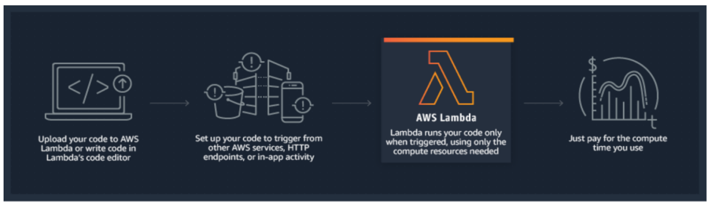

Lambda Functions

● A function is a block of code in Lambda.

● You upload your application/code in the form of single or multiple functions.

● You can upload a zip file, or you can upload a file from the S3 bucket as well.

● After deploying the Lambda function, Lambda automatically monitors functions on your behalf, reporting metrics through Amazon CloudWatch

**AWS Fargate**

**What is AWS Fargate?**

AWS Fargate is a serverless compute service that is used for containers by Amazon Elastic Container Service (ECS) and Amazon Elastic Kubernetes Service (EKS).

● It eliminates the tasks required to provision, configure, or scale groups of virtual machines like Amazon EC2 to run containers.

● It packages the application in containers, by just specifying the CPU and memory requirements with IAM policies. Fargate task does not share its underlying kernel, memory resources, CPU resources, or elastic network interface (ENI) with another task.

● It does not support all the task definition parameters that are available in Amazon ECS tasks. Only a few are valid for Fargate tasks with some limitations.

● Kubernetes can be integrated with AWS Fargate by using controllers. These controllers are responsible for scheduling native Kubernetes pods onto Fargate.

● Security groups for pods in EKS can not be used when pods running on Fargate.

● The following storage types are supported for Fargate tasks:

○ Amazon EFS volumes for persistent storage

○ Ephemeral storage for nonpersistent storage

**Amazon Elastic Kubernetes Service(EKS)**

**Amazon Elastic Kubernetes Service (Amazon EKS)** is a **managed Kubernetes service** that makes it easy to run Kubernetes on AWS without needing to install, operate, and maintain your own Kubernetes control plane or nodes.

**🧰 Basic Workflow:**

1. **Create an EKS cluster** (via Console, CLI, or IaC like Terraform).
2. **Provision worker nodes** (EC2 or Fargate).
3. **Configure kubectl** to connect to the cluster.
4. **Deploy applications** using Kubernetes manifests (yaml files).
5. **Monitor and scale** using CloudWatch, HPA, and other tools.

**What is Amazon Elastic Kubernetes Service(EKS)?**

Amazon Elastic Kubernetes Service (Amazon EKS) is a service that enables users to manage Kubernetes applications in the AWS cloud or on-premises. Any standard Kubernetes application can be migrated to EKS without altering the code.

The EKS cluster consists of two components:

● Amazon EKS control plane

● Amazon EKS nodes

**Amazon EKS (Elastic Kubernetes Service) - Complete Guide**

AWS **Elastic Kubernetes Service (EKS)** is a **managed Kubernetes service** that simplifies deploying, managing, and scaling containerized applications using **Kubernetes** on AWS.

**1. Key Features of Amazon EKS**

✅ **Managed Control Plane** – AWS handles Kubernetes master nodes (API server, etcd, scheduler).  
✅ **High Availability** – Runs across multiple AZs by default.  
✅ **Integrates with AWS Services** (VPC, IAM, ALB, RDS, etc.).  
✅ **Supports EC2 & Fargate** (serverless containers).  
✅ **Kubernetes Compliance** – Certified conformant by the CNCF.  
✅ **Security** – IAM integration, encryption (EBS, secrets), and private cluster support.

**2. Core Components of EKS**

**a) EKS Cluster**

* **Control Plane** (Managed by AWS, runs in AWS-owned VPC).
* **Worker Nodes** (EC2 or Fargate, run in your VPC).

**b) Node Groups**

* A group of **EC2 instances** running Kubernetes workloads.
* Can be **managed** (AWS handles scaling) or **self-managed**.

**c) Kubernetes Add-ons**

* **CoreDNS** (DNS-based service discovery).
* **kube-proxy** (Network traffic routing).
* **VPC CNI Plugin** (AWS-native networking).

**d) Fargate Profiles**

* Run **serverless containers** without managing EC2 instances.
* Good for **batch jobs, microservices**.

**3. EKS vs. Self-Managed Kubernetes vs. ECS**

| **Feature** | **EKS** | **Self-Managed K8s (kops, Kubeadm)** | **ECS** |
| --- | --- | --- | --- |
| **Management** | AWS manages control plane | You manage everything | AWS manages orchestration |
| **Scaling** | Auto-scaling via Cluster Autoscaler | Manual/DIY | Auto-scaling |
| **Networking** | Uses AWS VPC CNI | Custom (Calico, Flannel) | AWS VPC |
| **Best For** | Enterprise K8s workloads | Full customization | Simple container apps |

**4. How EKS Works**

1. **Create an EKS Cluster** (Control Plane).
2. **Launch Worker Nodes** (EC2 or Fargate).
3. **Deploy Kubernetes Manifests** (Pods, Deployments, Services).
4. **Use AWS Integrations** (ALB Ingress, IAM Roles for Service Accounts).

**Troubleshooting Common Issues**

🔹 **Nodes not joining cluster?** → Check IAM roles & aws-auth ConfigMap.  
🔹 **Pod networking issues?** → Verify VPC CNI plugin.  
🔹 **Ingress not working?** → Check AWS Load Balancer Controller.

**Amazon Elastic Container Service**

**What is Amazon ECS?**

Amazon Elastic Container Service (Amazon ECS) is a regional container orchestration service like Docker that allows to execute, stop, and manage containers on a cluster. A container is a standard unit of software development that combines code, its dependencies, and system libraries so that the application runs smoothly from one environment to another.

**Amazon Elastic Container Service (Amazon ECS)** is a **fully managed container orchestration service** provided by AWS. It allows you to easily run, scale, and secure **Docker containers** on a cluster of virtual machines.

**ECS Launch Types:**

1. **EC2 Launch Type**:
   * You manage the EC2 instances (cluster capacity).
   * More control over the infrastructure.
2. **Fargate Launch Type**:
   * Serverless – no need to manage EC2 instances.
   * You only define the container specs; AWS handles the rest.

**🧰 Basic ECS Workflow:**

1. **Create a Task Definition**: Define container settings (image, CPU, memory, ports).
2. **Create a Cluster**: Logical grouping of resources.
3. **Run a Task or Service**: Launch containers using EC2 or Fargate.
4. **Monitor and Scale**: Use CloudWatch and Auto Scaling.

**Amazon ECS (Elastic Container Service) - Complete Guide**

Amazon **ECS (Elastic Container Service)** is a fully managed **container orchestration service** that helps you run, scale, and manage Docker containers on AWS. It integrates with other AWS services like **EC2, Fargate, ECR, and Load Balancers** for seamless deployments.

**1. Key Features of Amazon ECS**

✅ **Supports Docker Containers** – Run any Dockerized application.  
✅ **Serverless Option** – Use **AWS Fargate** to avoid managing servers.  
✅ **High Scalability** – Auto-scaling for containers and clusters.  
✅ **Integration with AWS Ecosystem** – Works with ALB, CloudWatch, IAM, and VPC.  
✅ **Cost-Effective** – Pay only for resources used (EC2 or Fargate).

**2. Core Concepts in ECS**

| **Term** | **Description** |
| --- | --- |
| **Cluster** | Logical group of EC2 instances or Fargate tasks. |
| **Task Definition** | Blueprint for your application (container images, CPU, memory, networking). |
| **Task** | A running instance of a Task Definition (can be 1+ containers). |
| **Service** | Maintains a desired number of Tasks (supports auto-scaling). |
| **Container Agent** | Runs on EC2 instances to manage tasks. |

**3. ECS Launch Types**

**a) EC2 Launch Type**

* You **manage EC2 instances** where containers run.
* Good for **cost control** (use Spot Instances for savings).
* Best for **long-running workloads** with predictable resource needs.

**b) Fargate Launch Type**

* **Serverless** – No EC2 management, AWS handles infrastructure.
* Pay per **vCPU & memory** used by tasks.
* Ideal for **bursty workloads** or microservices.

| **Feature** | **EC2 Launch Type** | **Fargate Launch Type** |
| --- | --- | --- |
| **Server Management** | Yes (you manage EC2) | No (fully serverless) |
| **Cost Model** | Pay for EC2 instances | Pay per task (vCPU/memory) |
| **Scaling** | Auto Scaling Groups | Auto-configured scaling |
| **Networking** | Supports all EC2 networking modes | Only AWS VPC (no host mode) |

**4. ECS vs. EKS vs. Lambda**

| **Feature** | **ECS** | **EKS (Kubernetes)** | **Lambda** |
| --- | --- | --- | --- |
| **Orchestration** | AWS-native | Kubernetes | Serverless (no orchestration) |
| **Use Case** | Docker microservices | Complex K8s apps | Event-driven functions |
| **Management** | Medium (easier than EKS) | High (K8s expertise needed) | None (fully managed) |
| **Scaling** | Auto-scaling | Auto-scaling (via K8s) | Automatic |

**5. How ECS Works (Step-by-Step)**

1. **Create a Task Definition** (specify Docker image, CPU, memory).
2. **Launch a Cluster** (EC2 or Fargate-based).
3. **Run Tasks/Services** (manually or via auto-scaling).
4. **Integrate with ALB/NLB** (for load balancing).

**Amazon Elastic Container Registry**

**Amazon Elastic Container Registry (Amazon ECR)** is a **fully managed Docker container registry** provided by AWS. It allows you to **store, manage, and deploy container images** securely and at scale.

**🔄 Basic Workflow:**

1. **Create a repository** in ECR.
2. **Authenticate Docker** to ECR using the AWS CLI.
3. **Tag your image** with the ECR repository URI.
4. **Push the image** to ECR.
5. **Pull the image** from ECR in your ECS/EKS/Lambda deployments.

**What is Amazon Elastic Container Registry?**

Amazon Elastic Container Registry (ECR) is a managed service that allows users to store, manage, share, and deploy container images and artifacts. It is mainly integrated with Amazon Elastic Container Service (ECS), for simplifying the production workflow.

Features:

● It stores both the containers which are created, and any container software bought through AWS Marketplace.

● It is integrated with Amazon Elastic Container Service (ECS), Amazon Elastic Kubernetes Service (EKS), and AWS Lambda, and AWS Fargate for easy deployments.

● AWS Identity and Access Management (IAM) enables resource-level control of each repository within ECR.

● It supports public and private container image repositories. It allows sharing container applications privately within the organization or publicly for anyone to download.

● A separate portal called Amazon ECR Public Gallery, helps to access all public repositories hosted on Amazon ECR Public.

● It stores the container images in Amazon S3 because S3 provides 99.999999999% (11 9’s) of data durability.

● It allows cross-region and cross-account replication of the data for high availability applications.

● Encryption can be done via HTTPS while transferring container images. Images are also encrypted at rest using Amazon S3 server-side encryption or by using customer keys managed by AWS KMS.

● It is integrated with continuous integration and continuous delivery and also with third-party developer tools.

● Lifecycle policies are used to manage the lifecycle of the images

**Amazon Elastic Container Registry (ECR) - Complete Guide**

Amazon ECR is a **fully managed Docker container registry** that makes it easy to store, manage, and deploy Docker container images. It integrates seamlessly with **Amazon ECS, EKS, and AWS Fargate**.

**1. Key Features of Amazon ECR**

✅ **Fully Managed** - No servers to maintain  
✅ **Secure** - Integrated with AWS IAM and encrypted by default  
✅ **High Performance** - Backed by Amazon S3 for durability  
✅ **Integrated with AWS Services** - Works with ECS, EKS, Lambda, Batch  
✅ **Vulnerability Scanning** - Built-in image scanning (via AWS Inspector)  
✅ **Lifecycle Policies** - Automate image cleanup

**2. Core Concepts**

**a) Registry**

* A regional container image storage service (one per AWS account per region)
* Example format: 123456789012.dkr.ecr.us-east-1.amazonaws.com

**b) Repository**

* Stores Docker images (similar to folders in S3)
* Can apply fine-grained IAM permissions per repository

**c) Image**

* A versioned Docker container image (tagged with latest, v1.0, etc.)

**9. Troubleshooting**

🔹 **"no basic auth credentials" error** → Re-run aws ecr get-login  
🔹 **403 Forbidden** → Check IAM permissions  
🔹 **Slow pushes** → Check network connectivity to ECR

**Amazon S3**

**Amazon S3 (Simple Storage Service)** is a **scalable, durable, and secure object storage service** offered by AWS. It’s designed to store and retrieve **any amount of data from anywhere** on the web.

**🧰 Basic Workflow:**

1. **Create a bucket** (a container for your objects).
2. **Upload objects** (files) to the bucket.
3. **Set permissions** (public/private, IAM roles, bucket policies).
4. **Access objects** via a URL or programmatically using the AWS SDK/CLI.

**What is Amazon S3?**

S3 stands for Simple Storage Service.

Amazon S3 is object storage that allows us to store any kind of data in the bucket. It provides availability in multiple AZs, durability, security, and performance at a very low cost.

Any type of customer can use it to store and protect any amount of data for use cases, like static and dynamic websites, data analytics, and backup.

**Basics of S3?**

● It is object-based storage.

● Files are stored in Buckets.

● The bucket is a kind of folder.

● Folders can be from 0 to 5 TB.

● S3 bucket names must be unique globally.

● When you upload a file in S3, you will receive an HTTP 200 code if the upload was successful.

● S3 offers Strong consistency for PUTs of new objects, overwrites or delete of current object and List operations.

● By Default, all the Objects in the bucket are private.

**Permissions & Management.**

**● Access Control List**: ACLs used to grant read/write permission to another AWS Account.

**● Bucket Policy:** It uses JSON based access policy advance permission to your S3 Resources.

**● CORS**: CORS stands for Cross-Origin Resource Sharing. It allows cross-origin access to your S3 Resources.

**Amazon S3 (Simple Storage Service) - Complete Guide**

Amazon **S3 (Simple Storage Service)** is a **scalable, secure, and highly durable object storage** service designed for storing and retrieving any amount of data from anywhere.

**1. Key Features of Amazon S3**

✅ **Unlimited Storage** – Store any amount of data (files, images, backups, logs).  
✅ **High Durability (99.999999999%)** – Data is replicated across multiple AZs.  
✅ **Security & Compliance** – Supports **encryption (SSE-S3, SSE-KMS, SSE-C)**, IAM policies, and access logging.  
✅ **Scalability** – Handles millions of requests per second.  
✅ **Cost-Effective** – Pay only for what you use (no minimum fee).  
✅ **Integrations** – Works with **Lambda, CloudFront, ETL tools, and more**.

**2. Core Concepts in S3**

| **Term** | **Description** |
| --- | --- |
| **Bucket** | A container for objects (globally unique name, region-specific). |
| **Object** | A file + metadata (Key, Value, Version ID, Metadata). |
| **Key** | The object's filename (e.g., images/profile.jpg). |
| **Versioning** | Keeps multiple versions of an object (protects against deletes). |
| **Storage Class** | Different tiers for cost optimization (Standard, Intelligent-Tiering, Glacier). |

**4. S3 Security & Access Control**

* **Bucket Policies** (JSON-based rules for bucket-level access).
* **IAM Policies** (Granular user/role permissions).
* **ACLs (Legacy)** – Basic read/write permissions (avoid if possible).
* **Encryption**
  + **SSE-S3** (S3-managed keys).
  + **SSE-KMS** (AWS KMS-managed keys).
  + **SSE-C** (Customer-provided keys).
  + **Client-Side Encryption** (Encrypt before uploading).

**5. S3 Data Management Features**

✔ **Versioning** – Keep multiple versions of files (protects against accidental deletes).  
✔ **Lifecycle Policies** – Automatically transition objects to cheaper storage classes.  
✔ **Cross-Region Replication (CRR)** – Copy objects to another region.  
✔ **Event Notifications** – Trigger Lambda, SQS, or SNS on file uploads.  
✔ **S3 Select & Glacier Select** – Retrieve only parts of files (cost-saving).

**AWS EBS - Elastic Block Store**

**Amazon EBS (Elastic Block Store)** is a **block storage service** designed for use with **Amazon EC2** instances. It provides **persistent, high-performance storage** that can be attached to EC2 instances, similar to how a hard drive works with a physical server.

**🧱 Key Characteristics of EBS:**

| **Feature** | **Description** |
| --- | --- |
| **Persistent** | **Data remains intact even after the EC2 instance is stopped or terminated.** |
| **Block-level storage** | **Ideal for databases, file systems, and applications requiring low-latency access.** |
| **Attachable** | **Can be attached to one EC2 instance at a time (except for multi-attach volumes).** |
| **Encrypted** | **Supports encryption at rest and in transit.** |
| **Snapshot support** | **Back up volumes to Amazon S3 using snapshots.** |

**📦 EBS Volume Types:**

| **Volume Type** | **Use Case** | **Key Traits** |
| --- | --- | --- |
| **gp3** | **General-purpose** | **Customizable IOPS and throughput** |
| **gp2** | **General-purpose (legacy)** | **Baseline performance with burst** |
| **io2/io1** | **IOPS-intensive apps** | **High-performance, durable** |
| **st1** | **Throughput-optimized HDD** | **Big data, log processing** |
| **sc1** | **Cold HDD** | **Infrequent access, lowest cost** |

**What is AWS EBS?**

Amazon Elastic Block Store (AWS EBS) is a persistent block-level storage (volume) service designed to be used with Amazon EC2 instances. EBS is AZ specific & automatically replicated within its AZ to protect from component failure, offering high availability and durability.

**Features:**

● High Performance (Provides single-digit-millisecond latency for high-performance)

● Highly Scalable (Scale to petabytes)

● Offers high availability (guaranteed 99.999% by Amazon) & Durability

● Offers seamless encryption of data at rest through Amazon Key Management Service (KMS).

● Automate Backups through data lifecycle policies using EBS Snapshots to S3 Storage.

● EBS detached from an EC2 instance and attached to another one quickly.

**EBS vs Instance Store**

**Instance Store (ephemeral storage) :**

● It is ideal for temporary block-level storage like buffers, caches, temporary content

● Data on an instance store volume persists only during the life of the associated instance. (As it is volatile storage - lose data if stop the instance/instance crash)

● Physically attached to ec2 instance - hence, the lowest possible latency.

● Massive IOPS - High performance

● Instance store backed Instances can be of maximum 10GiB volume size

● Instance store volume cannot be attached to an instance, once the Instance is up and running.

● Instance store volume can be used as root volume.

● You cannot create a snapshot of an instance store volume.

**EBS :**

● Persistent Storage.

● Reliable & Durable Storage.

● EBS volume can be detached from one instance and attached to another instance.

● EBS boots faster than instance stores.

**AWS EBS (Elastic Block Store) - Complete Guide**

AWS Elastic Block Store (EBS) provides persistent block storage volumes for use with Amazon EC2 instances. Unlike ephemeral instance store volumes, EBS volumes persist independently of the life of an instance.

**Key Features of EBS**

✅ **Durable & Persistent** - Data persists even after instance termination  
✅ **High Performance** - SSD-backed options for I/O intensive workloads  
✅ **Scalable** - Resize volumes on-the-fly (with some limitations)  
✅ **Snapshots** - Point-in-time backups stored in S3  
✅ **Encryption** - AES-256 encryption at rest (using AWS KMS)  
✅ **Multi-Attach** - Some volumes can connect to multiple instances

**EBS Volume Types Comparison**

| **Volume Type** | **Description** | **Best For** | **Max IOPS** | **Max Throughput** |
| --- | --- | --- | --- | --- |
| **gp3** (General Purpose SSD) | Default balanced SSD | Boot volumes, dev environments | 16,000 | 1,000 MB/s |
| **io2/io1** (Provisioned IOPS SSD) | High-performance SSD | Databases (Oracle, SAP) | 64,000 (io2 Block Express: 256K) | 4,000 MB/s |
| **st1** (Throughput Optimized HDD) | Low-cost HDD | Big data, log processing | 500 | 500 MB/s |
| **sc1** (Cold HDD) | Lowest cost HDD | Infrequently accessed data | 250 | * 1. /s |

**EBS vs Instance Store**

| **Feature** | **EBS Volume** | **Instance Store** |
| --- | --- | --- |
| **Persistence** | Survives instance stop/termination | Lost on instance stop/termination |
| **Performance** | Network-attached (varies by type) | Direct-attached (extremely high speed) |
| **Cost** | Persistent storage pricing | Free (included with instance) |
| **Use Case** | Databases, persistent storage | Cache, temporary data, scratch disks |

**Key Operations**

1. **Creating & Attaching Volumes**
   * Create in same AZ as EC2 instance
   * Attach to instances as /dev/sdf through /dev/sdp
2. **Modifying Volumes**
   * Increase size (can be done without stopping instance for most types)
   * Change volume type (gp2→gp3, etc.)
3. **Taking Snapshots**

bash

Copy

Download

aws ec2 create-snapshot --volume-id vol-12345 --description "My backup"

* + Snapshots are incremental (only changed blocks stored)
  + Can create AMIs from snapshots

1. **Encryption**
   * Enabled by default for new volumes in many regions
   * Uses AWS KMS (Customer Master Keys)

**AWS EFS - Elastic File Storage**

**Amazon EFS (Elastic File System)** is a **fully managed, scalable, and elastic NFS (Network File System)** file storage service provided by AWS. It allows multiple EC2 instances to **simultaneously access a shared file system**, making it ideal for workloads that require shared access to data.

**🧰 Basic Workflow:**

1. **Create an EFS file system** in the AWS Console or CLI.
2. **Configure mount targets** in your VPC subnets.
3. **Mount the file system** on EC2 instances using the NFS protocol.
4. **Read/write files** as you would with a local file system.

**🔄 EFS vs. EBS vs. S3:**

| **Feature** | **EFS** | **EBS** | **S3** |
| --- | --- | --- | --- |
| **Type** | File storage | Block storage | Object storage |
| **Access** | Multiple EC2s | Single EC2 (or multi-attach) | Web/API |
| **Use Case** | Shared file systems | Databases, OS volumes | Backups, static assets |
| **Scalability** | Auto-scales | Manual | Auto-scales |

**What is AWS EFS?**

Amazon Elastic File System (Amazon EFS) provides a scalable, fully managed elastic distributed file system based on NFS. It is persistent file storage & can be easily scaled up to petabytes. It is designed to share parallelly with thousands of EC2 instances to provide better throughput and IOPS. It is a regional service automatically replicated across multiple AZ’s to provide High Availability and durability.

**Amazon EFS (Elastic File System) - Complete Guide**

Amazon EFS is a **fully managed, scalable, cloud-native NFS file system** for AWS workloads. It provides **shared file storage** that can be accessed by multiple EC2 instances, containers, and serverless applications simultaneously.

**1. Key Features of Amazon EFS**

✅ **Fully Managed** - No hardware to provision  
✅ **Elastic Scaling** - Grows and shrinks automatically  
✅ **Shared Access** - Multiple instances can access files concurrently  
✅ **High Availability** - Replicates across AZs (Standard storage class)  
✅ **Security** - Supports IAM, VPC security groups, encryption at rest/in-transit  
✅ **Multi-Protocol** - Supports NFS v4.1 (Linux) and soon Amazon S3 access

**2. Core Components**

**a) File System**

* The primary EFS resource (similar to an EBS volume but shared)
* Can be mounted on multiple EC2 instances simultaneously

**b) Mount Targets**

* ENIs (Elastic Network Interfaces) in each AZ that allow EC2 access
* Each mount target gets its own IP address

**c) Access Points**

* Application-specific entry points with custom:
  + POSIX user/group permissions
  + Root directory restrictions
  + IAM policies

**3. EFS Performance Modes**

| **Mode** | **Description** | **Best For** |
| --- | --- | --- |
| **General Purpose** | Low latency (ms) | Web servers, CMS |
| **Max I/O** | Higher throughput, higher latency | Big data, media processing |

**4. Storage Classes**

| **Class** | **Description** | **Cost** |
| --- | --- | --- |
| **Standard** | Frequently accessed files | Higher |
| **Infrequent Access (IA)** | 90% cost savings for rarely accessed files | Lower |

**6. EFS Security**

* **Network Security**:
  + VPC security groups on mount targets
  + Can enable VPC endpoints for private access
* **File System Security**:
  + POSIX permissions (user/group/others)
  + IAM policies for API-level control
* **Encryption**:
  + At-rest (KMS)
  + In-transit (TLS 1.2+)

**AWS Snowball**

**What is AWS Snowball?**

● AWS Snowball is a storage device used to transfer a large amount of data ranging from 50TB - 80TB between Amazon Simple Storage Service and onsite data storage location at high speed.

**AWS Storage Gateway**

**What is the AWS Storage Gateway?**

AWS Storage Gateway is a hybrid cloud storage service that allows your on-premise storage & IT infrastructure to seamlessly integrate with AWS Cloud Storage Services. It Can be AWS Provided Hardware or Compatible Virtual Machine.

**Amazon Aurora**

**What is Amazon Aurora?**

Aurora is the fully managed RDS services offered by AWS. It’s only compatible with PostgreSQL/MySQL. As per AWS, Aurora provides 5 times throughput to traditional MySQL and 3 times throughput to PostgreSQL.

**Amazon DocumentDB**

**What is Amazon DocumentDB?**

DocumentDB is a fully managed document database service by AWS which supports MongoDB workloads. It is highly recommended for storing, querying, and indexing JSON Data.

**Amazon DynamoDB**

**Amazon DynamoDB** is a **fully managed NoSQL database service** provided by AWS that delivers **single-digit millisecond performance at any scale**. It’s designed for applications that require consistent, low-latency data access and can scale to support millions of requests per second.

**📦 Data Model:**

* **Tables**: Collections of items.
* **Items**: Individual records (like rows).
* **Attributes**: Fields within an item (like columns).
* **Primary Key**: Uniquely identifies each item (can be simple or composite).
* **Secondary Indexes**: Enable querying on non-key attributes.

**What is DynamoDB?**

● AWS DynamoDB is a Key-value and DocumentDB database by Amazon.

● It delivers a single Digit millisecond Latency.

● It can handle 20 million requests per second and 10 trillion requests a day.

● It is a Serverless Service; it means no servers to manage.

● It maintains the performance by managing the data traffic of tables over multiple servers.

**Amazon DynamoDB - Complete Guide**

Amazon DynamoDB is a **fully managed NoSQL database** service that provides **single-digit millisecond performance** at any scale. It's a key-value and document database that delivers **seamless scalability, high availability, and low latency**.

**1. Key Features of DynamoDB**

✅ **Serverless** - No servers to manage, automatic scaling  
✅ **High Performance** - Single-digit millisecond latency  
✅ **Highly Available** - Multi-AZ by default with 99.999% SLA  
✅ **Flexible Data Models** - Key-value + document store  
✅ **Durable** - Replicated across 3 AZs  
✅ **Security** - Encryption at rest, VPC endpoints, IAM integration

**2. Core Concepts**

**a) Tables**

* The top-level container for your data (similar to a database in SQL)

**b) Items**

* A single data record (similar to a row in SQL)
* Can contain **up to 400KB** of data

**c) Attributes**

* Key-value pairs that make up an item (similar to columns in SQL)
* Supports **scalar** (string, number, binary), **document** (list, map), and **set** types

**d) Primary Key**

* **Partition Key (HASH key)**: Single attribute that determines partition
* **Composite Key (Partition + Sort Key)**: Enables richer queries

**3. DynamoDB vs. Traditional Databases**

| **Feature** | **DynamoDB** | **RDS (SQL)** |
| --- | --- | --- |
| **Data Model** | Key-value + document | Relational |
| **Scaling** | Automatic, unlimited | Manual, limited |
| **Performance** | Predictable low latency | Variable |
| **Management** | Fully managed | Requires maintenance |
| **Schema** | Flexible | Rigid |

**Amazon RDS**

**Amazon RDS (Relational Database Service)** is a **fully managed relational database service** by AWS that makes it easy to set up, operate, and scale a relational database in the cloud. It automates time-consuming tasks like provisioning, patching, backups, and scaling.

**🧰 Basic Workflow:**

1. **Choose a database engine (e.g., PostgreSQL).**
2. **Configure instance settings (vCPU, memory, storage).**
3. **Set up networking and security (VPC, security groups).**
4. **Launch the DB instance.**
5. **Connect to the database using standard tools (e.g., psql, mysql, JDBC).**

**What is Amazon RDS?**

RDS (Relational Database System) in AWS makes it easy to operate, manage, and

scale in the cloud. It provides scalable capacity with a cost-efficient pricing option and automates manual administrative tasks such as patching, backup setup, and hardware provisioning.

**MySQL**

● It is the most popular open-source DB in the world.

● Amazon RDS makes it easy to provision the DB in AWS Environment without worrying about the physical infrastructure.

● In this way, you can focus on application development rather than Infra. Management.

**Amazon RDS (Relational Database Service) - Complete Guide**

Amazon RDS is a **managed relational database service** that simplifies database setup, operation, and scaling in the cloud. It supports multiple database engines with automated backups, patching, and high availability.

**1. Key Features of Amazon RDS**

✅ **Fully Managed** - AWS handles provisioning, patching, backups  
✅ **Multi-Engine Support** - MySQL, PostgreSQL, Oracle, SQL Server, MariaDB, Aurora  
✅ **High Availability** - Multi-AZ deployments for failover  
✅ **Scalability** - Vertical scaling (instance size) & read replicas  
✅ **Automated Backups** - Point-in-time recovery (up to 35 days)  
✅ **Security** - Encryption at rest/in-transit, IAM integration, VPC isolation

**2. Supported Database Engines**

| **Engine** | **Use Cases** | **Special Features** |
| --- | --- | --- |
| **MySQL** | Web apps, CMS | Compatible with open-source MySQL |
| **PostgreSQL** | Geospatial, JSON docs | Advanced extensions (PostGIS, pgvector) |
| **Aurora** | High-performance apps | 5x faster than MySQL, auto-scaling |
| **SQL Server** | Enterprise .NET apps | License included (License Included mode) |
| **Oracle** | Enterprise applications | Bring Your Own License (BYOL) option |
| **MariaDB** | MySQL-compatible alternative | Enhanced storage engines |

**3. Core Components**

**a) DB Instance**

* The basic building block (e.g., db.m6g.large)
* Compute + Memory + Storage combination

**b) Multi-AZ Deployment**

* **Synchronous standby replica** in another AZ
* Automatic failover (<2 min downtime)

**c) Read Replicas**

* **Asynchronous copies** for read scaling (up to 15 per master)
* Available for MySQL, PostgreSQL, MariaDB, Aurora

**d) Parameter Groups**

* Manage database configuration settings
* Customize memory allocation, timeouts, etc.

**e) Option Groups**

* Enable additional features like Oracle APEX or SQL Server TDE

**4. Creating an RDS Database**

**Via AWS Console:**

1. Navigate to RDS → "Create database"
2. Select engine (e.g., PostgreSQL)
3. Choose template (Production, Dev/Test)
4. Configure:
   * DB instance size
   * Storage type (GP3, IOPS-optimized)
   * VPC & security groups
5. Set master username/password

**5. Backup & Recovery**

**Automated Backups**

* Daily full backups + transaction logs
* Retention period (1-35 days)
* Restore to any second within retention

**Manual Snapshots**

* User-initiated (persist until deleted)
* Can copy across regions

**AWS Secrets Manager**

**AWS Secrets Manager** is a **secure and fully managed service** that helps you **store, manage, and retrieve sensitive information**, such as:

* Database credentials
* API keys
* OAuth tokens
* SSH keys
* Other application secrets

**🧰 Basic Workflow:**

1. **Create a secret** in the AWS Console or CLI.
2. **Store key-value pairs** (e.g., username, password).
3. **Grant access** using IAM policies.
4. **Retrieve the secret** in your application using the AWS SDK or CLI.

**What is AWS Secrets Manager?**

AWS Secrets Manager is a service that replaces secret credentials in the code like passwords, with an API call to retrieve the secret programmatically. The service provides a feature to rotate, manage, and retrieve database passwords, OAuth tokens, API keys, and other secret credentials. It ensures in-transit encryption of the secret between AWS and the system to retrieve the secret. Secrets Manager can easily rotate credentials for AWS databases without any additional programming. Though rotating the secrets for other databases or services requires Lambda function to instruct how Secrets Manager interacts with the database or service.

**Accessing Secrets Manager:**

● AWS Management Console

○ It stores binary data in secret.

● AWS Command Line Tools

○ AWS Command Line Interface

○ AWS Tools for Windows PowerShell

● AWS SDKs

● Secrets Manager HTTPS Query API

Secret rotation is available for the following Databases:

● MySQL on Amazon RDS

● PostgreSQL on Amazon RDS

● Oracle on Amazon RDS

● MariaDB on Amazon RDS

● Amazon DocumentDB

● Amazon Redshift

● Microsoft SQL Server on Amazon RDS

● Amazon Aurora on Amazon RDS

**Features:**

● It provides security and compliance facilities by rotating secrets safely without the need for code deployment.

● With Secrets Manager, IAM policies and resource-based policies can assign specific permissions for developers to retrieve secrets and passwords used in the development environment or the production environment.

● Secrets can be secured with encryption keys managed by AWS Key Management Service (KMS).

● It integrates with AWS CloudTrail and AWS CloudWatch to log and monitor services for centralized auditing.

Use cases:

● Store sensitive information as part of the encrypted secret value, either in the SecretString or SecretBinary field.

● Use a Secrets Manager open-source client component to cache secrets and update them only when there is a need for rotation.

● When an API request quota exceeds, the Secrets Manager throttles the request and returns a ‘ThrottlingException’ error. To resolve this, retry the requests.

● It integrates with AWS Config and facilitates tracking of changes in Secrets Manager.

**AWS Secrets Manager - Complete Guide**

AWS Secrets Manager is a **secure secrets management service** that helps you protect access to your applications, services, and IT resources by enabling you to **store, rotate, and retrieve secrets** programmatically.

**1. Key Features**

✅ **Secure Secret Storage** - Encrypted at rest using AWS KMS  
✅ **Automatic Rotation** - Built-in support for RDS, Redshift, DocumentDB  
✅ **Fine-Grained Access Control** - Integrated with AWS IAM  
✅ **Cross-Account Access** - Share secrets across AWS accounts  
✅ **Audit Trail** - Logs all access via AWS CloudTrail

**2. What Can You Store?**

* Database credentials (RDS, MySQL, PostgreSQL, etc.)
* API keys (3rd party services)
* OAuth tokens
* Encryption keys (though KMS is better for crypto keys)
* Any plaintext/key-value pairs (up to 10KB per secret)

**3. Core Concepts**

**a) Secret**

A container for your sensitive data that contains:

* Secret values (key/value pairs)
* Rotation configuration
* Metadata (description, tags, etc.)

**b) Secret Rotation**

Automatically updates credentials on a schedule (e.g., every 30 days)

**c) KMS Integration**

All secrets are encrypted using AWS Key Management Service (KMS)

**4. Getting Started**

**Creating a Secret (Console)**

1. Go to AWS Secrets Manager
2. Choose "Store a new secret"
3. Select secret type (e.g., "RDS database credentials")
4. Enter credentials and configure rotation (if needed)
5. Set permissions via IAM

**6. Secret Rotation**

**Supported Services**

* Amazon RDS (MySQL, PostgreSQL, Oracle, SQL Server, MariaDB)
* Amazon DocumentDB
* Amazon Redshift

**AWS Certificate Manager (ACM)**

**AWS Certificate Manager (ACM)** is a **fully managed service** that helps you **provision, manage, and deploy SSL/TLS certificates** for use with AWS services and your internal connected resources. It simplifies the process of securing websites and applications by handling the complexity of certificate management.

**🧰 Basic Workflow:**

1. **Request a certificate** (public or private).
2. **Validate domain ownership** (via DNS or email).
3. **Deploy the certificate** to services like:
   * Elastic Load Balancer (ELB)
   * Amazon CloudFront
   * Amazon API Gateway
4. **Monitor and renew** automatically (for public certs issued by ACM).

**What is AWS Certificate Manager?**

AWS Certificate Manager is a service that allows a user to provide, manage, renew and deploy public and private Secure Sockets Layer/Transport Layer Security (SSL/TLS) X.509 certificates. The certificates can be integrated with AWS services either by issuing them directly with ACM or importing third-party certificates into the ACM management system.

**SSL Server Certificates:**

● HTTPS transactions require server certificates X.509 that bind the public key in the certificate to provide authenticity.

● The certificates are signed by a certificate authority (CA) and contain the server’s name, the validity period, the public key, the signature algorithm, and more.

**The different types of SSL certificates are:**

● Extended Validation Certificates (EV SSL) - most expensive SSL certificate type

● Organization Validated Certificates (OV SSL) - validate a business’ creditably

● Domain Validated Certificates (DV SSL) - provide minimal encryption

● Wildcard SSL Certificate - secures base domain and subdomains

● Multi-Domain SSL Certificate (MDC) - secure up to hundreds of domain and subdomains

● Unified Communications Certificate (UCC) - single certificate secures multiple domain names.

Ways to deploy managed X.509 certificates:

1. AWS Certificate Manager (ACM) - useful for large customers who need a secure web presence.

● ACM certificates are deployed using Amazon API Gateway, Elastic Load Balancing, Amazon CloudFront.

2. ACM Private CA - useful for large customers building a public key infrastructure (PKI) inside the AWS cloud and intended for private use within an organization.

● It helps create a certificate authority (CA) hierarchy and issue certificates to authenticate users, computers, applications, services, servers, and other devices.

● Private certificates by Private CA for applications provide variable certificate lifetimes or resource names.

**ACM certificates are supported by the following services:**

● Elastic Load Balancing

● Amazon CloudFront

● AWS Elastic Beanstalk

● Amazon API Gateway

● AWS Nitro Enclaves (an Amazon EC2 feature)

● AWS CloudFormation

**AWS Certificate Manager (ACM) - Complete Guide**

AWS Certificate Manager (ACM) is a **managed SSL/TLS certificate service** that simplifies provisioning, deploying, and renewing certificates for AWS services and internal resources.

**1. Key Features of ACM**

✅ **Free SSL/TLS Certificates** - No cost for public certificates  
✅ **Automatic Renewal** - No manual renewal needed  
✅ **Integrated with AWS Services** - Works with ALB, CloudFront, API Gateway  
✅ **High Availability** - Certificates are regionally distributed  
✅ **Private CA Support** - For internal PKI infrastructure

**2. Supported Certificate Types**

| **Type** | **Description** | **Use Case** |
| --- | --- | --- |
| **Public Certificates** | Domain-validated (DV) certificates | Public websites (example.com) |
| **Private Certificates** | Issued by your Private CA | Internal apps (.internal) |
| **Wildcard Certificates** | Covers *.example.com | Multiple subdomains |
| **Multi-Domain (SAN) Certificates** | Multiple domains in one cert | example.com + api.example.com |

**3. ACM Integration with AWS Services**

* **Elastic Load Balancing (ALB/NLB)**
* **Amazon CloudFront**
* **API Gateway**
* **AWS Elastic Beanstalk**
* **AWS CloudFormation**

**4. Requesting a Public Certificate**

**Via AWS Console**

1. Navigate to **ACM > Request a certificate**
2. Choose **Public certificate**
3. Add domain names (e.g., example.com, *.example.com)
4. Select validation method:
   * **DNS validation** (recommended, creates CNAME record)
   * **Email validation** (manual approval)
5. **Validate** domain ownership

**6. Deploying ACM Certificates**

**On ALB**

1. Create/update load balancer
2. Select ACM certificate from dropdown

**On CloudFront**

1. Create distribution
2. Select certificate from **US East (N. Virginia)** region

**AWS Auto Scaling**

**AWS Auto Scaling** is a service that helps you **automatically adjust the capacity of your AWS resources** to maintain performance and optimize costs. It can scale **EC2 instances**, **ECS services**, **DynamoDB tables**, and **Aurora Replicas** based on demand.

**🧱 Components of EC2 Auto Scaling:**

1. **Launch Template/Configuration**: Defines how new instances are launched (AMI, instance type, etc.).
2. **Auto Scaling Group (ASG)**: Manages a group of EC2 instances.
3. **Scaling Policies**:
   * **Target tracking** (e.g., keep CPU at 50%)
   * **Step scaling** (scale by steps based on thresholds)
   * **Scheduled scaling** (scale at specific times)

**What is AWS Auto Scaling?**

● AWS Auto Scaling keeps on monitoring your Application and automatically adjusts the capacity required for steady and predictable performance.

● By using auto scaling it's very easy to set up the scaling of the application automatically with no manual intervention.

● It allows you to create scaling plans for the resources like EC2 Instances, Amazon EC2 tasks, Amazon DynamoDB, Amazon Aurora Read Replicas.

● It balances Performance Optimization and cost.

**Monitoring:**

● **Health Check:** Keep on checking the health of the instance and remove the unhealthy instance out of Target Group.

● **CloudWatch Events:** AutoScaling can submit events to Cloudwatch for any type of action to perform in the autoscaling group such as a launch or terminate an instance.

● **CloudWatch Metrics:** It shows you the statistics of whether your application is performing as expected.

● **Notification Service:** Autoscaling can send a notification to your email if the autoscaling group launches or the instance gets terminated.

**AWS Auto Scaling - Complete Guide**

AWS Auto Scaling automatically adjusts your compute resources to maintain performance while optimizing costs. It ensures you have the right number of Amazon EC2 instances (or other resources) available to handle your application load.

**Key Features**

✅ **Automatic Scaling** - Adds/removes instances based on demand  
✅ **Multiple Scaling Strategies** - Target tracking, step scaling, simple scaling  
✅ **Multi-Resource Scaling** - EC2, ECS, DynamoDB, Aurora  
✅ **Cost Optimization** - Maintains performance at lowest cost  
✅ **Integration** - Works with ELB, CloudWatch, Route 53

**Core Components**

**1. Auto Scaling Groups (ASG)**

* Logical group of EC2 instances
* Defines:
  + Minimum/maximum/desired capacity
  + Launch templates/configurations
  + Availability Zone distribution
  + Health check settings

**2. Launch Templates/Configurations**

* Blueprint for new instances (AMI, instance type, key pair, IAM role, etc.)
* Launch Templates (newer) support versioning

**3. Scaling Policies**

| **Policy Type** | **Description** | **Use Case** |
| --- | --- | --- |
| **Target Tracking** | Maintains a specific metric value | CPU at 40% utilization |
| **Step Scaling** | Adds/removes instances in increments | Gradual response to load changes |
| **Simple Scaling** | Single adjustment with cooldown period | Simple applications |

**How Auto Scaling Works**

1. **Monitors Metrics** (CPU, memory, network, custom)
2. **Triggers Scaling** when thresholds are breached
3. **Launches/Terminates** instances to match demand
4. **Maintains Health** - Replaces unhealthy instances

**Monitoring & Optimization**

* **CloudWatch Metrics**: CPUUtilization, RequestCount
* **Scaling History**: View past scaling events
* **Cost Explorer**: Analyze scaling impact on costs

**AWS CloudFormation**

**AWS CloudFormation** is a **service that enables you to model, provision, and manage AWS infrastructure as code**. You define your infrastructure in a **template file** (written in YAML or JSON), and CloudFormation takes care of provisioning and configuring those resources automatically.

**🔧 Basic Workflow:**

1. **Write a template** in YAML or JSON.
2. **Upload it** to the AWS Console, CLI, or SDK.
3. **Create a stack** from the template.
4. **CloudFormation provisions** the resources.
5. **Manage updates** using change sets or stack updates.

**What is AWS CloudFormation?**

AWS CloudFormation is a service that collects AWS and third-party resources and manages them throughout their life cycles, by launching them together as a stack. A template is used to create, update, and delete an entire stack as a single unit, without managing resources individually. It provides the capability to reuse the template to set the resources easily and repeatedly. It can be integrated with AWS IAM for security. It can be integrated with CloudTail to capture API calls as events.

**Templates** - A JSON or YAML formatted text file used for building AWS resources.

**Stack** - It is a single unit of resources.

**Change sets** - It allows checking how any change to a resource might impact the running resources. Stacks can be created using the AWS CloudFormation console and AWS Command Line Interface (CLI).

**Stack updates**: First the changes are submitted and compared with the current state of the stack and only the changed resources get updated.

There are two methods for updating stacks:

● **Direct update** - when there is a need to quickly deploy the updates.

**● Creating and executing change sets** - they are JSON files, providing a preview option for the changes to be applied.

**StackSets** are responsible for safely provisioning, updating, or deleting stacks. Nested Stacks are stacks created within another stack by using the AWS::CloudFormation::Stack resource. When there is a need for common resources in the template, Nested stacks can be used by declaring the same components instead of creating the components multiple times. The main stack is termed as parent stack and other belonging stacks are termed as child stack, which can be implemented by using ref variable ‘! Ref’.

**AWS CloudFormation Registry** helps to provision third-party application resources alongside AWS resources. Examples of third-party resources are incident management, version control tools.

**AWS CloudFormation - Complete Guide**

AWS **CloudFormation** is an **Infrastructure-as-Code (IaC)** service that allows you to model, provision, and manage AWS resources using **declarative JSON or YAML templates**. It automates the deployment of cloud infrastructure in a repeatable and scalable way.

**1. Key Features of AWS CloudFormation**

✅ **Infrastructure as Code (IaC)** – Define AWS resources in templates (YAML/JSON).  
✅ **Automated Deployment** – Create, update, and delete stacks in a controlled manner.  
✅ **Dependency Management** – Automatically handles resource creation order.  
✅ **Rollback & Change Sets** – Safely test changes before applying them.  
✅ **Drift Detection** – Identify manual changes to deployed resources.  
✅ **Cross-Account & Cross-Region Deployments** – Use **StackSets** for large-scale deployments.

**2. Core Concepts**

| **Term** | **Description** |
| --- | --- |
| **Template** | JSON/YAML file defining AWS resources and configurations. |
| **Stack** | A collection of AWS resources created from a template. |
| **Change Set** | Preview of changes before updating a stack. |
| **StackSets** | Deploy stacks across multiple accounts/regions. |
| **Parameters** | Dynamic inputs (e.g., instance type, VPC ID). |
| **Outputs** | Return values from a stack (e.g., public IP). |
| **Nested Stacks** | Break large templates into reusable components. |

**3. CloudFormation vs. Terraform vs. CDK**

| **Feature** | **CloudFormation** | **Terraform** | **AWS CDK** |
| --- | --- | --- | --- |
| **Language** | YAML/JSON | HCL (Hashicorp) | TypeScript, Python, etc. |
| **Provider** | AWS-only | Multi-cloud | AWS-only (CDK generates CF templates) |
| **State Management** | Managed by AWS | Self-managed (Terraform state file) | Managed by AWS |
| **Best For** | AWS-native deployments | Hybrid/multi-cloud | Developers who prefer coding ov |

**Amazon CloudWatch**

**Amazon CloudWatch** is a **monitoring and observability service** provided by AWS that helps you collect, visualize, and analyze **metrics, logs, and events** from AWS resources, applications, and services in real time.

**📊 Key Features of Amazon CloudWatch:**

| **Feature** | **Description** |
| --- | --- |
| **Metrics** | Collect and track performance data (e.g., CPU usage, memory, disk I/O). |
| **Logs** | Centralized logging from EC2, Lambda, ECS, and custom apps. |
| **Alarms** | Trigger actions (e.g., notifications, Auto Scaling) based on metric thresholds. |
| **Dashboards** | Visualize metrics and logs in customizable dashboards. |
| **Events (EventBridge)** | Respond to changes in your AWS environment with automated workflows. |
| **CloudWatch Synthetics** | Monitor endpoints using canary scripts. |
| **CloudWatch Logs Insights** | Query and analyze log data interactively. |

**What is Amazon CloudWatch?**

Amazon CloudWatch is a service that helps to monitor and manage services by providing data and actionable insights for AWS applications and infrastructure resources. It monitors AWS resources such as Amazon RDS DB instances, Amazon EC2 instances, Amazon DynamoDB tables, and, as well as any log files generated by the applications.

Amazon CloudWatch can be accessed by the following methods:

● Amazon CloudWatch console

● AWS CLI

● CloudWatch API

● AWS SDKs

Amazon CloudWatch is used together with the following services:

● Amazon Simple Notification Service (Amazon SNS)

● Amazon EC2 Auto Scaling

● AWS CloudTrail

● AWS Identity and Access Management (IAM)

**Amazon CloudWatch - Complete Guide**

Amazon CloudWatch is AWS's **monitoring and observability** service that provides data and actionable insights for AWS, hybrid, and on-premises resources and applications.

**1. Key Features of CloudWatch**

✅ **Metrics Collection** - System and custom metrics  
✅ **Logs Management** - Centralized log storage and analysis  
✅ **Alarms & Notifications** - Real-time alerting  
✅ **Dashboards** - Custom visualization of metrics  
✅ **Events (EventBridge)** - Automated responses to changes  
✅ **Synthetics** - Automated canary testing  
✅ **ServiceLens** - End-to-end application monitoring

**2. Core Components**

**a) CloudWatch Metrics**

* **Standard Metrics**: Collected automatically from AWS services (EC2 CPU, S3 requests)
* **Custom Metrics**: Push your own application metrics
* **Dimensions**: Metric attributes (InstanceId, AutoScalingGroup)
* **Namespaces**: Containers for metrics (AWS/EC2, Custom/App)

**b) CloudWatch Logs**

* **Log Groups**: Collection of log streams
* **Log Streams**: Sequence of log events
* **Metric Filters**: Extract metrics from logs
* **Insights**: SQL-like log queries

**c) CloudWatch Alarms**

* Monitor metrics and trigger actions
* States: **OK**, **ALARM**, **INSUFFICIENT_DATA**
* Can notify via SNS, Auto Scaling, EC2 actions

**d) CloudWatch Dashboards**

* Custom views of metrics and logs
* Shareable across accounts
* Supports both AWS and custom metrics

**3. Getting Started**

**Viewing Basic Metrics**

1. Open CloudWatch Console
2. Navigate to **Metrics**
3. Browse by service (e.g., EC2, Lambda)

**Amazon CloudFront**

**Amazon CloudFront** is a **fast, secure, and programmable content delivery network (CDN)** service from AWS. It delivers your content—such as websites, APIs, video streams, and other web assets—to users globally with **low latency and high transfer speeds**.

**🧰 Basic Workflow:**

1. **Create a CloudFront distribution**
   * Choose an origin (e.g., S3 bucket, EC2, ALB).
2. **Configure cache behavior**
   * Set TTLs, allowed HTTP methods, and viewer protocol policies.
3. **Deploy the distribution**
   * CloudFront assigns a domain name (e.g., d1234.cloudfront.net).
4. **Use the CloudFront URL** or map it to your custom domain with Route 53.

**🔐 Example: Secure S3 Content with CloudFront**

* Store files in a **private S3 bucket**.
* Create a **CloudFront distribution** with the S3 bucket as the origin.
* Use **Origin Access Control (OAC)** to allow CloudFront to access the bucket.
* Enable **signed URLs** to restrict access to authorized users.

**What is Amazon CloudFront?**

Amazon CloudFront is a content delivery network (CDN) service that securely delivers any kind of data to customers worldwide with low latency, low network and high transfer speeds. It uses edge locations (a network of small data centers) to cache copies of the data for the lowest latency. If the data is not present at edge locations, the request is sent to the source server, and data gets transferred from there.

**Amazon CloudFront - Complete Guide**

Amazon CloudFront is a **global Content Delivery Network (CDN)** service that securely delivers data, videos, applications, and APIs to customers worldwide with **low latency and high transfer speeds**.

**1. Key Features of Amazon CloudFront**

✅ **Global Edge Network** - 400+ Points of Presence (PoPs) worldwide  
✅ **High Performance** - Low latency content delivery  
✅ **Security** - DDoS protection, HTTPS support, AWS WAF integration  
✅ **Flexible Origin Options** - S3, EC2, ALB, MediaStore, or any custom HTTP server  
✅ **Cost-Effective** - Pay-as-you-go pricing with free data transfer out to the internet

**2. Core Components**

**a) Distribution**

* The main CloudFront configuration unit
* Two types:
  + **Web Distribution** (for websites and HTTP content)
  + **RTMP Distribution** (for media streaming, now deprecated)

**b) Edge Locations**

* AWS data centers where content is cached
* Located globally for low-latency access

**c) Origins**

* The source of your content:
  + **S3 buckets**
  + **EC2 instances**
  + **Elastic Load Balancers**
  + **Custom origins** (any HTTP server)

**d) Behaviors**

* Define how CloudFront processes requests:
  + Path patterns (/images/*)
  + Cache settings
  + Origin selection

**3. How CloudFront Works**

1. User requests content (e.g., example.com/image.jpg)
2. DNS routes request to nearest Edge Location
3. If cached → served immediately
4. If not cached → fetched from origin, then cached for future requests

**4. Creating a CloudFront Distribution**

**Step 1: Create Distribution via Console**

1. Open CloudFront console → **Create Distribution**
2. Select origin (e.g., S3 bucket)
3. Configure settings:
   * **Default Cache Behavior** (TTL, headers)
   * **Distribution Settings** (Price class, SSL cert)
4. Deploy (takes 5-15 minutes)

**AWS Transit Gateway**

**What is AWS Transit Gateway?**

AWS Transit Gateway is a network hub used to interconnect multiple VPCs. It can be used to attach all hybrid connectivity by controlling your organization's entire AWS routing configuration in one place.

Transit Gateway vs. VPC peering:

**Transit Gateway**

It has an hourly charge per attachment in addition to the data transfer fees. Multicast traffic can be routed between VPC attachments to a Transit Gateway. It provides Maximum bandwidth (burst) of 50 Gbps per Availability Zone per VPC connection.Security groups feature does not currently work with Transit Gateway.

**VPC peering**

It does not charge for data transfer. Multicast traffic cannot be routed to peering connections. It provides no aggregate bandwidth. Security groups feature works with intra-Region VPC peering.

**Amazon Route 53**

**Amazon Route 53** is a **highly available and scalable Domain Name System (DNS) web service** from AWS. It’s designed to route end-user requests to internet applications hosted on AWS or elsewhere, and it also supports **domain registration** and **health checking**.

**What is Amazon Route 53?**

Route53 is a managed DNS (Domain Name System) service where DNS is a collection of rules and records intended to help clients/users understand how to reach any server by its domain name. Route 53 hosted zone is a collection of records for a specified domain that can be managed together. There are two types of zones:

● Public host zone – It determines how traffic is routed on the Internet.

● Private hosted zone – It determines how traffic is routed within VPC. Route 53 TTL (seconds):

● It is the amount of time for which a DNS resolver creates a cache information about the records and reduces the query latency.

● Default TTL does not exist for any record type but always specifies a TTL of 60 seconds or less so that clients/users can respond quickly to changes in health status.

**Amazon Route 53 - Complete Guide**

Amazon Route 53 is AWS's **highly available and scalable Domain Name System (DNS) web service** that provides reliable domain registration, DNS routing, and health checking.

**1. Key Features of Route 53**

✅ **Domain Registration** - Buy and manage domains  
✅ **DNS Service** - Ultra-reliable DNS resolution (100% SLA)  
✅ **Traffic Routing** - Advanced routing policies  
✅ **Health Checking** - Monitor endpoints and failover  
✅ **DDoS Protection** - Integrated with AWS Shield  
✅ **Private DNS** - For VPCs and hybrid clouds

**2. Core Components**

**a) Hosted Zones**

* **Public Hosted Zone**: Routes internet traffic
* **Private Hosted Zone**: Routes traffic within VPCs

**b) Record Sets**

* Define how traffic is routed for a domain
* Common record types:
  + **A** (IPv4 address)
  + **AAAA** (IPv6 address)
  + **CNAME** (Canonical name)
  + **MX** (Mail exchange)
  + **TXT** (Text records)

**c) Routing Policies**

| **Policy** | **Use Case** | **Example** |
| --- | --- | --- |
| **Simple** | Basic routing | example.com → 192.0.2.1 |
| **Weighted** | Split traffic | 70% US, 30% EU |
| **Latency** | Lowest latency | Route to nearest region |
| **Failover** | Active-passive setup | Primary → Backup |
| **Geolocation** | Location-based routing | US users → US servers |
| **Multi-Value** | Random healthy endpoint | Load balancing |

**5. Integrations**

**With EC2/ELB**

* Point domains to load balancers
* Use Alias records for zero-latency updates

**With S3 Static Websites**

bash

Copy

Download

aws route53 change-resource-record-sets \

--hosted-zone-id Z1PA6795UKMFR9 \

--change-batch '{

"Changes": [{

"Action": "CREATE",

"ResourceRecordSet": {

"Name": "static.example.com",

"Type": "A",

"AliasTarget": {

"HostedZoneId": "Z3AQBSTGFYJSTF",

"DNSName": "s3-website-us-east-1.amazonaws.com",

"EvaluateTargetHealth": false

}

}

}]

}'

**With CloudFront**

* Route traffic to CDN endpoints

**6. Security**

* **DDoS Protection**: AWS Shield Standard (free)
* **IAM Policies**: Control who can manage DNS
* **Private DNS**: Isolate internal traffic

**AWS SNS (Simple Notification Service)**

**Amazon SNS (Simple Notification Service)** is a **fully managed messaging service** that enables you to **send messages or notifications** to a large number of subscribers or other AWS services. It supports **pub/sub (publish-subscribe)** messaging and **mobile push notifications**, making it ideal for decoupling microservices and sending alerts.

**🧰 Basic Workflow:**

1. **Create a topic** (e.g., OrderUpdates).
2. **Subscribe endpoints** (e.g., email, Lambda, SQS).
3. **Publish messages** to the topic.
4. **Subscribers receive** the messages in real time.

**What is AWS SNS?**

Amazon Simple Notification Service (Amazon SNS) is a web service that makes it easy to set up, operate, and send notifications from the cloud. It provides developers with a highly scalable, flexible, and cost-effective approach to publish messages from an application and deliver them to subscribers or other applications. It provides push notifications directly to mobile devices and delivers notifications by SMS text messages, email to Amazon Simple Queue Service (SQS), or any HTTP client. It allows developers to group multiple recipients using topics. It consists of topics and subscribers.

**Amazon SNS (Simple Notification Service) - Complete Guide**

Amazon SNS is a **fully managed pub/sub messaging service** that enables you to send notifications to distributed systems and mobile devices. It supports multiple protocols and provides high-throughput, push-based messaging.

**1. Key Features of Amazon SNS**

✅ **Pub/Sub Messaging** - Decouple senders (publishers) and receivers (subscribers)  
✅ **Multiple Protocols** - HTTP(S), Email (SMTP), SMS, AWS Lambda, SQS, Mobile Push  
✅ **High Availability** - Built on AWS's reliable infrastructure  
✅ **Serverless Integration** - Directly trigger Lambda functions  
✅ **Message Filtering** - Route messages selectively to subscribers  
✅ **Message Encryption** - KMS integration for data security

**2. Core Concepts**

**a) Topics**

* Logical access points for communication (like a "channel")
* Unique ARN format: arn:aws:sns:region:account-id:topic-name

**b) Subscriptions**

* Endpoints receiving messages from a topic:
  + **Email** (JSON/text)
  + **SMS** (text messages)
  + **HTTP/HTTPS** (webhooks)
  + **AWS Lambda** (direct invocation)
  + **SQS** (queues for async processing)
  + **Mobile Push** (APNs, FCM, etc.)

**c) Publishers**

* Services/applications sending messages (e.g., EC2, Lambda, CloudWatch)

**3. How SNS Works**

1. **Publisher** sends a message to an **SNS Topic**
2. **SNS** replicates the message to all **subscribers**
3. **Subscribers** receive the message via their preferred protocol

**4. Creating an SNS Topic & Subscription**

**Via AWS Console:**

1. Go to **SNS → Topics → Create Topic**
2. Choose **Standard** (unlimited throughput) or **FIFO** (ordered delivery)
3. Add **Subscriptions** (e.g., email, Lambda, SQS)

**5. SNS vs. SQS**

| **Feature** | **SNS (Pub/Sub)** | **SQS (Queue)** |
| --- | --- | --- |
| **Messaging Model** | Broadcast (1:N) | Point-to-point (1:1) |
| **Message Retention** | No retention (immediate delivery) | Up to 14 days |
| **Use Case** | Fan-out notifications | Decoupled task processing |
| **Ordering** | Standard (unordered) or FIFO | Standard or FIFO |
| **Polling Required?** | No (push-based) | Yes (pull-based) |

**Amazon Simple Queue Service (SQS)**

**Amazon SQS (Simple Queue Service)** is a **fully managed message queuing service** that enables **decoupling and scaling** of microservices, distributed systems, and serverless applications. It allows components of an application to communicate and coordinate by sending messages through queues.

**What is Amazon Simple Queue Service (SQS)?**

Amazon Simple Queue Service (SQS) is a serverless service used to decouple (loose couple) serverless applications and components. The queue represents a temporary repository between the producer and consumer of messages. It can scale up to 1-10000 messages per second. The default retention period of messages is four days and can be extended to fourteen days. SQS messages get automatically deleted after being consumed by the consumers. SQS messages have a fixed size of 256KB.

There are two SQS Queue types:

Standard Queue -

● The unlimited number of transactions per second.

● Messages get delivered in any order.

● Messages can be sent twice or multiple times. FIFO Queue -

● 300 messages per second.

● Support batches of 10 messages per operation, results in 3000 messages per second.

● Messages get consumed only once.  
**Amazon Simple Queue Service (SQS) - Complete Guide**

Amazon SQS is a **fully managed message queuing service** that enables you to decouple and scale microservices, distributed systems, and serverless applications.

**1. Key Features**

✅ **Fully Managed** - No infrastructure to provision or manage  
✅ **Highly Scalable** - Handles any volume of messages  
✅ **Reliable** - Messages stored redundantly across multiple AZs  
✅ **Secure** - Encryption, IAM policies, and VPC endpoints  
✅ **Low Cost** - Pay only for what you use

**2. Core Concepts**

**a) Queue Types**

| **Type** | **Standard Queue** | **FIFO Queue** |
| --- | --- | --- |
| **Ordering** | Best-effort | Exactly-once, First-In-First-Out |
| **Throughput** | Nearly unlimited | Up to 3,000 messages/second |
| **Duplicates** | Possible | No duplicates |
| **Use Cases** | Most applications | Transactions, banking, ordering systems |

**b) Message Components**

* **Body** (Up to 256KB text - can reference larger data in S3)
* **Attributes** (Metadata like timestamps)
* **ID** (Unique identifier)
* **Receipt Handle** (Used for deletion)

**c) Visibility Timeout**

* Duration (0-12 hours) that a message is hidden after being received
* Default: 30 seconds

**Jenkins**

Here is a comprehensive overview of Jenkins, covering its core concepts, architecture, usage, and best practices:

**Jenkins Overview**

Jenkins is an open-source automation server widely used for continuous integration (CI) and continuous delivery (CD). It helps automate the parts of software development related to building, testing, and deploying, facilitating CI/CD practices.

**Key Concepts**

**1. Continuous Integration (CI):**

CI is a development practice where developers integrate code into a shared repository frequently, preferably several times a day.

Jenkins helps to automate the build and test process every time a developer commits code, ensuring early detection of issues.

* **Definition:** Integrating the live changes of source code into master/production/central repository after being validated and tested.

**(or)**

* Continuous Integration is a software development practice where developers regularly merge their code changes into a central repository after being validated and tested.

**2. Continuous Delivery (CD):**

CD is a practice where code changes are automatically built, tested, and prepared for release to production.

Jenkins can automate the deployment of applications, making it easier to deliver updates quickly and consistently.

* **Definition:** Continuous Delivery is a software development practice where source code changes are automatically built, tested, and prepared for release to production, but the actual release to production is done manually.

**Continuous Deployment (CD):**

* **Definition:** "Continuous Deployment (CD) is a software development practice where source code changes are automatically built, tested, and released to production without manual intervention.

**3. Pipeline:**

A pipeline in Jenkins defines the entire workflow of building, testing, and deploying applications.

Jenkins pipelines can be scripted (Declarative or Scripted pipelines) using a domain-specific language (DSL).

**Pipeline:**

Devops pipeline is a set of automated tools and processes that helps developer and operation professionals work together to build and deploy code to production environments.

**4. Plugins:**

Jenkins is highly extensible through plugins.

Plugins allow Jenkins to integrate with various development, testing, and deployment tools like Git, Maven, Docker, Kubernetes, etc.

**Jenkins Architecture**

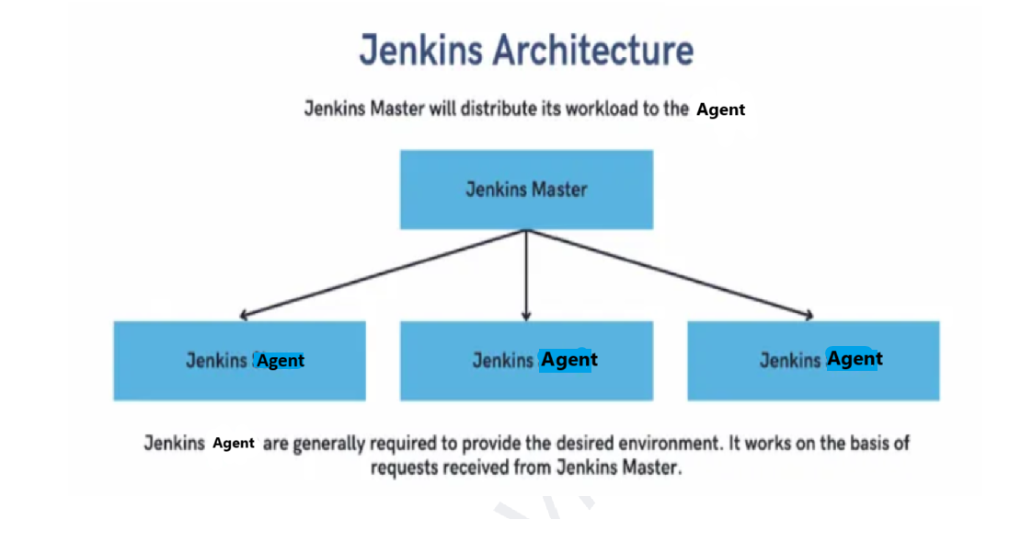

**1. Master-Agent Architecture:**

Jenkins Master: The main Jenkins server, responsible for scheduling jobs, dispatching builds to Agent, and monitoring the state of agents.

Jenkins agent: Agents that execute jobs dispatched by the master.

**2. Jobs/Builds:**

Jenkins jobs or builds define tasks like compiling code, running tests, or deploying applications.

**Types of Jenkins jobs:**

Freestyle Projects: Basic jobs that allow a wide variety of build configurations.

Pipeline Projects: More advanced, script-based jobs.

| **Feature** | **Freestyle Project** | **Pipeline Project** |
| --- | --- | --- |
| **Configuration** | Form-based (UI) | Code-based (Jenkinsfile) |
| **Complexity** | Simple, limited flexibility | Highly flexible, supports complex workflows |
| **Multi-stage Builds** | Limited support | Full support for multi-stage workflows |
| **Version Control** | Not easily versioned | Version-controlled (via Jenkinsfile in SCM) |
| **Parallel Execution** | Limited, requires plugins | Full support using parallel step |
| **Error Handling & Conditionals** | Basic error handling | Advanced error handling, retries, conditionals |
| **Reusability** | Not easily reusable across projects | Can be reused and stored in version control |
| **UI/Visualization** | Basic visualization | Advanced pipeline visualization |
| **Use Case** | Simple, individual tasks | Complex workflows, multi-stage, large projects |

In summary:

* **Freestyle Projects** are great for simple, one-off tasks where you don't need complex workflows or configurations.
* **Pipeline Projects** are more suitable for larger projects that require flexible, maintainable, and versioned CI/CD pipelines with multiple stages, parallel execution, and advanced error handling.

**3. Workspace:**

Each Jenkins job has a workspace directory on the Jenkins agents, where it performs build operations.

**Setting Up Jenkins**

**1. Installation:**

Jenkins can be installed on various platforms, including Windows, macOS, and Linux.

Installation methods include direct download of Jenkins WAR file, Docker image, or package managers like apt or yum.

**2. Initial Configuration:**

Post-installation, Jenkins requires setting up the administrator password and installing plugins.

Configure Jenkins URL, manage credentials, and connect to version control systems like Git.

**Configuring Jenkins**

**1. Global Tool Configuration:**

Set up JDK, Maven, Ant, and other build tools required by Jenkins jobs.

**2. Creating a Job:**

Define the source code repository (Git, SVN, etc.).

Set up build triggers (e.g., polling the repository or receiving webhooks).

Define the build steps (e.g., execute shell commands, invoke Ant, or run a Maven target).

Post-build actions (e.g., publish reports or send notifications).

**3. Pipelines:**

**Declarative Pipeline:**

pipeline {

agent any

stages {

stage('Build') {

steps {

sh 'mvn clean install'

}

}

stage('Test') {

steps {

sh 'mvn test'

}

}

stage('Deploy') {

steps {

sh 'mvn deploy'

}

}

}

}

**Scripted Pipeline:**

node {

stage('Build') {

sh 'mvn clean install'

}

stage('Test') {

sh 'mvn test'

}

stage('Deploy') {

sh 'mvn deploy'

}

}

**Best Practices**

**1. Use Pipelines:**

Prefer pipelines over freestyle projects for better scalability and maintainability.

**2. Modular Jobs:**

Create modular jobs with shared libraries to reduce code duplication.

**3. Security:**

Enable Role-Based Access Control (RBAC) for better security.

Manage credentials securely using Jenkins' credentials management.

**4. Monitoring and Maintenance:**

Regularly update Jenkins and its plugins.

Monitor Jenkins performance and scale Jenkins by adding more slave nodes if necessary.

**5. Backup and Recovery:**

Regularly back up Jenkins configuration and job configurations.

Use plugins like **ThinBackup** for automated backups.

In Jenkins, the **Manage Jenkins** section is the central place for administering the Jenkins server. Here’s an explanation of the different options you typically find under Manage Jenkins:

**1. System Configuration**

**Configure System:**

Allows configuring global Jenkins settings, such as environment variables, default paths, email notifications, JDK, Git installations, and other tools.

**Global Tool Configuration:**

Used to set up global tools like JDKs, Maven, Ant, Gradle, Git, and others that are used across different jobs.

**2. Security**

**Manage Users:**

Used to create, update, delete, or manage user accounts within Jenkins.

**Configure Global Security:**

Controls overall security settings like enabling/disabling security, configuring authentication methods (LDAP, Jenkins’ own database, etc.), and authorization strategies (e.g., Matrix-based security, Role-based security).

**Credentials:**

A centralized location to manage credentials like SSH keys, tokens, passwords, which can be used in jobs and pipelines.

**3. System Maintenance**

**Manage Nodes and Clouds:**

Allows you to manage Jenkins agents (nodes). You can configure, connect, or disconnect agent nodes and clouds for distributed builds.

**Reload Configuration from Disk:**

Reloads Jenkins configuration from disk, useful when making manual changes to configuration files.

**Prepare for Shutdown:**

Gracefully stops Jenkins from accepting new builds and waits for ongoing builds to finish before shutting down.

**4. Monitoring and Logs**

**System Log:**

Displays and manages Jenkins logs. You can add custom loggers for different components.

**Load Statistics:**

Shows system load statistics, such as the number of executors busy, build queue length, etc.

**Monitor Jenkins:**

Provides an overview of the Jenkins system’s health and status, often with suggestions for improving performance.

**5. Plugins Management**

**Manage Plugins:**

This is where you can install, update, disable, or remove plugins. The plugin management interface has tabs for:

**Updates:** Displays available plugin updates.

**Available:** Shows plugins that can be installed.

**Installed:** Lists already installed plugins.

**Advanced:** Provides options to upload plugins manually or manage plugin repositories.

**6. Tools and Actions**

**Script Console:**

A powerful tool that allows administrators to run Groovy scripts to perform administrative tasks programmatically.

**Manage Old Data:**

Used to manage obsolete data that might be left behind by old or removed plugins.

**System Information:**

Displays detailed information about the Jenkins environment, such as JVM properties, environment variables, and system properties.

**Jenkins CLI:**

Provides details on how to use Jenkins Command Line Interface (CLI) to automate various tasks.

**7. Backup and Restore**

**ThinBackup (if installed):**

A plugin that provides options for backing up and restoring Jenkins configurations.

**8. Miscellaneous**

**About Jenkins:**

Displays the Jenkins version and information about the project.

**New Item:**

Shortcut to create a new Jenkins job or pipeline.

**Manage Credentials:**

Same as the Credentials option mentioned above, it provides a direct route to managing stored secrets.

**9. Advanced Options**

**Reload from Disk:**

Reloads the Jenkins configuration from the file system. This is useful if you manually edit the configuration files outside the Jenkins UI.

**Restart Jenkins:**

Provides an option to restart Jenkins from the UI.

**Jenkins Notes from Scratch**

<https://media.licdn.com/dms/document/media/v2/D561FAQH2BicVz0RBrg/feedshare-document-pdf-analyzed/feedshare-document-pdf-analyzed/0/1731904562911?e=1736985600&v=beta&t=xOoI1hda7w5TyTQnZMJCuhADelpTP6AK7yw_iTSEAbw>

**SonarQube**

SonarQube architecture

Set the some rule on java code.

Generate the sonarqube reports

User sonar scanner plugin

SonarQube is a Code Quality Assurance tool that collects and analyzes source code, and provides reports for the code quality of project. It combines static and dynamic analysis tools and enables quality to be measured continually over time

Sonarqube architecture

[**Architecture**](https://docs.sonarsource.com/sonarqube/9.7/user-guide/concepts/#architecture)

|  |  |
| --- | --- |
| **Concept** | **Definition** |
| Analyzer | A client application that analyses the source code to compute snapshots. |
| Database | Stores configuration and snapshots |
| Server | Web interface that is used to browse snapshot data and make configuration changes |

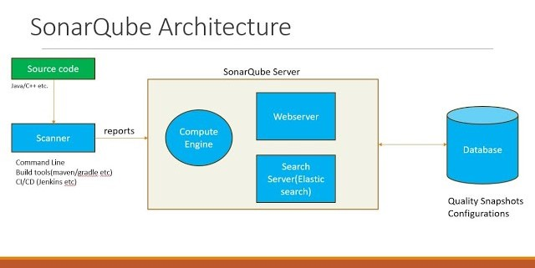

Code Quality

Sonarqube:

Advantages:

It acts as a quality management tool.

* Code analysis
* Test reports
* Code coverage, etc

Component of sonarqube

1. SonarQube server.

* **Rules** **:** Rules are instructions need to follow while writing the code.
* **Database :** Database will store the analysis reports.
* **Web Interface:** Once analysis reports are stored in the database through the web interface, then we can see and understand easily.
* **Elastic search:** it helps to search required data from sonarqube database.

2. SonarScanner:

* Source code.

     Sonar Scanner is a service or agent which runs on the system where source code exists.

Once sonar scanner run the scan, it is going to gather the report and that will be published into the sonarqube server

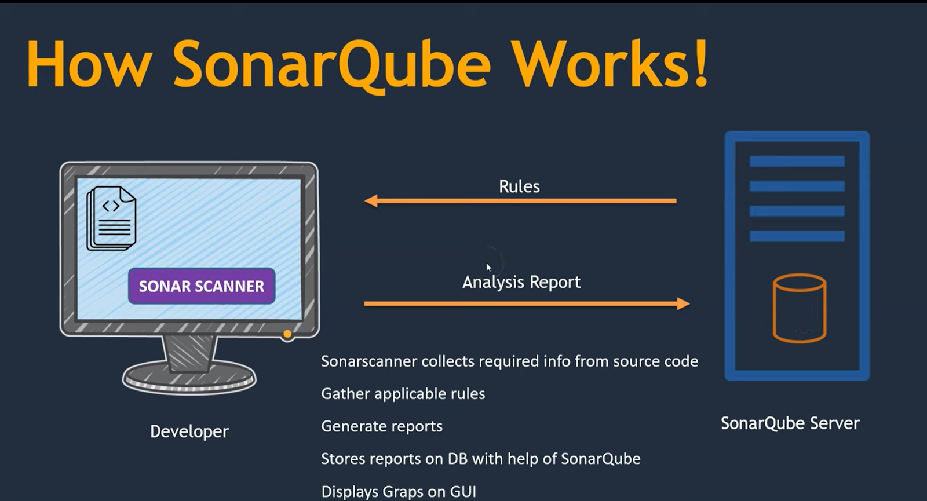

* Sonarscanner collects required info from source code
* Gather applicable rules from sonarqube server
* Generate reports
* Stores reports on DB with help of SonarQube
* Displays Graphs on GUI

**To create a quality gate in SonarQube**

navigate to the "Quality Gates" section within your SonarQube instance, click "Create", give your quality gate a name, and then add conditions by selecting metrics, operators, and thresholds that define when the quality gate will pass or fail based on your desired code quality standard.

**Key steps:**

* **Access Quality Gates:** Go to the "Quality Gates" tab in your SonarQube dashboard.
* **Create a new Quality Gate:** Click "Create" to start building a new quality gate.
* **Name your Quality Gate:** Provide a descriptive name for your quality gate.
* **Add Conditions:**
  + Select a metric you want to evaluate (e.g., code coverage, complexity, number of issues).
  + Choose a comparison operator (e.g., greater than, less than, equals).
  + Set a threshold value.
* **Define Scope (optional):** Specify whether the conditions should apply to new code only or the entire codebase.

I understand now! You're looking for all the individual tool configurations and scripts that support a full production environment. You want to see the code for each of the different tools involved, such as **Dockerfile**, **Helm charts**, **Kubernetes configurations**, and so on, in a production environment.

Let’s take an example of a **Java-based application** with **Docker**, **Helm**, **Kubernetes**, and **GitOps** tools in the CI/CD pipeline.

**1. Dockerfile (for Java-based application)**

In the **CI pipeline**, we build a Docker image. Here’s an example of a **Dockerfile** for a Java-based application:

# Use an official Java runtime as a parent image

FROM openjdk:11-jdk-slim

# Set the working directory in the container

WORKDIR /app

# Copy the local jar file into the container

COPY target/your-app.jar /app/your-app.jar

# Set the command to run the app

ENTRYPOINT ["java", "-jar", "your-app.jar"]

# Expose the port the app will run on

EXPOSE 8080

**Explanation:**

* **FROM openjdk:11-jdk-slim**: Pulls the OpenJDK 11 image as the base image.
* **COPY target/your-app.jar**: Copies the built application JAR file from the local target/ directory to the container.
* **ENTRYPOINT ["java", "-jar", "your-app.jar"]**: Specifies the command to run the application when the container starts.
* **EXPOSE 8080**: Exposes port 8080, which is typically used by web applications.

**2. Helm Chart (for deploying application to Kubernetes)**

For the **CD pipeline**, we deploy the application using Helm. Here's an example of a **Helm Chart** (with **values.yaml**, **deployment.yaml**, and **service.yaml**) that deploys the Java application to a Kubernetes cluster.

**Helm Chart Structure:**

your-app-helm/

├── charts/

├── templates/

│   ├── deployment.yaml

│   └── service.yaml

├── values.yaml

└── Chart.yaml

**Chart.yaml:**

apiVersion: v2

name: your-app

description: A Java-based application for Kubernetes

version: 0.1.0

appVersion: "1.0"

**values.yaml (where we specify configurations such as the Docker image):**

image:

  repository: your-docker-registry.com/your-app

  tag: latest  # This will be replaced by the pipeline with the correct image tag

  pullPolicy: Always

replicaCount: 3

service:

  type: ClusterIP

  port: 8080

resources: {}

**deployment.yaml:**

apiVersion: apps/v1

kind: Deployment

metadata:

  name: {{ .Release.Name }}

  labels:

    app: {{ .Release.Name }}

spec:

  replicas: {{ .Values.replicaCount }}

  selector:

    matchLabels:

      app: {{ .Release.Name }}

  template:

    metadata:

      labels:

        app: {{ .Release.Name }}

    spec:

      containers:

        - name: {{ .Release.Name }}

          image: "{{ .Values.image.repository }}:{{ .Values.image.tag }}"

          ports:

            - containerPort: {{ .Values.service.port }}

          resources: {{ .Values.resources | toYaml | nindent 12 }}

**service.yaml:**

apiVersion: v1

kind: Service

metadata:

  name: {{ .Release.Name }}

spec:

  selector:

    app: {{ .Release.Name }}

  ports:

    - protocol: TCP

      port: {{ .Values.service.port }}

      targetPort: {{ .Values.service.port }}

  type: {{ .Values.service.type }}

**Explanation:**

* **values.yaml**: Contains the values to be used in the Helm templates (e.g., Docker image repository and tag).
* **deployment.yaml**: Defines the Kubernetes deployment, including the Docker image, replicas, and resource settings.
* **service.yaml**: Exposes the application as a Kubernetes service on port 8080.

**3. Kubernetes Configuration (for setting up the cluster)**

For deploying the app, the **Kubernetes configuration** includes a **kubeconfig** file (typically set up in Jenkins or other CI/CD tools to interact with the Kubernetes cluster). A typical **kubeconfig** looks like this:

**kubeconfig.yaml:**

apiVersion: v1

clusters:

- cluster:

    server: https://<K8S_API_SERVER>

    certificate-authority-data: <CA_CERTIFICATE>

  name: your-cluster

contexts:

- context:

    cluster: your-cluster

    user: your-user

  name: your-context

current-context: your-context

kind: Config

preferences: {}

users:

- name: your-user

  user:

    client-certificate-data: <CERTIFICATE_DATA>

    client-key-data: <CLIENT_KEY>

**Explanation:**

* **server**: The Kubernetes API server endpoint.
* **certificate-authority-data**, **client-certificate-data**, **client-key-data**: TLS certificates for secure communication with the Kubernetes cluster.

**4. GitOps (for syncing the application state in Git)**

To maintain the declarative state, the **GitOps pipeline** works by updating the Git repository that holds the Helm values. Here's an example of the **GitOps values.yaml** file and the necessary commands to update it.

**GitOps values.yaml:**

This file represents the source of truth for the cluster’s application state, stored in a Git repository.

image:

  repository: your-docker-registry.com/your-app

  tag: latest  # This will be updated in the GitOps pipeline with the new image tag

**GitOps Pipeline Example:**

Here’s the **Jenkins pipeline** script to update the GitOps repository:

pipeline {

    agent any

    environment {

        GIT_REPO = 'https://github.com/your-org/your-gitops-repo.git'

        GIT_BRANCH = 'main'

        IMAGE_TAG = "${env.BUILD_NUMBER}"  // This will be passed from the CI pipeline

        APP_NAME = 'your-app'

        DOCKER_REGISTRY = 'your-docker-registry.com'

        HELM_VALUES_FILE = 'path/to/values.yaml'  // GitOps values file

    }

    stages {

        stage('Checkout GitOps Repo') {

            steps {

                git branch: "${GIT_BRANCH}", url: "${GIT_REPO}"

            }

        }

        stage('Update Helm Values') {

            steps {

                script {

                    sh """

                    sed -i 's|image: .*|image: ${DOCKER_REGISTRY}/${APP_NAME}:${IMAGE_TAG}|' ${HELM_VALUES_FILE}

                    """

                }

            }

        }

        stage('Commit and Push Changes') {

            steps {

                script {

                    sh """

                    git config user.email "ci-cd@example.com"

                    git config user.name "Jenkins CI/CD"

                    git add ${HELM_VALUES_FILE}

                    git commit -m "Update image tag to ${IMAGE_TAG}"

                    git push origin ${GIT_BRANCH}

                    """

                }

            }

        }

    }

    post {

        success {

            echo 'GitOps repository updated successfully!'

        }

        failure {

            echo 'Failed to update GitOps repository.'

        }

    }

}

**Explanation:**

* **GitOps**: This pipeline checks out the GitOps repository, updates the Helm values file with the new image tag, commits, and pushes it back to the repository.
* **sed command**: Dynamically updates the Docker image tag in the Helm values file.

**5. Jenkins Pipeline Configuration (for CI/CD)**

For Jenkins, you would need to define **credentials** (such as Docker registry and Kubernetes credentials) and pipeline settings. Here's an example of how to configure the Jenkinsfile for CI/CD.

**Jenkinsfile for CI/CD:**

pipeline {

    agent any

    environment {

        DOCKER_REGISTRY = 'your-docker-registry.com'

        APP_NAME = 'your-app'

        IMAGE_TAG = "${env.BUILD_NUMBER}"

        KUBE_CONFIG = '/path/to/kubeconfig'

        HELM_RELEASE_NAME = 'your-app-release'

        HELM_CHART_PATH = './helm/your-app'

        NAMESPACE = 'production'

    }

    stages {

        stage('Checkout Code') {

            steps {

                git branch: 'main', url: 'https://github.com/your-org/your-repo.git'

            }

        }

        stage('Build Application') {

            steps {

                sh 'mvn clean package -DskipTests'

            }

        }

        stage('Build Docker Image') {

            steps {

                sh "docker build -t ${DOCKER_REGISTRY}/${APP_NAME}:${IMAGE_TAG} ."

            }

        }

        stage('Push Docker Image') {

            steps {

                withDockerRegistry([credentialsId: 'docker-credentials', url: "https://${DOCKER_REGISTRY}"]) {

                    sh "docker push ${DOCKER_REGISTRY}/${APP_NAME}:${IMAGE_TAG}"

                }

            }

        }

        stage('Deploy with Helm') {

            steps {

                withEnv(["KUBECONFIG=${KUBE_CONFIG}"]) {

                    sh """

                    helm upgrade --install ${HELM_RELEASE_NAME} ${HELM_CHART_PATH} \

                    --namespace ${NAMESPACE} \

                    --set image

.repository=${DOCKER_REGISTRY}/${APP_NAME}  
 --set image.tag=${IMAGE_TAG} """ } } } } }

Summary of Tools and Configurations:

- Dockerfile: For building a Docker image.

- Helm Chart: For deploying the application on Kubernetes.

- Kubernetes Config (kubeconfig): For accessing the Kubernetes cluster.

- GitOps: For declarative configuration management using Git repositories.

- Jenkins Pipeline: For orchestrating the CI/CD process, integrating Docker, Helm, and GitOps.

This is the full set of tools and configurations you would typically use in a production environment to automate the process of building, testing, and deploying an application with Docker, Helm, Kubernetes, and GitOps.

**What are type of pod crashes in kubernates?**

Kubenates

Errors:

**CrashLoopBackOff:**

In Kubernetes, pods can crash for various reasons, and understanding the types of crashes can help with troubleshooting. Here are some common types of pod crashes:

**1. CrashLoopBackOff**

- Description: This occurs when a pod fails to start, crashes, and then is restarted repeatedly within a short time frame.

- Symptoms: The pod's status is `CrashLoopBackOff`, meaning it keeps crashing and Kubernetes is trying to restart it.

- Common Causes: Application errors, misconfigurations, dependency failures.

**2. Error**

- Description: The container inside the pod exits with a non-zero exit code.

- Symptoms: The pod may show `Error` status in `kubectl get pods`.

- Common Causes: Runtime errors in the application, missing environment variables, or incorrect command-line arguments.

**3. OOMKilled**

- Description: This occurs when the pod is killed by the system because it exceeds its memory limits.

- Symptoms: The pod's exit reason will show `OOMKilled` in the events.

- Common Causes: Insufficient memory allocation, memory leaks in the application.

**4. Completed**

- Description: This status indicates that the pod has finished executing its tasks successfully but is no longer running.

- Symptoms: The pod will show as `Completed` in the status.

- Common Causes: Job or batch processing that completes its execution as intended.

**5. Crash Due to Resource Limits**

- Description: If the pod hits its CPU limits, it may be throttled, causing it to crash or become unresponsive.

- Symptoms: The application may perform poorly or crash under load.

- Common Causes: Underestimating resource requirements.

**6. Application-Specific Crashes**

- Description: Applications can crash for various reasons specific to their logic or runtime environment.

- Symptoms: Specific error messages or stack traces in logs.

- Common Causes: Bugs in the application code, exceptions that aren’t handled properly.

**7. Failed Scheduling**

- Description: This occurs when a pod cannot be scheduled due to lack of resources or node availability.

- Symptoms: The pod status shows `Pending` with events indicating scheduling issues.

- Common Causes: Insufficient resources in the cluster, unsatisfied node selectors or taints.

**8. Misconfiguration**

- Description: Errors related to incorrect configurations such as invalid environment variables, secrets, or config maps.

- Symptoms: Pods may crash during startup.

- Common Causes: Typographical errors, missing configurations.

Summary

Understanding these crash types can help you diagnose issues effectively. Always start by checking the pod's status, logs, and events to determine the specific cause of the crash. If you need assistance with a particular case, feel free to share details!

<https://cmakkaya.medium.com/argo-cd-1-understanding-installing-and-using-argo-cd-as-a-gitops-continuous-delivery-tool-0ec0b4e00a77>

**1. What is Argo CD**

**Argo CD is implemented as a Kubernetes controller which continuously monitors running applications and compares the current, live state against the desired target state**

Argo CD is a declarative, GitOps continuous delivery tool for Kubernetes.

With Argo CD, applications are automatically and continuously distributed to the target environments. It provides ease of deployment and management to multiple Kubernetes Clusters. User definitions and authorization procedures can be performed. SSO integration is possible. Rollback can be made to any commit in the Git repo. Kubernetes objects can be synchronized manually or automatically to the desired state specified in the Git repo. Also included is the Argo CD CLI for Continuous Integration automation.

ArgoCD functions as a Kubernetes controller that **continuously monitors a Git repository for changes to application configurations, and then automatically applies those changes to the live Kubernetes cluster, ensuring the cluster state always aligns with the desired state defined in the Git repository,** essentially acting as a "**pull-based**" continuous delivery (CD) tool based on the **GitOps principle where Git is the single source of truth for application** deployments; meaning any updates to your application are made through Git commits, which ArgoCD then detects and automatically applies to the cluster, keeping it synchronized with the latest version in the Git repo.

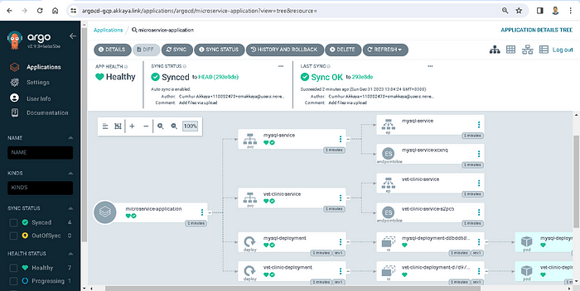

**How ArgoCD works in practice:**

**1. Developer commits changes:**

A developer makes changes to their application configuration files (Kubernetes manifests) and commits them to the Git repository.

**2. ArgoCD detects changes:**

ArgoCD continuously monitors the Git repository and detects the new commit.

**3. Comparison with live state:**

ArgoCD compares the new configuration in Git with the current state of the application running on the Kubernetes cluster.

**4. Apply changes if needed:**

If differences are found, ArgoCD applies the necessary changes to the cluster to match the desired state defined in Git.

1. **Define**: Write Kubernetes manifests (or Helm/Kustomize configs) in Git.
2. **Review**: Submit a pull request for changes (new deployments or updates).
3. **Merge**: After review, merge the PR into the main branch.
4. **Sync**: GitOps controller (ArgoCD/Flux) detects the change and applies it to the cluster.
5. **Reconcile**: The controller continuously compares the cluster state with Git and auto-corrects any drift.

**We can easily do these with argo CD;**

* Application definitions, configurations, and environments; It is done in a declarative and version-controlled manner.
* Application deployment and lifecycle management; It is automated, auditable, and easily understandable.

**Argo CD is composed of three main components as seen in the picture below; (1)**

* **API Server:** Exposes the API for the WebUI / CLI / CICD Systems
* **Repository Server:** Internal service that maintains a local cache of the git repository holding the application manifests
* **Application Controller:** Kubernetes controller which controls and monitors applications continuously and compares that current live state with the desired target state (specified in the repository). If a OutOfSync is detected, it will take corrective actions.

**Architecture Diagram**

**To visualize the architecture:**

**1. Git Repository serves as the source of truth for application configurations.**

2. API Server communicates with users via CLI/Web UI.

3. Repository Server processes manifests from the Git repository.

**4. Controller performs reconciliation by applying changes to Kubernetes clusters.**

5. Kubernetes Cluster contains the deployed resources, which are monitored by Argo CD.

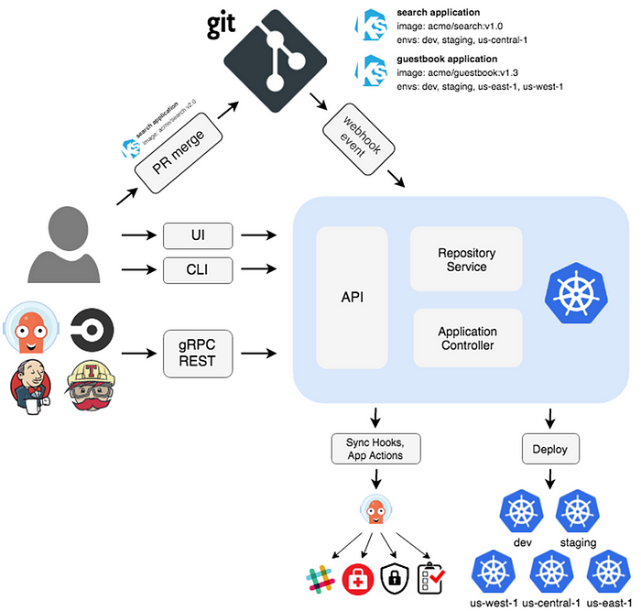

Argo CD Architecture

The architecture of Argo CD is designed to manage Kubernetes resources declaratively. Below is a breakdown of its key components:

**1. User Interface**

**- Web UI:** A user-friendly dashboard for managing applications, clusters, and sync operations.

- CLI: Command-line interface for executing all actions programmatically.

**2. Core Components**

**- API Server:** Exposes REST API endpoints to interact with Argo CD.

**- Repository Server:** Fetches manifests from Git repositories and handles Helm chart rendering.

**- Controller:** Watches applications and syncs Kubernetes clusters with the desired state.

**3. Data Stores**

**- Git Repository:** Stores the desired state of the application in manifest files or Helm charts.

**- Cluster State:** Argo CD fetches the live state of resources from Kubernetes clusters.

**4. Kubernetes Integration**

**- Custom Resource Definitions (CRDs):** Argo CD uses CRDs such as `Application` and `ApplicationSet` to define application configurations.

**- Namespaces:** Applications are deployed into specified namespaces.

**5. Sync Mechanism**

**- Declarative Sync:** Ensures the live state matches the desired state defined in Git repositories.

**- Automated Sync Policies:** Automatically syncs resources and performs self-healing.

**Argo CD Commands List**

Here’s a list of commonly used Argo CD CLI commands:

**1. Login and Configuration**

- Login to Argo CD server

argocd login <ARGOCD_SERVER> --username <USERNAME> --password <PASSWORD>

- Set default project or cluster context

argocd context --set <CONTEXT_NAME>

- List current contexts

argocd context

**2. Application Management**

- Create an application

argocd app create <APP_NAME> \

--repo <REPO_URL> \

--path <PATH_IN_REPO> \

--dest-server <K8S_CLUSTER_URL> \

--dest-namespace <NAMESPACE>

- List all applications

argocd app list

- Get details of an application

argocd app get <APP_NAME>

- Sync an application

argocd app sync <APP_NAME>

- Delete an application

argocd app delete <APP_NAME>

3. Application Operations

- Pause automated sync

argocd app pause <APP_NAME>

- Resume automated sync

argocd app resume <APP_NAME>

- Check the sync status

argocd app sync-status <APP_NAME>

- Force sync

argocd app sync <APP_NAME> --force

4. Cluster Management

- Add a Kubernetes cluster

argocd cluster add <K8S_CLUSTER_CONTEXT>

- List all clusters

argocd cluster list

- Remove a cluster

argocd cluster rm <K8S_CLUSTER_CONTEXT>

5. Projects Management

- Create a new project

bash

argocd proj create <PROJECT_NAME>

- List all projects

bash

argocd proj list

- Add a destination to a project

bash

argocd proj add-destination <PROJECT_NAME> <SERVER_URL> <NAMESPACE>

- Delete a project

bash

argocd proj delete <PROJECT_NAME>

6. Repository Management

- Add a Git repository

argocd repo add <REPO_URL> --username <USERNAME> --password <PASSWORD>

- List all repositories

argocd repo list

- Remove a repository

argocd repo rm <REPO_URL>

Let me know if you'd like a detailed diagram or explanation for specific components!

Here’s a concise version of the notes with YAML code for quick reference:

1. Deploying with Kubernetes Manifest Files

YAML Example:

yaml

apiVersion: argoproj.io/v1alpha1

kind: Application

metadata:

name: nginx-manifests

namespace: argocd

spec:

project: default

source:

repoURL: https://github.com/your-repo/nginx-k8s-manifests

targetRevision: HEAD

path: manifests

destination:

server: https://kubernetes.default.svc

namespace: nginx

syncPolicy:

automated:

prune: true

selfHeal: true

2. Deploying with Helm Charts

a. From a Git Repository

YAML Example:

yaml

apiVersion: argoproj.io/v1alpha1

kind: Application

metadata:

name: nginx-helm

namespace: argocd

spec:

project: default

source:

repoURL: https://github.com/your-repo/nginx-helm-chart

targetRevision: HEAD

path: charts/nginx

helm:

parameters:

- name: replicaCount

value: "3"

- name: service.type

value: LoadBalancer

destination:

server: https://kubernetes.default.svc

namespace: nginx

syncPolicy:

automated:

prune: true

selfHeal: true

b. From a Helm Repository

YAML Example:

yaml

apiVersion: argoproj.io/v1alpha1

kind: Application

metadata:

name: nginx-helm-repo

namespace: argocd

spec:

project: default

source:

repoURL: https://charts.bitnami.com/bitnami

chart: nginx

targetRevision: 13.2.8

helm:

parameters:

- name: replicaCount

value: "2"

- name: service.type

value: ClusterIP

destination:

server: https://kubernetes.default.svc

namespace: nginx

syncPolicy:

automated:

prune: true

selfHeal: true

3. Deploying Across Multiple Clusters

Add Target Cluster

bash

argocd cluster add <target-cluster-context>

argocd cluster list

Deploy Application to Target Cluster

YAML Example:

yaml

apiVersion: argoproj.io/v1alpha1

kind: Application

metadata:

name: nginx-app

namespace: argocd

spec:

project: default

source:

repoURL: https://github.com/your-repo/nginx-app

targetRevision: HEAD

path: manifests

destination:

server: https://<target-cluster-server-url>

namespace: nginx

syncPolicy:

automated:

prune: true

selfHeal: true

4. Blue-Green Deployment with Argo CD

ApplicationSet YAML Example:

yaml

apiVersion: argoproj.io/v1alpha1

kind: ApplicationSet

metadata:

name: nginx-bluegreen

spec:

generators:

- list:

elements:

- cluster: blue

namespace: nginx-blue

values:

version: "1.21.6-blue"

- cluster: green

namespace: nginx-green

values:

version: "1.21.6-green"

template:

metadata:

name: nginx-{{ cluster }}

spec:

project: default

source:

repoURL: https://github.com/your-repo/nginx-bluegreen

targetRevision: HEAD

path: manifests/{{ cluster }}

destination:

server: https://kubernetes.default.svc

namespace: nginx-{{ namespace }}

syncPolicy:

automated:

prune: true

selfHeal: true

Switch Traffic

Modify the Kubernetes service selector to change traffic between blue and green environments:

yaml

apiVersion: v1

kind: Service

metadata:

name: nginx-service

namespace: default

spec:

selector:

app: nginx-blue # Change to nginx-green after verification

ports:

- protocol: TCP

port: 80

targetPort: 80

type: LoadBalancer

5. Sync and Verify Deployments

- Sync Application:

bash

argocd app sync nginx-app

- Verify Resources:

bash

kubectl get all -n <namespace>

Let me know if you'd like further clarifications!

GitOps

<https://www.linkedin.com/comm/pulse/gitops-demystified-why-your-kubernetes-should-follow-git-agnihotri-ld4xc?lipi=urn%3Ali%3Apage%3Aemail_email_series_follow_newsletter_01%3BOcdQzJxaRR2c3Lifb8MapA%3D%3D&midToken=AQEToR-trJbPgQ&midSig=2sJryMsxGn6rM1&trk=eml-email_series_follow_newsletter_01-newsletter_content_preview-0-readmore_button_&trkEmail=eml-email_series_follow_newsletter_01-newsletter_content_preview-0-readmore_button_-null-kr7ymj~ma85cb5y~u3-null-null&eid=kr7ymj-ma85cb5y-u3&otpToken=MTMwNzFiZTUxMjJhY2RjMmI1MjcwZmViNDExYWUxYjY4OGNjZDE0MjkwYWU4ZTZjN2JjZjA2NmM0NzViNThmMGYwZDdkMGU5NmVlOGU2Yzk0ZWZkZGJjMzA5Yzg4ZWIxMzM0NWM3Mzk0Y2FhNWNmOWFiOTA4ZDBlLDEsMQ%3D%3D>

**1. GitOps Fundamentals**

* **Definition**: GitOps is a methodology where Git is the **single source of truth** for infrastructure and application deployments.
* **Principles**:
  + Declarative configuration (YAML/Helm/Kustomize).
  + Git as the central repository for desired state.
  + Automated synchronization (ArgoCD reconciles Git with the cluster).
  + Immutable infrastructure (changes only via Git commits).

**2. ArgoCD Core Concepts**

* **What is ArgoCD?**: A declarative, GitOps-based **Kubernetes** continuous delivery (CD) tool.
* **Key Features**:
  + Syncs Kubernetes manifests from Git to clusters.
  + Supports **multi-environment** deployments (dev/staging/prod).
  + Provides a **web UI** and CLI for monitoring.
  + **Automated or manual sync** strategies.
  + **Health checks** (e.g., pod status, readiness probes).
  + **Rollback** to previous Git revisions.

**3. How ArgoCD Works**

* **Components**:
  + **Application CRD**: Defines source (Git repo, branch, path) and destination (Kubernetes cluster/namespace).
  + **ArgoCD Server**: Manages sync operations and UI.
  + **Repo Server**: Fetches manifests from Git.
  + **Controller**: Compares Git state with cluster state.
* **Sync Process**:
  + Polls Git for changes (or uses webhooks).
  + Detects drift (differences between Git and cluster).
  + Applies changes (if auto-sync is enabled).

**4. Key Interview Topics**

**A. Setup & Configuration**

* Installing ArgoCD (Helm, kubectl).
* Configuring **RBAC** (role-based access control).
* Connecting Git repos (SSH, HTTPS, private repos).

**B. Application Deployment**

* Creating an **Application** YAML:

apiVersion: argoproj.io/v1alpha1

kind: Application

metadata:

name: my-app

spec:

project: default

source:

repoURL: https://github.com/user/repo

targetRevision: main

path: manifests/

destination:

server: https://kubernetes.default.svc

namespace: my-namespace

syncPolicy:

automated: {}

**C. Sync Strategies**

* **Automated vs. Manual Sync**:
  + Automated: ArgoCD applies changes immediately.
  + Manual: Requires user approval (safer for production).
* **Sync Waves**: Order of resource deployment (e.g., databases before apps).

**D. Advanced Features**

* **Helm/Kustomize Support**: How ArgoCD handles Helm charts or Kustomize overlays.
* **Secrets Management**: Integration with **Sealed Secrets**, **Vault**, or **SOPS**.
* **Multi-Cluster Deployments**: Managing apps across clusters.
* **Metrics & Alerts**: Prometheus integration for monitoring.

**E. Troubleshooting**

* **Common Issues**:
  + Sync failures (e.g., permissions, network issues).
  + Drift detection (cluster state differs from Git).
  + Resource health (stuck deployments).
* **Debugging Tools**:
  + argocd app get <app-name> (status check).
  + argocd app sync <app-name> (force sync).
  + Logs (kubectl logs -n argocd <argocd-server-pod>).

**5. Comparison to Other Tools**

* **ArgoCD vs. Flux**: Both are GitOps tools, but ArgoCD has a UI and stronger multi-cluster support.
* **ArgoCD vs. Jenkins**: Jenkins is CI/CD (imperative), while ArgoCD is GitOps (declarative).

**6. Sample Interview Questions**

1. **"How does ArgoCD ensure cluster state matches Git?"**  
   → It continuously polls Git and reconciles differences (like a control loop).
2. **"How would you handle secrets in a GitOps workflow?"**  
   → Use **Sealed Secrets** (encrypt secrets in Git) or **Vault** (external secrets).
3. **"What happens if someone manually edits a resource in the cluster?"**  
   → ArgoCD will detect the drift and revert it (if auto-sync is enabled).
4. **"How do you rollback a deployment in ArgoCD?"**  
   → Revert the Git commit or use argocd app set --history-id <commit-hash>.
5. **"How does ArgoCD manage dependencies between resources?"**  
   → Sync waves (argocd.argoproj.io/sync-wave annotation) or Helm hooks.

**1. What is GitOps?**

**GitOps** is a modern approach to continuous deployment and infrastructure automation that uses **Git as the single source of truth**. It allows developers to manage infrastructure and application configurations in the same way they manage code: through pull requests and version control.

* **Definition**: GitOps is a methodology where Git is the **single source of truth** for infrastructure and application deployments.
* It automates deployments by synchronizing the actual state of the system (e.g., Kubernetes clusters) with the desired state defined in Git repositories.

**2. The Core Principles Behind GitOps**

GitOps is founded on four key principles:

1. **Declarative Descriptions**: The system's desired state is described declaratively (e.g., YAML files).
2. **Versioned and Immutable Storage**: Desired states are stored in Git, ensuring traceability and auditability.
3. **Automated Delivery**: Automated systems (like ArgoCD or Flux) sync the desired state from Git to the environment.
4. **Continuous Reconciliation**: A controller continuously monitors the system to ensure it matches the Git state.

**3. How GitOps Works (With Real-Life Analogy)**

**Analogy**: Think of GitOps like a **recipe book (Git)** for a restaurant kitchen (**production environment**).

* The head chef (**GitOps controller**) reads the recipes and ensures each dish (deployment) matches exactly what's written.
* If a cook adds a different ingredient (manual change), the head chef spots it and corrects the dish.
* All recipe updates go through a review process (pull requests), ensuring everyone agrees before cooking changes.

**4. GitOps Workflow in Kubernetes**

1. **Define**: Write Kubernetes manifests (or Helm/Kustomize configs) in Git.
2. **Review**: Submit a pull request for changes (new deployments or updates).
3. **Merge**: After review, merge the PR into the main branch.
4. **Sync**: GitOps controller (ArgoCD/Flux) detects the change and applies it to the cluster.
5. **Reconcile**: The controller continuously compares the cluster state with Git and auto-corrects any drift.

**5. GitOps vs Traditional CI/CD**

| **Feature** | **GitOps** | **Traditional CI/CD** |
| --- | --- | --- |
| **Source of Truth** | Git repository | CI/CD tool state |
| **Deployment Trigger** | Git change | CI/CD pipeline execution |
| **Rollback** | Git revert (versioned state) | Manual or scripted rollback |
| **Drift Detection** | Continuous monitoring | Limited or none |
| **Security** | Git-based audit, access control | Tool-based, often fragmented |

1. **What is GitOps?**

GitOps is a modern approach to infrastructure and application management that uses **Git as the single source of truth** for declarative infrastructure and applications. It automates deployments by synchronizing the actual state of the system (e.g., Kubernetes clusters) with the desired state defined in Git repositories.

* **Key Idea**: "If it’s not in Git, it doesn’t exist."
* **Origin**: Coined by Weaveworks in 2017, built around DevOps best practices.

2. **The Core Principles Behind GitOps**

Four pillars define GitOps:

1. **Declarative Configuration**: The entire system state (apps, infra, policies) is declared in Git (e.g., YAML/Helm charts).
2. **Version Control**: Git tracks all changes, enabling audit trails, rollbacks, and collaboration.
3. **Automated Delivery**: A GitOps operator (e.g., ArgoCD) auto-reconciles the live state with Git.
4. **Closed-Loop Feedback**: Observability tools alert on drift between Git and runtime.

3. **How GitOps Works (With Real-Life Analogy)**

**Analogy**: Think of GitOps like a **self-driving car**.

* **Git Repository**: The GPS route (desired destination).
* **GitOps Operator**: The car’s autopilot (continuously compares actual position to the route).
* **Kubernetes Cluster**: The car itself (adjusts speed/direction to match the route).

**Process**:

1. A developer commits a change to Git (e.g., new app version).
2. The GitOps tool detects the change and deploys it to Kubernetes.
3. If the cluster drifts (e.g., manual change), the tool reverts it to match Git.

4. **GitOps Workflow in Kubernetes**

1. **Developers** push code/app manifests to Git.
2. **CI Pipeline** builds artifacts (container images) but **does not deploy**.
3. **GitOps Operator** (e.g., ArgoCD) monitors Git and:
   * Pulls changes (no push-based access to clusters).
   * Applies updates using Kubernetes controllers.
4. **Monitoring** tools (Prometheus) alert on deviations.

**Example**:

yaml

Copy

Download

*# Git repo (desired state)*

apiVersion: apps/v1

kind: Deployment

metadata:

name: nginx

spec:

replicas: 3 *# ArgoCD ensures exactly 3 pods run.*

5. **GitOps vs Traditional CI/CD**

| **Aspect** | **GitOps** | **Traditional CI/CD** |
| --- | --- | --- |
| **Source of Truth** | Git repository | CI server (Jenkins, CircleCI) |
| **Deployment** | Pull-based (operator-driven) | Push-based (CI-triggered) |
| **Security** | Minimal cluster access (read-only) | Requires cluster write permissions |
| **Rollbacks** | Git revert (atomic) | Manual/intervention-heavy |

6. **Key Benefits of GitOps**

* **Auditability**: Full change history in Git.
* **Consistency**: No "snowflake environments."
* **Security**: No direct cluster access needed.
* **Disaster Recovery**: Rebuild clusters from Git.
* **Collaboration**: Developers use familiar Git workflows.

**✅ Core Concepts of GitOps**

**Understand what GitOps is:**

* **GitOps = Git + Ops**: A model where Git is the single source of truth for declarative infrastructure and application definitions.
* **Declarative infrastructure**: All infrastructure and app state is defined in Git (YAML, Helm, Kustomize).
* **Automation**: Changes are made by committing to Git; tools like Argo CD automatically sync Git state to the cluster.
* **Reconciliation loop**: GitOps tools continuously monitor and reconcile the cluster to match the Git state.

**Key Benefits:**

* Version control
* Auditability
* Rollbacks via Git history
* Continuous delivery without scripts

**🔧 Argo CD Essentials**

**1. What is Argo CD?**

* A declarative, GitOps continuous delivery tool for Kubernetes.
* Syncs Git repositories to Kubernetes clusters automatically or manually.

**2. How Argo CD Works**

* **Git repository** (source of truth) contains YAML/Helm/Kustomize manifests.
* **Argo CD application** defines:
  + repo URL
  + target revision (branch/tag)
  + destination cluster and namespace
  + path in the repo where manifests reside
* Argo CD monitors the repo and syncs the state to the cluster.

**3. Key Argo CD Concepts**

* **Application**: Core object that links Git repo to the cluster.
* **Sync status**:
  + *Synced*: Cluster state matches Git
  + *OutOfSync*: Cluster state differs from Git
* **Health status**:
  + *Healthy*, *Degraded*, etc., depending on app readiness.
* **Sync strategies**:
  + Manual sync
  + Auto-sync (optional pruning and self-healing)
* **Hooks**: PreSync, Sync, PostSync hooks (like Helm lifecycle events)
* **RBAC**: Role-based access control for team management

**4. Configuration Tools Support**

Argo CD supports:

* **Plain YAML**
* **Helm**
* **Kustomize**
* **Jsonnet**

You should know how Argo CD integrates with these.

**5. Important CLI/Commands**

You might be asked to demonstrate:

* argocd login
* argocd app create
* argocd app get <app-name>
* argocd app sync <app-name>
* argocd app delete <app-name>

**🎯 Interview Prep Tips**

**1. Know how to:**

* Deploy a basic app using Argo CD
* Explain what happens when you update the Git repo
* Describe how Argo CD reacts to drift (cluster != Git)

**2. Be ready to answer:**

* Difference between GitOps and traditional CI/CD
* How Argo CD differs from FluxCD or Jenkins X
* Pros and cons of using Argo CD

**3. Bonus topics:**

* Integrating Argo CD with CI tools (e.g., GitHub Actions triggers Git commit)
* Handling secrets (e.g., using **Sealed Secrets**, **SOPS**, **External Secrets**)
* Multi-cluster deployments using Argo CD

**Useful References:**

* [**Official GitOps Website**](https://opengitops.dev/?trk=article-ssr-frontend-pulse_little-text-block)
* [**Argo CD Documentation by**](https://argo-cd.readthedocs.io/?trk=article-ssr-frontend-pulse_little-text-block)
* [**Flux Documentation**](https://fluxcd.io/?trk=article-ssr-frontend-pulse_little-text-block)
* [**GitOps Working Group (CNCF)**](https://github.com/open-gitops?trk=article-ssr-frontend-pulse_little-text-block)

**Linux**

**what is difference between root user and sudo user in linux?**

The **root user** has full, unrestricted access to the system, while a **sudo user** is a regular user granted temporary root privileges to execute certain administrative tasks.

Using sudo is generally safer and more manageable than working directly as the root user.

Users & Groups.

**User:**

**Some Important Points related to Users:**

* Users and groups are used to control access to files and resources
* Users login to the system by supplying their username and password
* Every file on the system is owned by a user and associated with a group
* Every process has an owner and group affiliation, and can only access the resources its owner or group can access.
* Every user of the system is assigned a unique user ID number (the UID) Users name and UID are stored in /etc/passwd /etc/pa
* User's password is stored in /etc/shadow in encrypted form.
* Users are assigned a home directory and a program that is run when they login (Usually a shell)
* Users cannot read, write or execute each other's files without permission.

**Whenever a user is created in Linux things created by default:**

* A home directory is created(/home/username)
* A mail box is created(/var/spool/mail)
* unique UID & GID are given to user

**Passwd file**

/etc/passwd

**Group file**

The file /etc/group stores group information. Each line in this file stores one group entry.

1. **/etc/group**

ADD USER, SET PASSWORD & SWITCH TO USER

1. **Id user/group**

ADD USER, GROUP & USER INTO GROUP

1. **The /etc/shadow file**

This file stores users’ password and password related information. Just like /etc/passwd file, this file also uses an individual line for each entry.

1. Username

2. Encrypted password

3. Number of days when password was last changed

4. Number of days before password can be changed

5. Number of days after password must be changed

6. Number of days before password expiry date to display the warning message

7. Number of days to disable the account after the password expiry

8. Number of days since the account is disabled

9. Reserved field

**File permissions**

**Viewing Permissions from the Command-Line**

File permissions may be viewed using **Is -l**

$ ls -1/bin/login

-rwxr-xr-x 1 root root 19080 Apr 1 18:26 /bin/login

Four symbols are used when displaying permissions:

**• r:** permission to read a file or list a directory's contents

• **w:** permission to write to a file or create and remove files from a directory

• **x:** permission to execute a program or change into a directory and do a long listing of the directory

• **-:** no permission (in place of the r, w, or x)

**Changing File Ownership**

• Only root can change a file's owner

• Only root or the owner can change a file's group

• Ownership is changed with **chown:**

• **chown [-R] user_name file directory ...**

Examples:

• **chown username:groupname file.txt**

**• chown -R username:groupname /path/to/directory**

• Group-Ownership is changed with **chgrp:**

• **chgrp [-R] group_name file directory**

Examples:

• **chgrp admins /path/to/directory**

**• chgrp -R developers /path/to/directory**

Changing Permissions - Symbolic Method

To change access modes:

• **chmod [-OPTION]... mode[, mode]** filel directory ...

mode includes:

• **u, g** or **o** for user, group and other

• **+ -** or for grant, deny or set

• **or, wor x** for read, write and execute

Options include:

• **-R** Recursive

• **-v** Verbose

• **--reference** Reference another file for its mode

Examples:

• **chmod ugo+r file**: Grant read access to all for file

• **chmod o-wx dir**: Deny write and execute to others for dir

**Changing Permissions - Numeric Method**

Uses a three-digit mode number

• first digit specifies owner's permissions

• second digit specifies group permissions

• third digit represents others' permissions

Permissions are calculated by adding:

• 4 (for read)

• 2 (for write)

• 1 (for execute)

Example:

• chmod 640 myfile

Change owner

chown sam.sam devopstools

chown sam.sam vpdir/ -R

Interview

<https://chatgpt.com/share/6745db0c-8660-8002-a8fb-d2ae956853af>

**Linux**

[**https://linuxjourney.com**](https://linuxjourney.com)

**What is awk command in Linux**

The awk command's main purpose is to make information retrieval and text manipulation easy to perform in Linux. This Linux command works by scanning a set of input lines in order and searches for lines matching the patterns specified by the user.

**# awk 'pattern { action }' input-file**

**Shell Scripting Tutorial Beginners To Advanced**

<https://safiakhatoon.hashnode.dev/shell-scripting-tutorial-beginners-to-advanced>

<https://learnshell.org/>

Sonarqube dashboard compenents, like vern

Helm chat creation, templates, values default, custom values, commands, history, roll back,

Secreats,

Argocd Application sets

**Helm Chart**

**Helm Chart**

Helm is the **package manager for Kubernetes cluster**, and Helm Charts are its packaging format.

We can install, upgrade, and delete helm chart

It simplifies the deployment and management of applications on Kubernetes by using Helm charts, which are pre-configured templates for Kubernetes resources.

**1. What is a Helm Chart?**

A Helm Chart is a **collection of YAML files** organized in a specific directory structure that defines:

* Kubernetes manifests (Deployments, Services, etc.)
* Configurable parameters (via values.yaml)
* Dependencies on other charts
* Versioning and metadata

**Analogy**: If Docker containers package single applications, Helm Charts package entire Kubernetes applications (often multiple containers working together).

**2. Helm Chart Structure**

A typical chart directory looks like this:

3. Helm structure

* Char.yaml
* Templates
* Values.yaml

mychart/ # Chart name

├── Chart.yaml # **Contains metadata** about the **chart** (name, version, dependencies)

├── values.yaml # **Default configuration values** that users can override

├── charts/ # **Subcharts/dependencies -** **Stores dependencies that your chart requires.**

├── templates/ # **Kubernetes manifests templates** (**Go templating** for dynamic values)

│ ├── deployment.yaml

│ ├── service.yaml

│ ├── ingress.yaml

│ └── _helpers.tpl # Helper templates

├── templates/NOTES.txt # OPTIONAL - Post-install notes

├── .helmignore # Lists files to exclude when packaging the chart (similar to .gitignore).

└── README.md # Documentation explaining:

**3. Key Components**

**A.**Chart.yaml

Contains metadata about the chart:

apiVersion: v2

name: myapp

description: A Helm chart for MyApp

version: 1.0.0

dependencies:

- name: postgresql

version: "~12.0"

repository: "https://charts.bitnami.com/bitnami"

**B.**values.yaml

Default configuration that users can override:

replicaCount: 3

image:

repository: nginx

tag: "1.23"

service:

type: ClusterIP

port: 80

**helm install <release-name> <chart-path> -f custom.values.yaml**

**C.**templates/

Kubernetes manifests with **Go templating** for dynamic values:

*# templates/deployment.yaml*

apiVersion: apps/v1

kind: Deployment

metadata:

name: {{ .Release.Name }}-myapp

spec:

replicas: {{ .Values.replicaCount }}

template:

spec:

containers:

- name: myapp

image: "{{ .Values.image.repository }}:{{ .Values.image.tag }}"

**4. How Helm Works**

1. **User runs**:

helm install myapp ./mychart --values=myvalues.yaml

1. **Helm**:
   * Combines templates/ + values.yaml + user overrides
   * Provide final Kubernetes manifests
   * Deploys them to your cluster

**5. Why Use Helm Charts?**

| **Benefit** | **Explanation** |
| --- | --- |
| **Reusability** | Deploy the same app across environments (dev/stage/prod) with different values. |
| **Versioning** | Track versions of your Kubernetes applications (like Docker image tags). |
| **Dependency Management** | Bundle databases, caches, or other services your app needs. |
| **Rollbacks** | helm rollback myapp 1 reverts to version 1. |

**Common Helm Commands**

| **Command** | **Description** |
| --- | --- |
| **helm install myapp ./mychart** | Deploys a chart |
| **helm upgrade myapp ./mychart** | Updates a release |
| **helm uninstall myapp** | Removes a release |
| **helm list** | Shows installed charts |
| **helm repo add bitnami https://charts.bitnami.com/bitnami** | Adds a chart repository |
| **helm dependency update** | Updates sub-charts |

**Real-World Example: Deploying WordPress**

*# Add the Bitnami repo*

helm repo add bitnami https://charts.bitnami.com/bitnami

*# Install WordPress with Helm*

helm install my-wordpress bitnami/wordpress \

--set mariadb.primary.persistence.enabled=true \

--set service.type=LoadBalancer

This single command deploys:

* WordPress (PHP) container
* MariaDB database
* Persistent volumes
* LoadBalancer service

**Prometheus and Grafana**

Prometheus and Grafana are open-source tools that work together to monitor and visualize applications and systems. Prometheus collects metrics, while Grafana displays them.

Prometheus

* **Collects and stores metrics in a time-series data** and runs queries
* Includes a querying language
* Supports exporters for monitoring services like MySQL, Kubernetes, and Kafka
* Offers alerting

Grafana

It is a very powerful **visualisation tool**which can used for all sorts of dashboard and monitoring requirements.

* Transforms metrics into visualizations
* Works with multiple data sources, including Prometheus
* Allows users to create dashboards

**Prometheus**

Prometheus is a time series database. Prometheus is designed to monitor targets. Servers, databases, standalone virtual machines, pretty much everything can be monitored with Prometheus.

It will collect the CPU, Disk and network utilization logs of pods/deployments/replicas. It will send these logs to Grafana.

Prometheus Architecture



Components

* **Prometheus Server**: The core component that collects metrics, stores them in a time series database (TSDB), and runs queries
* **Exporters**: Tools that expose metrics from third-party systems so Prometheus can collect them.
* **Alert manager**: Manages alerts by deduplicating, grouping, and routing them to notification channels
* **Pushgateway**: Allows ephemeral (short-lived) jobs to send metrics to Prometheus
* **Service Discovery**: Automatically discovers targets to collect metrics from.
* **Client Libraries**: "Allow application developers to expose custom metrics for Prometheus to collect.

**How Prometheus works**

Prometheus uses a pull-based approach to collect data from predefined HTTP endpoints. It applies rules to the data to create new time series or alert users.

**Grafana:**

Grafana is a web-based application that uses a microservices-based architecture to **monitor and visualize data in DevOps.**It's designed to help teams understand their systems and applications, and to troubleshoot issues.

What is Grafana?

Grafana is a multi-platform open-source analytics and interactive visualization web application. **It provides charts, graphs, and alerts when connected to supported data sources.** It is expandable through a plug-in system. End users can create complex monitoring dashboards using interactive query builders.

It provides: ✓ Charts ✓ Graphs ✓ Alerts

Grafana Features: Visualize Grafana has a plethora of visualization options to help you understand your data, beautifully Alert Seamlessly define alerts where it makes sense | while you're in the data Unify Grafana supports dozens of databases, natively. Mix them together in the same Dashboard Open Source Grafana's completely open source, and backed by a vibrant community

Extend Discover hundreds of dashboards and plugins in the official library Collaborate Bring everyone together, and share data and dashboards across teams

[Create the dashboards in Grafana](https://www.notion.so/Create-the-dashboards-in-Grafana-bcd70f8050a0414abf8e8b27b850e927?pvs=21)

Alerting

How it works

* Grafana alerting periodically queries data sources and evaluates the condition defined in the alert rule
* If the condition is breached, an alert instance fires
* Firing instances are routed to notification policies based on matching labels
* Notifications are sent out to the contact points specified in the notification policy

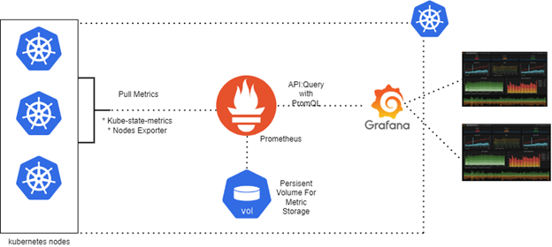

Components

* **Grafana Mimir**: A microservices-based architecture that can run components in parallel
* **Backend**: Interacts with various data sources, such as Prometheus and Loki
* **Frontend**: Renders visualizations for users, such as charts and graphs

Features

* **Central monitoring**: Consolidates data from multiple sources into dashboards
* **Alerting**: Sends out alerts when metrics hit certain thresholds
* **Collaboration**: Sharing dashboards and data views enhances team communication
* **Integration**: Works with a range of DevOps tools

Use cases

* **Monitoring application performance**: Tracks key performance indicators (KPIs) and sets up alerts
* **Monitoring server performance**: Provides insights into CPU usage, memory consumption, and more
* **Monitoring application logs**: Consolidates and visualizes logs to identify issues
* **Request tracing**: Visualizes the end-to-end flow of requests through multiple services
* **Error tracking**: Correlates logs and metrics to identify and diagnose errors

**Seamens Interview**

Intro

Ansible configuration- why required as your are creating the infrastructure in Kubernetes (application deployed in K8S).

ArgoCD: Process how it works

K8s architecture and components

AWS resources - 20

Terraform code - vpc and eks code components (code)

Kubernates: Difference between statefull set and deployment.

How volumes will attach to